Historically Significant Phono Cartridges
Part 1 – Shure
By Marc Silver
Recently Constantine Soo (www.dagogo’s Publisher) asked me to write an article that focused on the most significant phono cartridge over the last 80 years.
I thought it would be a lot of fun but requiring a great deal of research. At first we thought one or perhaps two articles focusing on early classics and then more current designs. Once I started my research, I realized that to do any justice to the topic, it is going to take more articles than we thought. There are just too many cartridges, and each has their own history that really needs to be discussed.
This is the first of an unknown number of articles. Where to start I left to chance. I reached into my memory to compile a list of cartridges I personally find significant. Some I admit are personal favorites and some not so much. But each one significant in their own right. I sent out some requests for historical information by e-mail to as many as I could. Many of my choices have been out of business for decades, so for them I will rely on my memory and some industry friends.
Back in 1968 my very first HiFi turntable was a used Dual 1209SK with a Shure M55E cartridge first introduced about five years earlier. Although I only used the Shure for about 4 or 5 weeks before replacing it with a Stanton 681EE, it got me started in what has turned out to be 52 plus years as an Audio Professional and Hobbyist.
I will admit that Shure is not my favorite cartridge company, but it is without a doubt one of the most influential companies in the history of HiFi and the subject for the first article on historically significant cartridges.

On April 15, 2020 I conducted a phone interview with Shure corporate’s historian, Michael Pettersen. The following is the result of our phone conversation.
- Michael, can you tell me a little about yourself?
Michael: I have been with Shure for 44 years. I started in 1976 and have had five different careers at Shure. I am a professional musician and still a working musician with a degree in music from the University of Illinois, but my hobby has always been electronics. I had planned on becoming a Professor of Music. But discovered that wasn’t going to work out. So because of my hobby I approached Shure Brothers and was hired in sales department and eventually became the Sales Manager, but realized I wasn’t really cut out for that. Then I got into product management and eventually became Product Manager. I then went into Advance Product Planning looking at new technologies. In 1993 started I created the Applications Engineering department. At the same time, I was Shure’s liaison to the White House and worked with both President Bush’s, Clinton and Obama. Now, I am Shure’s Corporate Historian.

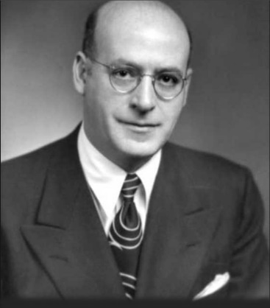
I know Shure was founded back in 1925 by Sidney N. Shure in Chicago as the Shure Radio Company and produced Radio Parts Kits.
Sidney N. Shure
- What was Shure’s first finished products?
Michael: That would have been in 1932 a Carbon Microphone. In 1928 the name was changed to Shure Brothers when his brother joined him. In 1929 Shure started distributing Microphones from Universal and Ellis Electrical Labs but decided in 1932 he could build his own.
Historical Note: 1933: Shure begins to supply OEM crystal pickups to various manufacturers of record players.
- Shure has been making cartridges for turntables since 1937 along with tonearms. Tell me why Mr. Shure decided to enter the cartridge business?
Michael: He was buying crystal elements from Brush Development Corporation and decided to expand the business.
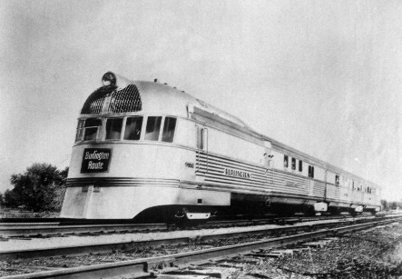
- His first was the 99A Zephyr Arm and crystal cartridge. Can you tell me something about that combination?
Michael: In 1937 Shure introduced the model 99A Zephyr - a balanced tracking crystal record reproducer. This product featured a full-floating, non-resonant tone arm; low "needle-point" impedance; and "needle tilt" that kept the stylus in true alignment with the record groove. It was styled after the Zephyr train of that period.
Historical Note: 1951: Shure offers a complete line of crystal and ceramic pickups
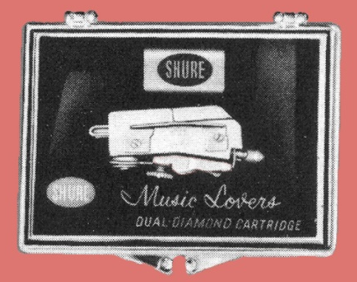
Historical Note: 1955: Shure introduces the ML44 Series known as the Music Lover's Cartridge. It was a ceramic pickup with a twin-lever coupling and the ability to play three speeds of records. Two styli (1 mil and 3 mil) were interchangeable by the user.
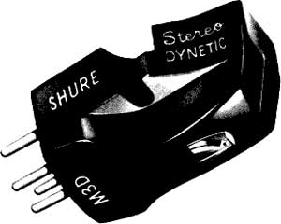
- Shure introduced the first stereo Moving Magnet cartridge the model Michael: The M3D was Shure’s first stereo moving magnet design. Shure and Columbia worked in secret for three years during the development of the first Stereo LP. Which is why they both came out at the same time. There was a downside. Ben Bauer, Shure’s M3D stereo Dynetic Cartridge, in 1958, with a separation of 20 dB at 20 kHz.
VP of Engineering at the time was our contact with CBS and CBS hired him away from us.

The V15 was perhaps one of the world’s most successful audiophile cartridges.
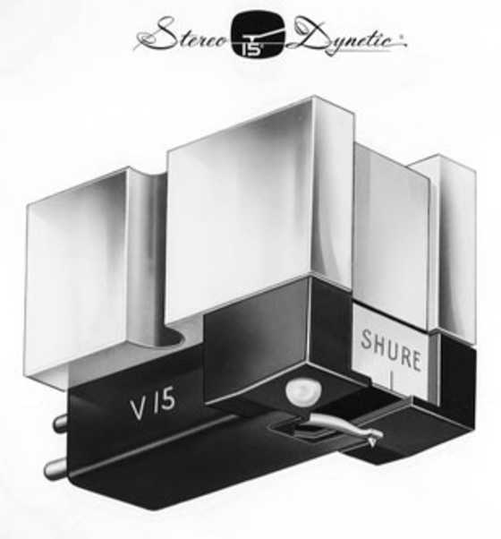
1964: The V15 Stereo Dynetic High Fidelity Cartridge is first sold. It features a 15-degree vertical tracking angle, a bi-radial elliptical stylus (0.0002 x 0.0009 inch), and is subjected to exacting quality control and inspections that are unique in the industry.
- What do you think propelled the V15 to become so popular? Michael: The V15 was introduced in 1964. The name described the 15 degrees Vertical tracking angle and was eventually standardized for the industry. Its sonic quality put us on the map as an audiophile cartridge manufacturer.
Historical Note: History of the V15: V15 1964-1966, V15 Type II 1966-1970, V15 Type II Improved 1970-1973, V15 Type III 1973-1978, V15 Type IV 1978-1982, V15 Type V 1982-1983, V15 Type V-MR 1983-1993, V15 Type VxMR 1996-2005
Shure is privately held and has the ability to do things other companies can’t or won’t do. They have a complete archive with at least one of every product they have ever made since 1932.
- When did Shure change their name to Shure Incorporated?
Michael: For the 75th anniversary in 2000.
1966: The V15 Type II superseded the V15. This new V15 was designed using an analog computer and introduced the concept of Trackability - the ability to maintain contact between the stylus tip and the record groove at all frequencies using a minimum tracking force. A flip-action stylus guard was another new feature.
- What was Shure’s unique technology of the time?
Michael: The V15III was its flat response and trackability. It really was it’s trackability that made is special. and crazy popular The Type IV introduced the dynamic stabilizer.
Historical Note: Once the V15-V was introduced, the IV design was reused for the M97.
Historical Note: 1973: The V15 Type III debuts with a uniformly flat, unaccented, uncolored frequency response. This was accomplished by reducing the stylus mass by 25% and by employing a new laminated pole piece design.
- What innovations was Shure known for?
Michael: The III with its trackability and flat response was the big thing. The IV was my favorite, just because of the fact that there was the oil shortage and record companies were cutting back on quality and the LP’s would warp. We came up with the dynamic stabilizer which solved the problem of tracking a warped record. It cleaned your record; it stabilized the cartridge and it removed the static. So, it was a huge leap in performance.
Historical Note: 1978: Shure introduces the V15 Type IV. It features a viscous-damped Dynamic Stabilizer that overcomes most record warps. The Stabilizer brush also cleans the record and reduces any static charge. A hyper-elliptical, nude mounted stylus tip improved the tip-to-groove contact area.
Was Shure the first to use rolled a Beryllium cantilever?.
Michael: The V15V Micro Ridge was unique to Shure. Also Type V introduced an ultra-thin wall rolled beryllium stylus shank. It made the cartridge shank incredibly light and rigid. I think we were the first to use rolled beryllium. It was like a foil that we rolled into a tube.

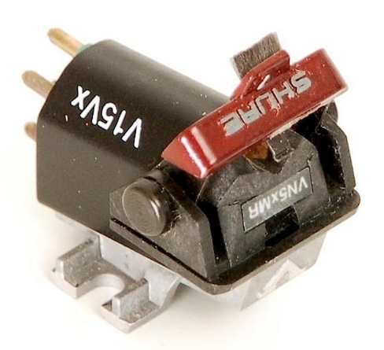
Historical Note: 1982: The V15 Type V features a MASAR polished stylus tip to reduce friction. The ultra-thin beryllium stylus shank dramatically improves trackability. A Duo-Point alignment gauge is used during installation to minimize lateral tracking angle error.
Historical Note: 1983: The V15 Type V-MR features a Micro-Ridge stylus shaped that emulates the shape of a cutting stylus. This greatly improves trackability in the high frequency range.
Historical Note: 1997: The V15VxMR is introduced with improvements in the stylus design and pole piece design to provide a warmer and more musical sound quality.
- What killed the Type V?
Michael: OHSA ruled that beryllium dust was a health hazard. Even though the Type V used rolled beryllium and dust was not created, OSHA was not convinced. The possibility of beryllium dust, the health concerns for Shure employees shaping the beryllium, the OSHA standards for air filtration – all helped to kill the V15 by the end of 2005. To install just the filtering equipment needed meant a long payback period; since vinyl sales were falling, it just didn’t make financial sense. The safety of the employees was most important factor to Mrs. Rose L. Shure.
- Did Shure ever consider a moving coil design?
Michael: They did in the late 70s. But we couldn’t come up with something better performing than what we had in moving magnet units.
My first cartridge was the M55E back in 1968 and remember the M44-7 being around at that time as their entry level cartridge.
- How did the M44-7 develop into a favorite with DJ’s?
Michael: They became popular because they stayed in the groove when back cuing and scratching. They really stayed in the groove and that is what the DJ’s loved.
Historical Note: 2003: Shure Incorporated awarded the National Academy of the Recording Arts and Sciences Technical GRAMMY, awarded to individuals and/or companies that have made outstanding contributions of technical significance to the recording industry.
Historical Note: The Shure V15 cartridge introduced in 1964 and remained in production until 2005. In June four years later, the last remaining Shure V15VxMR inventory was purchased by the Library of Congress. Also, Sony did as well for disc transfers.
- I understand that Shure officially discontinued production on May 1st, 2018 with production to end that summer. Production ended in July. Why did they make that decision?
Michael: The reason had to do with issues of reduced demand and the difficulty to maintain quality standards, but it was primarily suppliers were disappearing and the parts supplied to us were not as good as they were at one time. We felt it better to exit the phono market while our reputation for quality was still high. We just didn’t want to take the chance of not producing the very best performing products, so we decided to discontinue the cartridges, make a clean break and take the social media abuse. The abuse lasted for about a month and then it mostly receded. We produced cartridges for about 15 years longer than we actually thought we would.

- Why not license the designs like B&O?
Michael: That is a very simple question to answer. Shure is privately held and bears the name of the family. To protect the family name is a priority and we won’t let the name be used by anyone else. Although Mr. and Mrs. Shure are gone now, we still want to protect the name and the brand.
- Shure continues with their rather successful lines of microphones and headphones.
Do you think that Shure may ever change their mind and re-enter the cartridge business?
Michael: I doubt it. Here is what I read, there were 25 million vinyl records produced in 2019, In 1976 there were half a billion. You can never say never, but probably not.
I would like to thank Michael Pettersen for his time and very informative interview. It is always a pleasure to reminisce about a hobby that is every changing and for some of us old timers will never be quite the same.
Added resources:
https://service.shure.com/s/article/vintage-shure-catalogs-1933-1984?language=en_US

https://service.shure.com/s/article/brief-history-of-shure-phonograph-cartridges?language=en_US

