Guardians of the Coast
By Marc Silver

Historic Lighthouses and the People Who Kept Them
For centuries, lighthouses stood as fixed points in an unpredictable world. Storms shifted coastlines, currents changed without warning, and ships depended on little more than compass headings, charts, and distant points of light. Behind those lights were men and women whose work was monotonous, isolating, physically demanding, and often dangerous. Lighthouse keepers rarely thought of themselves as heroes. They were caretakers of systems that had to work every night, without exception.
Their stories reveal a profession shaped as much by endurance and routine as by moments of sudden courage.

From Fire Beacons to Stone Towers
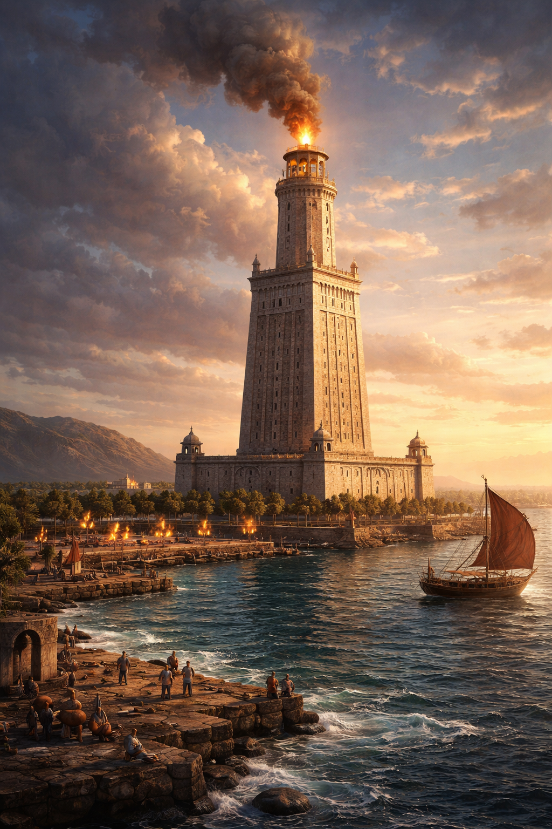
The idea of guiding ships with light is ancient. Long before permanent towers, coastal fires and simple beacons marked dangerous passages. The most famous early example was the Pharos of Alexandria, constructed in the early third century BCE. Rising hundreds of feet above the harbor, it stood among the tallest structures of the ancient world and guided ships into Alexandria for more than a thousand years before being destroyed by earthquakes in the Middle Ages.
Europe preserved the lighthouse tradition more continuously. The Tower of Hercules in A Coruña, Spain, built by the Romans in the first century CE, still operates today. Other early examples include Hook Lighthouse in Ireland, whose core dates to the twelfth century.
Figure 1 Pharos of Alexandria
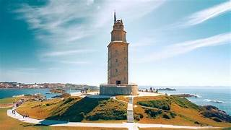
In North America, lighthouse construction began later. Boston Light, completed in 1716 on Little Brewster Island, marked the start of a system that would grow alongside colonial trade and, later, national expansion.

Figure 2 Tower of Hercules

What the Job Actually Required
Before turning to individual lives, it helps to understand what lighthouse keeping demanded on a daily basis.
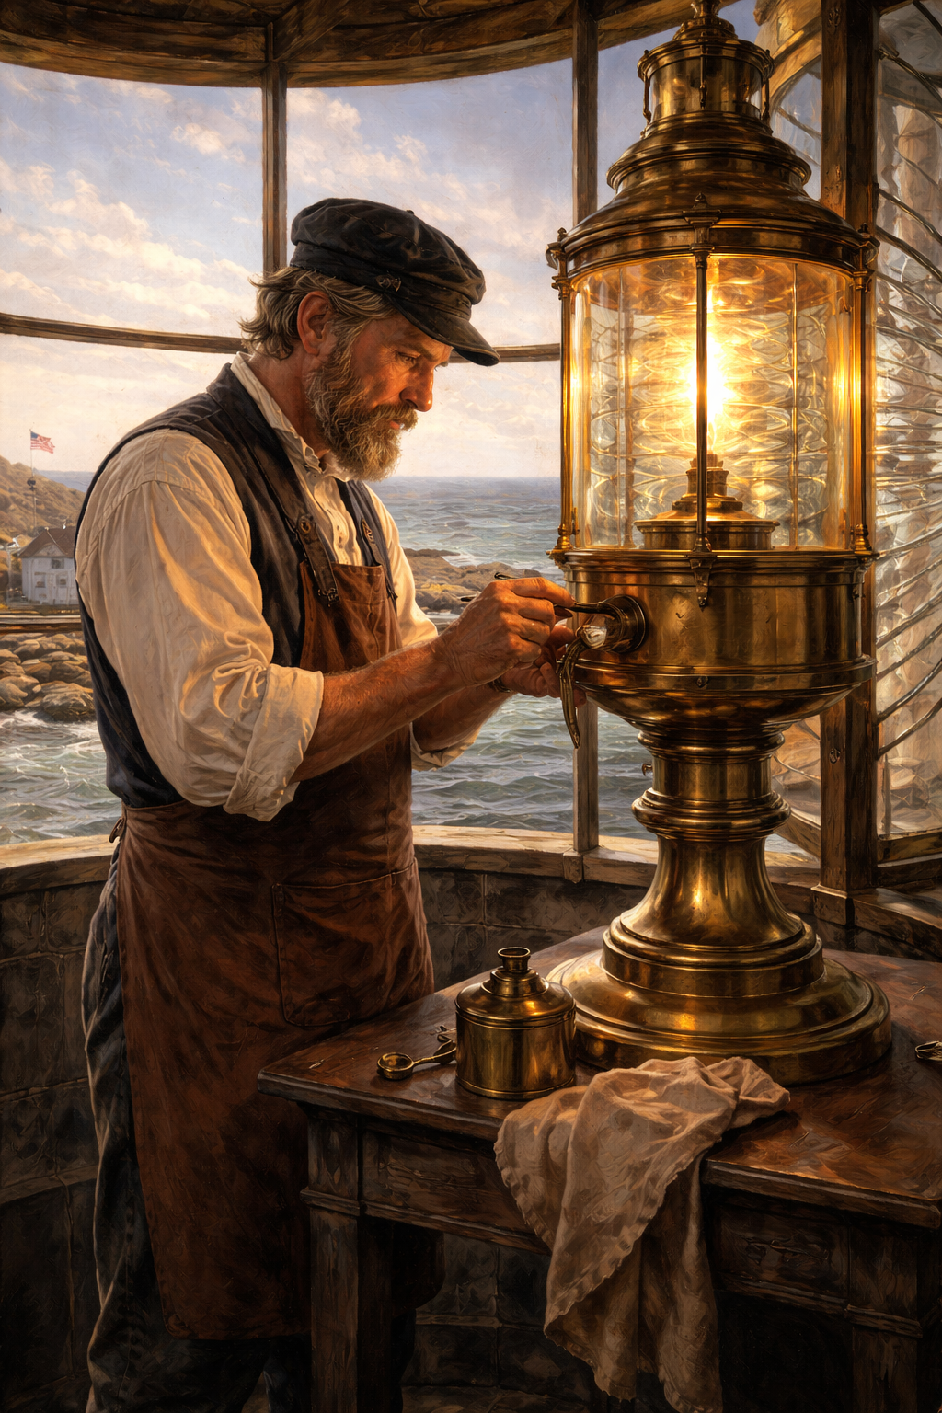
The keeper’s responsibility was simple in theory and unforgiving in practice. The light had to operate on schedule every night, regardless of weather, illness, or personal circumstance. Storms, when ships most needed guidance, were when the work became most punishing.
Early lights burned oil and later kerosene, requiring constant attention. Wicks had to be trimmed, fuel replenished, lenses cleaned and polished. Rotating lens assemblies relied on clockwork mechanisms that needed regular winding. Fog signals were operated manually during low visibility, sometimes for days at a time.
Administrative duties were constant. Keepers maintained detailed logbooks recording weather, equipment condition, and ship movements. Reports were submitted regularly, and inspections were frequent. Failure to meet standards could result in dismissal.
At offshore stations, three keepers typically rotated through four-hour watches, covering six watch periods per day. Sleep was fragmented. Relief boats arrived on fixed schedules unless weather intervened. When supplies failed to arrive, keepers relied on stored provisions, preserved food, and whatever could be caught locally.
Isolation was not incidental. It was part of the job.

America’s First Keepers and an Early Tragedy
America’s first official lighthouse keeper was George Worthylake, appointed to Boston Light in 1716. He earned an annual salary considered respectable for the period but was warned that negligence would bring heavy financial penalties. In addition to tending the light, he also served as a harbor pilot, guiding ships through Boston’s narrow approaches.
On November 3, 1718, Worthylake, his wife Ann, daughter Ruth, a servant, an enslaved man named Shadwell, and a friend were returning from Boston when their boat capsized. All six drowned within sight of the lighthouse. Days later, Worthylake’s replacement also drowned while attempting to reach the station.
The event shocked the colony. A young Benjamin Franklin wrote and sold a ballad titled The Lighthouse Tragedy, giving the incident its enduring name. It remains an early reminder that lighthouse keeping was never merely technical work. It was lived at the edge of danger.
The brief appearance of Shadwell in historical accounts also points to a larger reality. Lighthouse keeping, like most early public service, was not racially inclusive. Enslaved labor appeared occasionally at stations, but official appointments overwhelmingly excluded non-white candidates well into the twentieth century.

Women in the Lighthouse Service
Women entered lighthouse keeping most often through necessity. When husbands fell ill or died, wives and daughters stepped in to keep the light operating. Over time, many received official appointments.
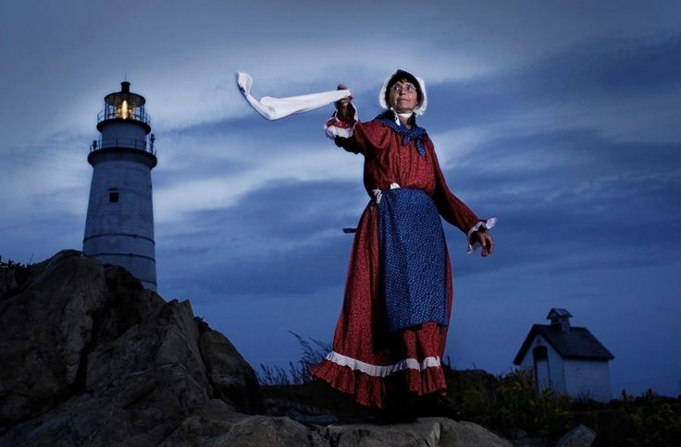
Hannah Thomas became the first woman formally appointed as a lighthouse keeper in the United States in 1776 at Plymouth’s Gurnet Lighthouse. Records indicate that she earned the same annual salary as her late husband, a sum comparable to skilled trades but well below professional incomes.
Figure 3 Depiction of Hannah Thomas
Ida Lewis remains the most famous American lighthouse keeper. Stationed at Lime Rock Lighthouse in Rhode Island, she assisted her parents from her teens and later became principal keeper. Over a career spanning more than five decades, she rescued at least eighteen people from the water. She received the Gold Lifesaving Medal and national recognition for her actions.
Her fame was unusual. Most women who served did so quietly, with little public acknowledgment.

Abbie Burgess and the Limits of Endurance
Abbie Burgess Grant’s story endures because it captures the profession at its most extreme.
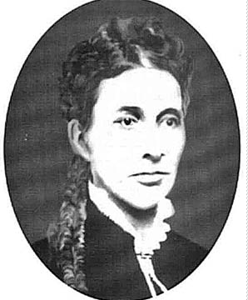
She arrived at Matinicus Rock, twenty-five miles off the Maine coast, in 1853 at the age of fifteen. The station consisted of two towers on a bare granite outcrop. Her father, Samuel Burgess, was the principal keeper. Abbie assumed responsibility for tending the lights while he fished to supplement the family’s income, a common necessity at remote stations.
In January 1856, Samuel left the island to obtain supplies after the scheduled relief cutter failed to arrive the previous fall. Shortly after his departure, a severe gale struck. For days, waves swept across the rock,
destroying the dwelling house and flooding lower portions of the towers.
Figure 4 Abbie Burgess Grant
With her mother ill and younger siblings to protect, Abbie kept both lights burning for nearly a month until her father could return. She was seventeen years old.
Samuel Burgess lost his position in 1860 during a period when lighthouse appointments were still influenced by administrative and political change. Records confirm the dismissal but do not reliably document its cause. Abbie remained in service as an assistant keeper, later marrying Isaac Grant. Together, they served at multiple stations while raising four sons.
Late in life, Abbie wrote of her enduring attachment to lighthouse work and expressed a wish that her gravestone resemble a lighthouse. Decades later, a small beacon was placed at her grave in fulfillment of that request.

Rescue as an Unofficial Duty
Although lighthouse keepers were not primarily rescue workers, their proximity to danger made intervention unavoidable.
In 1881, Isaac Grant of Whitehead Light launched a boat with his son during a storm to rescue survivors clinging to an overturned yawl. In 1906, Klass Hamringa rowed seven miles through winter conditions on Isle Royale after noticing distant smoke, discovering forty-three shipwreck survivors.
Even children acted when necessary. In 1890, fourteen-year-old Maebelle Mason launched a boat alone on the Detroit River and saved a man who had capsized more than a mile from shore.
Across the Atlantic, Grace Darling’s rescue off the Farne Islands demonstrated how similar the risks and expectations of lighthouse service were across countries.

Organization, Reform, and Professionalization
The United States Lighthouse Service was established in 1789 under the first Congress, making it one of the nation’s earliest federal programs. For much of the nineteenth century, appointments were influenced by patronage. That changed gradually. In 1896, keepers became civil service employees, bringing standardized hiring, inspections, and job security.
In 1910, the Bureau of Lighthouses was created to modernize administration. In 1939, the U.S. Coast Guard absorbed the service, integrating lighthouses into a broader navigational system.

Technology and the End of the Keeper
Automation arrived gradually, driven by technological change rather than sudden policy shifts.
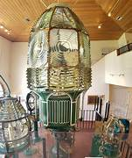
Fresnel lenses reduced fuel consumption and extended visibility. Electrification eliminated wick trimming and oil handling. Automated timers and photoelectric sensors replaced manual operation. Radio navigation, radar, and eventually
satellite-based systems reduced dependence on fixed visual aids.

Figure 5 Fresnel lens
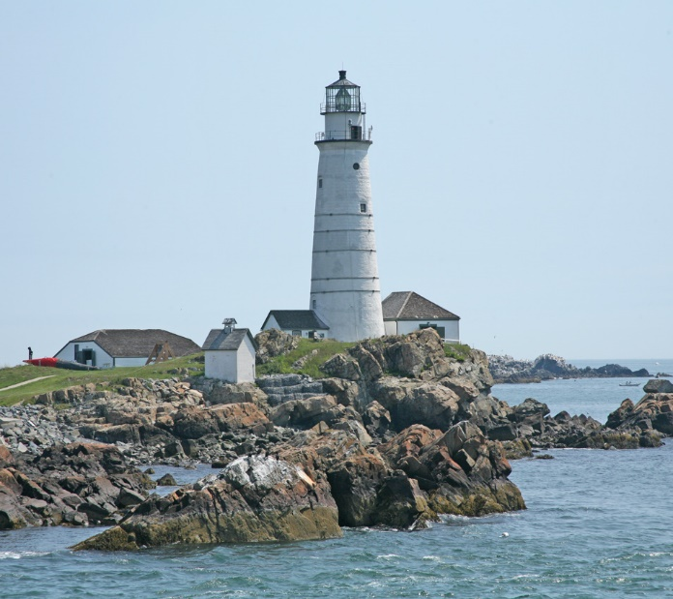
By the late twentieth century, the cost and risk of staffing remote stations outweighed the benefits. In 1990, the last American lighthouse was automated.
One exception remains. Congress mandated that Boston Light remain permanently staffed as a living historical monument. Sally Snowman served as keeper from 2003 until her retirement in 2023, becoming the first woman to hold that role and the last civilian lighthouse keeper in the United States.

Lives Worth Remembering
Some keepers became notable not for heroics but for professionalism.
Emily Fish, keeper at Point Pinos, maintained one of the most meticulously kept stations in the service while hosting visiting scientists and artists. Laura Hecox, stationed at Santa Cruz, combined lighthouse keeping with natural history, laying the groundwork for what became the Santa Cruz Museum of Natural History.
Laura Hedges, serving in New Jersey in the 1920s, recorded her husband’s death in the logbook with a single line, then continued the day’s entries.
The light remained lit.

Legacy
Between 1996 and 2000, the Coast Guard commissioned a class of coastal buoy tenders named after notable lighthouse keepers. These vessels maintain navigational aids once tended by hand, continuing the mission in a different form.
Many historic lighthouses now serve as museums or preservation sites. They no longer require keepers, but they still tell stories.

Closing Reflections
Lighthouse keepers lived ordinary lives under extraordinary conditions. They did not command ships or shape policy. They kept systems working. Night after night. Storm after storm.
From early colonial tragedies to the final staffed lighthouse, the profession reflects the changing relationship between people and technology. The lights still shine, automated and precise. The people who once tended them remind us that reliability, endurance, and quiet responsibility matter long after the work itself disappears.
As long as lighthouses stand, they stand for those who kept them burning.

Citations and Sources
- United States Coast Guard, Aids to Navigation Historical Overview
- National Park Service, Lighthouse Keepers and Lighthouse History
- Smithsonian Institution, Fresnel Lenses and Maritime Navigation
- Edward Rowe Snow, The Lighthouses of New England
- U.S. Lighthouse Service Annual Reports, 19th–20th centuries
- Library of Congress, Early American Lighthouse Records
- UNESCO World Heritage Centre, Tower of Hercules
- Rhode Island Historical Society, Ida Lewis Papers
- Maine Maritime Museum, Matinicus Rock Lighthouse History
- Boston Light Historical Records, U.S. Coast Guard

