High-End Audio Tweaks:
What Actually Works (And What's Complete BS)
By Marc Silver
Look, I've been in this High-End Audio industry for over 56 years, and I've seen it all. Magic rocks, thousand-dollar fuses, wooden cubes that supposedly "tune" your room, you name it, someone's tried to sell it to audiophiles. Some of this stuff actually works. Most of it os pure snake oil.
I'm probably going to piss off a lot of people in the industry with this article, but somebody needs to tell the truth. My goal here isn't to be popular, it's to help you spend your money on things that actually improve your sound, not line the pockets of charlatans.
The Golden Rule: If It Sounds Too Good to Be True...
Here's the thing, real audio improvements follow the laws of physics. They don't break them. If someone's selling you a tweak and can't explain why it works using basic engineering principles, run away, runaway fast.
The tweaks that have stood the test of time, think back to classics like the Sorbothane dampers or XXX
, they worked because they solved real, measurable problems. Not because they harnessed "quantum energy" or whatever nonsense is popular that week.
Vibration Control: Where Physics Actually Matters
Spikes and Cones: The Real Story
Alright, let's talk about spikes. Half the internet thinks they're magic, the other half thinks they're useless. The truth? They're neither.
Spikes work by creating a mechanical pathway for vibrations to escape your gear. Think of it like a highway for unwanted energy, you want that energy to go somewhere instead of rattling around in your equipment. But here's the catch: that highway has to lead somewhere useful.
When spikes help:
- You've got a concrete floor or a really solid platform (300+ pounds)
- Your gear is heavy and well-built
- You need to stop speakers from wobbling on carpet
When they hurt:
- Your floor is suspended wood (think raised foundations, most houses nationwide are this style of building)
- You're in an apartment (hello, angry neighbors)
- Your gear has its own suspension system (like most turntables)
I learned this the hard way years ago. Spent a fortune on brass spikes for a Linn LP12, only to find they made everything worse. Turns out, when you have a suspended turntable, you don't want to couple it to anything, you want to isolate it.
The Wooden Cube Scam
Oh boy, where do I even start with these things? Mpingo discs, Shakti Hallographs, all those little wooden cubes you're supposed to scatter around your room like some kind of acoustic feng shui...
Look, I get it. Someone with impressive credentials tells you that these tiny pieces of African Blackwood will transform your sound by "tuning" your room's resonances. It sounds plausible, especially when they throw around terms like "sympathetic vibration."
But here's the problem: physics doesn't care about marketing copy.
A small wooden cube trying to affect a 100Hz bass mode is like trying to stop a freight train with a toothpick. The wavelength at 100Hz is over 11 feet long. Your little cube is 1/68th the size of the wave it's supposedly controlling. It's not going to happen.
I've seen people spend thousands on these things, moving them around their rooms like they're tuning a piano. The placebo effect is real, folks. When you spend $200 on a piece of wood, your brain wants it to work. But every legitimate measurement I've seen shows they do absolutely nothing.
Want to fix bass problems? Get real bass traps. Big ones. Or hire an acoustician. Don't buy decorative cubes.
Sorbothane: The Stuff That Actually Works
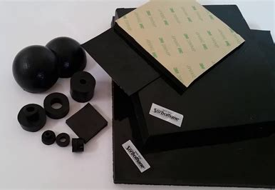
Now here's a material that deserves respect. Sorbothane is essentially a vibration-eating monster, it takes mechanical energy and turns it into heat through internal friction. It's the real deal; it’s been used in everything from audio gear to spacecraft.
Figure 1 Sorbothane: Sheet, Pads, Domes and Bushings
But and this is important, you have to use it right. I see people slapping Sorbothane pads under everything, thinking more is better. Wrong. The material only works when it's compressed to about 15-25% of its height. Too little compression and it doesn't engage. Too much and it bottoms out.
For turntables, use the softer grades (30-50 Shore). For electronics, go harder (70+). And keep it away from heat, I've seen too many people put Sorbothane near tube amps and watch it turn into expensive goo.
The Great Power Cord Debate
Hospital Grade: Marketing vs. Reality
"Hospital grade" power cords. Man, the audio industry really knows how to make something sound important, doesn't it?
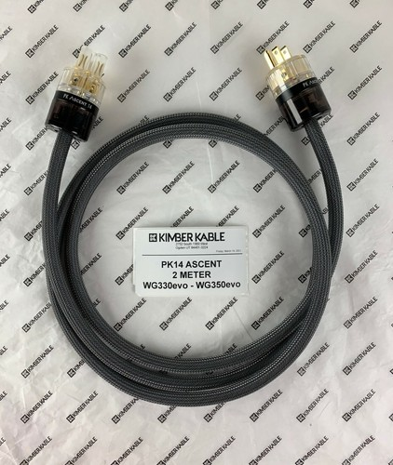
Here's what hospital grade actually means: the plugs grip tighter to prevent them from falling out when some EMT is wheeling crash carts around. That's it. They're not magic. They don't have special copper blessed by electrical monks.
Figure 2 Kimber Kable Ascent PK14 AC Power Cable
The shielding is better than a basic cord, sure, but we're talking about rejecting radio frequency interference above 1MHz. Your audio gear is vulnerable to much lower frequency stuff, the kind that comes from dimmer switches and refrigerator motors, not WIFI routers.
I've done blind tests with these things. Good ones, with proper protocols. Zero audible difference in 95% of cases. The 5% where they helped? The original cord was damaged or severely undersized.
Save your money. Buy a decent 12-gauge cord for under $100 and spend the rest on music. That being said I have used and still use some $300 to $500 power cords on my system, I have compared them to lesser cords and feel they do make a difference, but honestly, I can’t prove it decisively.
The Mega-Dollar Fuse Insanity
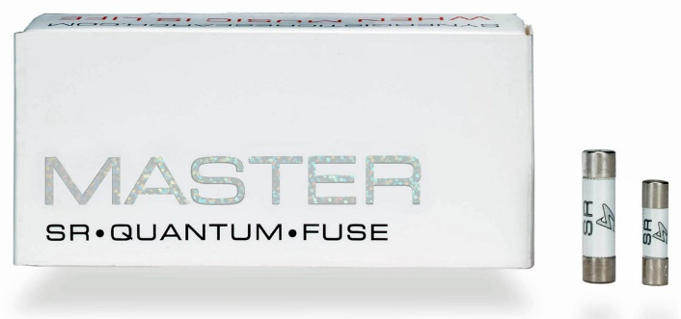
OK, this one really gets my blood boiling. Audiophile fuses. Cryo-treated, silver-plated, "directional" fuses that cost more than some people's entire systems.
Here's the thing about fuses: they're not in your signal path. They sit in the power supply, protecting your gear from electrical faults. The audio never sees them. Never. The electrons flowing through your speakers have been through transformers, rectifiers, and filter caps, they've been completely divorced from whatever's happening at the fuse.
If changing a fuse changes your sound, you have a problem. Either the fuse holder is corroded, or your power supply is failing, or you're experiencing the mother of all placebo effects.
I've seen the measurements. Fuse resistance varies by maybe 0.01% between a $5 Bussmann and a $500 "audiophile" version. In my opinion in a power supply handling 120 volts, that's completely irrelevant.
Digital Tweaks: Where Desperation Meets Physics
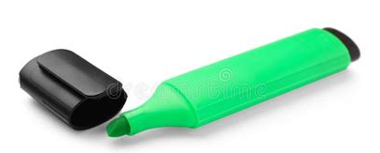
The Green Marker Myth
This one takes me back to the '80s, when everyone was convinced that coloring the edge of their CDs with a green marker would improve the sound. The theory was that it would reduce laser scatter and improve error correction.
Except... the laser never sees the edge. It reads from the bottom of the disc, through the clear polycarbonate to the aluminum layer. The edge is completely irrelevant to the optical path.
But people swore it worked! Why? Because when you take a CD out to color it, you're handling it, maybe cleaning it a bit, definitely paying more attention to the playback process. All of that can affect your perception.
External Clocks: The Ultimate Overkill
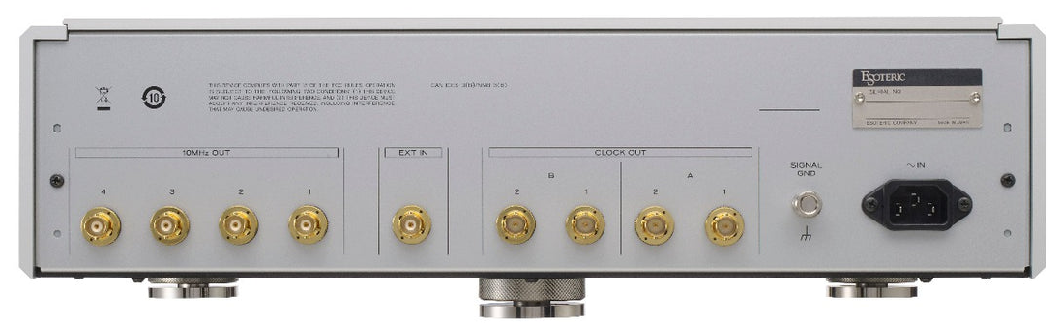
External master clocks are the latest must-have accessory for digital audio. Feed your DAC a "cleaner" clock signal, and supposedly everything becomes more musical, more spacious, more... whatever adjective sells units that month.
Figure 3 $20,000 Esoteric G-01X G Series Rubidium Master Clock Generator
Look, jitter is real. Bad clocks can cause timing errors that affect sound quality. But modern DACs have gotten really, really good at dealing with this stuff internally. Most of them re-clock the incoming signal anyway, so your expensive external clock is just another step in the chain.
The few times I've heard a genuine improvement from an external clock, it was because the DAC had a genuinely terrible internal clock to begin with. Fix the real problem, buy a better DAC, don't add Band-Aids that don’t work.
Analog Mysteries: Where Things Get Interesting
Turntable Mats: The SACG Revelation
Now this is where things get fun. A few years back, I was working with the Sacramento Audio Club on a turntable mat comparison. We had everything, felt, rubber, cork, leather, carbon fiber, even a $1,900 copper mat that weighed more than some turntables.
Six different listeners, all with different preferences and systems. We went through dozens of mats over several sessions. And you know what? For the first time in decades of audio testing, we all actually agreed on something.
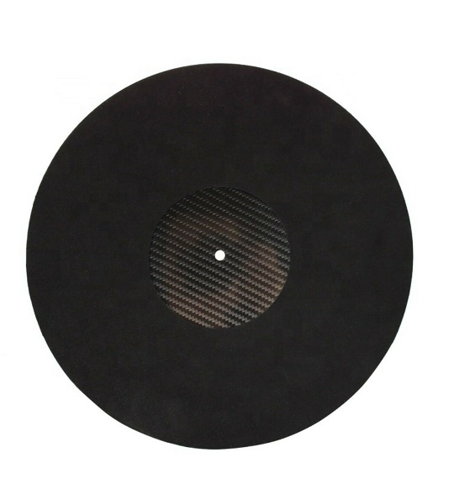
The carbon fiber mat wasn't just better; it was obviously better. Backgrounds got quieter, images got more focused, even surface noise became less intrusive. It was the kind of improvement that makes you question everything you thought you knew about your system.
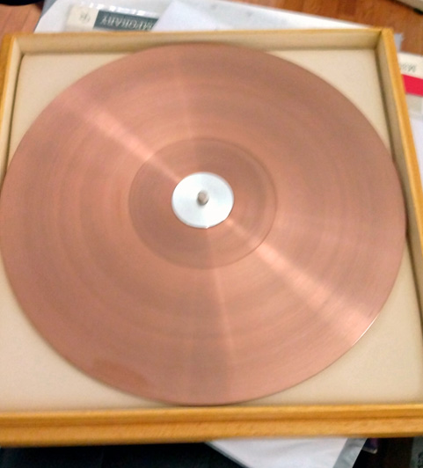
Why did it work? The carbon fiber was doing exactly what good engineering materials should do, it was rigid enough to not add its own resonances, but had enough internal damping to absorb energy from the record. Plus, it was antistatic, so no more crackling when you lifted the stylus.
Figure 4 Torqueo Copper Mat Cu-2900 $1,900
Meanwhile, that expensive copper mat? Made everything sound like it was underwater. Beautiful to look at, but it turned every record into a sonic mudslide.
The CD Demagnetizer Story
Here's a story that'll make you question everything you think you know about audio tweaks.
Back in the '80s, I was a Bedini dealer. My sales rep shows up one day with a CD "demagnetizer", basically a device that was supposed to remove magnetic fields from CDs to improve playback. I looked at him like he was crazy. CDs aren't magnetic media!
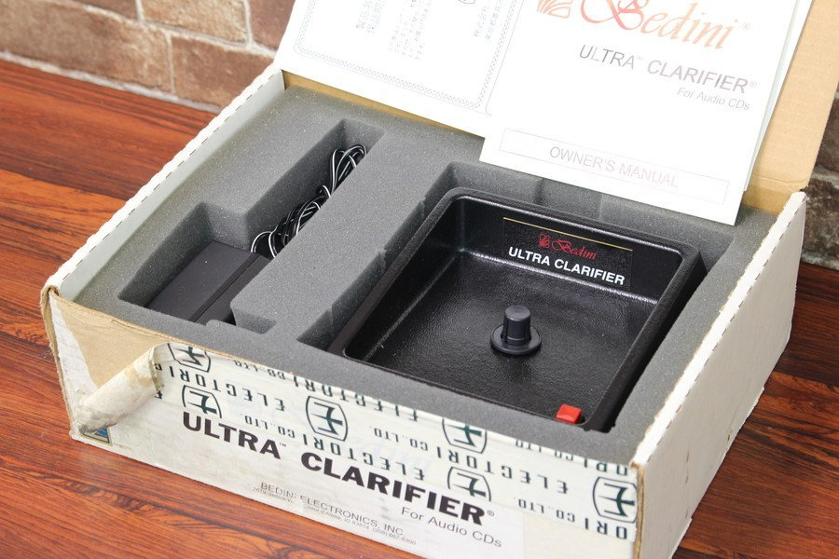
Figure 5 Bedini ULTRA CLARIFIER CD demagnetizer
But he insisted I try it. So, I played a CD on my McCormack transport, then ran it through the demagnetizer, then played it again. And damned if it didn't sound better. Clearer imaging, less grain, more natural presentation and better focus.
I was baffled. This went against everything I knew about digital audio. So, I kept testing, trying to figure out what was happening. Finally, I noticed something while handling the CD, there was a ribbon cable that ran from inside the transport to the laser. It ran very close to the disc as it spun. And that's when it hit me.
The "demagnetizer" wasn't removing magnetic fields. It was removing static charge. CDs build up static electricity from handling and spinning, and that static was interfering with the delicate signals in the transport's circuitry. Remove the static, and the interference goes away.
It worked, but not for the reason anyone thought. I ended up ordering some and sold them for several years. But if you still use CD, there are less expensive ways to solve the problem. Like and antistatic cleaner or even try window cleaner on a clean cloth. It works.
Room Tweaks: The Stuff That Actually Matters
Bass Traps vs. Acoustic Jewelry
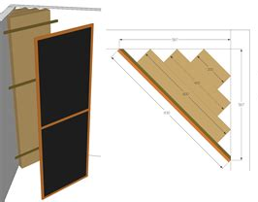
Your room is probably the biggest problem in your system. Not your cables, not your fuses, not your power conditioning, your room. And fixing room problems requires serious acoustic treatment, not decorative gewgaws.
Figure 6 DIY Bass Trap
I see people spending thousands for tiny resonators and diffusers that look impressive but do nothing measurable. Meanwhile, their room has a 10dB bass hump at 63Hz that's making everything sound like it's being played in a submarine.
Want to improve your sound? Get a measurement microphone and some software. Find out what your room is actually doing to your music. Then treat the real problems with real solutions, thick bass traps in corners, broadband absorption at reflection points, proper diffusion on the back wall.
It's not sexy. It's not mystical. But it works.
The Chair Test
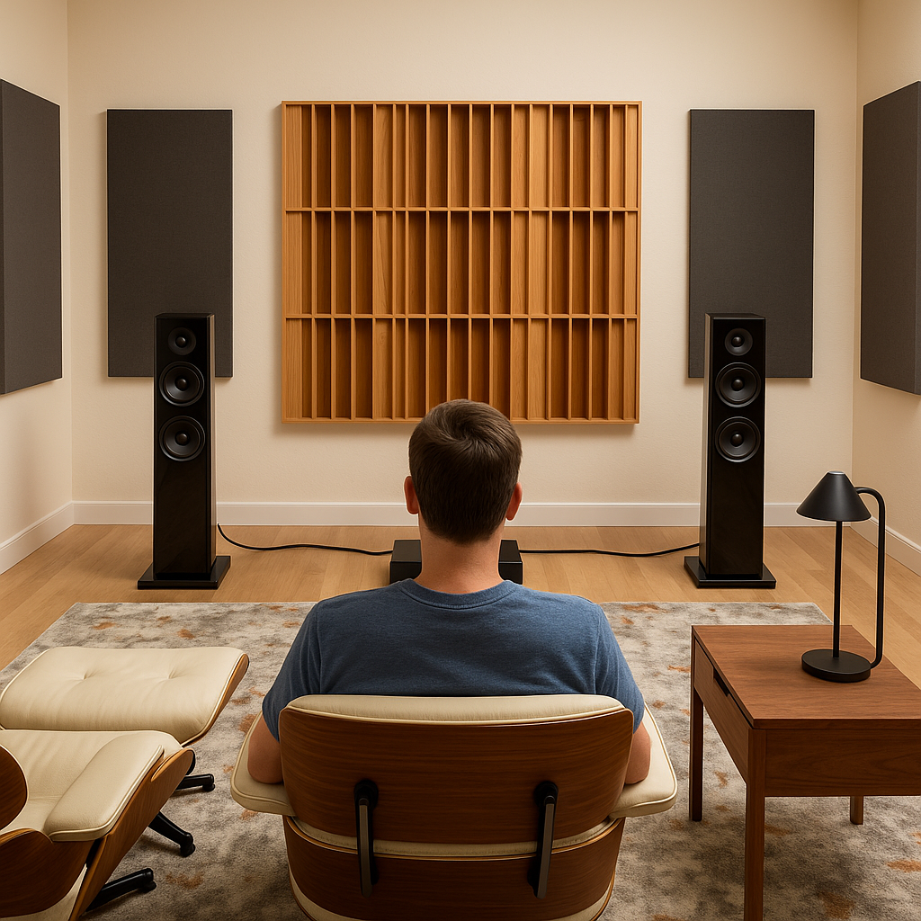
Here's a free tweak that actually works: move your listening chair. Forward, backward, up, down, small changes in position can have huge effects on imaging and tonal balance. You can also try moving your speakers or toeing then in or out. Assuming you didn’t supper glue your equipment to the floor this is an easy mod.
I've seen systems that sounded mediocre with the chair in one spot sound absolutely magical when moved just 18 inches forward. Why? Because you're changing the acoustic relationship between your ears and the room boundaries. You're finding the spot where the direct sound from your speakers and the reflected sound from your walls combine in a way that supports the music instead of fighting it.
The Psychology of Tweaks
Why We Want to Believe
Look, I get it. We all want that magic bullet, that one tweak that's going to transform our systems and make us hear our music in a whole new way. The audio industry feeds on that hope, that endless quest for perfection.
But here's the thing, most of the time, the biggest improvements come from the most mundane fixes. Clean your stylus. Position your speakers properly. Treat your room. Use decent cables that aren't broken. These things aren't exciting, but they work.
The exotic tweaks? Sometimes they help, usually they don't, and occasionally they make things worse. But they're always more expensive than the basics you should be doing first.
When Tweaks Actually Work
The tweaks that work tend to have a few things in common:
- They solve a real, measurable problem
- They're based on solid engineering principles
- Their effects can be demonstrated reliably
- They don't require mystical explanations
The tweaks I mentioned earlier, worked because they were designed by people who understood materials science. They used polymer chains to convert mechanical energy into heat; basic physics applied to a real problem.
Most tweaks that survive long-term are like this. They're not revolutionary, they're evolutionary. Small improvements based on sound engineering.
My Advice After 56 Years
Start with the basics. Get your room sorted. Position your speakers properly. Use decent gear that's well-matched. Then, and only then, start worrying about the esoteric stuff.
When someone tries to sell you a tweak, ask them to explain why it works. Not with mystical language about "quantum fields" or "molecular alignment," but with real physics. If they can't give you a straight answer, walk away.
Trust your ears, but verify with measurements when possible. The placebo effect is real and powerful, especially in audio. If a salesperson describes what you’re going to hear then repeats it over and over during the demo, most people accept it as real. We want our expensive tweaks to work, so sometimes we convince ourselves they do even when they don't.
And remember, the best tweak is often the simplest one. Sometimes the answer isn't a $500 accessory. Sometimes it's just cleaning your stylus, tightening a loose connection, or moving your chair six inches to the left.
The music is what matters. Everything else is just engineering in service of that goal. Don't let the tweaks become more important than the tunes.
Final Thoughts
I've probably made some enemies with this article. The tweak industry doesn't like it when someone points out that the emperor has no clothes. But after more than half a century in this business, I've learned that the truth is more important than making friends.
Some tweaks work. Many don't. All of them cost money. Spend yours wisely.
And remember, the best audio tweak is buying more music. Everything else is just fiddling while Rome burns.
Marc Silver has been involved in high-end audio for over 56 years as a dealer, consultant, and designer. He's currently working on a book about the intersection of audio engineering and human perception.

