Georgetown Grand Cayman Walking Tour
Starting Point: Cruise Ship Dock / Harbor
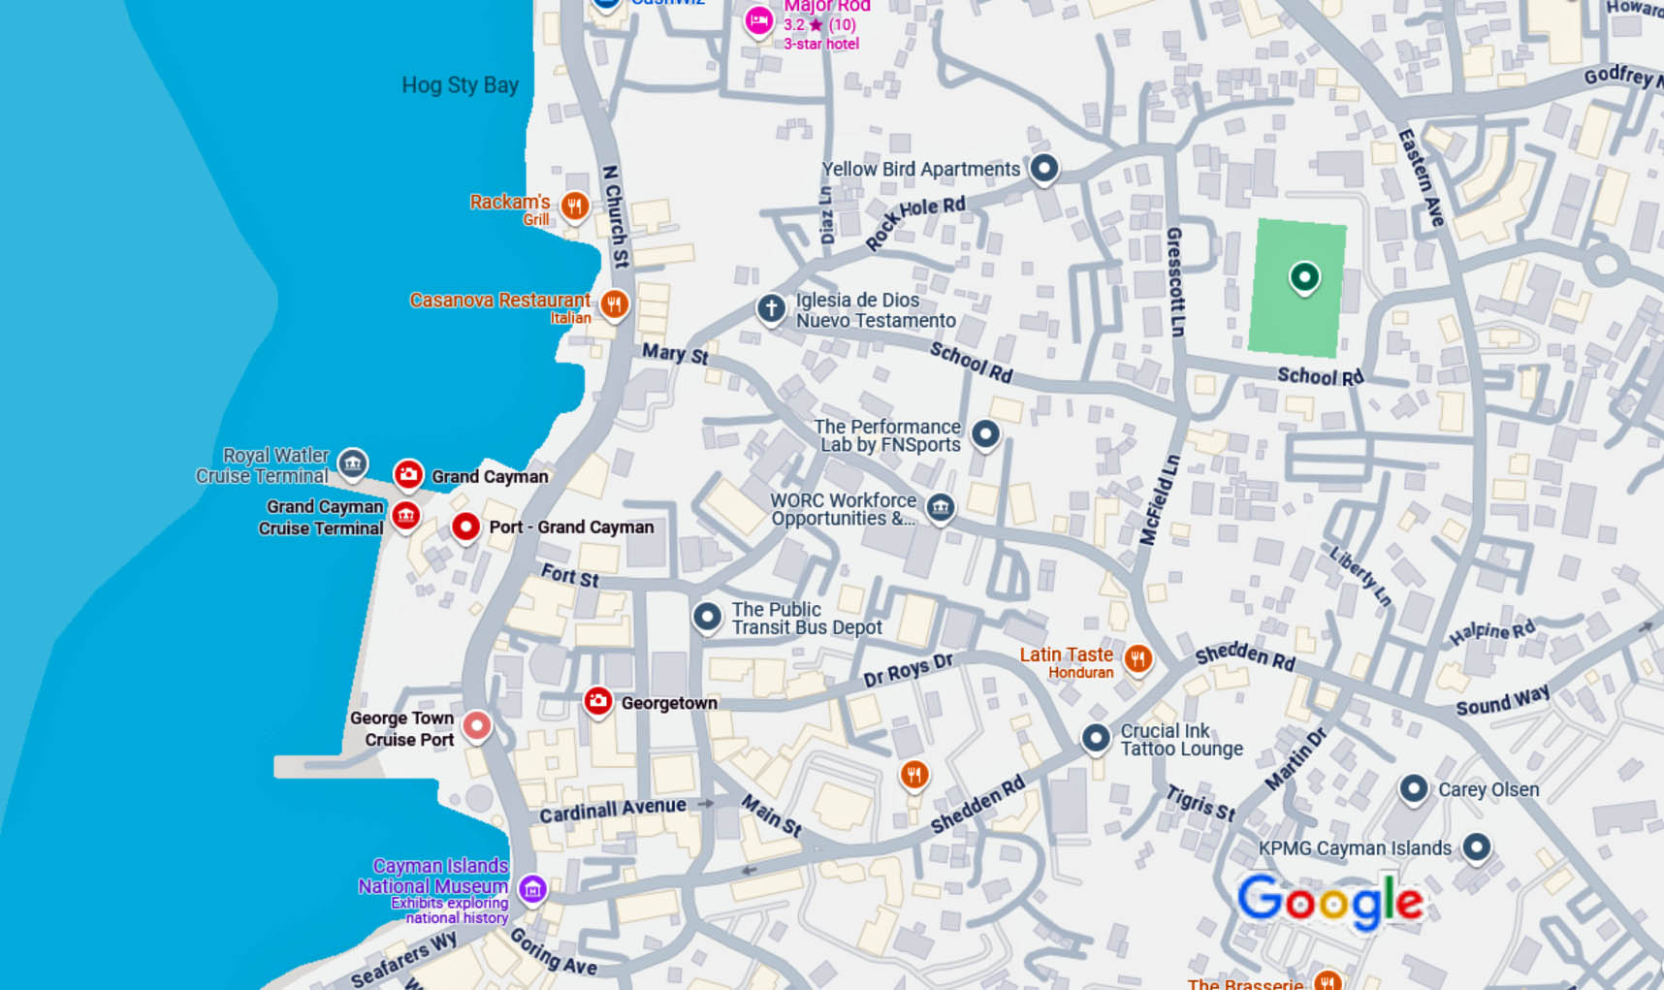
Route Overview:
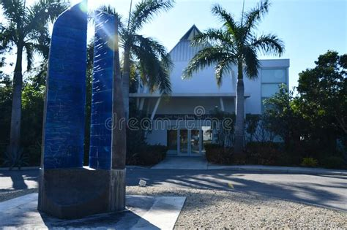
1. Cayman Islands National Museum (Head south 0.1 mile from dock, ~2-minute walk)
Kick off your journey with a dive into Cayman’s rich history. This small but fascinating museum offers exhibits on the islands' maritime heritage, culture, and natural history. A great introduction to the Caymanian way of life.
🎟 Admission: ~$10 USD
2. National Gallery of the Cayman Islands (0.3 miles from the museum, ~5-7 minute walk)
This contemporary gallery showcases incredible local and Caribbean art, along with a peaceful outdoor sculpture garden. A perfect stop for art lovers!
🆓 Free Admission
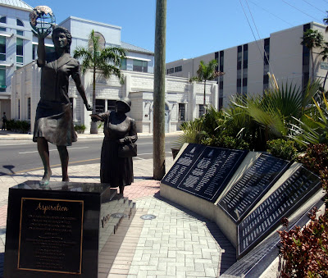
3. Heroes Square (0.2 miles from the gallery, ~3-4 minute walk)
Step into the heart of Georgetown’s history at this central square, home to monuments honoring the Cayman Islands' most influential figures. A great spot for photos and a short break.
4. George Town Harbor Front (0.1 miles from Heroes Square,
2-3-minute walk)
Take in scenic ocean views, browse local craft vendors, and watch fishermen and boats along the waterfront. This is also a great place to pick up souvenirs.
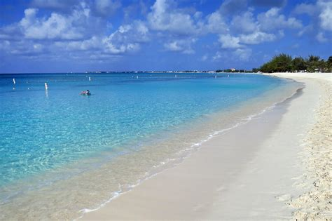
5. Seven Mile Beach Access Point (1 mile from Harbor Front, ~20-minute walk or short taxi ride)
Wrap up your tour with some relaxation at one of the Caribbean’s most famous beaches. Whether you dip your toes in the sand, take a quick swim, or grab a drink at a nearby beach bar, this is the perfect way to unwind.
📏 Total Walking Distance: ~1.7 miles
⏳ Estimated Walking Time: 35-45 minutes
Practical Tips:
✔ Wear comfortable walking shoes
✔ Bring water and sun protection
✔ If needed, take a short taxi ride or catch a local bus to Seven Mile Beach
✔ Mornings or late afternoons are best to avoid the midday heat
Recommended Refreshment Stops:
☕ Waterfront Cafe (near Heroes Square) – Relax with a coffee or fresh juice
🍽️ Cimboco Caribbean Cafe (on Harbor Drive) – Try authentic Caymanian cuisine
Optional Extensions:
🗂️ Cayman Islands National Archive – Learn more about local history
🎨 Local Art Galleries – Discover hidden gems along the route
🛍️ Duty-Free Shops – Pick up luxury goods and souvenirs
This self-paced walking tour offers a fantastic mix of history, culture, and natural beauty—perfect for cruise visitors looking to explore Georgetown on foot.

