Fuerte Amador, Panama – Long Cruise Port Walking Tour
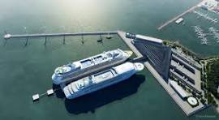
Presented by Marc Silver
You are docked at Fuerte Amador, at the Pacific entrance to the Panama Canal. This is not colonial Panama. It is not old town charm. This is wind, water, ships, and skyline.
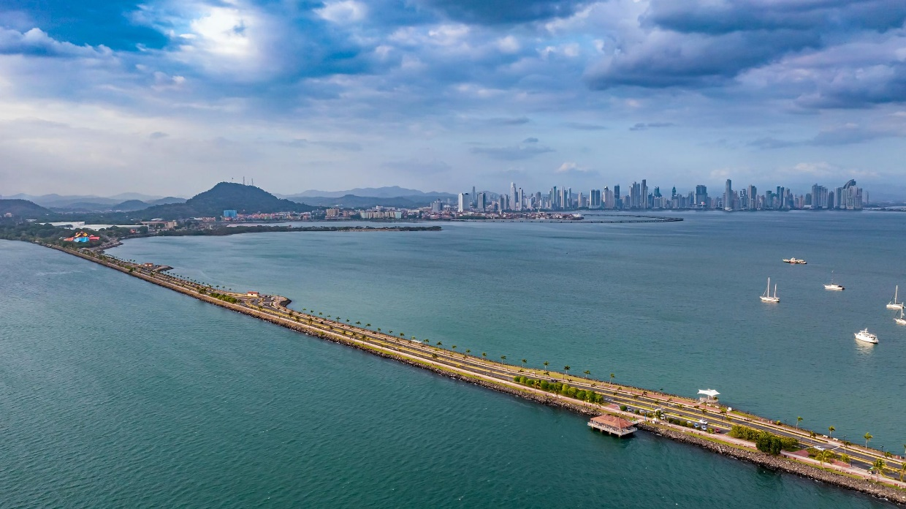
The walk is flat. Easy. Paved the entire way. You will follow the Amador Causeway, built from rock excavated during construction of the Canal. The causeway links four small islands, Naos, Perico, Culebra, and Flamenco.
Total walking time, unhurried, is about 90 minutes. With stops and photos, plan for two hours.
Wear sunscreen. The sun here is direct and serious.

Stop 1 – Cruise Terminal Promenade
0–10 Minutes | 0.2 miles
Step off the ship and pause before you rush anywhere.
Look right. Look left. You are standing at the Pacific gateway to one of the greatest engineering projects ever completed. Massive container ships pass slowly in the distance, lining up for Canal transit.
If you glance west, you’ll see the sweeping arc of the Bridge of the Americas. Completed in 1962, it was the only fixed link between North and South America for decades.
This is a good orientation moment. You are on ground created by ambition.
Walk toward the main Causeway path.
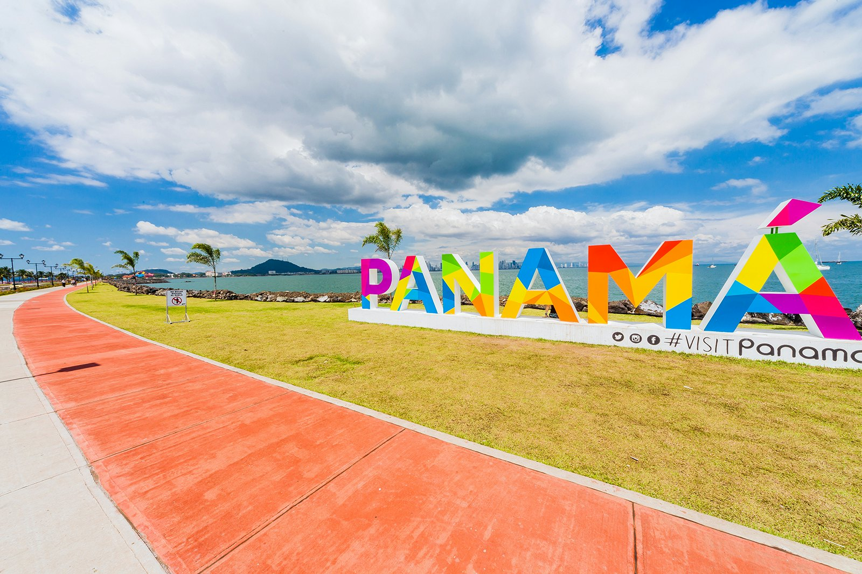
Stop 2 – Amador Causeway Walk
10–35 Minutes | 0.8 miles
The path runs straight, wide, and breezy.
To your left, the Pacific. To your right, the Bay of Panama. Straight ahead, the skyline of Panama City rises like a glass wall.
Notice the contrast. Behind you, jungle-covered hills. In front of you, modern high-rises. Panama is always negotiating between nature and commerce.
You’ll likely see joggers, cyclists, fishermen casting lines, and families strolling. This is one of the city’s favorite weekend escapes. Walk at a relaxed pace toward Flamenco Island.

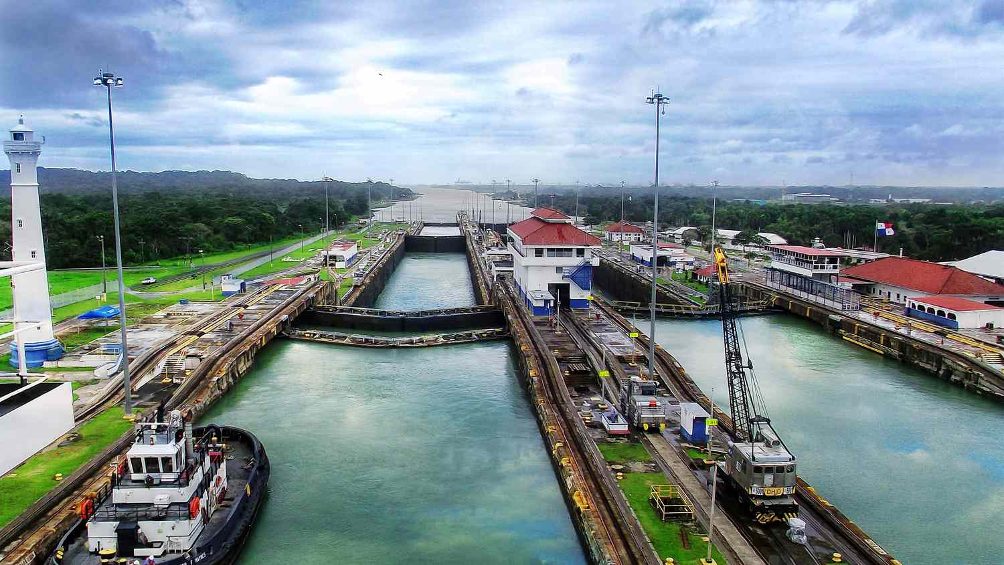
Stop 3 – Panama Sign & Skyline View
35–50 Minutes
Near the restaurants and marina area, you’ll find the colorful “PANAMA” sign. Yes, it is touristy. Take the photo anyway.
Turn around. The skyline is your real backdrop. On a clear day, the towers shimmer in the humidity.
If you want context, that skyline represents one of Latin America’s strongest financial hubs. The Canal drives global shipping, banking, insurance, and trade.
It feels modern because it is. Much of this skyline rose in the past twenty years.
Take a few minutes here.

Stop 4 – Punta Culebra Nature Area (Exterior View)
50–65 Minutes
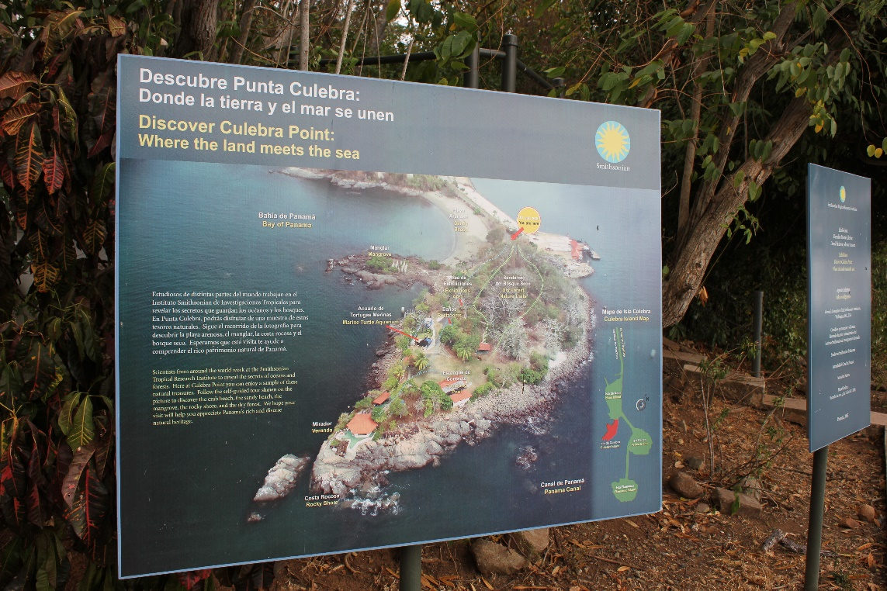
As you continue along the Causeway, you will pass the entrance to the Smithsonian Tropical Research Institute’s Punta Culebra Nature Center.
If you have more time in port, this is worth a separate visit. It focuses on marine ecosystems and Panama’s biodiversity.
For this walk, simply pause and notice how quickly the environment shifts from urban promenade to mangrove and tropical coastline.
You may spot pelicans gliding low over the water. They are not posing. They are hunting.

Stop 5 – View Toward the Bridge of the Americas
65–80 Minutes
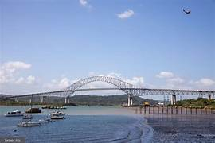
Continue walking just a bit farther until you have a clean angle toward the Bridge of the Americas.
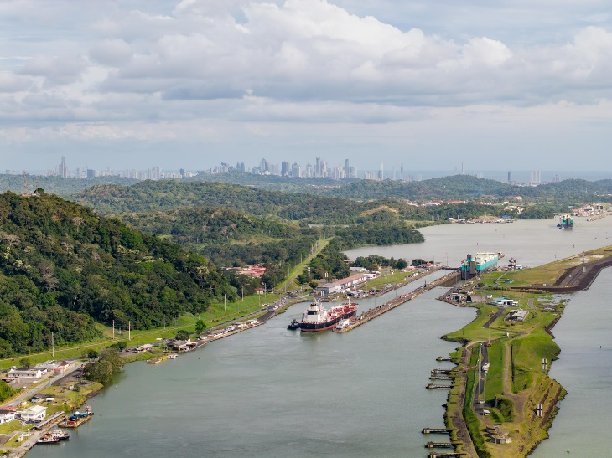
From here, you can often see vessels queuing for Canal entry. Some are container ships the size of small cities.
Look inland and you may spot Ancon Hill rising above the skyline. It is one of the city’s natural landmarks and once marked the Canal Zone boundary.
This stretch gives you a sense of scale. Engineering, geography, trade, all in one frame. Turn around here.

The Return Walk
80–110 Minutes
Retrace your steps along the Causeway back toward the terminal.
The view changes when you reverse direction. Now the skyline is ahead of you, the Pacific breeze at your back.
Take it slow. This is a working harbor. You may hear the low engines of passing ships or see tugs guiding giants into place.

Optional Quick Stop – Marina & Coffee Break
If Time Allows
Near the Flamenco marina are small cafés and casual restaurants. If you have 20 minutes to spare, sit with a coffee and watch the boats.
You are looking at the Pacific entrance to one of the most important trade routes on Earth.

Final Stretch – Back to the Ship
110–120 Minutes
Follow the marked pedestrian path back to the cruise terminal. Security is straightforward, but allow a few extra minutes for re-entry procedures.
Before boarding, take one last look outward.
You walked on stones blasted from the Continental Divide to build the Panama Canal. You watched ships that connect Asia to the Atlantic. You stood between rainforest and finance towers.
It is not a dramatic walk.
It is a powerful one.
And you return exactly where you started, with a better sense of where you are in the world.
If You Have More Time in Port
If your ship is in port for most of the day, Fuerte Amador can be just the beginning.
A short taxi ride brings you to Casco Viejo, the restored historic district of Panama City. Founded in 1673 after the original city was destroyed by pirates, it’s now a UNESCO World Heritage Site filled with plazas, churches, and pastel colonial buildings. Walk the narrow streets. Step inside a cathedral. Sit in a shaded square and watch daily life unfold.
If the engineering side of Panama fascinates you, visit the Miraflores Visitor Center at the Panama Canal. From the viewing terraces, you can watch ships rise and fall in the locks. Seeing a vessel lifted by water rather than machinery changes your understanding of how this canal actually works.
For a natural perspective, consider Ancon Hill. It rises above the city and offers panoramic views of the skyline, the Canal, and even the Causeway where you began your walk. It’s a reminder that before finance towers and cargo ships, this was rainforest.
All three options are within a 20–30 minute drive from the cruise terminal, depending on traffic.
Before You Go
Currency: U.S. Dollar (USD), locally called the Balboa. Paper currency is U.S. dollars. You may receive Panamanian coins as change. Credit cards are widely accepted along the Causeway, but small bills are useful for coffee stops or small vendors.
Safety: The Amador Causeway is generally safe and well-patrolled, especially during daylight hours. Stay on the main promenade. Watch for cyclists, as the path is shared. As in any port city, remain aware of your surroundings.
Weather: Panama is hot and humid year-round. The dry season typically runs December through April. The rainy season brings brief but heavy afternoon showers. Wear sunscreen, a hat, and light clothing. Bring water. The sun here is stronger than it feels.
Etiquette: Casual dress is acceptable along the Causeway. When interacting with locals, a simple “Buenos días” or “Buenas tardes” is appreciated. Service is friendly but relaxed. Tipping 10% is customary in restaurants if not already included.

In Summary
Fuerte Amador is not about colonial streets or deep history on foot. It is about geography and scale. You are standing at the Pacific doorway of the Panama Canal, between rainforest and skyline, between two oceans connected by human determination.
In less than two hours, you walk through layers of global trade, engineering ambition, and modern Latin American energy.
Sometimes the most powerful perspective comes from simply walking the edge of the water and watching the world move past you.

