Fuerte Amador, Panama
A Self-Guided Two-Hour Walk from the Cruise Terminal
Presented by Marc Silver
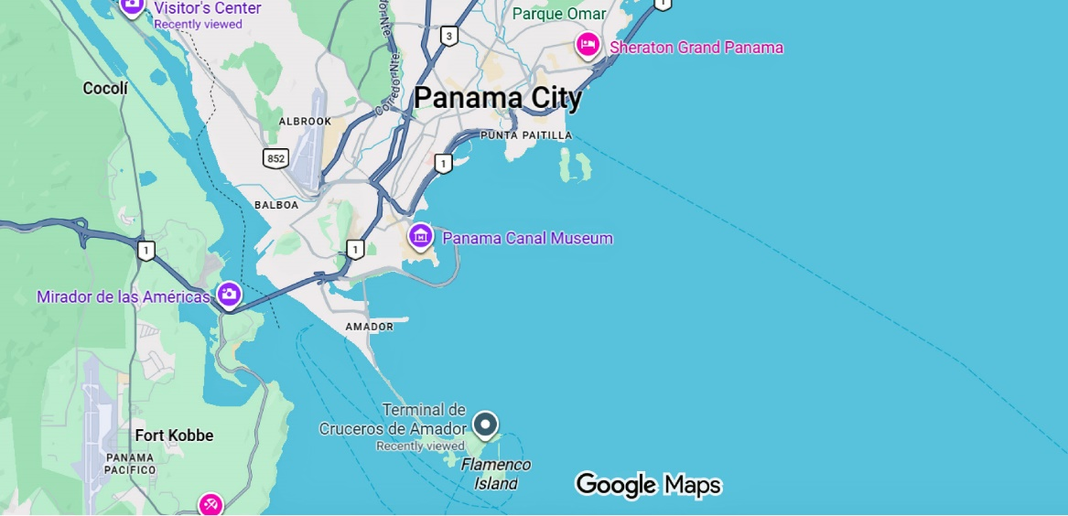
You step off the ship and you are ready to see what the port has to offer.
Fuerte Amador sits at the Pacific entrance to the Panama Canal. Behind you, the rainforest hills that once blocked two oceans. Ahead of you, container ships lining up for transit. In the distance, the glass skyline of Panama City.
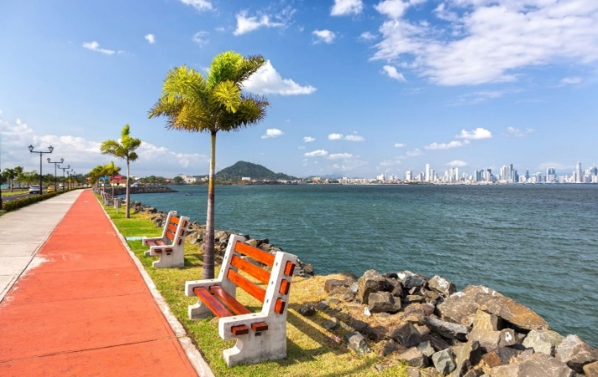
This is not a colonial stroll. It is a geography lesson you can walk.
The route is flat, paved, and easy. Total walking distance is about 2 miles round trip, unhurried. With pauses and photos, plan for roughly two hours from dock and back.
Bring water. The sun here is direct and strong.

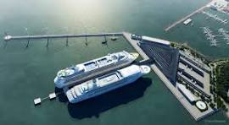
Step 1 – Orientation at the Terminal
0–10 Minutes
Before you start walking, turn slowly and take it in.
Look west and you’ll see the sweeping arc of the Bridge of the Americas. Completed in 1962, it was once the only permanent road link between North and South America.
Look out toward open water. Ships appear almost still, but they are moving, positioning for one of the most complex transit systems in the world.
You are standing on land created from rock blasted out of the Continental Divide to build the Canal itself. Even the ground beneath you has a story.
Now head onto the Amador Causeway pedestrian path.

Step 2 – The Amador Causeway Walk
10–40 Minutes | About 0.8 miles out
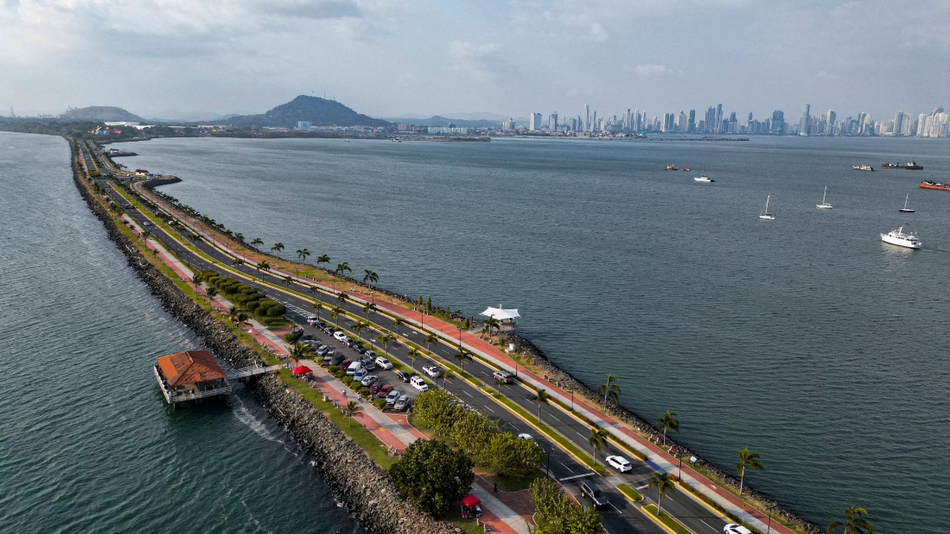
The Causeway connects four small islands: Naos, Perico, Culebra, and Flamenco. It was built using excavated rock from the Canal project more than a century ago.
To your left is the Pacific Ocean. To your right, the Bay of Panama. Straight ahead, the skyline grows clearer with each step.
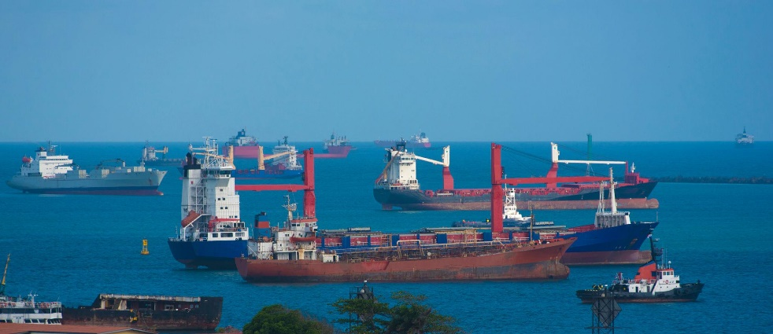
You will see joggers, cyclists, fishermen, and families. This is where locals come for breeze and space.
Walk at a relaxed pace toward Flamenco Island. There is no need to rush. The walk itself is the experience.

Step 3 – Skyline & Panama Sign
40–55 Minutes
Near the marina area on Flamenco Island, you’ll find restaurants, small shops, and the colorful “PANAMA” sign.
Take the photo. Then turn around.
The skyline in front of you represents one of Latin America’s major financial centers. The Canal transformed Panama from crossroads to commercial engine. The modern towers tell that story without a single plaque.
Pause here for a few minutes. Watch the boats move through the marina. Feel the wind coming off the Pacific.
This is your turnaround point.

Step 4 – Toward the Bridge Viewpoint
Optional Extension | 55–65 Minutes
If you have energy, walk farther to get a clean angle back toward the Bridge of the Americas and the Canal entrance.
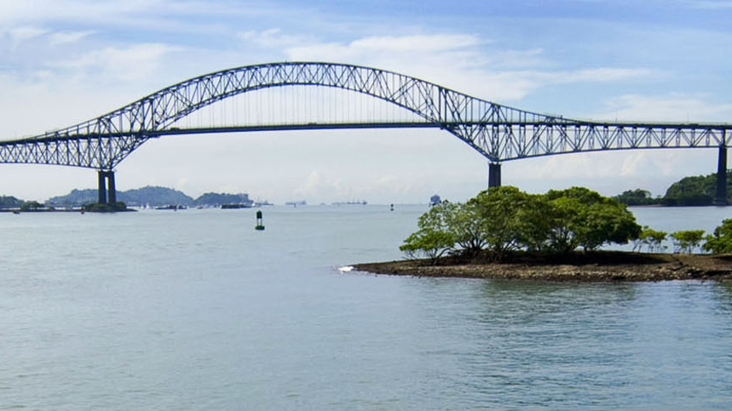
From here, you may see vessels lining up for lock entry. Some carry more cargo than entire cities did a century ago.
Inland, you may notice Ancon Hill rising above the skyline, once part of the Canal Zone boundary.
This view brings together engineering, trade, and landscape in a single frame.
Now begin your return walk.

Step 5 – The Return
65–110 Minutes
Walking back changes the perspective.
Now the skyline is ahead of you. The Pacific breeze is at your back. You may hear the low engines of passing ships or see tugs guiding giants into position.
Take it slowly. Notice how active this waterway is. This is not a museum piece. It is operating in real time.

Final Minutes – Back at the Terminal
110–120 Minutes
You arrive where you began.
Two hours. About two miles. No hills. No tickets. Just perspective.
You walked on the remains of one of the most ambitious engineering projects in human history. You stood at the doorway between oceans. You watched global trade move past you.
It is a simple walk.
But it puts you in the middle of something much larger than the shoreline.

