From Stars to Satellites:
How Humans Learned to Find Their Way at Sea
By Marc Silver
A thousand years ago, somewhere in the middle of the Pacific, a navigator lay flat in the hull of a canoe.
There was no compass. No chart. No instrument of any kind.
He felt the ocean through his ribs.
Long swells rolled in from one direction, smaller wind waves crossed them from another. The canoe moved in patterns he had memorized since childhood. Above him, stars rose and set at precise points along the horizon. Each star marked a path. Each path meant direction.
He was not guessing. He was navigating.
Now step onto the bridge of a modern container ship. Climate-controlled. Screens glowing. Position fixed continuously to within a few meters by satellites orbiting 12,000 miles overhead. Digital charts update automatically. Other vessels appear as moving symbols with names, headings, and speeds attached.
Same ocean.
Completely different relationship to it.
The history of maritime navigation is not just a history of technology. It is a history of how humans have tried to answer one terrifying question:
Where am I?

Before Instruments, There Was Memory
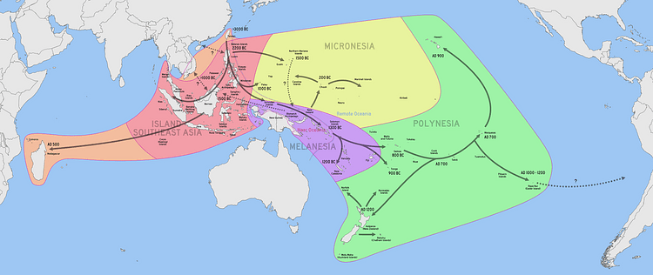
Long before European explorers worried about longitude, Pacific navigators were crossing open ocean distances that still impress modern sailors.
Between roughly 3,000 BCE and 1,200 CE, Austronesian and Polynesian sailors settled islands scattered across a vast blue emptiness. They did it without written charts and without metal instruments.
Figure 1 Austronesian and Polynesian navigation
They built an internal navigation system.
They memorized star paths, knowing which stars rose at particular bearings during specific seasons. They shifted from star to star as the night progressed, keeping a steady heading through darkness. They read ocean swells that traveled thousands of miles from distant weather systems. Even when wind changed, deep swells preserved direction.
They watched birds whose feeding ranges signaled nearby land. They read cloud formations reflecting lagoons. They sensed changes in water color and temperature.
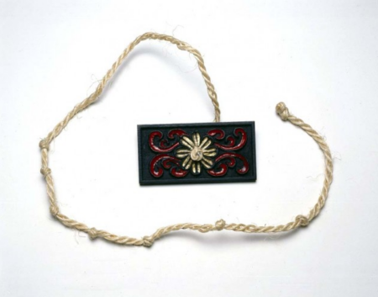
Navigation was not mathematics. It was apprenticeship. It lived in memory.
In the Mediterranean, Phoenician sailors used Polaris to establish north-south position around 1,000 BCE. Greek scholars formalized latitude by measuring solar and stellar altitude. Arab navigators refined techniques across the Indian Ocean using a simple wooden device called the kamal to measure Polaris’s height and maintain steady latitude across monsoon routes.
Latitude became manageable. Longitude did not.

Figure 2 Replica of ancient kamal

The Problem That Drowned Fleets
For centuries, east and west remained dangerously uncertain.
A ship could determine how far north or south it had sailed by measuring the height of the sun at noon. But knowing how far east or west required knowing the precise time difference between local noon and a fixed reference point. At sea, clocks drifted wildly.
In 1707, a British fleet returning home misjudged its longitude and smashed into the rocks of the Scilly Isles. Nearly 1,400 men drowned. The disaster shocked the nation.
Parliament declared longitude a national emergency and offered a reward equivalent to millions of dollars today for a workable solution.
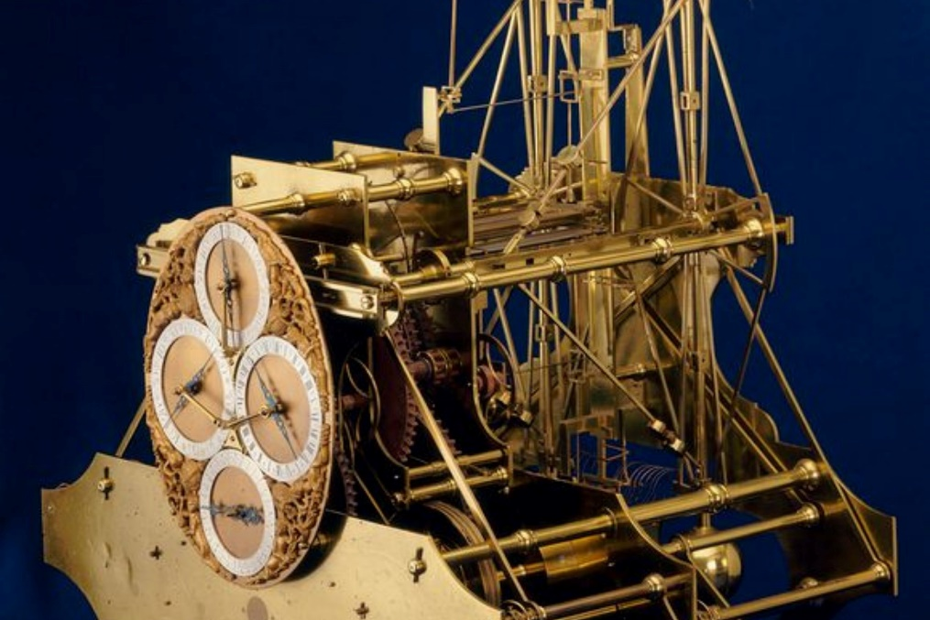
The popular story centers on, the self-taught clockmaker who spent decades building timepieces resilient enough to survive shipboard motion, humidity, and temperature swings. In 1761, his fourth marine chronometer sailed to the Caribbean and back, maintaining time accurately enough to determine longitude within half a degree.
Figure 3 John Harrison's H1 timepiece
But Harrison’s watch was not the only path forward.
Skilled navigators also used the lunar distance method, measuring the angle between the moon and background stars, then consulting detailed astronomical tables to calculate longitude. It worked. It was mathematically demanding and slow. It required clear skies and careful reduction of observations.
The chronometer eventually proved simpler and more reliable for routine use. Over time, it became the practical solution.
Longitude was no longer a mystery.
But something fundamental had shifted.
Navigation moved from embodied observation toward instrument dependency.

Instruments Take the Helm
For the next two centuries, navigation meant mastering tools.
The sextant allowed sailors to measure celestial angles with astonishing precision. Nautical almanacs translated observations into position. Officers practiced daily star sights and noon sights as ritual.
Then electricity transformed the bridge.
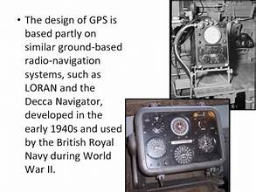
Steel hulls distorted magnetic compasses, so engineers developed the gyrocompass, which aligned with the Earth’s rotation rather than magnetic north. Lead lines measuring depth by rope gave way to echo sounders sending acoustic pulses to the seabed. Radio direction finding allowed ships to determine bearing from shore transmitters without seeing land.
During World War II, LORAN used synchronized radio signals to fix positions across entire oceans.
Each system reduced uncertainty.
Each also created new reliance.
Radio required functioning transmitters. Gyrocompasses required power. Electronic systems required maintenance and calibration.
Navigation was becoming systemic rather than personal.

The Satellite Revolution
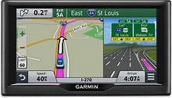
When GPS became fully operational for civilian use in the early 1990s, it changed everything.
Position was no longer determined by observation and calculation. It appeared instantly on a screen. Electronic charts replaced paper. AIS transponders broadcast ship identity, speed, and heading. Integrated bridge systems merged radar, satellite signals, and chart data into one coherent display.
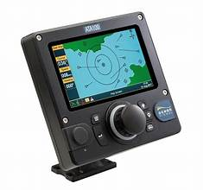
Navigation shifted from finding position to supervising systems.
It was a triumph of precision.
It was also the beginning of a new vulnerability.
GPS signals are extraordinarily weak by the time they reach Earth’s surface. They can be jammed with relatively simple equipment. More concerning is spoofing, broadcasting counterfeit signals that trick receivers into calculating false positions.
Over the past decade, maritime safety authorities have documented large-scale spoofing incidents in regions including the Black Sea and parts of the Middle East. In some cases, vessels reported digital positions miles inland while physically at sea. Crews were forced to cross-check with radar and visual bearings to confirm reality.
Figure 4 AIS transponder
The pattern repeats.
The chronometer solved longitude but made navigation dependent on mechanical precision.
GPS solved global positioning but made navigation dependent on invisible signals from space.
We traded uncertainty for abstraction.

The Human Factor
Roughly 90 percent of global trade moves by sea. Tens of thousands of vessels operate continuously across the world’s oceans.
Maritime safety investigations over decades consistently show that a majority of serious incidents involve human or navigational factors. Fatigue, misinterpretation of radar data, poor watchkeeping, overreliance on automation, the list is familiar to investigators.
Automation promises improvement. If human error dominates accidents, reduce the human element.
But automation changes the nature of error.
When crews rely heavily on digital systems, manual skills fade. Some naval academies have quietly reinstated celestial navigation training in recent years as insurance against satellite disruption.
The ocean punishes overconfidence.
Sometimes the failure is not ignorance. It is misplaced trust.

The Autonomous Horizon
Autonomous maritime vessels are no longer experimental curiosities. They are operating in limited commercial environments.
Sensor fusion systems combine radar, lidar, cameras, AIS data, and satellite positioning to build a constantly updating model of surrounding traffic. Algorithms trained on vast traffic datasets predict collision risk and generate maneuvering decisions designed to comply with international navigation rules.
On paper, the logic is compelling.
If 70 to 80 percent of incidents involve human factors, then reducing human error should reduce accidents.
But autonomy concentrates responsibility into code.
Consider a congested harbor where two autonomous vessels approach one another. Both systems interpret the same data. Both comply with collision regulations. Both calculate optimal maneuvering solutions.
What happens when sensor interpretation differs? When weather degrades camera performance? When GPS input is corrupted? When two automated systems interact in unexpected ways?
Responsibility becomes diffuse. Is the fault with the shipowner? The software developer? The remote operator? The manufacturer of a faulty sensor?
Traditional navigation distributed risk across human judgment and local decision-making. Autonomous systems centralize it within tightly coupled networks.
That does not make autonomy reckless. It makes it complex.
And complexity has its own failure modes.

The Recurring Longitude Problem
Every era of navigation believes it has solved the great uncertainty.
Polynesian navigators mastered star paths but depended on oral tradition that could be lost.
The lunar distance method worked but required intellectual discipline few possessed.
The chronometer simplified longitude but required precision engineering.
Radio freed ships from clear skies but tethered them to infrastructure.
GPS delivered global accuracy but created vulnerability to interference.
Autonomous systems promise safer seas but embed navigation within layers of software abstraction few mariners truly understand.
Navigation has not become easier.
It has become more abstract.
Three thousand years ago, a navigator lay in a canoe and felt the ocean directly. Today, position is computed by algorithms interpreting signals from space.
Both methods aim to reduce uncertainty.
But the ocean has never respected confidence for its own sake.
It respects vigilance.
The tools evolve.
The risk migrates.
The question remains.
Where am I?
And perhaps more importantly now:
How do I know?

References
Bowditch, Nathaniel. The American Practical Navigator. National Geospatial-Intelligence Agency.
Gladwin, Thomas. East Is a Big Bird: Navigation and Logic on Puluwat Atoll. Harvard University Press.
Hewson, J. B. A History of the Practice of Navigation. Brown, Son & Ferguson.
International Maritime Organization (IMO) – SOLAS, COLREGs, MASS framework.
National Institute of Standards and Technology (NIST) – Economic impact of GPS.
Royal Institute of Navigation – Journal of Navigation archives.
Sobel, Dava. Longitude. Walker & Company.
U.S. Coast Guard Navigation Center.
European Maritime Safety Agency accident investigations and reports.
Williams, J. E. D. From Sails to Satellites: The Origin and Development of Navigational Science. Oxford University Press.

