From Pictures to Letters
By Marc Silver
How Writing Learned to Represent Sound
The earliest writing systems did not record language.
They recorded things.
A fish meant a fish. A jar meant a jar. A mark meant a count. Early writing was visual bookkeeping. It tracked goods, labor, land, and ritual. It was not designed to capture speech, grammar, or abstract thought. At first, it did not need to. Today we think that writing is how we communicate on paper, but that is not how it started. Writing has evolved over millennia.
The current idea that writing should represent spoken language came later. Much later.
The shift from pictures to sound-based writing was not a single invention or moment of insight. It was a long, uneven process that unfolded over roughly two thousand years.
The First Steps Toward Sound
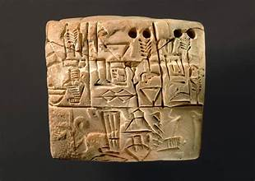
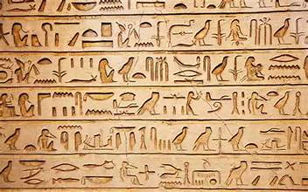
The earliest known writing appears in Mesopotamia and Egypt around 3200 BCE. In both regions, writing began as pictographs. In Mesopotamia, this developed into cuneiform. In Egypt, it became hieroglyphic writing.
By around 2800 BCE, both systems were already changing. Scribes began using symbols not only for what they represented, but for how they sounded when spoken. This shift did not replace pictographs overnight. It layered sound onto meaning.
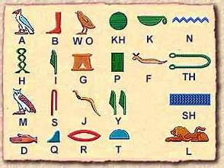
In Sumerian cuneiform, symbols originally tied to concrete objects were reused for their phonetic value. A sign that meant “mouth” could also stand for the sound of the word “mouth.” By roughly 2600 BCE, this mixed system was well established. Cuneiform combined logograms for meaning with phonograms for sound. That combination made it possible to write names, grammar, and abstract ideas that could never be drawn.
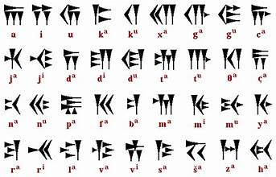
Egyptian hieroglyphs followed a similar path. Many hieroglyphs functioned as phonetic signs representing one, two, or three consonants. Determinatives were added to clarify meaning. The system always looked pictorial, but it had already moved well beyond pictures.
Writing had learned how to represent speech, even if it still looked like art.
The Alphabet Changes the Equation
A more radical simplification arrived much later.
Between roughly 1800 and 1550 BCE, Semitic-speaking workers in the Levant adapted Egyptian symbols into what scholars call Proto-Sinaitic script. Instead of hundreds of signs, this system used a small set of symbols, each tied to a single consonant sound. One sound, one sign.
That idea mattered more than any single inscription. It dramatically lowered the barrier to literacy.
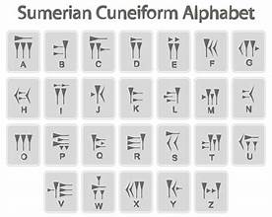
The Phoenicians later refined this approach into a standardized consonantal alphabet of 22 letters. The date often given for this development is around 1050 BCE, though that figure is conventional rather than archaeological. The earliest surviving Phoenician inscriptions date to the 10th century BCE. The earlier date reflects scholarly reconstruction, not a single physical artifact.
By the early first millennium BCE, the Phoenician alphabet was stable and portable. It spread because it worked.
Greek Adaptation and an Open Record
The Greeks adopted the Phoenician alphabet sometime in the early 8th century BCE. Most evidence places this between roughly 800 and 750 BCE, with early inscriptions appearing around 770 to 750 BCE. There is debate about whether informal use began earlier, but the physical record begins around that time.
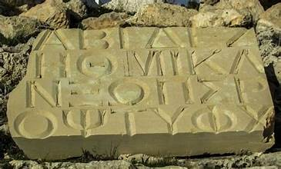
The Greek innovation was decisive. Greeks required vowels to function clearly, so unused Phoenician consonants were reassigned as vowel letters. This created the first writing system in which both consonants and vowels were written as separate symbols.
This is the direct ancestor of most modern alphabets.
From the first phonetic experiments in cuneiform to the Greek alphabet recognizable today, the transition took close to two thousand years.
Why Some Systems Did Not Fully Alphabetize
It is easy to assume that alphabetic writing represents the final stage of progress. However, that assumption does not hold up.
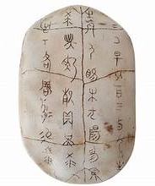
Chinese and Japanese writing systems are often described as leftovers from a pictographic past. That description seems to miss how much they evolved.
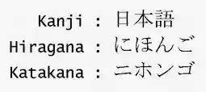
Chinese writing changed dramatically from its earliest oracle bone inscriptions. Modern characters are highly structured. Historically, over 90 percent of Chinese characters originated as phono-semantic compounds, combining a meaning element with a sound element. That figure refers to character origins in the traditional system. In modern simplified character sets, phonetic transparency is lower due to simplification and sound change.
The principle still holds. Chinese characters encode sound, just not sound alone.
The character 妈 (mā, mother) pairs 女 (woman) for meaning with 马 (horse, mǎ) for pronunciation. The horse has nothing to do with the meaning. It is there to guide sound.
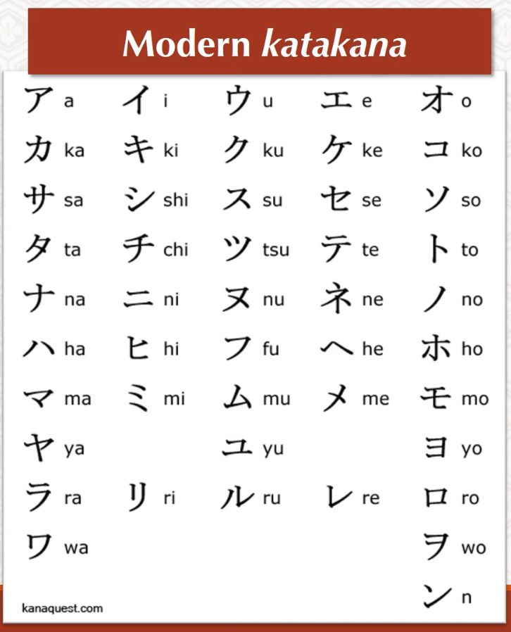
Japanese writing takes a different route. It uses three systems at once. Kanji carries core meaning. Hiragana and katakana are fully phonetic syllabaries, each symbol representing a syllable. This hybrid system fits Japanese grammar efficiently, especially verb endings and particles.
These systems persist for practical reasons.
Mandarin Chinese has extensive homophony. Many words share the same pronunciation even with tonal distinctions. A purely phonetic system would introduce constant ambiguity.
Characters also allow rapid recognition. Skilled readers process them as complete units rather than assembling sounds letter by letter.
There is also a unifying function. China contains many spoken languages that are not mutually intelligible. Shared characters allow written communication across those boundaries.
Cultural continuity matters as well. Characters connect modern readers directly to classical texts without translation.
No Single End Point
Writing did not move from pictures to letters because letters were inevitable. It moved in different directions because languages and societies needed different solutions.
Sound-based writing expanded when speech itself needed to be recorded precisely. Alphabets spread where they reduced complexity. Character-based systems endured where they offered clarity, efficiency, and continuity.
Writing did not evolve toward one ideal form. It evolved toward forms that worked.

Sources and Further Reading
- Daniels, Peter T., and William Bright, The World’s Writing Systems, Oxford University Press
https://global.oup.com/academic/product/the-worlds-writing-systems-9780195079937
- Houston, Stephen D., The First Writing: Script Invention as History and Process, Cambridge University Press
https://www.cambridge.org/core/books/first-writing/5E1C0F3A4F6A91F6F6A1E9C0AEB6C4A6
- Coulmas, Florian, Writing Systems: An Introduction to Their Linguistic Analysis, Cambridge University Press
https://www.cambridge.org/core/books/writing-systems/9E2A6E63C3A71E2F92D69D6F97C6E36F
- Boltz, William G., The Origin and Early Development of the Chinese Writing System, American Oriental Society
https://www.jstor.org/stable/602999
- Rogers, Henry, Writing Systems: A Linguistic Approach, Blackwell Publishing
https://onlinelibrary.wiley.com/doi/book/10.1002/9780470691685

