From Ocean Liners to Floating Cities
How Cruise Ships Reinvented Themselves After the Jet Age
By Marc Silver
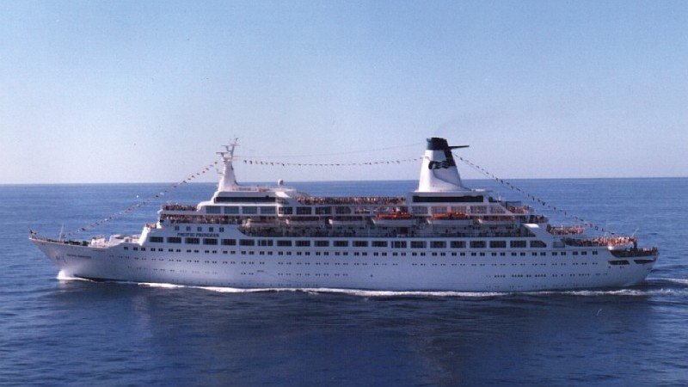
I took my first cruise in 1979.
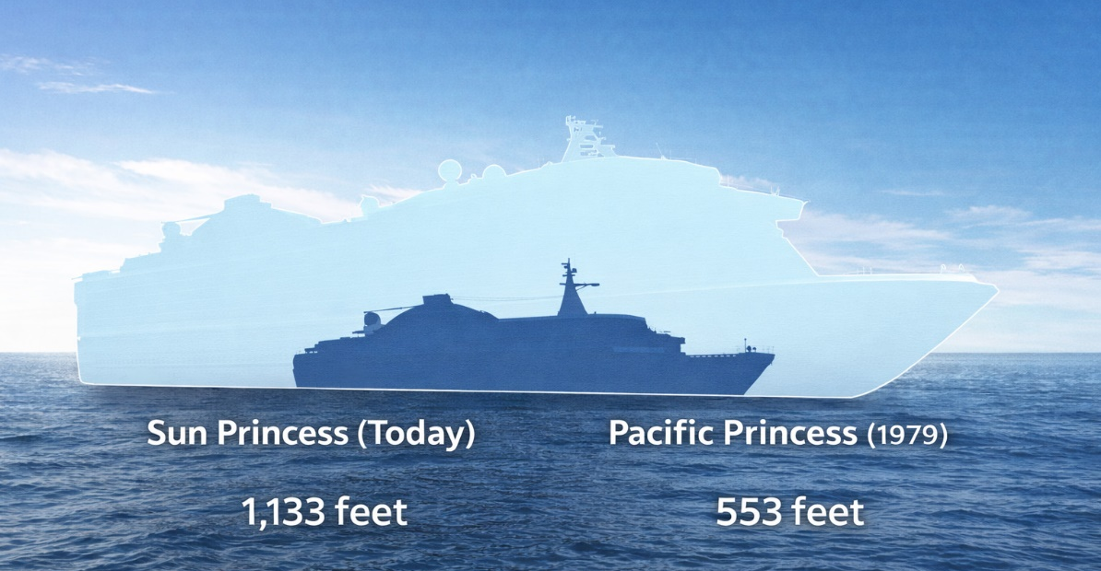
It was aboard the Pacific Princess, long before she became nostalgic shorthand for another era. She was modest by today’s standards. No neighborhoods. No towering atriums. No surf simulators. Just a few hundred passengers, formal dining rooms, assigned seating, and the famous midnight buffet carved into ice sculptures under fluorescent lighting.
Dinner jackets were expected. Formal nights meant something. You dressed for dinner not because it was required, but because it felt appropriate.
Over the next four decades, I watched that world change.
The midnight buffets disappeared. Dress codes relaxed. Specialty restaurants replaced grand dining rituals. Ships grew taller, wider, denser. What once felt like a refined hotel at sea now resembles a floating city.
When I boarded the Pacific Princess, she carried fewer than 700 passengers. Today’s largest vessels carry more than 6,000.
What changed wasn’t just the size of the ships. It was the culture on board.
The idea behind cruising is older than most people realize.
It started back in 1867, on a wooden paddle steamer called the Quaker City when it left New York carrying a group of curious Americans to Europe and the Holy Land. Among them was Mark Twain. His account of that journey, The Innocents Abroad, did more than sell books. It introduced a new idea. He was describing the beginning of an entire new era… the era of cruising.
What if the voyage itself could be the purpose? The cruise was the reason for the trip no longer the destination.
At the time, ships existed to move people and cargo. Speed mattered. Schedules mattered. Survival mattered. Leisure did not.
Today, ships can stretch nearly 1,200 feet, carry more than 6,000 passengers, and feature ice-skating rinks, surf simulators, parks, and full theater productions. The transformation from transportation to destination did not happen overnight. It unfolded across wars, technological revolutions, cultural shifts, and television screens.
Certain ships did more than carry passengers. They changed the direction of the industry.

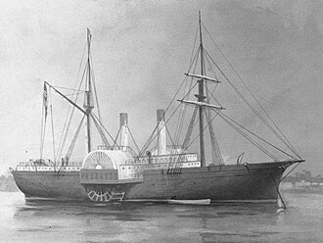
When Travel Became Pleasure
The cruise industry did not begin with a purpose-built cruise ship. It began with repurposing.
The Quaker City was a former Civil War vessel turned excursion steamer. Her 1867 Mediterranean voyage is widely considered the first organized cruise departing from North America. Twain’s irreverent observations helped normalize leisure travel for Americans who had previously crossed oceans only out of necessity.
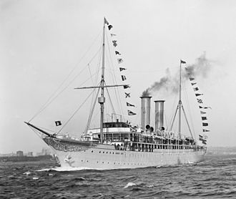
A few decades later, the Hamburg-America Line took a more deliberate step. In 1900, Albert Ballin commissioned Prinzessin Victoria Luise, widely regarded as the first purpose-built cruise ship. She carried no cargo. No emigrants. Only first-class passengers.
On board were a library, a gymnasium, refined dining rooms, and shaded promenades. Ballin had realized something practical. Wealthy Europeans preferred winter cruising to warmer climates rather than sitting idle in frozen northern ports. Cruising became seasonal, intentional, aspirational.
The concept had been invented.

Glamour, Competition, and Catastrophe
By the early twentieth century, ocean liners became symbols of national ambition. Britain, France, Germany, and later the United States competed for prestige as fiercely as for speed.
The most famous of them all, RMS Titanic, was marketed as a triumph of engineering and luxury. Her first-class spaces featured grand staircases, Turkish baths, palm courts, and elaborate dining salons modeled after European hotels. Passengers did not simply cross the Atlantic. They inhabited a floating palace. 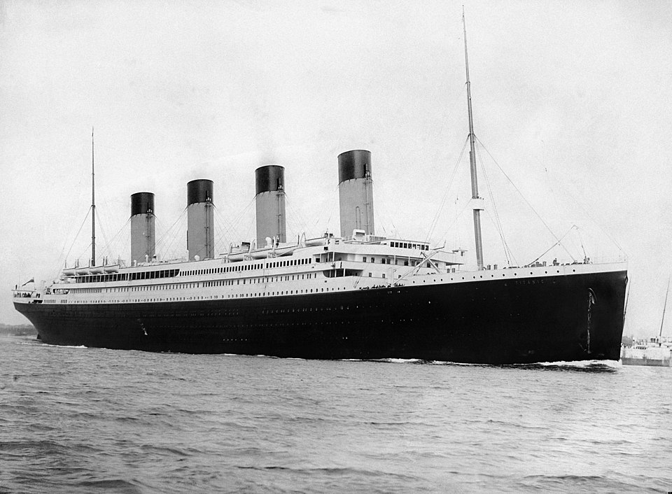
Her sinking in April 1912, with more than 1,500 lives lost, shattered confidence in maritime infallibility. The disaster led directly to the 1914 Safety of Life at Sea Convention, lifeboat reforms, and permanent changes to passenger ship design.
Luxury would continue. But innocence would not.
France offered a different form of innovation. When SS Île de France launched in 1927, she replaced heavy Victorian interiors with sleek Art Deco lines. Geometric patterns, modern lighting, lacquered panels. She did not resemble a nineteenth-century drawing room. She looked forward. Ocean liners became cultural statements as much as transportation systems.
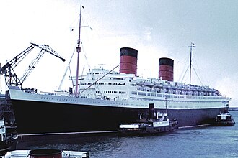
Cunard’s great liners, RMS Queen Mary and RMS Queen Elizabeth, represented the height of transatlantic glamour in the 1930s. Walking into the Queen Mary’s main dining room meant stepping beneath high ceilings, polished wood, and restrained Art Deco detailing. Orchestras played. Crystal reflected light from carefully positioned sconces. Service moved with near-military precision.
Then war arrived.
Both ships were stripped of ornament and painted naval gray. The Queen Mary could transport more than 15,000 troops in a single voyage. Luxury vanished. Speed and capacity mattered again.
When peace returned, they resumed passenger service. But the world had changed.

Speed Meets the Jet Age
In 1952, SS United States captured the Blue Riband for the fastest transatlantic crossing, averaging over 35 knots. Built with lightweight aluminum superstructure and advanced fireproofing, she embodied American technological confidence during the Cold War.
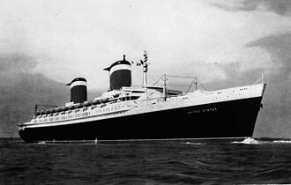
She was also a swan song.
Commercial aviation accelerated rapidly. The Boeing 707 entered service in 1958. A journey that once required five days at sea could now be completed in hours. By the late 1960s, the economic foundation of transatlantic liners had collapsed. Grand ships were retired, scrapped, or laid up.
For a brief moment, passenger shipping seemed destined for history books.
Instead, it reinvented itself.

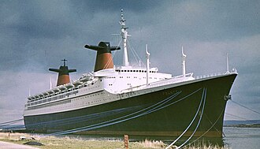
From Crossing Oceans to Circling Islands
The transformation came through ships like SS France. Launched in 1960 as one of the last great liners, she struggled as air travel dominated Atlantic routes. In 1979, Norwegian Cruise Line purchased her, renamed her SS Norway, and repositioned her for Caribbean cruising.
The shift was subtle but decisive. Instead of competing with airplanes on speed, cruise ships would compete on experience. Warm-weather itineraries. Casual dress. Repeating island loops rather than fixed-point crossings.
Carnival Cruise Line embraced the model fully. When Mardi Gras entered service in 1972, the emphasis was not aristocratic refinement but accessibility and entertainment. Prices dropped. Formality softened. The demographic widened.
Cruising stopped being elite. It became attainable.
By the 1980s, annual cruise passenger numbers were climbing steadily, and the industry entered sustained expansion. What had once been seasonal European leisure became year-round global tourism.

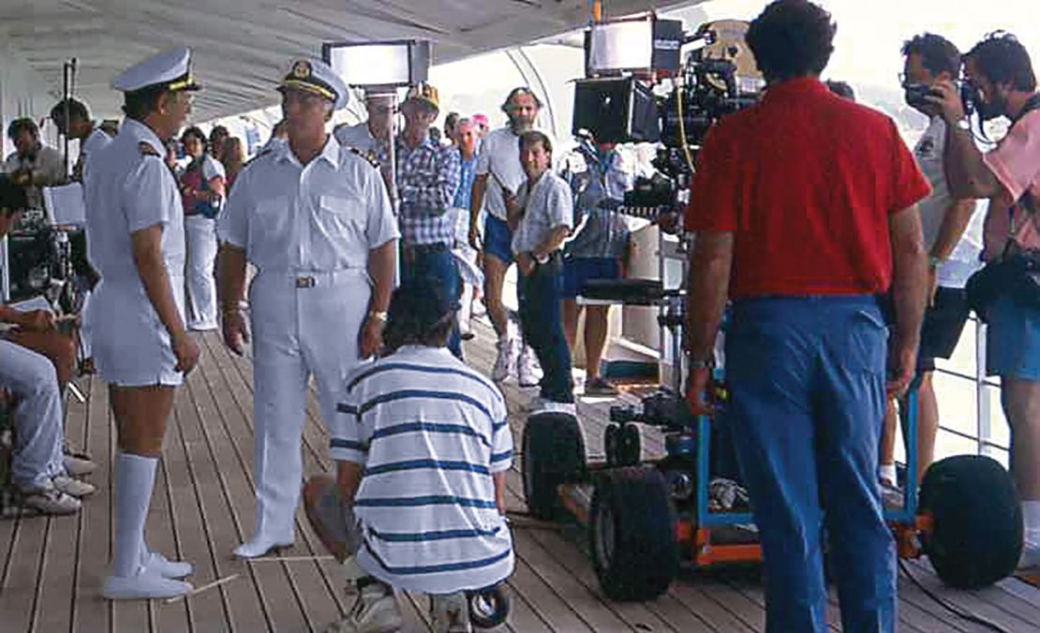
Television and the Democratization of Desire
No marketing campaign matched the influence of television.
MS Pacific Princess became the filming location for The Love Boat, which aired from 1977 to 1990. Week after week, millions of viewers watched stories unfold aboard a ship that felt glamorous yet approachable.
Cruising entered American living rooms.
The effect was measurable. Industry passenger numbers, roughly 1.4 million annually in 1980, more than doubled by the end of the decade. Ships filled. New vessels were ordered. Cruise lines expanded aggressively.
The image had shifted. Cruising was no longer a remnant of the liner era. It was contemporary, social, romantic.

The Ship Becomes the Destination
In 1987, Royal Caribbean launched MS Sovereign of the Seas, then the largest cruise ship in the world. Size was not new. Philosophy was.
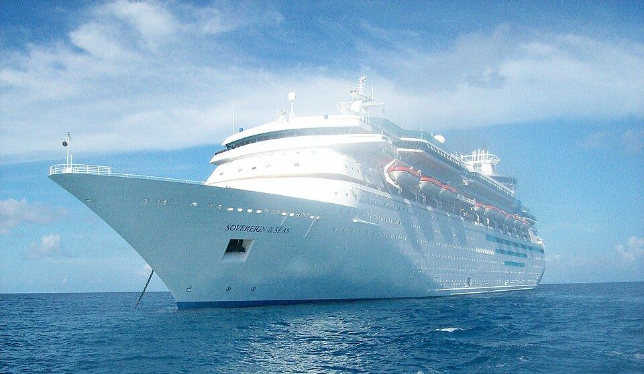
The ship itself became the primary attraction.
Instead of racing across oceans, ships offered shopping promenades, multiple dining venues, expanded pool decks, and structured entertainment programs. The itinerary mattered less than the onboard experience.
That concept reached architectural scale in 2009 with MS Oasis of the Seas. Her design divided the vessel into themed neighborhoods, including an open-air Central Park planted with real trees. A carousel spun above the waterline. An amphitheater faced the sea.
Standing on an upper deck, passengers no longer saw a traditional ship. They saw an engineered environment. A contained city at sea.
Today’s largest ships exceed 1,180 feet in length and carry more than 6,000 guests, supported by crews numbering in the thousands. The scale rivals small municipalities.
Cruising is no longer about crossing water. It is about inhabiting a floating infrastructure.

The Liner That Refused to Disappear
Amid this transformation, one vessel preserves the older philosophy.
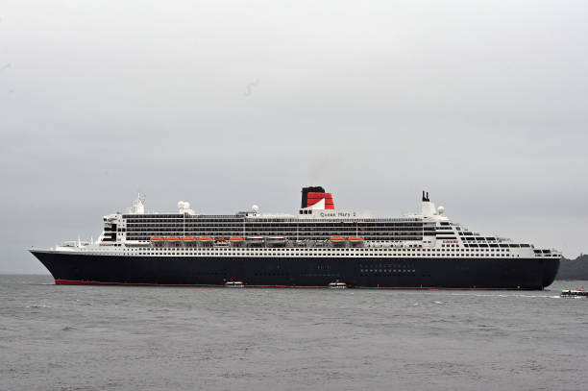
RMS Queen Mary 2, launched in 2004, was designed as a true ocean liner, with a reinforced hull, higher bow, and engineering built for North Atlantic crossings. She maintains regular transatlantic service between New York and Southampton.
She is not faster than airplanes.
Just different.
Her existence reminds passengers that cruising did not begin with water slides and Broadway revues. It began with crossings.

Scale, Sustainability, and the Next Chapter
The modern cruise industry carries more than 30 million passengers annually and generates tens of billions in global economic activity. It is a complex blend of hospitality, logistics, engineering, and entertainment.
It also faces scrutiny.
Large vessels concentrate thousands of visitors in historic ports. Overtourism strains infrastructure. Energy consumption and emissions draw regulatory attention. In response, newer ships increasingly adopt liquefied natural gas propulsion, advanced wastewater treatment systems, and shore-power capabilities designed to reduce local pollution while docked.
Whether these efforts will prove sufficient remains an open question.
What is certain is this: ships have always mirrored the priorities of their era.
Industrial confidence produced record-breaking liners. Wartime urgency turned glamour into transport. Jet engines forced reinvention. Television democratized aspiration. Corporate ambition built floating cities.
But something else is happening now.
Alongside the megaships, a quieter shift has emerged. Smaller luxury vessels. Expedition ships built to reach remote coastlines. Yachts carrying a few hundred guests instead of several thousand. The emphasis has moved from spectacle to access. From onboard neighborhoods to destination immersion.
After decades of building higher and wider, parts of the industry are rediscovering intimacy.
It is not a rejection of scale. It is a recalibration. 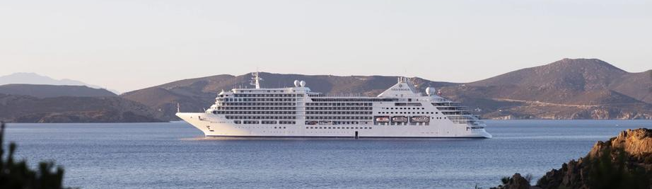
From wooden paddle steamers to neighborhood-sized megaships, and now back toward smaller, more deliberate vessels, cruise ships continue to reflect the way we want to travel.
The sea has remained constant.
Our expectations have not.
