The Floating Villages of the Mekong
By Marc Silver
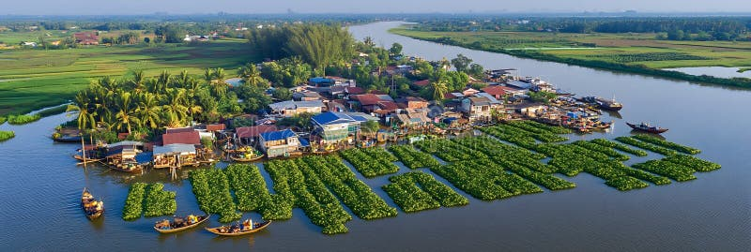
If you want to visit Cambodia’s floating villages, timing is everything. From August to November, when the Mekong River swells with monsoon rains, Tonle Sap Lake becomes a vast, glittering highway. This is when entire communities take to the water, schools, pagodas, police stations, even karaoke bars, all drifting gently in place. I joined the Aqua Mekong cruise one high-water season and found an entire civilization afloat, a town that could, in theory, drift away if the wind changed its mind.
Tonle Sap isn’t just a lake, it’s the heart of Cambodia. During the Khmer Empire’s height in the 1200s, it fed more than a million people. Today, it still nourishes over three million and provides three-quarters of the country’s inland fish. It’s the region’s living pulse, swelling and shrinking with the seasons, dictating the rhythm of life for everyone who depends on it.

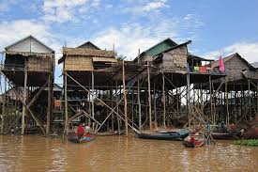
The Lake That Breathes
To understand Tonle Sap, you first have to understand that it’s alive. For half the year it lies calm and shallow, about 2,500 square kilometers across, more like a flooded meadow than a lake. Villagers can walk their boats across the silt-brown shallows, the water barely brushing the knees. Children play in the mudflats, chasing crabs and frogs among the reeds. Then June arrives, and the mood changes.
The Mekong River, swollen with snowmelt from the distant Tibetan Plateau, begins to push back against gravity itself. Its current reverses, sending water rushing upstream into the Tonle Sap River and flooding back into the lake. It’s like watching a river change its mind. Within weeks, Tonle Sap grows more than sixfold, to over 16,000 square kilometers, and the water deepens to nine meters.
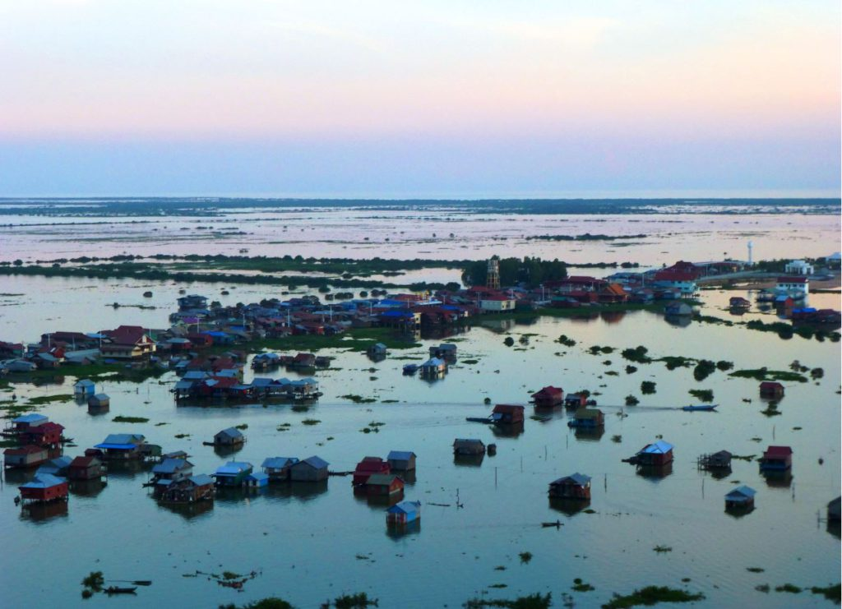
Forests vanish beneath the surface, becoming vast underwater nurseries where fish spawn by the millions. Trees sway like seaweed in the brown currents, their branches sheltering eggs and fry. Villages that once sat comfortably on shorelines now float like islands. Every rise and fall is a breath, an inhale of floodwaters, an exhale into the dry months. For the people who live here, that pulse dictates everything: when to fish, when to plant vegetables on the receding mud, when to move the house if the water comes too high.
“Here,” a fisherman told me, tapping the side of his boat, “the lake is our calendar. We don’t read months, we read the water.”

A World Balanced on Water
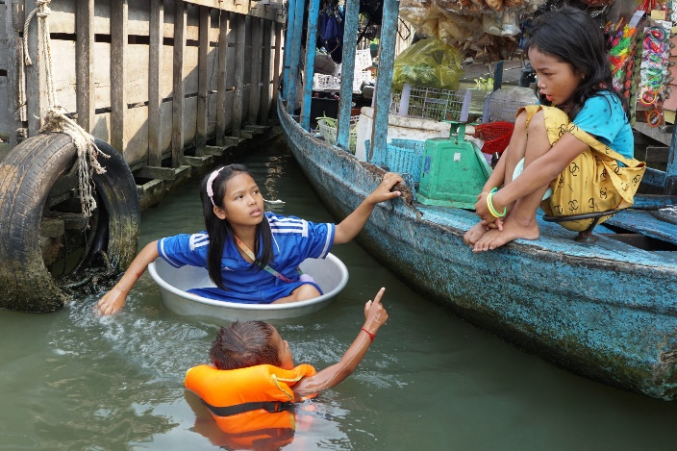
These aren’t clusters of houseboats strung together; they’re entire towns that have learned to float. In places like Kampong Phluk and Kampong Khleang, houses perch on stilts fifteen or twenty meters high or rest on bamboo rafts tethered by long poles that rise and fall with the tide. From a distance, they look like mirages, colorful boxes hovering over the water on spindly legs.
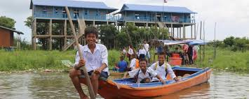
During the wet season, narrow wooden walkways link the homes, and boats replace bicycles. The morning commute to school is by paddle, not pedal. Inside, families cook rice over open fires, eat together on woven mats, and sleep in hammocks strung from beam to beam. The whole structure creaks and sighs with the movement of the water.
Children here learn to swim before they can walk. Toddlers splash in floating playpens while their parents mend nets or gut fish. A six-year-old paddling to school in a tin canoe is as ordinary here as a kid riding a scooter elsewhere. At dusk, smoke from cooking fires drifts low across the water, turning the lake into a soft haze of orange and gray. Radios play love songs, dogs bark at passing boats, and the air smells of wood smoke, river water, and fried fish.
For an outsider, it feels like stepping into a slow, rhythmic world that never quite touches solid ground. Everything here bends, floats, or sways, but nothing ever stops.

The Daily Catch
Fishing isn’t just an occupation; it’s the thread that ties everything together. Long before sunrise, the lake stirs to life with the soft slap of paddles and the putter of small engines. Lanterns glow like fireflies over the water as fishermen glide out into the mist.
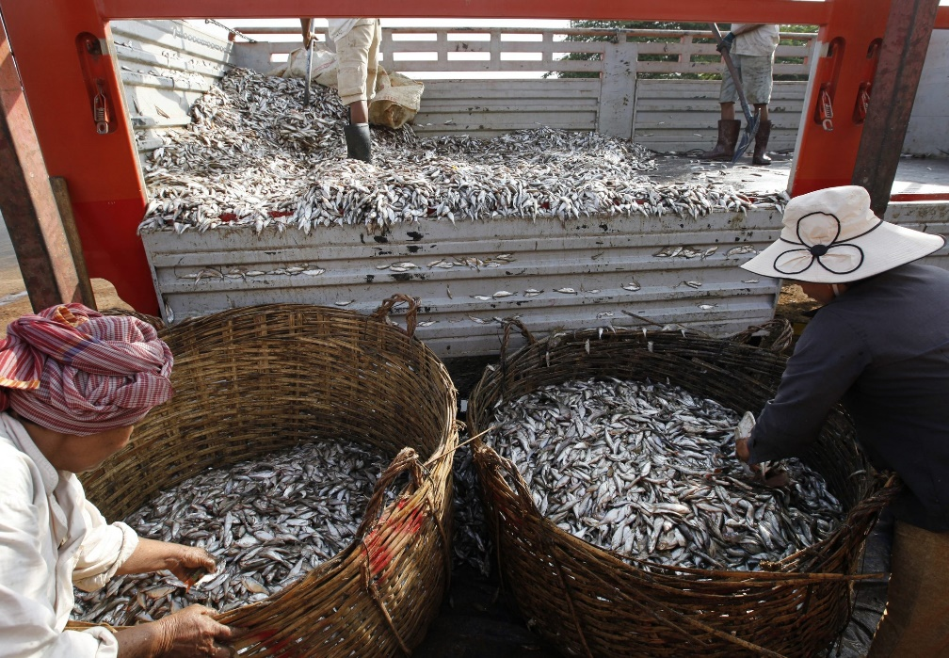
Their tools are ancient and ingenious: bamboo traps, weighted nets, and towering lift nets suspended from wooden frames that pivot on ropes. Each family knows where the currents converge, where the fish rise after the flood recedes. The catch might include small trey riel, catfish, snakehead, or, if fortune smiles, the massive Mekong giant catfish that can outweigh the fisherman himself.
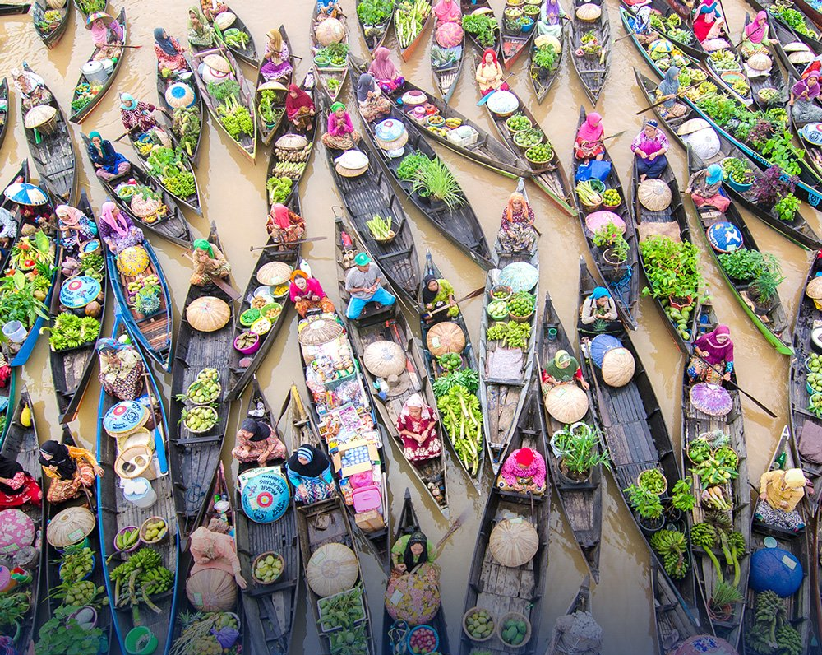
By mid-morning, floating markets bloom on the open water. Dozens of boats bump together, exchanging fish, rice, fuel, and gossip. The air fills with chatter and the smell of drying fish. Women and children work quickly to clean, salt, and smoke the day’s catch. Much of it becomes prahok, Cambodia’s famously pungent fermented fish paste, the national seasoning and the pride of every kitchen.
If you visit during the dry season, you’ll see racks of fish spread out in the sun, silver scales flashing like mirrors. The smell is unforgettable, equal parts salt, smoke, and stubborn tradition.

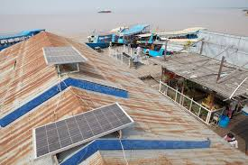
When the Internet Came to Town
Not long ago, this world was connected only by water and rumor. Today, cell towers have sprouted on the horizon like new kinds of trees. Solar panels hum on rooftops, powering lights, radios, and, most importantly, smartphones.
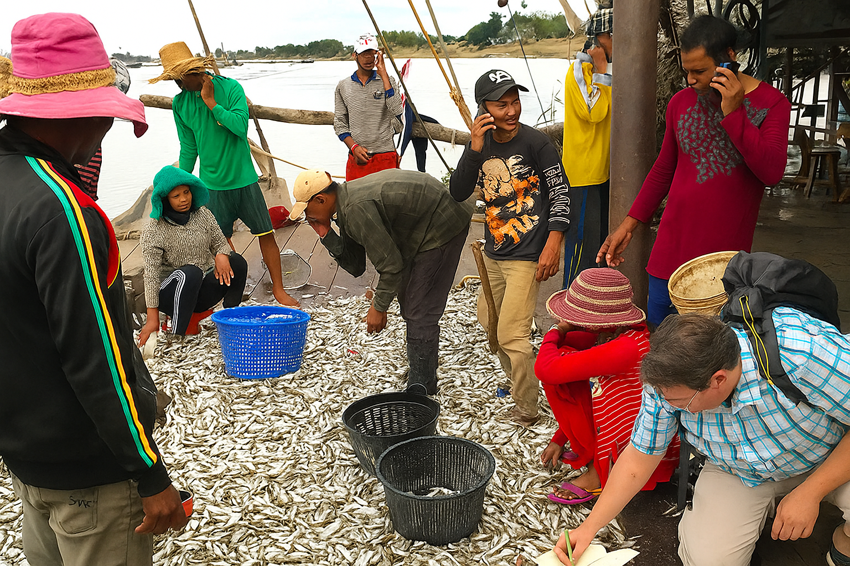
Now fishermen check fish prices in real time before selling their catch, ensuring a fairer deal than in years past. Mothers video-call children studying in cities hundreds of miles away. It’s a quiet revolution, taking place from the seats of wooden canoes.
But technology brings temptation as well as opportunity. Teenagers watch K-pop videos and city influencers, dreaming of motorbikes and apartment jobs. The lake that once defined their world has become a screen-sized window to something faster and brighter.
A boy might toss a net one-handed while scrolling through Instagram with the other. His grandfather, watching, shakes his head and says the lake is changing faster than the wind. Both are right.
The rhythm of Tonle Sap now competes with the rhythm of Wi-Fi. Yet even as the old ways bend, they rarely break. Modernity floats in on the same current as everything else, absorbed, adapted, and, somehow, made part of the lake’s story.

A Patchwork of Faiths and Faces
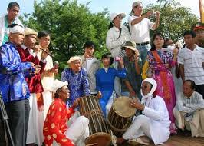
Tonle Sap’s floating world is a mosaic of cultures. Khmer Cambodians, Vietnamese, and Cham Muslims live side by side, their homes bobbing in the same current. The Vietnamese raise fish in submerged pens beneath their houses. The Cham maintain mosques with bright green domes visible for miles. Khmer families tend shrines filled with incense and ancestral photos.
At dawn, monks in saffron robes glide by in long, narrow boats to collect alms. Vietnamese women sell vegetables from flat-bottomed skiffs, calling out prices in a blend of Khmer and Vietnamese. From one house comes the metallic clang of a hammer repairing an engine; from another, the rhythmic slap of laundry against a wooden plank.
Though disputes over fishing rights and citizenship occasionally flare, daily life is built on cooperation. Storms don’t care about borders, and when roofs blow off or boats capsize, neighbors come running, whatever language they speak.

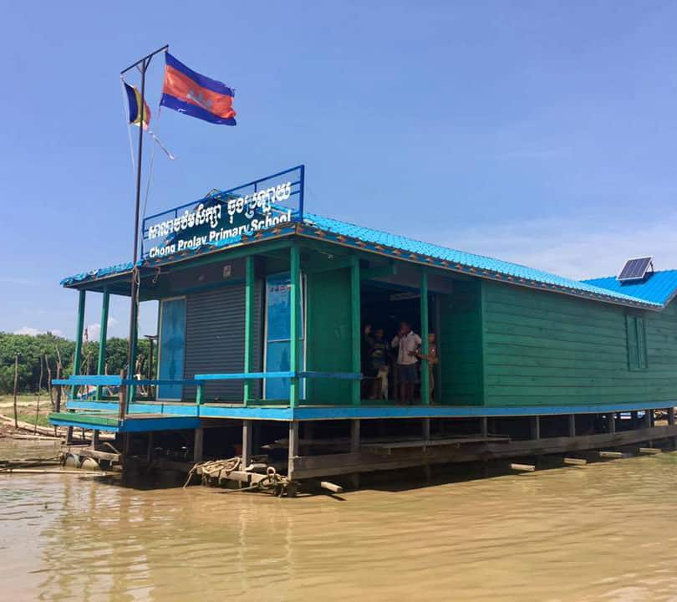
Learning to Stay Afloat
Education exists here, but it’s as fragile as the wooden decks that support it. Floating schools rock gently near the villages, staffed by teachers who earn little and work much. Supplies are scarce, and chalkboards warp in the humidity. Some lessons feel far removed from life on the lake, textbook chapters on rice farming or land navigation for children who have never walked a kilometer on dry soil.
A few NGOs are changing that. Solar-powered classrooms bring computer lessons to students who’ve never held a mouse. Floating libraries drift from village to village, swapping books for stories. Environmental programs teach children how overfishing or pollution can harm the ecosystem that feeds them.
Still, the pressure to leave school early is immense. Boys join their fathers on the boats; girls marry young or help care for younger siblings. Breaking that cycle means giving families new reasons to stay in school, jobs that don’t depend on the next catch, or on luck with the weather.
And that’s where thoughtful tourism and conservation step in.

Tourists on the Tide
Visitors come from around the world, drawn by the idea of a community that floats. When done right, tourism brings more than money, it brings respect and opportunity. A few organizations are making sure that happens.
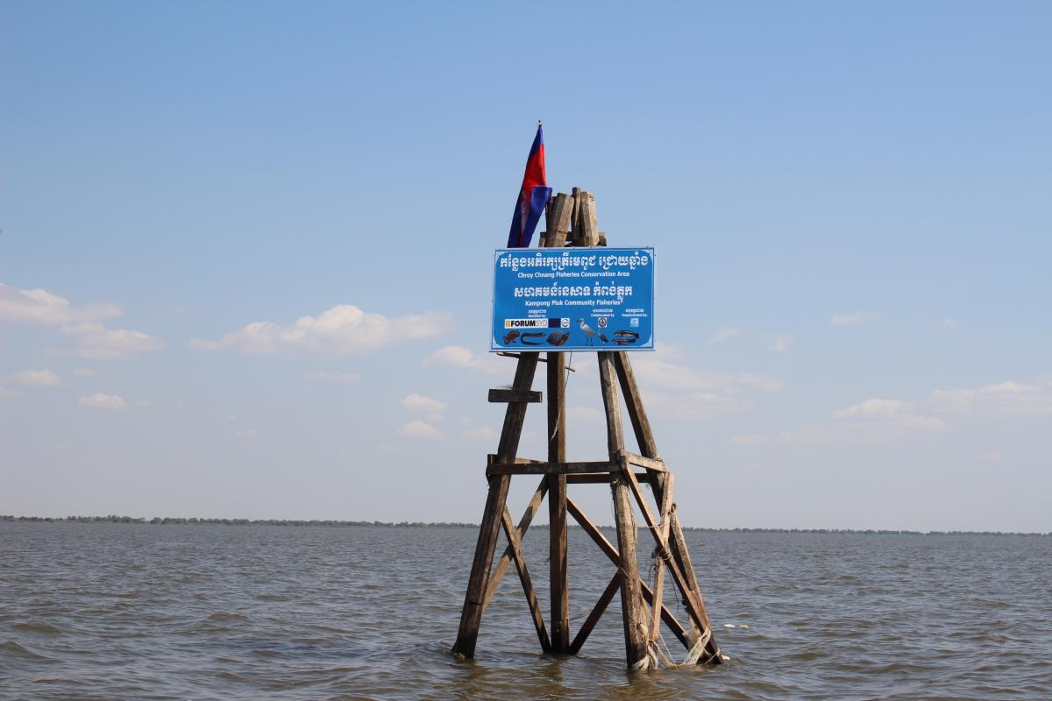
The Wildlife Conservation Society (WCS) Cambodia works with fishing families to protect flooded forests and patrol no-take zones where fish can breed undisturbed. Conservation International helps women’s cooperatives smoke, dry, and sell fish sustainably, creating steady income beyond the day’s catch. And through the “Our Tonle Sap” project, led by ForumCiv and local partners, villagers are learning to manage resources, restore wetlands, and adapt to a changing climate.
These initiatives prove that protecting a place can be as valuable as promoting it. Responsible travelers now seek tours that collaborate with such programs, small groups guided by local residents, where your spending stays in the village and your presence supports rather than disturbs.
A tourist once told me that the most memorable part of his visit wasn’t taking pictures of floating houses; it was sharing tea with a schoolteacher who taught lessons while her classroom gently rocked. When villagers have a say in how their stories are told, tourism becomes collaboration rather than intrusion.
And as more visitors choose this mindful approach, they help ensure that the lake remains not just a destination but a home, one where culture and ecology can still float in balance.
The tide of visitors rises each year, but the best among them leave only ripples behind.

When Nature Pushes Back
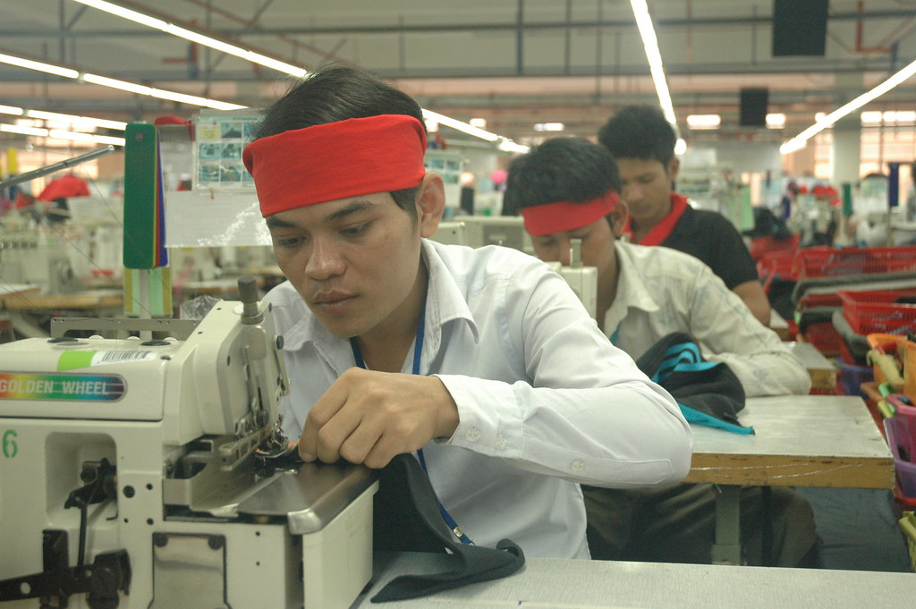
For centuries, the lake has given generously. Now it’s straining. Overfishing, deforestation, and agricultural runoff have thinned its bounty. Dams upriver disrupt the flood pulse that defines Tonle Sap’s rhythm, and climate change has made the seasons unpredictable, too much rain one year, too little the next.
The poorest fishermen feel it first. Their boats are smaller, their nets older, their margins thinner. Some have turned to aquaculture or handicrafts; others have moved to Phnom Penh in search of factory jobs. Yet even as livelihoods shift, the lake remains in their language, in their cooking, in their dreams.
Women’s cooperatives have stepped in, forming community groups that manage floating gardens or produce crafts from recycled fishing nets. These small acts of reinvention may seem modest, but together they form a kind of quiet resilience, the ability to rise again every time the waters do.
The lake, like its people, endures. But endurance alone won’t be enough. What’s needed now isn’t nostalgia for the past but innovation that respects it, a partnership between tradition and change.

A Future Between Two Worlds
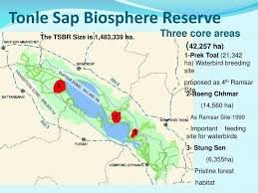
No one knows what Tonle Sap will look like in fifty years. Some predict the floating villages will disappear as the younger generation seeks steadier lives on land. Others imagine them evolving, powered by floating solar panels, supported by modern schools, and connected by technology that serves rather than replaces tradition.
Conservation efforts offer hope. The lake’s UNESCO Biosphere Reserve designation has brought new attention, and pilot projects are testing sustainable fishing zones and reforestation of flooded forests. The challenge is keeping pace with environmental change without losing the cultural heart that makes this world unique.
Tonle Sap has always balanced between abundance and fragility. The question is whether the next generation can find that balance again, between progress and preservation, between land and water, between past and future.

Drifting Through Time
Visiting the floating villages isn’t just travel, it’s a lesson in adaptation. The journey begins through flooded forest where tree trunks vanish beneath green water and ends on open lake, a sheet of shifting light. On the horizon, houses shimmer like mirages. Children wave from doorways; fishermen smile from their decks; somewhere a karaoke machine wails a love song that drifts across the water like smoke.
For the people who live here, this isn’t spectacle, it’s home. Their world may sway and creak with every gust of wind, but it endures, patient and alive.
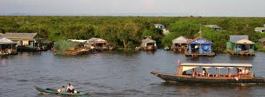
As the sun sinks low and the lake turns to gold, the air fills with the soft clatter of oars and the low murmur of families settling in for the night. You begin to sense the lake’s slow, steady heartbeat beneath it all, a rhythm that has shaped lives for centuries.
Tonle Sap doesn’t just sustain its people; it teaches them how to move with change, to bend without breaking, to float when the world feels uncertain.
When the waters rise, life rises with them. And when they fall, the people of Tonle Sap simply wait for the next breath.

