Wine Regions Revealed Episode 148 Bulgaria
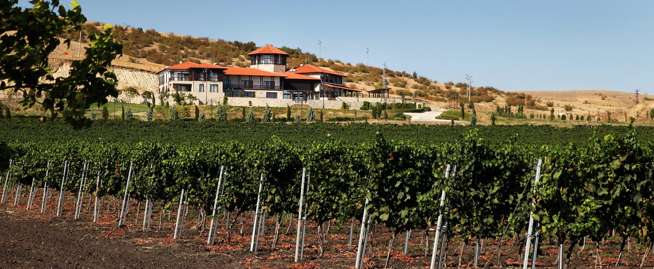
Hi! I’m Marc, and welcome to Wine Regions Revealed, the series where we explore the world’s wine regions, one small sip at a time.
Last time we explored Nashik, India’s unexpected wine region, where high elevations and a tropical climate are reshaping what many people think Indian wine can be.
Today, we’re heading to Bulgaria. And this surprises people, it’s one of the oldest wine-producing countries in Europe, with documented winemaking dating back to the Thracians around 4000 BC.
Bulgaria sits in Southeast Europe, bordered by Romania, Serbia, North Macedonia, Greece, Turkey, and the Black Sea. The geography shapes everything. Plains stretch across the north. Mountains divide the country. The south opens into broad, warm valleys. To the east, the Black Sea moderates temperatures and extends the growing season.
All of that creates a patchwork of soils, loam, clay, limestone, sandy pockets, and a range of microclimates that give the wines real diversity.
And here’s where it becomes especially compelling. Bulgaria is not just about international grapes. It has a deep bench of indigenous varieties that deserve far more attention.

Why Should I Care?
For drinkers, Bulgaria delivers value and character. You can find structured, age-worthy reds and aromatic, food-friendly whites without paying Bordeaux prices.
For enthusiasts, this region forces you to rethink what Eastern European wine means. Grapes like Mavrud (mah-VROOD), Melnik (MEL-nik), and Dimiat (DEE-mee-aht) are not copycat versions of Cabernet or Sauvignon Blanc. They have their own voice.
Try this: Pour a Bulgarian Mavrud next to a Cabernet Sauvignon from Napa. Notice how Mavrud leans into dark berries and spice with firm structure, yet carries an earthy edge that feels distinctly Balkan.

Practical Application
Sub-Regions to Know
Thracian Valley (THRAY-shun)
Southern Bulgaria. Warm, continental climate. This is the heartland for Mavrud and Melnik.
Look for structured reds with dark berry fruit, spice, and the ability to age. Many see time in oak, often six months or more.
Producers like Bessa Valley Winery are known for serious reds that bridge indigenous and international styles.
Danube Plain
Northern Bulgaria. Cooler influence from the Danube River. This region leans into whites, especially Dimiat and Misket.
Dimiat is aromatic and bright, often fermented in stainless steel to preserve citrus and green apple notes. Think seafood, grilled fish, light salads.
Black Sea Coast
Eastern Bulgaria, moderated by sea breezes.
You’ll find both indigenous and international varieties here. Cabernet Sauvignon and Chardonnay show well, but with a slightly fresher edge thanks to maritime influence.
Producers such as Santa Sarah Winery focus on polished whites and reds from this coastal corridor.
Struma Valley (STROO-mah)
Often labeled as PGI. This is Melnik territory.
Melnik produces reds with softer tannins, red berry notes, and herbal nuances. It can be elegant, even slightly rustic in a charming way.

Pro Tip
Learn the classification terms. Bulgaria follows the EU system of PDO and PGI.
PDO wines follow stricter rules around grape varieties, yields, and winemaking. PGI wines allow more flexibility.
If you see “PDO Thracian Valley” on a bottle, you’re generally looking at a more tightly regulated, regionally expressive wine.

The Grapes You Should Know
Mavrud
Deep color. Firm structure. Dark berries, spice, sometimes a hint of earth. Often aged in oak. Excellent with roasted lamb or slow-cooked stews.
Melnik
Softer tannins. Red berries. Herbal lift. A natural partner for grilled meats or Balkan-style sausages.
Dimiat
Bright acidity. Citrus and green apple. Sometimes floral. Great with seafood and lighter fare.
Misket (MIS-ket)
Aromatic, floral, gently fruity. Often blended.
There’s also Rubin, a cross of Nebbiolo and Syrah that brings structure and spice, and Pamid, an ancient red that tends to produce lighter, fruit-forward wines.

Common Mistakes
Don’t assume Bulgarian wine is inexpensive bulk production. That reputation largely comes from the late 20th century export era. Modern producers are focused on quality and rediscovering indigenous grapes.
Also, don’t ignore the whites. Danube Plain Dimiat can be surprisingly precise and food-friendly.
And avoid pairing structured Mavrud with delicate white fish. Instead, think roasted meats, hearty stews, or aged cheeses.

Quick Reference
Mavrud
Structured, oak-aged reds
Roasted lamb, stews, aged cheese
Melnik
Softer, herbal reds
Grilled meats, charcuterie
Dimiat
Aromatic, fresh whites
Grilled fish, seafood pasta
Misket
Floral, light whites
Salads, lighter poultry dishes

Bulgaria is a study in revival. Ancient roots. Ottoman-era decline. A modern return to identity and quality.
It’s not trying to be Bordeaux. It’s not trying to be Tuscany. It’s reclaiming what was already there.
Next time on Wine Regions Revealed, we’ll head to Romania, another historic region quietly redefining itself.
Until then, pour yourself a glass of Mavrud or Dimiat and email me your thoughts.
Keep exploring.

