Episode 128 Wine Gadgets - High-Tech Meets Old Tradition
Hi! I'm Marc, and welcome back to WINE IN SMALL SIPS.
Last time, we got naturally fizzy with Pet-Nat's wild bubbles.
Today, we're entering the future with Wine Gadgets—from $300 preservation systems to AI-powered sommeliers.
By the end, you'll know which high-tech tools actually improve your wine experience and which are just expensive toys for your kitchen counter.
The Core Concept: Why Wine Needs Gadgets
Wine has barely changed in 8,000 years, but our relationship with it has. We drink less but want better. We open bottles sporadically. We want precision without intimidation.
The Modern Wine Problems:
- Preservation: Half-finished bottles going bad
- Serving: Wrong temperatures ruining good wine
- Selection: Analysis paralysis at the wine shop
- Education: Learning without seeming pretentious
Why This Matters: The right gadget solves a real problem. The wrong one just clutters your kitchen. Think of wine gadgets like cooking tools—a good knife is essential, but you don't need 47 different spatulas.
The Gadget Philosophy: Technology should make wine more accessible, not more complicated. If it requires a manual thicker than a wine book, it's probably overkill.
Why Should I Care?
Three Reasons Wine Gadgets Deserve Your Attention:
1. Preservation means Less Waste Americans throw away 40% of opened wine. A $50 preservation system can save you hundreds in wasted bottles. It's like buying wine insurance.
2. Confidence Building Gadgets remove guesswork. Serving temperature thermometers, decanting timers, and tasting apps help you serve wine properly without years of trial and error.
3. Exploration Without Commitment Systems like Coravin let you taste expensive wines by the glass without opening the bottle. It's like having a wine bar in your kitchen—try before you fully commit.
Practical Application: The Essential vs. The Excessive
Tier 1: Actually Useful ($20-100)
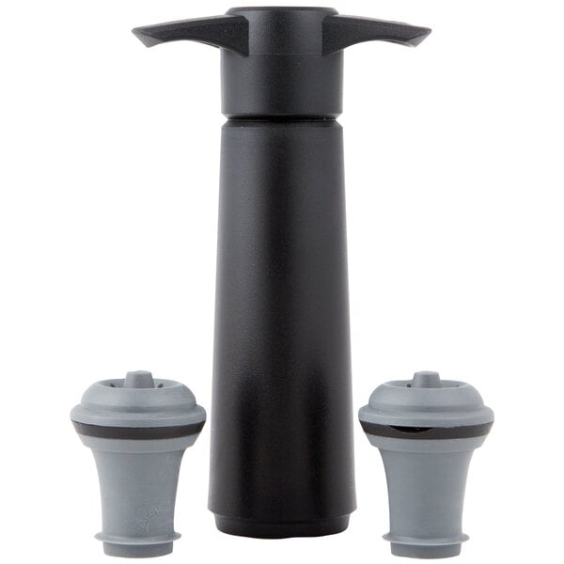
Vacu Vin Wine Saver ($15): This is what I use. It’s a simple pump that removes air from bottles. Works for 3-4 days. Perfect for casual drinkers.
Wine Thermometer ($25): Clip-on device shows ideal serving temperature. No more guessing if your Pinot Noir is too warm.
Ah-So Cork Puller ($20): Two-pronged tool removes old, crumbling corks without pushing them into the bottle. Vintage wine saver. I own and use versions of several.
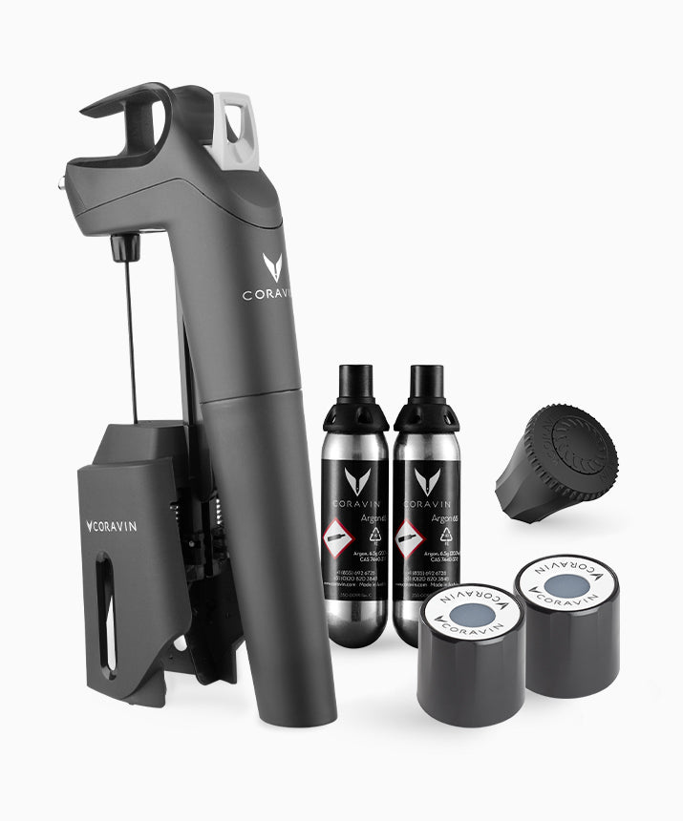
Tier 2: Serious Upgrades ($100-300)
Coravin Model Three ($200): Needle pierces cork, argon gas preserves wine. Taste expensive bottles without opening. Game-changer for collectors.
Riedel Decanter ($150): Proper decanting vessel with perfect proportions. Not a gadget per se, but engineered for optimal wine performance.
Wine Fridge: Consistent temperature storage. Essential if you buy more than you drink immediately. Prices can range from under $200 and into the thousands,
Tier 3: Luxury/Experimental ($300+)
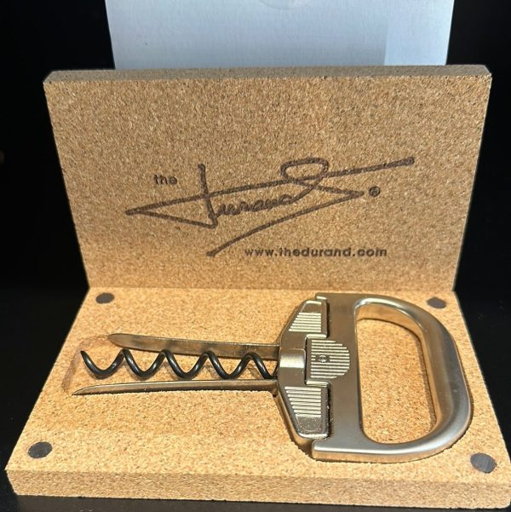
Durand Corkscrew ($65+): Combines traditional corkscrew with Ah-So technique. For ancient, valuable bottles only.
Sonic Decanter ($400): Ultrasonic waves supposedly accelerate aging. Jury's still out on effectiveness. I have read about this, but have not used it,
Wine Apps: The Digital Sommelier
Vivino (Free): Scan labels, read reviews, track what you like. Essential for wine exploration. This is a real time saver when researching wine.
Delectable ($10/month): Professional-grade tasting notes and recommendations. For serious enthusiasts.
Common Mistakes to Avoid
Mistake #1: Buying Gadgets Before Understanding Basics A $200 aerator won't fix bad wine or poor serving technique. Master the fundamentals first—proper storage, serving temperature, and glassware. Then add gadgets.
Mistake #2: Over-Complicating Simple Tasks Some gadgets solve problems that don't exist. Electric corkscrews, wine bottle lights, and automatic pourers often create more issues than they solve.
Mistake #3: Ignoring Maintenance Wine gadgets need cleaning and care. Preservation systems require gas cartridge refills. Decanters need proper drying. Factor maintenance into your purchase decision.
Why These Happen: Wine gadgets prey on our desire for perfection and fear of doing it wrong. Remember: humans have been enjoying wine for millennia without apps and aerators.
Quick Reference Cheat Sheet
Must-Have Gadgets:
- Wine preservation system (Vacu Vin or Coravin)
- Proper corkscrew (Waiter's friend or Ah-So)
- Wine thermometer (clip-on style)
- Vivino app (free wine database)
Nice-to-Have Gadgets:
- Decanter (for red wines over $30)
- Wine fridge (if you buy cases)
- Aerator (for young, tannic reds)
Skip These:
- Electric wine openers (unnecessary complexity)
- Wine bottle stoppers with dates (just write on the bottle)
- Aerating pourers (gimmicky, hard to clean)
Quick Decision Tips:
- New to wine? Start with preservation system and thermometer
- Drink expensive wine? Invest in Coravin
- Entertain frequently? Get a good decanter
- Budget under $50? Vacu Vin + thermometer covers basics
Wine Nerd Alert
The Coravin Science: Argon gas is heavier than air and inert (won't react with wine). When injected into a bottle, it creates a protective blanket over the wine, preventing oxidation for months.
Decanting Physics: Wide-bottom decanters maximize surface area for oxygen exposure. The swan-neck design isn't just pretty—it controls pour rate and prevents splashing.
Try This: The Gadget Test
The Experiment:
- Open two identical bottles of the same wine
- Use a preservation system on one, leave the other by just replacing the original cork.
- Taste both every day for the next 3 days
- Notice the difference in:
  - Aroma intensity
  - Flavor brightness
  - Overall quality
What You'll Learn: How effective preservation gadgets actually are—and whether they're worth the investment for your drinking habits.
Pro Tip: The One-Gadget Rule
Before buying any wine gadget, ask: "Will this solve a problem I actually have, or am I just buying wine anxiety insurance?"
Most wine lovers need only 2-3 gadgets maximum. Everything else is just kitchen theater.
On the Next Sip
Are you ready to protect your investment?
Next time we will explore Wine Counterfeiting from fake Bordeaux to altered labels, we're diving into wine's dark side and how to avoid getting scammed.
Until then, remember: The best wine gadget is knowledge. Everything else is just convenience. Cheers!

