DIY Sound Baffles
Simple Solutions for Reducing Room Echo
By Marc Silver
Introduction
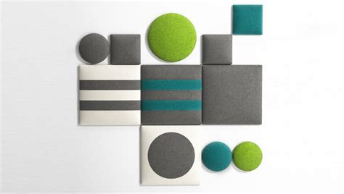
Improving your room’s acoustics doesn’t have to be complicated or expensive. You don’t need fancy equipment or professional contractors—just a few affordable materials, basic tools, and a little time. With some DIY sound baffles, you can tame midband reflections and reduce echo, making your space clearer and more comfortable for work, music, or relaxation.
If you’ve got the budget, you could always hire an expert to design a custom acoustic solution. But if you’re anything like me—frugal and hands-on—you’d rather roll up your sleeves, learn the process, and create something uniquely suited to your space. Not only will you save some cash, but there’s a real satisfaction in building something that works perfectly for your needs.
In my previous article on bass traps, we focused on solving low-frequency issues. But not every room needs that level of precision. For most spaces, simple sound baffles are the perfect solution for cutting down on harsh midrange reflections and reducing echo. Whether you’re setting up a home office, recording space, or cozy living room, these baffles are easy to make, cost-effective, and highly effective.
Let’s explore why they work, how to build them, and where to place them for the best results.

Why Use Sound Baffles? 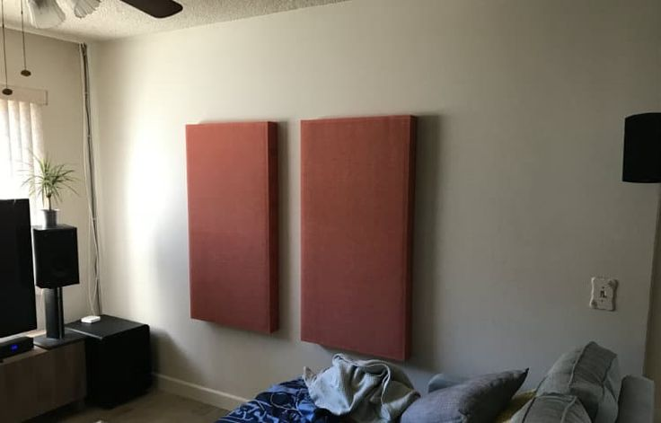
Sound baffles are designed to absorb midrange frequencies, typically between 250 Hz and 4 kHz. This range is where most voices and musical instruments reside, and it’s also the range most prone to reflections and echoes that muddy the sound in a room.
By cutting down on these reflections, sound baffles create a cleaner, more balanced sound environment. Whether you’re recording, hosting virtual meetings, or just enjoying music, reducing these midband reflections can make a dramatic difference.
Key benefits:
- Improved Clarity: Smoother, less harsh midrange frequencies help conversations and music come through with detail and warmth.
- Affordable and DIY-Friendly: With basic materials and tools, anyone can make these baffles at a low cost.
- Versatile Placement: Lightweight and flexible, baffles can be installed or moved to suit your space.

What Do Sound Baffles and Bass Traps Have in Common?
While bass traps target low frequencies, between 20 Hz and 250 Hz, sound baffles focus on the much higher, midrange and high frequencies. Both share some essential principles:
- Absorptive Materials: Both use materials like .
- Strategic Placement: Placing these tools at reflection points makes a big difference in sound clarity.
- DIY Potential: You don’t need to spend a fortune—simple designs work surprisingly well when tailored to your space.
Think of sound baffles as the simpler sibling to bass traps: easy to build, lightweight, and perfect for everyday acoustic needs.

Materials Needed
Here’s what you’ll need to build a basic sound baffle:
- Wood for the Frame: 1x2 or 1x4 boards (pine or MDF work well).
- Absorptive Material: Fiberglass, mineral wool, or acoustic foam—these absorb midrange reflections effectively.
- Fabric Covering: Breathable fabric like burlap, muslin, or even old curtains. Personally, I am a fan of using an open weave double knit material, because it comes in hundreds of colors, looks good, stretches around cabinets and is basically the same as most speaker grill material. Oh and did I mention inexpensive?
- Staple Gun and Staples: To secure the fabric. You can also use Velcro if you need or want access to the inside for any reason.
- Optional: Picture hangers or hooks for easy wall mounting.

Step-by-Step Guide to Building Sound Baffles
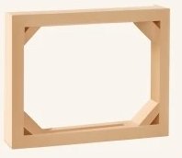
1. Build the Frame
- Cut the wood into four pieces to form a rectangular frame (e.g., 2x24x48 inches).
- Assemble the frame using screws or nails. I recommend adding small corner braces for extra strength and stability.
2c. Add the Absorptive Material
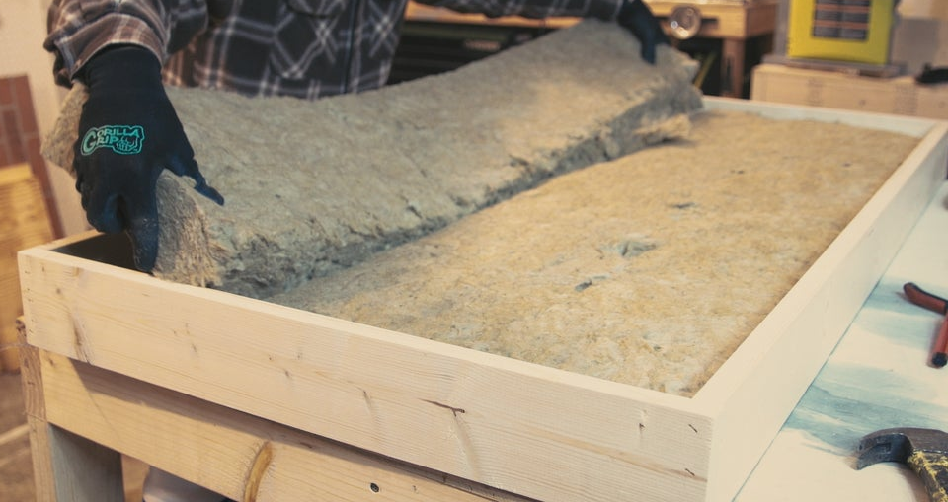
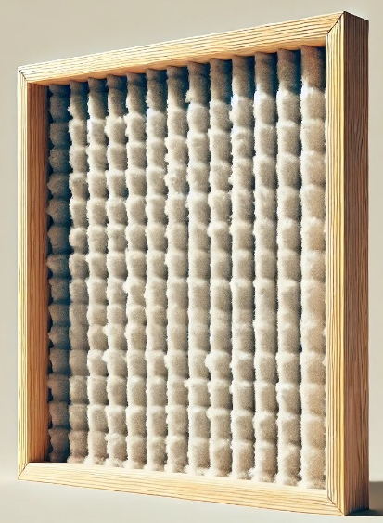
- Cut fiberglass or mineral wool to fit snugly inside the frame. I have also used carpet pad made from horse hair or similar material that can be bought or even gotten for free from carpet stores.
- Place it inside, ensuring there are no gaps.
3. Cover with Fabric
- Wrap the frame and insulation with breathable fabric, pulling it tight to avoid wrinkles.
- Secure the fabric to the back of the frame using a staple gun.
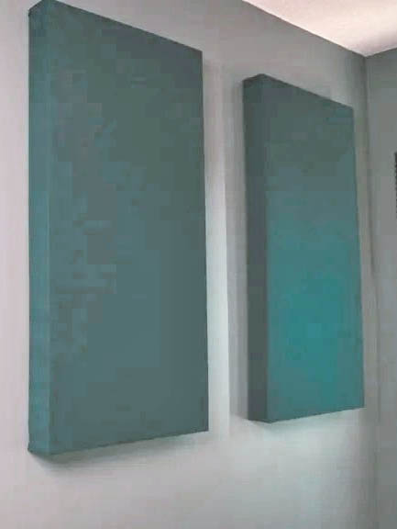
4. Mount the Baffles
- Attach picture hangers, hooks, or brackets to the back of the frame.
- Hang them on walls or ceilings at key reflection points (more on placement below).
Where to Place Your Baffles
Placement is key to getting the most out of your sound baffles. Here’s a quick guide:
- First Reflection Points: Hang baffles where sound reflects directly from your speakers to your ears. Use a mirror to identify these spots on side walls, ceilings, or behind you.
- Corners: Place baffles in corners to tame echoes and reflections.
- Overhead: In rooms with high ceilings, mounting baffles above your listening area can reduce reverb.
Remember, trial and error are part of the process. Move your baffles around and test the sound to find the sweet spot.
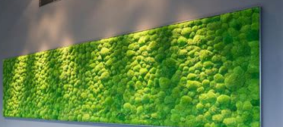
Personalize Your Design
Your sound baffles can be as stylish as they are functional:
- Use colorful fabric or patterns to blend them with your room décor. Some fabric can even make the panels look three dimensionals.
- Vary the sizes of the baffles to suit different parts of the room.
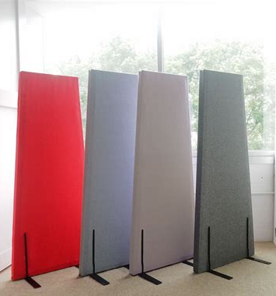
- Experiment with shapes like hexagons for a unique aesthetic.

One final supper simple design for those of you that don’t have access to wood working tools.
You can purchase peg board from your local home improvement store.
Any size is fine, 2’ x 4,’ 4’ x 4’ or even 2’ x 2’. Then you can use either pillow stuffing in sheets, or carpet pad (my favorite) and glue it to the panel edge to edge.
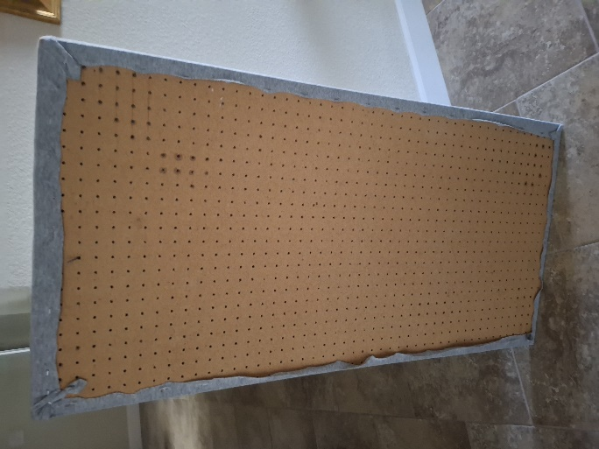
Next pick your favorite fabric. As I said before, mine is an open weave double knit, and drape it over the baffle and either staple to the back or you can even use double sided tape or glue. But staples do work better.
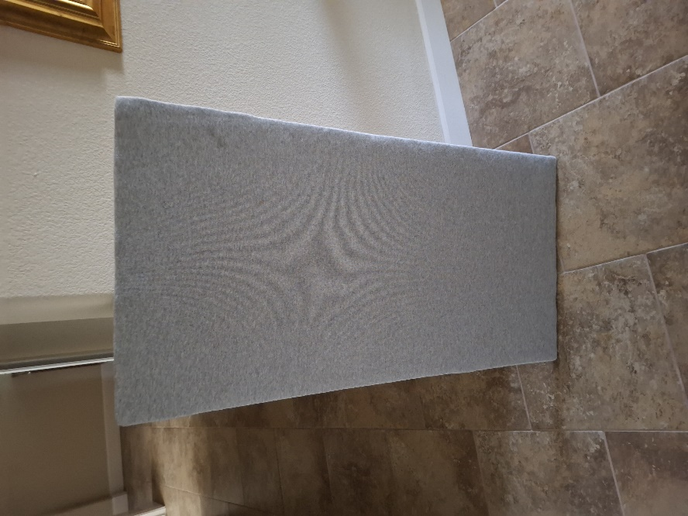

Finally trim the excess material and hang them on the wall. My trick is to fit a small head nail in two of the holes in the back and then press them into the wall.
You can also attach right angle brackets as feet and use them free standing.

Takeaways from Bass Traps
From the original bass trap discussion, we learned that simplicity is often the best approach. Just as bass traps work wonders for low frequencies, sound baffles focus on midrange and reflections, solving problems without overcomplicating the solution.
- Cost-Effective Results: Even basic baffles can transform your space for under $50 per panel.
- DIY Advantage: The satisfaction of building something yourself is priceless—and these projects are beginner-friendly.
- Placement Matters: Strategic placement is more important than the number of panels. A few well-placed baffles can make a big difference.

Conclusion
Sound baffles are a simple, affordable, and effective way to improve your room’s acoustics. Whether you're battling echo in a home office, optimizing a home theater, or creating a better recording space, these DIY panels can transform your sound environment. With just a few tools and some creativity, you’ll enjoy clearer sound, reduced echo, and a more comfortable space for any activity.

