DIY Diffusers to Complete Your Acoustic Treatment"
By: Marc Silver
After years of building absorption panels, I learned the hard way: too much absorption kills a room’s soul. Sure, the echo dies down and the bass stops booming, but something else disappears too, sparkle, presence, life. It’s like the air goes out of the music.
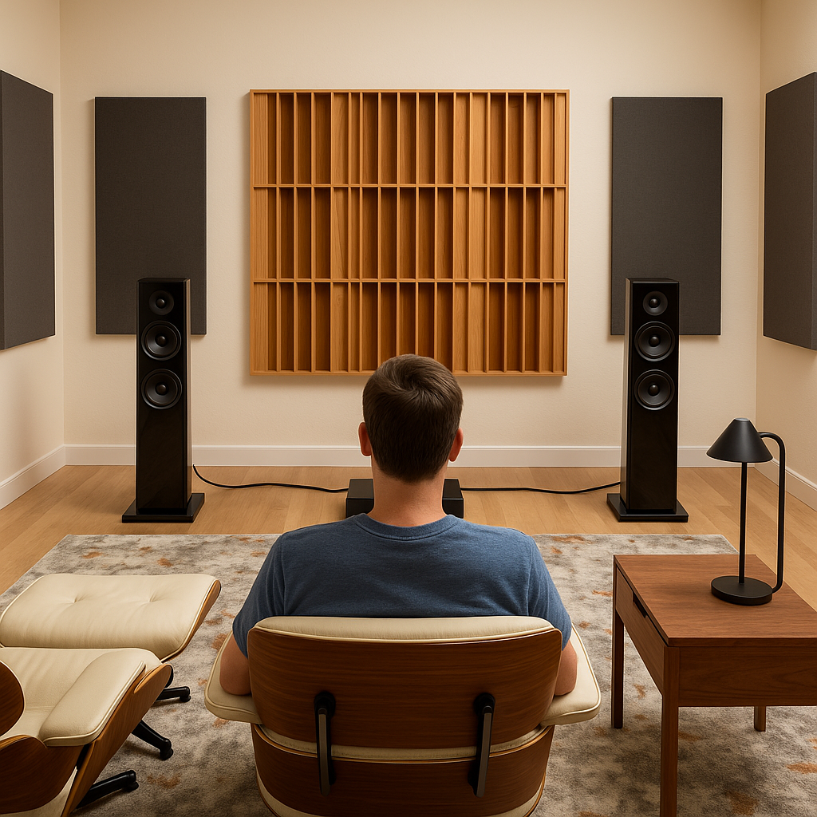
Absorption alone doesn’t fix everything. A room with nothing but foam and fiberglass start to sound sterile. There’s no depth, no spaciousness. Just dry sound and fast decay. That might be fine for a voice-over booth, but for music? It’s lifeless.
That’s where diffusion comes in. Instead of killing sound, diffusion scatters it. You keep the energy in the room, but in a way that’s controlled and natural. Voices feel more present. Guitars bloom. The space sounds like a space again, not a box covered in pillows.
And here's the real beauty, DIY diffusion doesn’t have to be expensive or complicated. You don’t need complex math or a CNC machine. You don’t even need new materials. A pile of scrap wood and an afternoon can turn your dead room into something that breathes again.

Diffusion Demystified
Let’s break this down without formulas.
Think of absorption like a sponge. It soaks up sound, energy gone. Handy for taming slap echo or reducing boom, but too much of it makes everything dull.
Now think of diffusion like a bed of rocks in a stream. Water (sound) still flows, but it changes direction, breaks up, and spreads. You hear more reflections, but they’re randomized, softer, and more pleasant. You don’t lose energy, you reshape it.
Why use diffusion at all?
- Diffusers preserve high-frequency content, cymbals, vocals, and string harmonics.
- It evens out decay times, so reverb tails don’t flutter or smear.
- It creates a sense of space, especially valuable in small rooms.
- It reduces phase issues and flutter without deadening the room.

Why Some Reflection Is a Good Thing
Here’s the thing: not all reflections are bad. In fact, some are essential.
Our brains evolved to hear in rooms, not in anechoic chambers. Reflections help us localize sound. They give music depth and space. Without them, everything sounds like it’s coming from inside your head.
A bit of reflected energy creates what we perceive as ambience. It’s what makes a live acoustic recording feel real and natural. You hear not just the instrument, but the room it was played in. That’s what makes a jazz trio in a club feel different from a studio recording.
Too much direct sound, and your system can feel surgical, pinpoint sharp, but flat and unnatural. Add the right amount of diffuse reflection, and suddenly voices have body, instruments have bloom, and the room opens up.
That’s why diffusion is so powerful. It keeps those reflections, but softens and scatters them so they don’t interfere with clarity. You get space without smearing. Detail without harshness. Liveliness without echo.

Key Difference: Absorption stops sound. Diffusion shapes it.
Most of us start with absorption, and that’s fine. But once the low end is under control and the first reflections are tamed, diffusion brings back the dimensionality.

Tools & Materials: You Probably Already Have What You Need
One of the reasons DIY diffusion is so rewarding is that it doesn’t require exotic tools or materials. This isn’t cabinetry. It’s sound shaping.
Here’s what you’ll need:
- Hand saw or circular saw
- Drill and screwdriver
- Wood glue
- Staple gun
- Measuring tape
- Level (for mounting)
You’ll be working with soft woods, plastic lattice, or pre-cut scrap pieces. No respirator or Tyvek suit required, unlike fiberglass work, this is clean, satisfying DIY. If you’ve built a baffle or hung a picture frame, you’re overqualified.
You don’t even need to spend much. One of the designs in this article uses nothing but your bookshelf. The rest? Scrap wood, yard-sale finds, or a couple of $10 hardware store pickups.

DIY Diffuser Designs: Low-Tech, High Impact
1. The Bookshelf Diffuser (Zero Build)
Let’s start with what you already have.
A bookshelf, especially one with a mix of book sizes and depths, is an excellent diffuser. All those irregular surfaces reflect sound in slightly different ways, breaking up harsh reflections and adding texture to the room’s sound.
Here’s how to make it better:
- Push some books forward, others back. Depth variation is your friend.
- Avoid symmetry. Mix tall and short, wide and narrow.
- Add small objects, vases, boxes, pottery, for more surface variation.
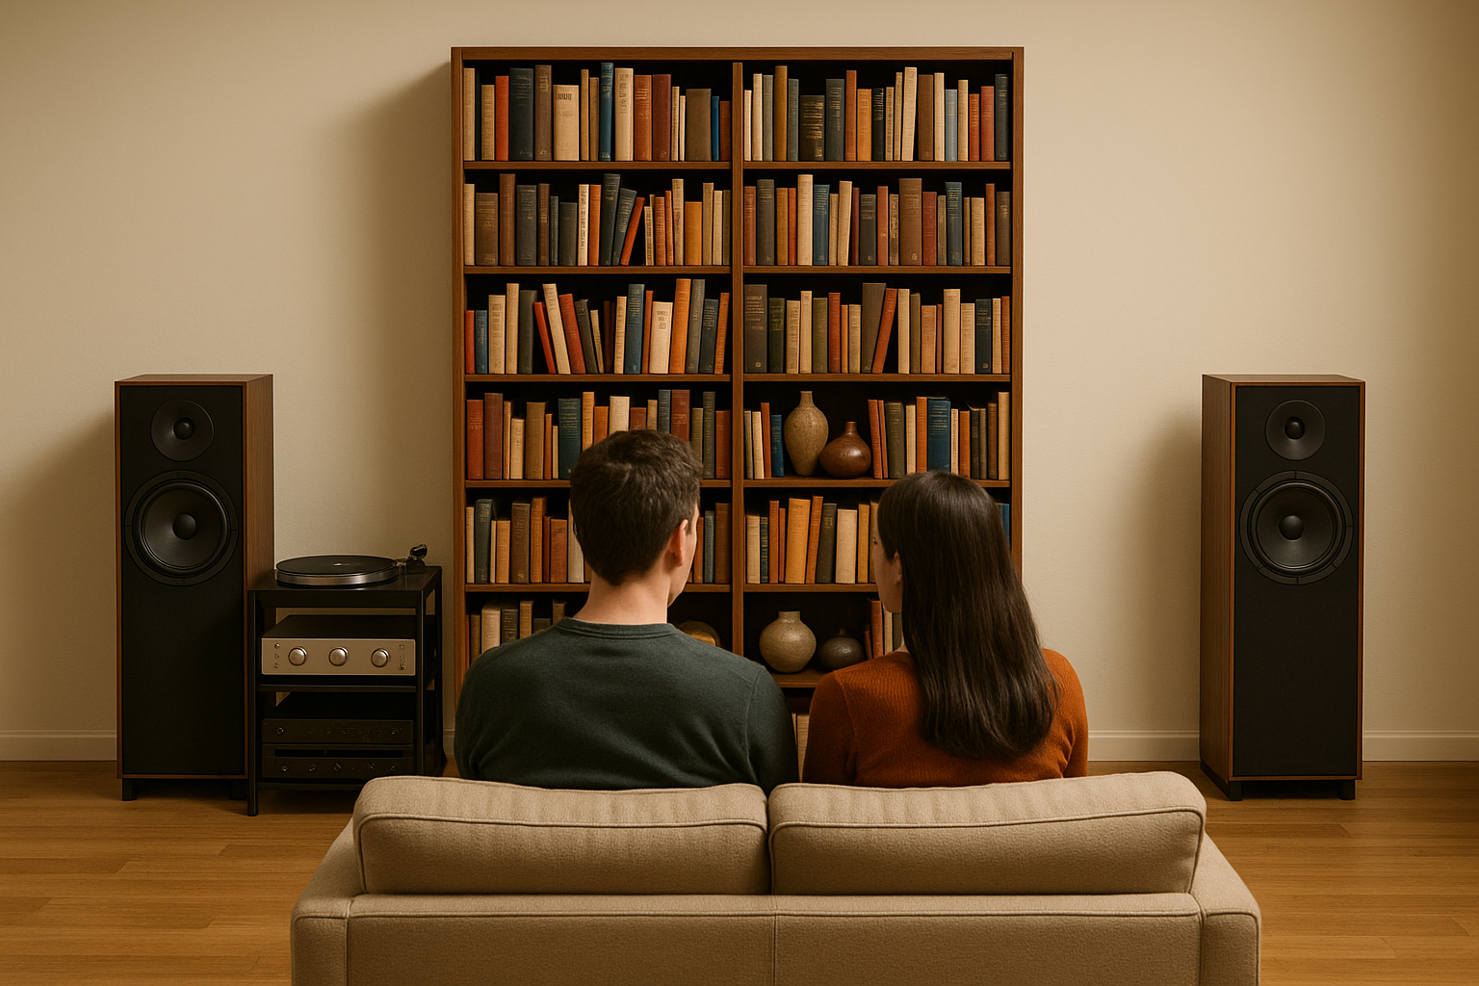
Where it works: Behind your listening chair is ideal. Side walls can work too, especially if you already have some absorption up front.
Aesthetic Tip: Resist the urge to neaten it up. A chaotic bookshelf often performs better than a tidy one.

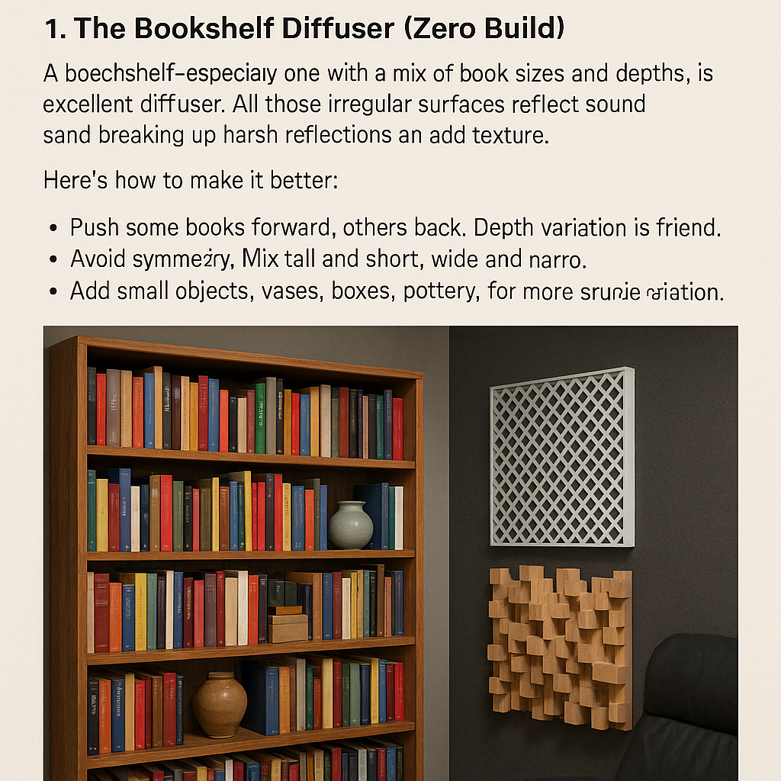
2. Garden Lattice Diffuser (Budget Beauty)
Plastic lattice panels, often used in gardening, make surprisingly effective lightweight diffusers. You’ve probably seen these, waffle-pattern panels sold in 2x4 or 4x8 foot sizes. Their grid naturally breaks up sound reflections.
You’ll need:
- 2x4’ plastic lattice panel
- Wood for a simple fr’ame (1x2s work fine)
- Breathable fabric’ x
- Staple gun and wood glue
- Wall-mount hardware (and spacers for an air gap)
Build Steps:
- Cut the lattice to your desired size. 2’ x 2’, 2’ x 4’ or 4’ x 8’ are tipical.
- Build a simple wooden frame around it.
- Stretch and staple fabric over the frame. Choose something decorative if this is going in a living space. Alternately, You can also skip the fabric or tack it behind the lattice for contrast.
- Mount to the wall with a 1–2” air gap behind it. The gap increases effectiveness, especially in the upper mid frequencies.
Where to place it: Try rear walls, or behind your listening chair. Side walls work well if you’re replacing some absorption.
Bonus: Backlight it with LED strips and you’ve got a great-looking piece of wall art.

3. Random Block “Skyline” Diffuser
This is the classic “scrap wood” diffuser. It’s heavier, but more effective at a wider frequency range. If you’ve got leftover 1x2s, 1x3s, 1x4s and 2x4s lying around, this is the project for you.
You’ll need:
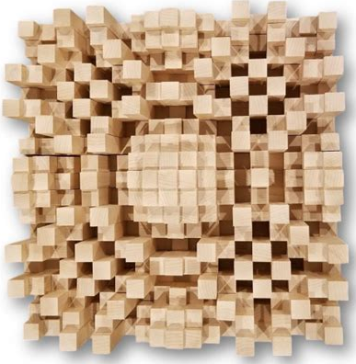
- Wood blocks in multiple lengths (cut to 4", 6", 8", and so on)
- Plywood backer (1/2" or 3/4")
- Wood glue
- Sandpaper and optional stain or fabric wrap
Build Steps:
- Cut wood blocks into 4–5 different depths. Each block should be 2–3” wide.
- Lay them out in a randomized grid pattern, avoid same-depth neighbors.
- Glue to a plywood backer, keeping spacing tight but irregular.
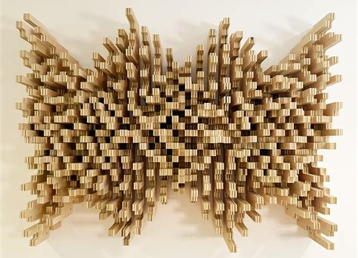
- Let dry, then finish with breathable stain or wrap with open-weave fabric.
- Be creative. Skyline diffusers can look like fine art.
Tech Tip: A range of depths between 1.5" and 4" will scatter frequencies from about 700Hz to 3kHz, right in the vocal and instrument sweet spot.
Placement: Rear wall or ceiling panel above the listening area.
Bonus Tip: Paint blocks different shades of gray or even different colors for a modern, textured art piece.4. QRD Lite Diffuser (For the Adventurous)
A true quadratic residue diffuser (QRD) is based on a mathematical sequence that determines the depth of a series of wells. The design spreads sound across a wide frequency range with scientific precision.
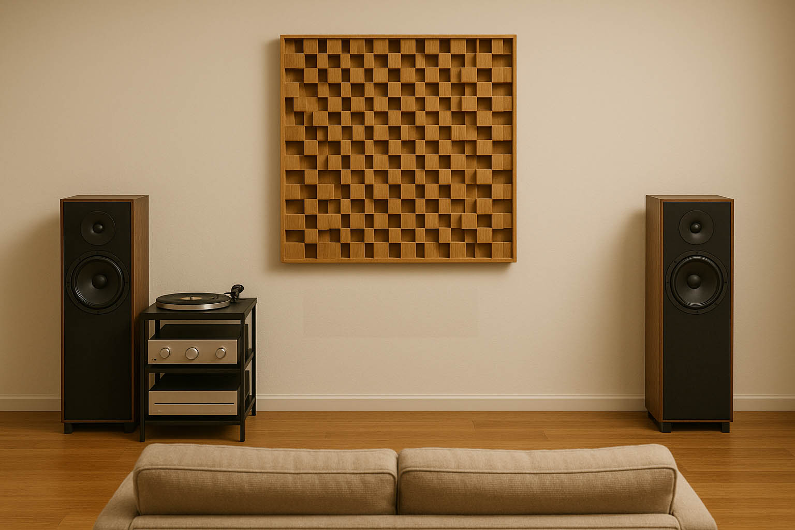
Here, we simplify it.
Materials:
- 1x4s cut to different depths (see table)
- Plywood base
- Optional fabric or perforated wood for a finish layer
Sample Depth Sequence (in inches):
[1, 4, 2, 5, 3, 0, 2]
Steps:
- Cut 1x4s to each depth in the sequence.
- Glue the “well” pieces to your base in exact order.
- Leave top open, or cover with fabric that doesn’t block airflow.
Key Principle: What matters is relative depth variation. Precision helps, but even a 1/4" margin won’t destroy performance.
Where It Works: Rear walls, high ceilings, or anywhere you want to add a professional touch.
Don’t Obsess: Diffusion is a game of averages. This design doesn’t need a PhD, just a saw and a weekend.

V. Where to Place Diffusers
Placement can make or break your treatment. Here’s how to get it right.
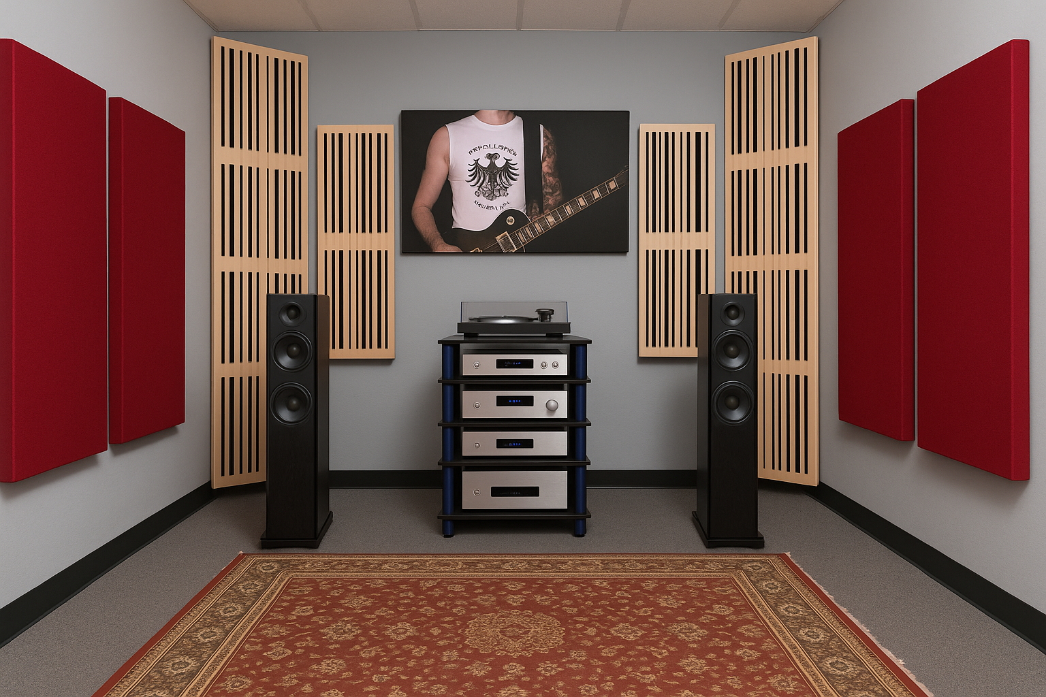
Rear Wall (Behind You):
The best spot in most listening rooms. Adds perceived space and breaks up slap echo.
Ceiling (Above Listening Position):
Reduces vertical flutter and helps tighten imaging. Works well with suspended panels.
Side Walls (Just Behind Reflection Points):
Only useful after front reflections are absorbed. Good for adding life back in.
Avoid:
- First reflection points (absorb, don’t diffuse)
- Behind speakers (diffusion here can blur imaging)
- Corners (use bass traps instead)
Pro Trick: Use the mirror method. Sit where you normally listen, and have someone move a mirror along the wall. If you can see a speaker, it’s a first reflection, absorb it. For areas just behind that spot, consider diffusion.

VI. When NOT to Use Diffusers
Just because diffusion is great doesn’t mean it’s always the answer.
Skip diffusion if:
- Your room already sounds “live” (tile, glass, plaster).
- You’re working with a very low ceiling (under 7’).
- The front wall behind your speakers needs absorption to tighten imaging.
Mistake to Avoid: Adding diffusion before you’ve dealt with bass. Low frequencies dominate in small rooms. Diffusion is more of a fine-tuning tool, not a fix for boomy bass or flutter echo.

VII. Troubleshooting & Pro Tips
“My room still echoes!”
You need more absorption. Diffusers scatter; they don’t stop sound.
“It sounds worse now!”
You may have overdone it. Pull one diffuser down and add back some absorption.
“It looks ugly.”
Then make it art. Paint your wood blocks. Wrap panels in fun fabrics. Add LED lighting or photo-printed fabric fronts.
“How do I know it’s working?”
Trust your ears, but also try a simple impulse clap test. Listen for flutter or ring. If it softens, you’re on the right path.

VIII. Conclusion: Bringing Rooms to Life
Diffusers are the final touch. Not always flashy. Not always understood. But get them right and you’ll notice it immediately: more air, more space, more music.
They don’t silence your room, they shape it. They don’t deaden, they refine.
You can build one this weekend. Or tweak what you already have. Either way, your ears will thank you.
Because acoustic treatment isn’t just science. It’s sculpture. It's craft. It's art.
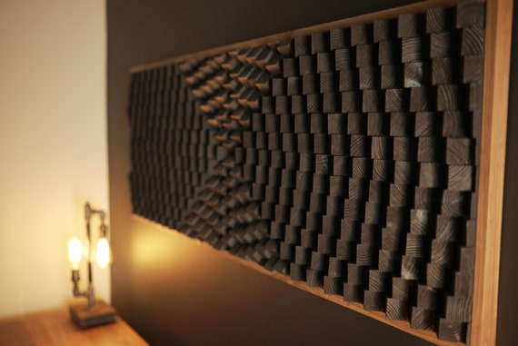
Figure 1 Acoustic Panel Black Sound Diffuser Large Wood Wall Art - Etsy UK
Next Up: Measuring your room’s flaws, so you can fix what actually matters.

