DIY Bass Traps: Effective Solutions for Better Acoustics
By Marc Silver
When I opened my first store in 1974, saying I was on a budget would be putting it lightly. My initial investment for the store was a total of $4,300. With that modest sum, I had to juggle a lot: leaving a deposit with the state of California for my resale license, paying for a city business license, covering first and last months' rent for the store (thankfully, the landlord didn’t require a security deposit), and buying all the wood and wall paneling to build out the space. On top of that, I needed a sales counter, a cash drawer, a deposit with the utilities company, and—most importantly—some inventory to actually open the store with.
I know it sounds crazy in today’s dollars, but back then, fortunately, things were a lot less expensive.
Once the store was up and running and actually making a little money, I realized my small 16’ x 20’ sound room didn’t sound very good. That realization set me off on a journey of research and experimentation. On a shoestring budget, I taught myself how to build basic room treatments to improve the sound—and it worked!
This is the first in a series of articles where I’ll share what I’ve learned over the years about room treatment, starting with DIY bass traps. Let’s dive in and get started!

The Foundation of Great Sound: Why DIY Bass Traps Matter
Good acoustics are the backbone of any great-sounding room, whether it's a home studio, theater, or just a music lover’s sanctuary. Low-frequency issues, like boomy bass or muddy sound, are common culprits that ruin audio clarity. This is where bass traps come in.
Bass traps absorb low-frequency sound waves, reducing echoes and standing waves in your room. The result is a balanced and clean sound environment that’s ideal for mixing, recording, or just enjoying music. If you are like most people, bass management in your sound room is not just a good idea but I have found that in 9 out of 10 home systems it is a necessity.
How Bass Traps Work
Bass traps absorb sound energy by converting it into heat through dense, porous materials such as Rockwool or fiberglass. To understand their effectiveness, it’s helpful to explore the physics behind low-frequency sound waves and room acoustics.
Sound Wave Properties
Low-frequency sound waves have long wavelengths, which makes them harder to absorb compared to higher frequencies. For example:
- At 100 Hz, the wavelength is 3.43 meters.
- At 50 Hz, the wavelength extends to 6.86 meters.
These waves interact with room boundaries (walls, floors, and ceilings), causing reflections that create standing waves—areas where sound waves amplify or cancel each other. This results in uneven bass response and muddied audio.
Trap Thickness and Absorption
For a bass trap to effectively absorb low frequencies, its thickness must align with the wavelength:
- To absorb 100 Hz effectively, the trap thickness should be λ/4\lambda / 4λ/4, or about 0.86 meters (86 cm).
- While thinner traps (4–6 inches) handle mid-to-high bass frequencies, thicker traps (8–12 inches) are needed for deeper bass.
Bass traps, when placed strategically in corners or reflective areas, dampen these standing waves and prevent excessive resonance.
But what if you’re working on a budget or want to add a personal touch? Building your own bass traps is a rewarding and surprisingly achievable DIY project. With a little creativity, you can get professional results at a fraction of the cost.

Materials That Won’t Break the Bank
DIY bass traps don’t have to cost a fortune. You can use materials easily found at hardware stores or online—and with a little ingenuity, you might even find some for free. Here’s what you’ll need:
- Rigid Fiberglass or Rockwool Insulation: Owens Corning 703 or Rockwool Safe’n’Sound are excellent options for their density and low-frequency absorption. If you’re resourceful, alternatives abound. For example, I once found horsehair padding in a carpet store dumpster, and it worked surprisingly well—for free! Just ensure any material you use is clean and odor-free—nobody wants a smelly bass trap ruining the room.
- Wood for Frames: Pine or MDF is affordable and easy to work with. For smaller traps, ½-inch MDF is sufficient, but for taller traps (6 feet or more), ¾-inch MDF adds stability. Reclaimed wood or heavy-duty cardboard are cost-saving alternatives.
Another materials hack is finding a home building site and asking the site manager if you can go through their scrap pile for wood. I have found in most cases you can get permission to take scrap to build your project.
- Fabric Covering: Choose breathable fabrics like burlap, muslin, or double knit to let sound pass through. Budget-friendly options include discounted end cuts from fabric stores. If cost isn’t an issue, pick fabric that matches your decor and personal style.
- Staples, Screws, and Adhesives: These essentials keep everything together. Home Depot or Lowe’s are great for hardware, but if you’re on a tight budget, check out your local Habitat for Humanity ReStore for discounted materials.
- Tools: A saw, measuring tape, drill, and staple gun are must-haves. If you don’t already own these, consider borrowing them from a friend or local tool library.

Types of DIY Bass Traps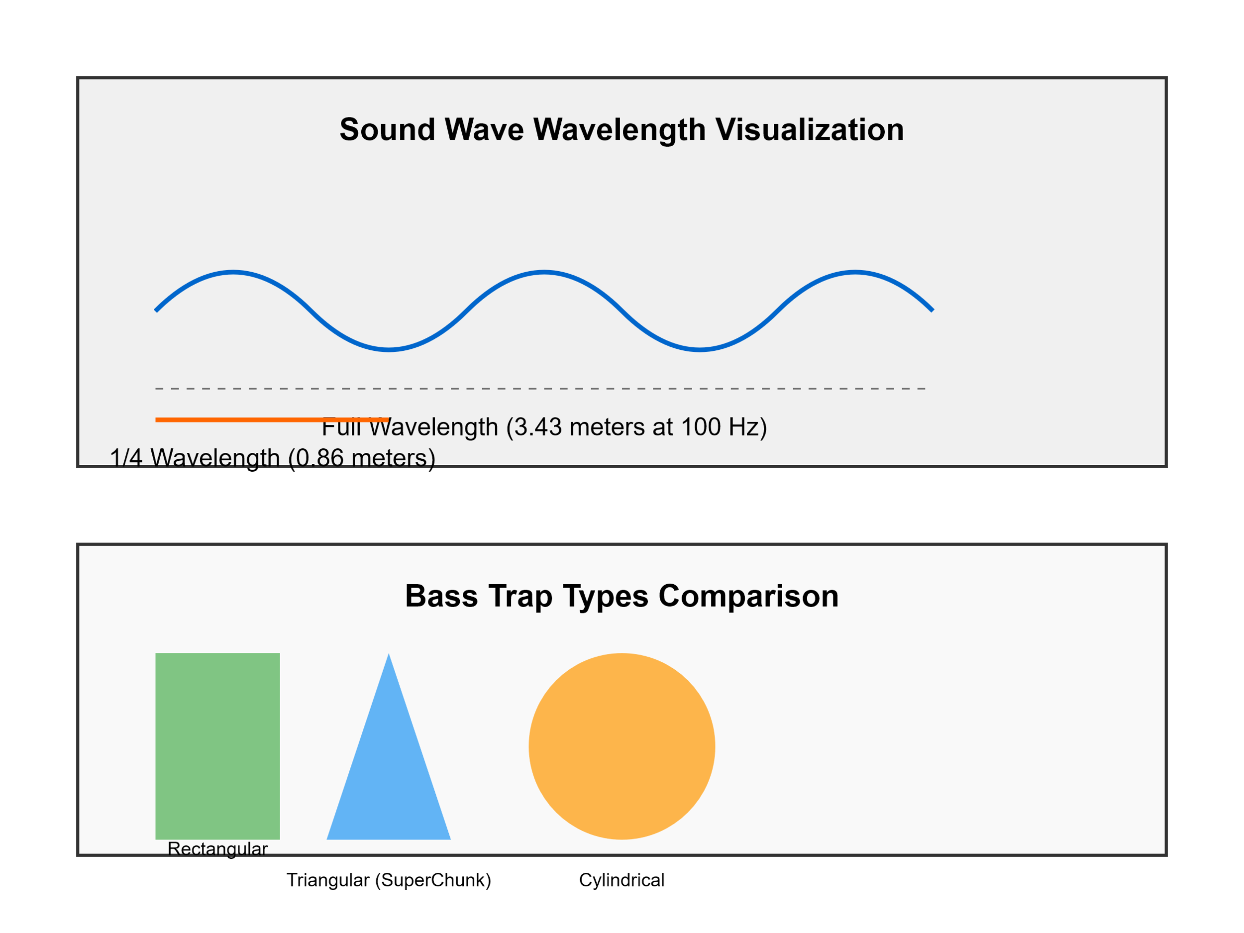
Bass traps come in several shapes and styles, each suited to different needs. Here are three common designs:
1. Rectangular Panel Bass Trap
Construction Steps
- Build the Frame: Cut wood or MDF into two 4-foot and two 2-foot pieces. Assemble into a rectangular frame using screws or corner brackets.
- Insert the Insulation: Cut rigid fiberglass or Rockwool to fit snugly inside the frame.
- Wrap the Fabric: Place the frame on a flat surface with breathable fabric underneath. Pull the fabric taut over the back edges and staple securely.
- Optional Backing: Attach a thin sheet of plywood or cardboard for durability.
Placement Tips
- Mount flat against walls behind speakers or the listening position.
- Stack vertically in corners to address low-frequency buildup.

2. Triangular Corner Bass Trap (SuperChunk)
Construction Steps
- Prepare Insulation: Cut large triangular pieces of insulation to fit snugly in a corner.
- Stack Layers: Build up the corner with stacked triangular pieces from floor to ceiling.
- Cover the Front: Stretch fabric across the exposed front of the corner trap, attaching it with staples or a lightweight frame.
Placement Tips
- Place in vertical corners where two walls meet.
- Ensure the stacked layers are tightly packed to maximize absorption.
Advantages and Disadvantages of Triangular (SuperChunk) Bass Traps
Advantages:
- Exceptional Low-Frequency Absorption:
The large volume of dense insulation in corners makes SuperChunk traps highly effective at handling deep bass frequencies.
- Optimized for Corners:
Their triangular shape allows them to fully utilize corner space, where low-frequency buildup is most significant.
- Stackable Design:
They can be built as modular units, making them easy to stack and customize based on room height.
- Durability:
Once installed, they are robust and unlikely to shift or deform over time.
- Minimal Wall Mounting:
Since they fit snugly into corners, they don’t typically require mounting brackets or hardware.
Disadvantages:
- Space Requirements:
SuperChunk traps take up significant corner space, which may not be ideal for smaller rooms.
- Higher Material Usage:
Due to their bulk, they require more insulation material compared to other designs, increasing cost and weight.
- Complex Construction:
Cutting precise triangular pieces and assembling them into a uniform stack requires more effort and time than rectangular traps.
- Limited Placement Options:
Their design is corner-specific, making them unsuitable for flat walls or other reflective areas.

3. Cylindrical Bass Trap
Construction Steps
- Choose Your Cylinder: Use a sturdy base, such as a large mailing tube or PVC pipe.
- Fill with Insulation: Pack the cylinder tightly with Rockwool or similar material.
- Wrap in Fabric: Cover the entire cylinder in acoustically transparent fabric, securing with adhesive or staples.

- Stand in corners or along walls.
- Place symmetrically for balanced performance.

Advantages and Disadvantages of Rectangular Panel Bass Traps
Advantages:
- Ease of Construction:
Rectangular panel traps are the simplest to build, requiring basic tools and minimal carpentry skills.
- Versatile Placement:
They can be mounted on walls, placed in corners, or stacked, making them adaptable to various room layouts.
- Cost-Effective:
These traps require less material compared to thicker designs, especially for mid- and high-bass absorption.
- Aesthetic Options:
They can be covered in fabric that complements room decor, making them visually appealing.
- Portability:
Lightweight and easy to move, rectangular traps offer flexibility for rearranging or transporting.
Disadvantages:
- Limited Low-Frequency Absorption:
Due to their thin profile (often 4–6 inches), they are less effective at absorbing very low frequencies (e.g., below 80 Hz) unless they are made thicker or used with additional techniques like spacing them off the wall.
- Requires Additional Traps for Corners:
To handle significant bass buildup in corners, multiple rectangular traps may need to be stacked or paired with triangular corner traps.
- Mounting Challenges:
Wall mounting may require brackets or hardware, adding to the setup time and complexity compared to freestanding designs.
- Not as Space-Efficient in Corners:
While effective on flat walls, rectangular traps don’t fully maximize corner absorption compared to triangular or cylindrical designs.

Placement Tips for Maximum Effectiveness
- Start with Corners: Low-frequency sound energy builds up in corners. Begin by placing traps in the vertical corners of your room, stacking from floor to ceiling.
- Ceiling-Wall Junctions: Add traps to horizontal corners where the ceiling meets the walls.
- Behind Speakers: Place traps behind your main speakers to absorb direct reflections.
- Symmetry is Key: Ensure traps are placed symmetrically for a balanced soundstage.
- Experiment and Adjust: Use software like Room EQ Wizard (REW) to analyze your room and optimize placement.
Advantages and Disadvantages of Cylindrical Bass Traps
Advantages:
- Highly Effective for Low Frequencies:
Their cylindrical shape ensures 360-degree absorption, making them excellent at taming low frequencies.
- Freestanding and Portable:
Cylindrical traps don’t require mounting and can be easily moved, offering flexibility for placement or reconfiguration.
- Space-Efficient:
They don’t rely on corners and can be placed anywhere in the room, including along walls or behind seating areas.
- Aesthetic Appeal:
When wrapped in fabric, cylindrical traps can have a clean, professional look that complements modern room designs.
Disadvantages:
- Challenging Construction:
Building cylindrical traps requires more advanced skills, especially to evenly pack insulation and maintain structural stability.
- Material Costs:
They often require specialized materials, such as sturdy cylindrical forms (e.g., mailing tubes or PVC pipes), which can be more expensive.
- Weight Considerations:
Due to their dense construction, cylindrical traps can be heavy, making them harder to move than anticipated.
- Limited Stackability:
Unlike triangular traps, stacking cylindrical traps is not practical, so they are typically used as standalone units.

Comparison of All Three Types of Bass Traps
Type | Best Use | Advantages | Disadvantages
Rectangular Panel | Flat walls, basic corner stacking | Easy to build; versatile; cost-effective | Less effective for very low frequencies
Triangular (SuperChunk) | Corners with heavy bass buildup | Excellent low-frequency absorption; corner-optimized | Bulky; high material usage
Cylindrical | Freestanding, anywhere in the room | 360-degree absorption; portable; aesthetic | Complex construction; more expensive

When to Use Each Type
Rectangular Panel Bass Traps
- Best for: General-purpose absorption, covering flat walls or basic corner stacking.
- Use if: You need an affordable, easy-to-build solution for mid- and high-bass frequencies.
Triangular (SuperChunk) Bass Traps
- Best for: Targeting low-frequency buildup in corners, especially in larger rooms or rooms with significant bass issues.
- Use if: Your main concern is deep bass absorption and you have the space to dedicate to corner traps.
Cylindrical Bass Traps
- Best for: Flexible placement anywhere in the room, especially when targeting specific problem areas.
- Use if: You want a freestanding solution that absorbs evenly in all directions and don’t mind the extra effort for construction.

General Recommendation
For most setups:
- Start with triangular traps in the corners, as they address the most critical areas for bass buildup.
- Add rectangular traps on flat walls or behind speakers to reduce reflections and improve clarity.
- Use cylindrical traps if you need extra low-frequency absorption in specific locations or want portable, freestanding options.
This combination ensures comprehensive low-frequency management while allowing you to customize based on room size, layout, and budget. Would you like diagrams or more placement advice to complement this information?

Final Thoughts
DIY bass traps are an affordable and effective way to transform your room’s acoustics. Whether you opt for rectangular panels, triangular corner traps, or cylindrical designs, these simple steps and tips will help you craft and place traps that fit your space and needs.
With the satisfaction of having built them yourself, you’ll enjoy improved sound clarity and balance like never before. Ready to get started?
Introduction
For the passionate audiophile, the pursuit of perfect sound is more than a hobby—it's an art form. Your listening room is the canvas, and bass traps are the crucial brushstrokes that transform good sound into exceptional audio clarity. This guide will walk you through creating your own bass traps, helping you optimize your sound room's acoustics without breaking the bank.
Safety First: Working with Acoustic Materials
Before diving into bass trap construction, understanding safety is paramount:
Personal Protection
- Respiratory Protection: Always wear an N95 mask or respirator when handling fiberglass or mineral wool.
- Protective Clothing:
  - Long-sleeve shirts
  - Long pants
  - Safety glasses
  - Disposable gloves
Material Handling
- Fiberglass and Rockwool Precautions:
  - Work in a well-ventilated area
  - Avoid direct skin contact
  - Wash hands thoroughly after handling
  - Store materials in sealed bags when not in use
Workspace Preparation
- Cover work surfaces with plastic sheeting
- Have a HEPA vacuum nearby to clean up any loose fibers
- Work outdoors or in a garage when possible
- Seal off the work area from living spaces
Tool Safety
- Use sharp, well-maintained tools
- Wear cut-resistant gloves when using saws or cutting materials
- Ensure proper lighting and stable work surfaces
- Keep a first-aid kit nearby
Understanding Sound Wave Physics (Revised)
Sound Wave Wavelength Explained
Let's break down low-frequency sound wave characteristics with clarity:
Wavelength Calculation Example:
- At 100 Hz: Wavelength = Speed of Sound ÷ Frequency
  - Speed of sound ≈ 343 meters/second
  - Wavelength = 343 ÷ 100 = 3.43 meters
Absorption Principle: To effectively absorb a specific frequency, your bass trap should be approximately 1/4 of the wavelength thick:
- For 100 Hz: Recommended trap thickness ≈ 0.86 meters (86 cm)
  - Calculation: 3.43 meters ÷ 4 = 0.86 meters
Visual Representation of Wavelength:
Absorption Principle: To effectively absorb a specific frequency, your bass trap should be approximately 1/4 of the wavelength thick:
- For 100 Hz: Recommended trap thickness ≈ 0.86 meters (86 cm)
  - Calculation: 3.43 meters ÷ 4 = 0.86 meters
Visual Representation of Wavelength:

Types of DIY Bass Traps
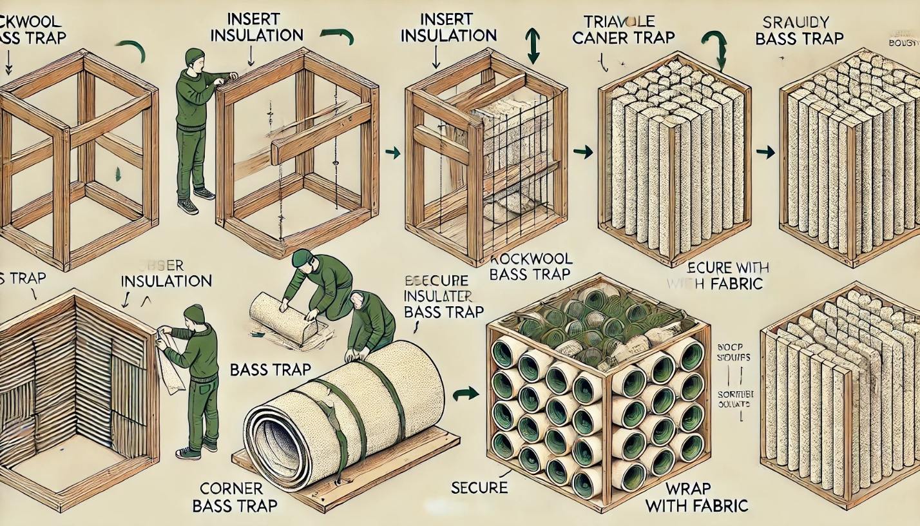
References and Citations
- Ethan Winer's "Build a Better Bass Trap"
Provides a detailed guide on constructing bass traps and their acoustic principles.
URL: https://ethanwiner.com/basstrap.html
- Acoustics Insider: DIY Bass Trap Construction Tutorials
Offers step-by-step video guides for building effective bass traps.
URL: https://acousticsinsider.com
- ATS Acoustics: Materials for Acoustic Treatments
Supplier of acoustic materials like Owens Corning 703 and Rockwool, with specifications and usage tips.
URL: https://www.atsacoustics.com
- Better Soundproofing: 18 DIY Bass Trap Ideas
Highlights various bass trap designs, including rectangular, triangular, and cylindrical options.
URL: https://bettersoundproofing.com/diy-bass-traps
- Mastering.com: Guide to DIY Acoustic Treatments
Explains the importance of bass traps and provides insights into design and placement.
URL: https://mastering.com/diy-bass-traps
- Soundproofing Tips: 5 Effective DIY Bass Trap Designs
A practical resource with beginner-friendly designs and cost-saving tips.
URL: https://www.soundproofingtips.com/diy-bass-traps
- Room EQ Wizard (REW)
Software for analyzing room acoustics to optimize bass trap placement.
URL: https://www.roomeqwizard.com

