Discovering Klawock, Alaska
By: Marc Silver
Where Ancient Culture Meets Wild Adventure
Nestled on Prince of Wales Island in Alaska's breathtaking Inside Passage, Klawock is a destination that captures the soul of Southeast Alaska like nowhere else.
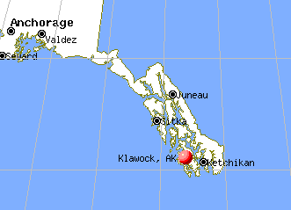
Welcome to Alaska's Hidden Cultural Treasure
Imagine stepping off a small cruise ship onto an island where towering totem poles tell stories thousands of years old, where pristine rivers run thick with salmon, and where the traditions of the Tlingit people come alive in every corner of daily life.
Welcome to Klawock, Alaska – a place where authentic Alaskan culture and jaw-dropping natural beauty create an unforgettable travel experience.
This remarkable community holds a special place in Alaska's history as the site of the state's first salmon cannery, established in 1878, and today stands as one of the most significant centers of Tlingit culture in Southeast Alaska.
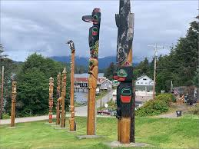
The Crown Jewel: Klawock Totem Park
No visit to Klawock is complete without experiencing the awe-inspiring Totem Park. Home to the largest collection of authentic totem poles in Alaska, this cultural sanctuary features 21 masterfully crafted totem poles that stand as silent guardians of ancient stories and traditions.

Each pole tells a unique story – from clan histories to spiritual beliefs – carved by master craftsmen whose skills have been passed down through generations. The park offers visitors a rare glimpse into the sophisticated artistic and spiritual world of the Tlingit people, making it one of Alaska's most culturally significant destinations.
Visitor Tip: Plan to spend at least an hour here. The stories behind each totem are fascinating, and the craftsmanship is absolutely breathtaking.
Outdoor Adventures That Will Leave You Breathless
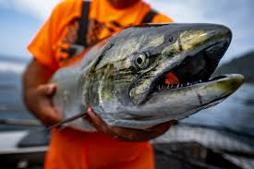
Fishing Paradise
Klawock sits at the heart of some of Alaska's most productive fishing waters. The local salmon runs have sustained the Tlingit people for thousands of years, and today offer visitors world-class fishing opportunities. Whether you're after salmon, halibut, or steelhead, the waters around Prince of Wales Island deliver experiences that fishing enthusiasts dream about.
Hiking and Wildlife Watching
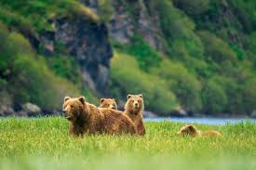
The new Swan Song Trail offers an incredible way to start your day in Alaska, where you'll encounter abundant wildlife and lush forest vegetation. The hiking trails around Klawock provide access to pristine wilderness areas where black bears, deer, and countless bird species make their home.
Kayaking and Water Adventures
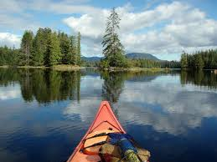
The protected waters around Klawock are perfect for kayaking, offering everything from gentle paddles suitable for beginners to challenging routes for experienced adventurers.
The coastline reveals hidden coves, dramatic rock formations, and wildlife viewing opportunities around every bend.
Culinary Delights: Taste the Best of Alaska
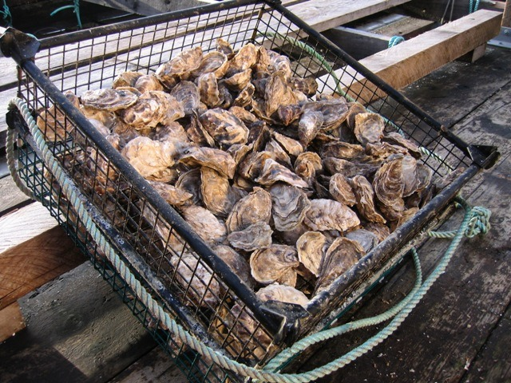
Klawock is renowned throughout Southeast Alaska for its exceptional oysters, fresh salmon, and other local delicacies. The community's deep connection to the sea means visitors can enjoy some of the freshest seafood anywhere in the world.
Local restaurants and tour operators offer curated tastings featuring:
- Fresh-shucked oysters with wine pairings
- Wild Alaska salmon prepared in traditional and contemporary styles
- Halibut caught in local waters
- Seasonal berries and kelp – unique flavors of the region
- Salmon roe (caviar) – a local delicacy
Cultural Immersion: Living History
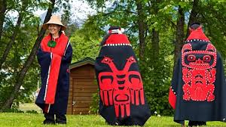
Klawock serves as a significant center of Tlingit culture, including annual celebrations of Elizabeth Peratrovich's pioneering civil rights work on behalf of Alaska Natives. Visitors have the opportunity to learn about this rich cultural heritage through community events, cultural presentations, and interactions with local residents who are proud to share their traditions.
The community's connection to its heritage isn't just historical – it's vibrantly alive. From traditional fishing methods to contemporary art inspired by ancient designs, Klawock offers an authentic cultural experience that's increasingly rare in today's world.
Getting There and Getting Around
Klawock features the only airport runway on Prince of Wales Island, making it the primary gateway to this incredible region. As Southeast Alaska's newest cruise ship destination, Klawock is becoming increasingly accessible to travelers.
Transportation Options:
- Fly into Klawock Airport from major Alaska cities
- Take advantage of local services like Klawock Totem Taxi and Tours for airport transfers and island exploration
- Arrive by cruise ship at the new port facility
- Ferry connections to other Southeast Alaska communities
When to Visit
The best time to visit Klawock is during the summer months (May through September) when:
- Weather is most favorable for outdoor activities
- Wildlife is most active
- All tours and services are operating
- Daylight hours are longest (nearly 18 hours in midsummer!)
What to Pack
- Waterproof gear (rain jacket and pants are essential)
- Warm layers for variable weather
- Comfortable hiking boots
- Camera with extra batteries
- Binoculars for wildlife viewing
- Sunscreen (the reflection off water and snow can be intense)
Beyond Klawock: Exploring Prince of Wales Island
Prince of Wales Island is the fourth largest island in the United States, offering endless opportunities for adventure. Use Klawock as your base to explore:
- Spectacular caves and underground formations
- Remote hot springs accessible only by boat or cruise ship
- Mountain biking trails through old-growth forests

- World-class fishing streams and lakes
- Historic mining sites and ghost towns
Why Klawock Should Be Your Next Destination
In a world where authentic cultural experiences are becoming increasingly rare, Klawock offers something truly special. This untamed island provides a culture-driven, community-centric experience that's truly one of a kind. It's a place where you don't just observe Alaska – you experience it through the eyes of people whose families have called this land home for thousands of years.
Whether you're drawn by the incredible fishing, fascinated by the rich cultural heritage, or simply seeking an adventure in one of America's last great wilderness areas, Klawock delivers experiences that will stay with you long after you return home.
Final Thoughts
Klawock reveals secrets of a captivating destination that leaves an indelible mark on wanderlust-filled souls. This isn't just another tourist destination – it's a place where the spirit of Alaska comes alive, where ancient traditions thrive alongside modern adventures, and where every visitor becomes part of the continuing story of this remarkable community.
Pack your sense of adventure and prepare to discover why Klawock, Alaska, deserves a place at the top of your travel bucket list.

