Coquimbo: Chile’s High-Altitude Wine Frontier
Region Overview
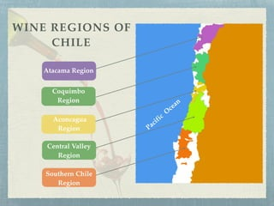
The Coquimbo wine region, located in northern Chile, is one of the country’s most challenging and exciting areas for viticulture. Positioned between 29° and 32° latitude south, it borders the Atacama Desert to the north and the Aconcagua region to the south. Coquimbo is defined by its high-altitude vineyards, extreme climatic conditions, and limited but high-quality production.
The region’s arid climate, coupled with the cooling influence of the Pacific Ocean and the Andes, creates a unique environment where viticulture is only possible through careful irrigation from Andean snowmelt. The combination of intense sunlight, minimal rainfall, and extreme diurnal temperature variations results in wines with high acidity, concentration, and distinct minerality. Soils in Coquimbo vary but are often limestone-rich, alluvial, and well-draining, offering excellent conditions for premium winemaking.
Key Grape Varieties
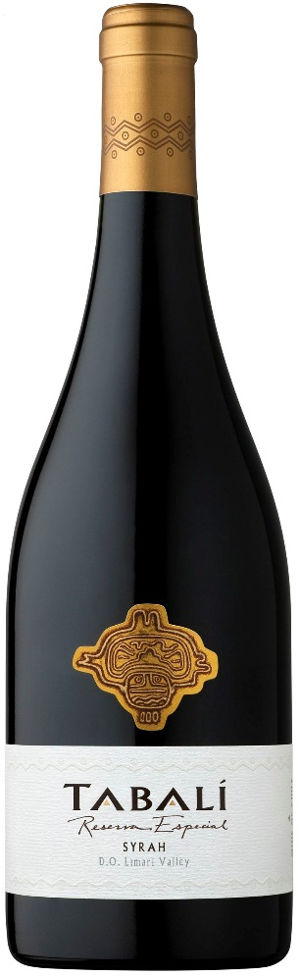
While Coquimbo remains a small-scale wine region, it has developed a reputation for producing elegant, high-altitude wines, particularly:
Figure 1 "Reserva Especial" Syrah 2011 - Viña Tabalí, región de Coquimbo
- Syrah – Grown at elevation, producing structured wines with black fruit, spice, and minerality.
- Chardonnay – Crisp and precise, often showing citrus, saline, and flinty notes.
- Sauvignon Blanc – Aromatic and fresh, benefiting from the cool coastal influences.
- Pinot Noir – Increasingly planted in higher-altitude sites, offering vibrant acidity and red fruit expression.
- Pedro Ximénez (PX) – Historically used for Pisco but also crafted into dry, mineral-driven whites.

Wine Classification System
Coquimbo is officially recognized within Chile’s Denomination of Origin (DO) system, and it encompasses three key subregions:
- Elqui Valley – The northernmost subregion, heavily influenced by the Andes, known for cool-climate Syrah, Sauvignon Blanc, and Pisco production.
- Limarí Valley – Renowned for Chardonnay and Syrah, with significant limestone deposits that contribute to the wines' mineral complexity.
- Choapa Valley – The smallest and least developed subregion, focusing on Cabernet Sauvignon and Syrah in limited quantities.
Notable Wine Styles
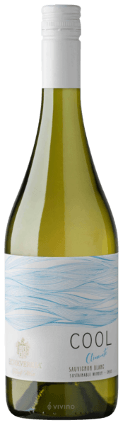
- High-Altitude Syrah – Powerful yet elegant, with dark fruit, black pepper, and fine tannins.
- Limestone-Influenced Chardonnay – Bright acidity, citrus, and a distinct mineral character.
- Cool-Climate Sauvignon Blanc – Aromatic and zesty, with grassy and citrus notes.
- Andes-Influenced Pinot Noir – Light, fresh, and structured, with excellent aging potential.
Additional Context
Coquimbo’s wine industry is young but rapidly growing, with many producers focusing on quality over quantity. The region’s potential has drawn attention from top Chilean winemakers, who are pushing the boundaries of cool-climate viticulture. However, challenges such as water scarcity, high production costs, and extreme weather conditions make winemaking here a demanding endeavor.
Takeaway for Sommeliers
Coquimbo represents Chile’s frontier of fine wine production, offering high-altitude, terroir-driven wines with precision and elegance. Sommeliers should pay attention to its Syrah, Chardonnay, and Sauvignon Blanc, which showcase a distinct sense of place and mineral-driven freshness. As viticulture in Coquimbo continues to evolve, expect even more exciting wines to emerge from this extreme yet promising region.
References
- Robinson, J., & Harding, J. (2020). The Oxford Companion to Wine (5th ed.). Oxford University Press.
- Wines of Chile. (2023). Regional Profiles and Climate Data. Retrieved from https://www.winesofchile.org
- Tapia, P. (2022). The Wines of South America. Infinite Ideas.
- Wine Enthusiast. (2022). Exploring Chile’s High-Altitude Vineyards. Retrieved from https://www.winemag.com

