Chile: The Long and Varied Wine Landscape
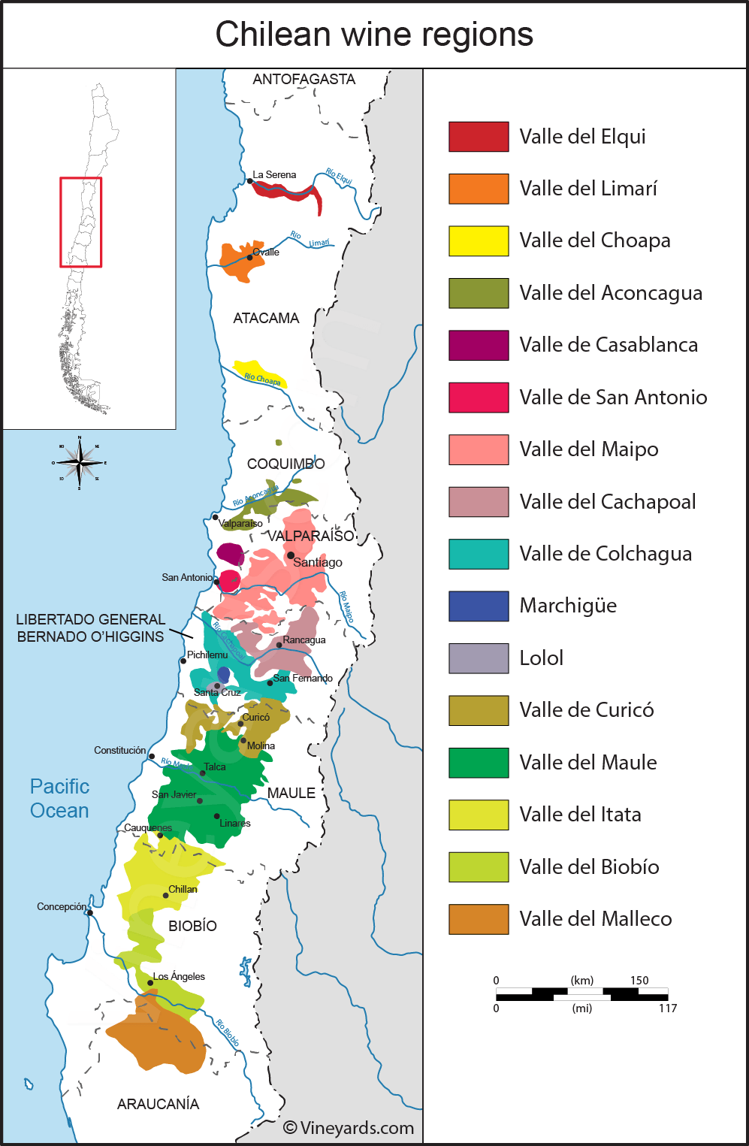
Region Overview
Chile’s unique geography makes it one of the most distinctive wine-producing countries in the world. Stretching approximately 2,650 miles (4,240 km) from north to south while averaging just 93 miles (150 km) in width, the country is naturally insulated by the Andes Mountains to the east and the Pacific Ocean to the west. These natural barriers have helped Chile remain largely free from devastating vineyard diseases such as phylloxera and powdery mildew (oidium), allowing vines to thrive on their own rootstocks—a rarity in the modern wine world.
Figure 1 Chile's Major and Minor Wine Regions
Most of Chile’s viticulture is concentrated in the central portion of the country, between 27° and 41° latitude south, where the Mediterranean climate provides warm, dry summers and cool, wet winters. The influence of the Humboldt Current, a cold oceanic current flowing along the coast, moderates’ temperatures in coastal vineyards, while the Andean snowmelt ensures reliable irrigation for many inland areas. This combination of climatic factors, along with diverse soils and elevations, contributes to Chile’s consistent and high-quality wine production.
Key Grape Varieties
Chile is primarily a red wine country, with 70% of production dedicated to red varieties. The leading grape is Cabernet Sauvignon, which accounts for 36% of total plantings. Other prominent varieties include:
- Sauvignon Blanc – Crisp and aromatic, thriving in coastal areas like Casablanca and Leyda.
- Merlot – Smooth and fruit-forward, often blended with other reds.
- Chardonnay – Fresh and balanced, with both mineral-driven and oak-aged expressions.
- Carmenère – Originally from Bordeaux but now Chile’s signature grape, known for its deep color, rich dark fruit, and spicy notes.
- Syrah – Increasingly planted, showing bold flavors with peppery and smoky characteristics.
Chile’s Wine Regions
Chile’s wine industry is divided into six main viticultural regions, moving from north to south:
- Atacama – Primarily known for table grapes and pisco production, though some experimental vineyards exist.
- Coquimbo – Home to high-altitude vineyards with limited rainfall, producing premium Syrah and Chardonnay.
- Aconcagua – Includes the renowned Casablanca Valley, a coastal region famous for cool-climate Sauvignon Blanc and Chardonnay, as well as Aconcagua Valley, producing bold reds.
- Central Valley (Valle Central) – The heart of Chilean wine production, housing Maipo, Rapel, Curicó, and Maule Valleys, best known for structured Cabernet Sauvignon and Carmenère.
- Southern Region (Sur) – A cooler, wetter area with expanding plantings of Pinot Noir and aromatic whites such as Riesling.
- Austral – The emerging frontier of Chilean viticulture, featuring extreme cool-climate conditions suitable for experimental varieties.
Appellations and Geographic Classifications
In addition to regional designations, Chile’s wine law allows for three additional appellations that describe a vineyard’s location relative to the Andes Mountains and the Pacific Ocean. These classifications help define the growing conditions more precisely:
- Costa – Refers to vineyards closest to the Pacific Ocean, where the Humboldt Current cools the climate, leading to bright acidity and refined aromatics.
- Entre Cordilleras – Covers vineyards located between the Coastal Range and the Andes, where the climate is warmer and drier, producing full-bodied, fruit-driven wines.
- Andes – Applies to vineyards at higher elevations near the Andes foothills, benefiting from cold mountain airflows, which preserve acidity and freshness.
To qualify for one of these geographical indications, at least 85% of the grapes must be grown in the designated area.
Takeaway for Sommeliers
Chile’s diverse terroirs, disease-free vines, and ideal growing conditions make it a powerhouse in the global wine market. Understanding the regional distinctions and key grape varieties is essential for selecting the best expressions of Chilean wine. Whether it’s a structured Cabernet Sauvignon from Maipo, an ocean-influenced Sauvignon Blanc from Casablanca, or a spicy Carmenère from Rapel, Chile offers something for every palate.
References
- Robinson, J., & Harding, J. (2020). The Oxford Companion to Wine (5th ed.). Oxford University Press.
- New Zealand Winegrowers. (2023). Annual Report on the Chilean Wine Industry. Retrieved from https://www.nzwine.com
- Tapia, P. (2022). The Wines of South America. Infinite Ideas.
- Wines of Chile. (2023). Geographic Indications and Regional Profiles. Retrieved from https://www.winesofchile.org
- Wine Enthusiast. (2022). Top Chilean Wines to Try Now. Retrieved from https://www.winemag.com

