Charting the World by Sea
How Ships Connected the Planet Before the 20th Century
By Marc Silver
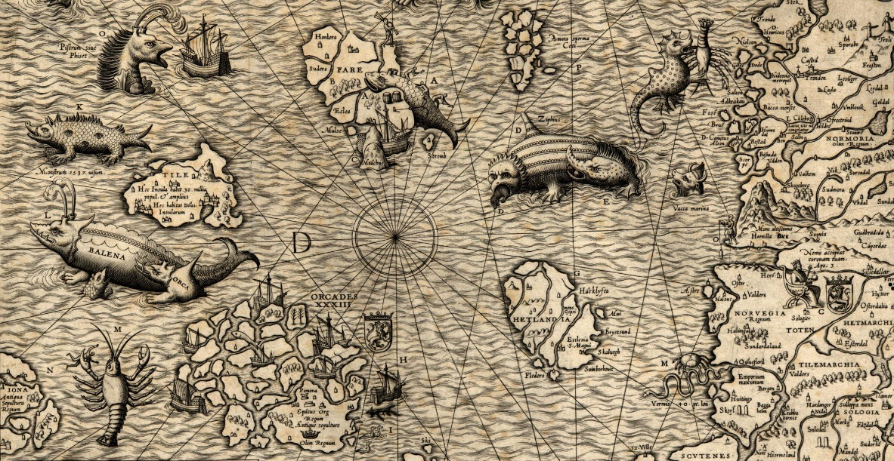
There was a time when the ocean was not a highway.
It was a boundary.
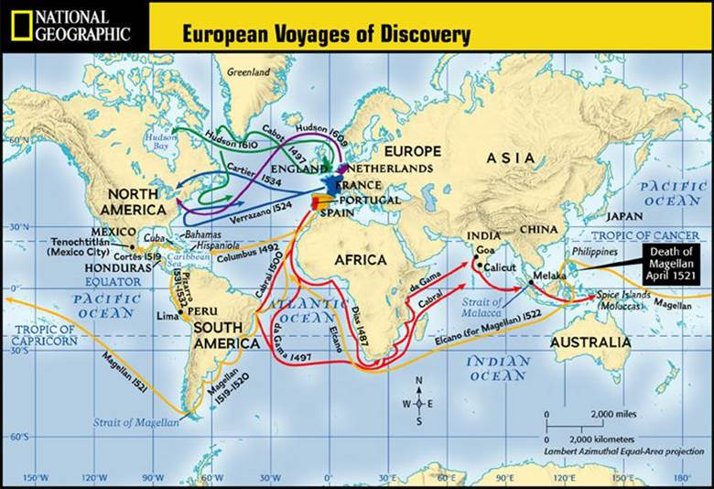
Beyond sight of land, sailors entered a world governed by wind, current, and educated guesswork. Maps dissolved into speculation. Storms arrived without warning. Food spoiled. Fresh water turned foul. And yet, over several centuries, a relatively small number of ships stitched the continents together.
The modern world was not built in conference rooms.
It was built on the decks of ships.
This is the story of the voyages that turned isolated regions into a connected planet.

Before Europe: The Ocean Was Already in Motion
European exploration did not begin the maritime story.
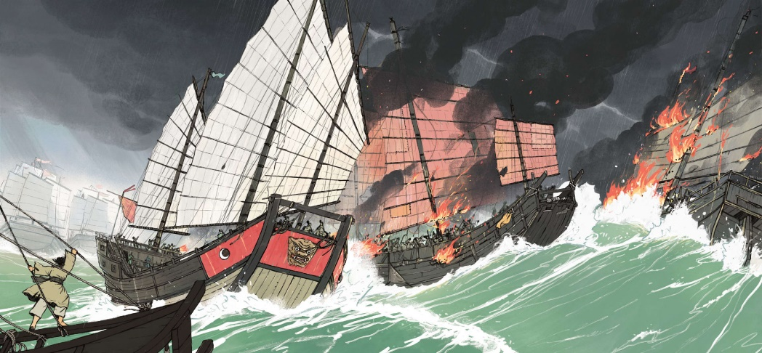
Between 1405 and 1421, the Chinese Admiral Zheng He commanded immense state-sponsored fleets across the Indian Ocean. His expeditions reached Southeast Asia, India, Arabia, and the east coast of Africa. The ships were large, well-organized, and politically backed. China demonstrated that long-distance maritime power was technologically possible and logistically sustainable.
After the Yongle Emperor’s death, however, the voyages stopped. The fleets were dismantled. China turned inward.
At the same time, Arab and Indian Ocean sailors were navigating predictable monsoon wind systems with sophistication. Seasonal winds allowed round-trip trade across vast distances. Maritime networks already linked East Africa, the Arabian Peninsula, India, and Southeast Asia.
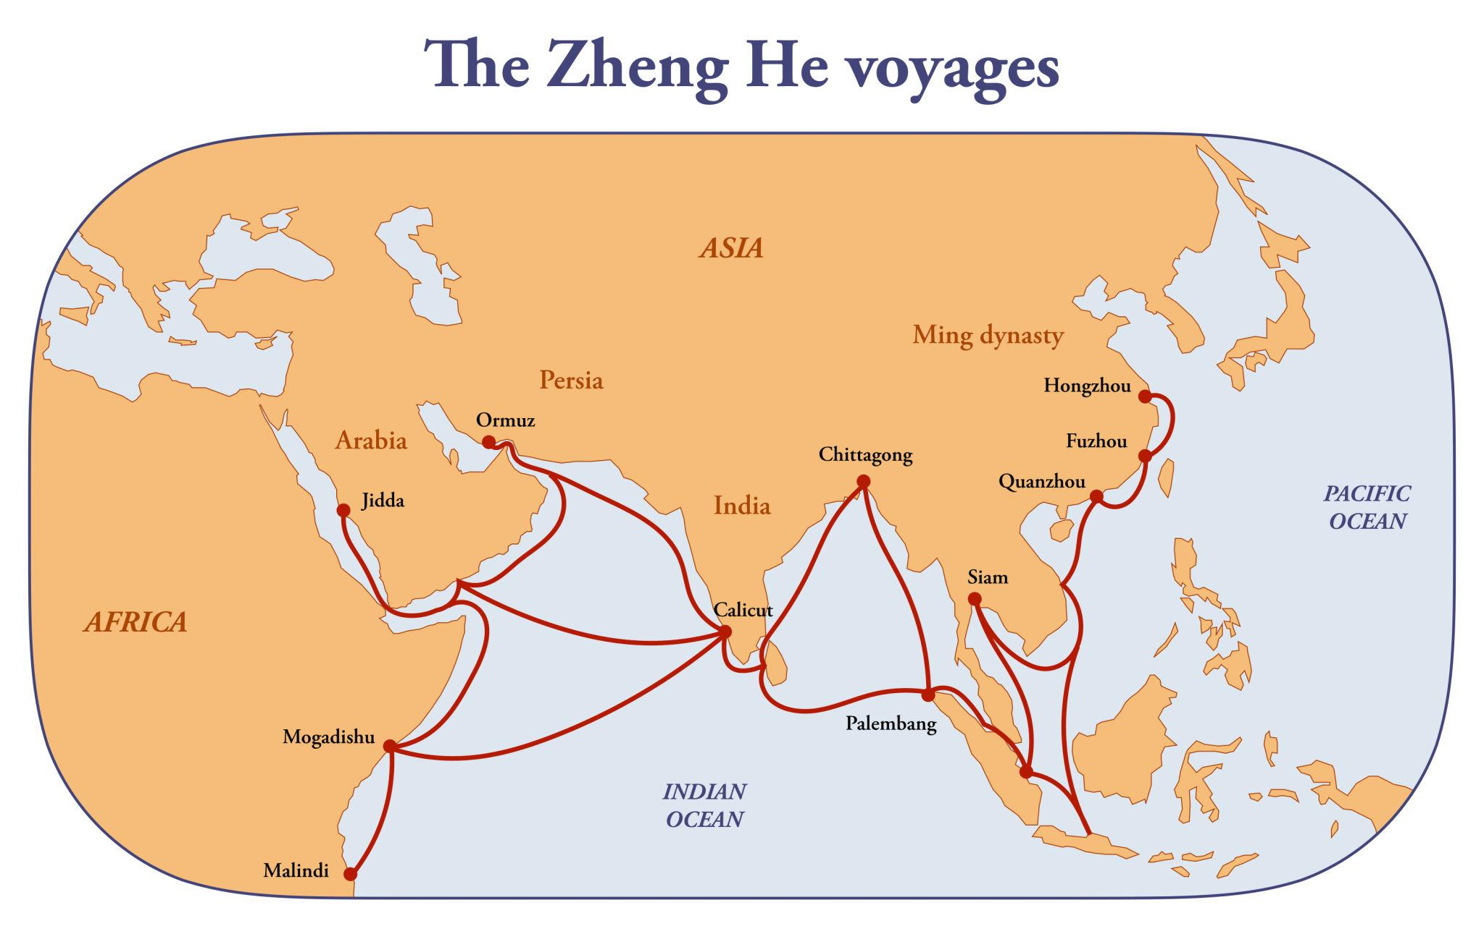
The ocean was not empty. It already carried commerce, language, and culture across predictable wind systems. Europeans did not invent global trade. They inserted themselves into it.
Some modern writers have suggested that Zheng He may have reached the Americas decades before Columbus. While the idea is intriguing, mainstream historians find no convincing documentary or archaeological evidence to support it. The established record places his voyages firmly within the Indian Ocean world.
Europe’s turn would come soon enough.

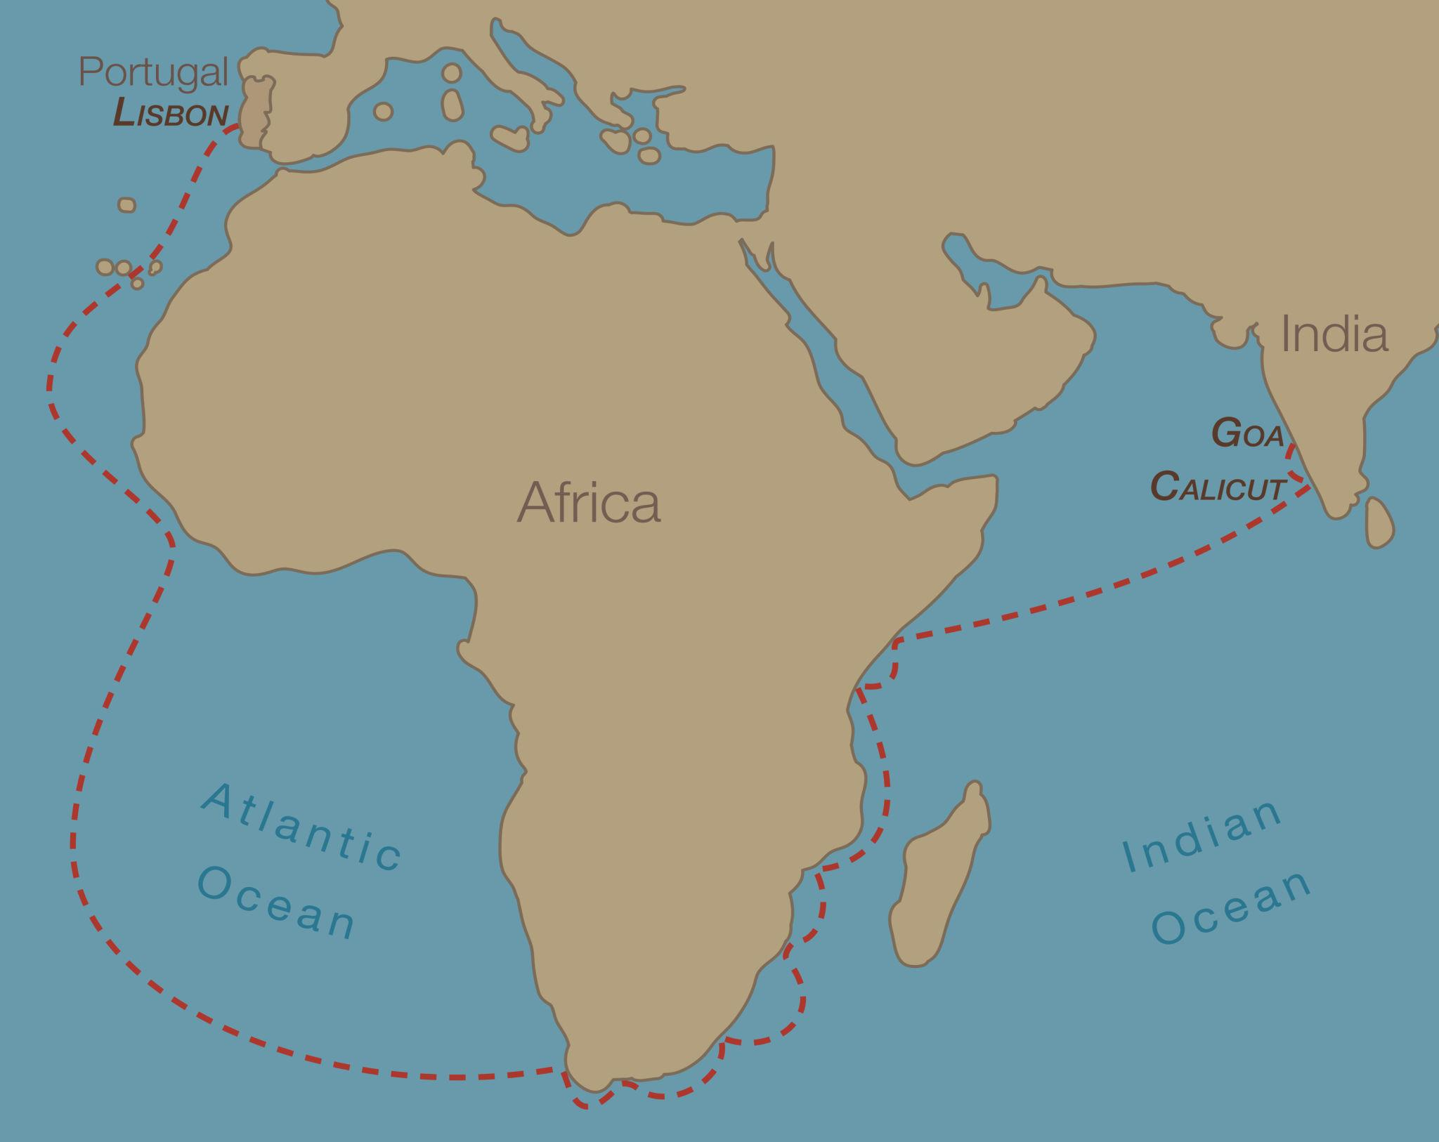
Portugal’s Long Patience
The European breakthrough did not arrive with a dramatic leap. It arrived with persistence.
Prince Henry of Portugal, known as Henry the Navigator, supported a sustained program of exploration down West Africa’s coastline in the early 15th century. These voyages were cautious and incremental. Each expedition moved a little farther south, correcting maps and gathering intelligence.
The caravel, a nimble vessel capable of sailing more effectively against the wind, proved critical. Combined with improved charts and instruments such as the astrolabe, Portuguese sailors slowly built confidence in open-ocean navigation.
In 1488, Bartolomeu Dias rounded the southern tip of Africa. He called it the Cape of Storms. The Portuguese crown renamed it the Cape of Good Hope, recognizing what it represented: access to the Indian Ocean by sea.
In 1498, Vasco da Gama completed the journey to India. With that voyage, Europe entered the Indian Ocean trade network directly. Fortified ports followed. Armed ships enforced commercial claims. Maritime reach became economic leverage.
The center of gravity in global trade began shifting toward the Atlantic.

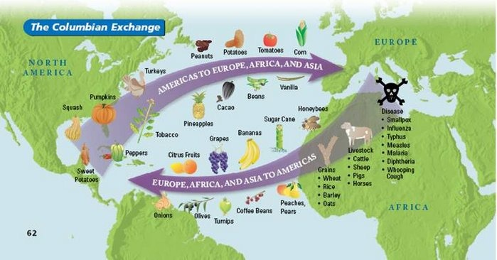
Columbus and the Atlantic System
Christopher Columbus did not prove the Earth was round. Sailors had long understood that. What he demonstrated in 1492 was a repeatable Atlantic crossing using prevailing wind systems.
By sailing southwest into the trade winds and returning via the westerlies, Columbus established a reliable maritime loop between Europe and the Americas. That wind pattern made sustained transatlantic travel possible.
The consequences were immense.
Ships began carrying crops, livestock, precious metals, and people across the Atlantic. What followed was not simply commerce. It was biological upheaval.
The Spanish reintroduced horses to the Americas, animals that had been extinct there for thousands of years. They brought cattle, pigs, sheep, and goats, reshaping landscapes and diets. Wheat and sugarcane followed, altering agriculture in regions that had never grown them.
The exchange moved in both directions. Maize, potatoes, tomatoes, cacao, chili peppers, and tobacco traveled east. The potato alone would become a staple across Ireland, Germany, and Russia, supporting population growth for generations. Chocolate, once consumed in Mesoamerica, entered European courts and then global markets.
Silver mined in the Americas crossed the Atlantic, then moved onward to Asia through Spanish trade networks, linking Europe, the Americas, and China in a continuous commercial circuit.
Disease traveled fastest of all. Smallpox and other pathogens devastated indigenous populations with catastrophic speed.
The Atlantic was no longer a dividing line.
It had become the central artery of a new global system.
None of this would have happened without mastery of wind and current.

Magellan and the Proof of Connection
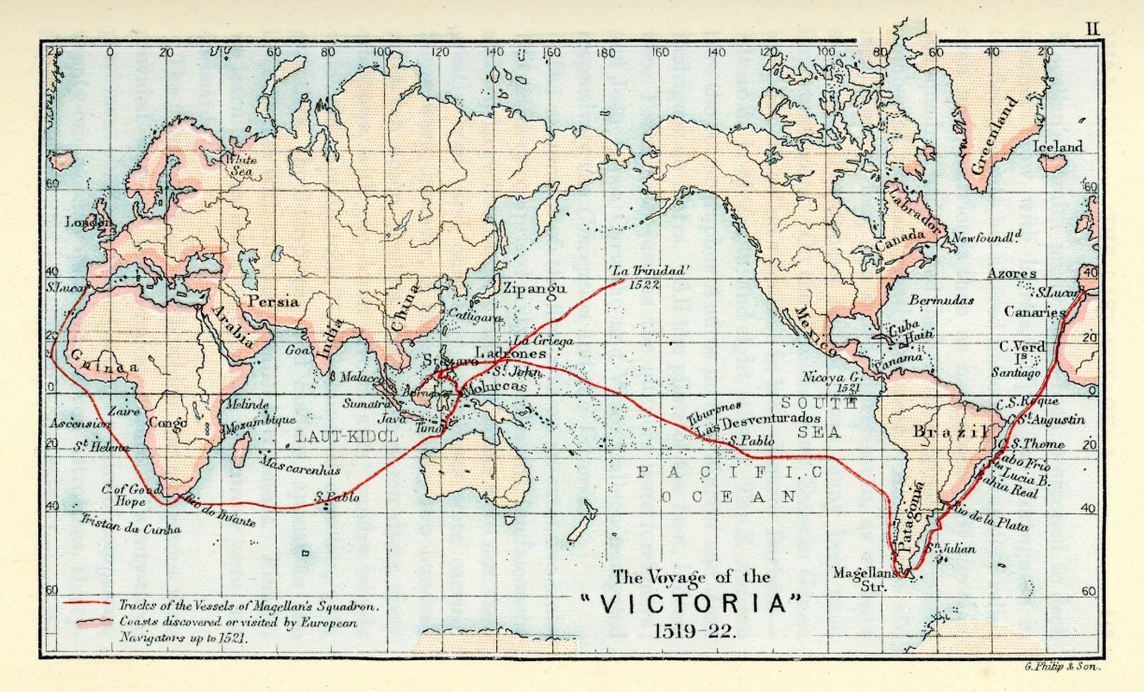
If Columbus linked two continents, Ferdinand Magellan proved that the oceans themselves formed a single system.
In 1519, Magellan sailed west from Spain seeking a route to the Spice Islands. After navigating the narrow strait at South America’s southern tip, his fleet entered the Pacific Ocean, vast and unforgiving.
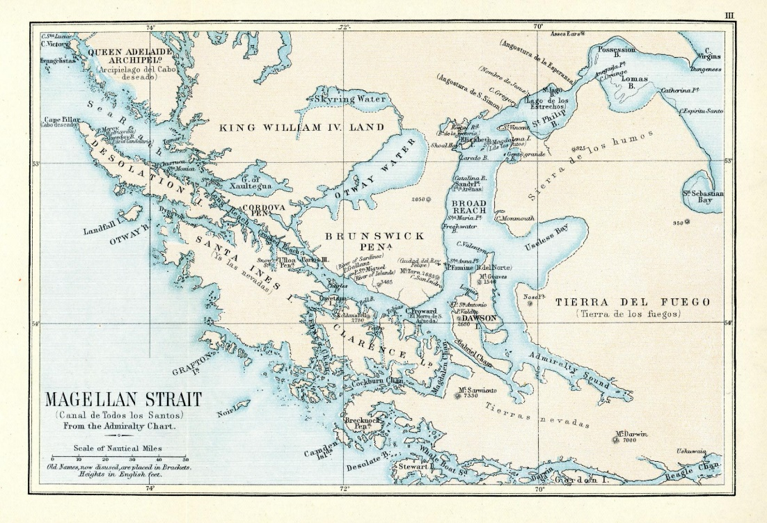
The crossing lasted months. Scurvy spread. Supplies dwindled. Magellan was killed in the Philippines. Yet in 1522, one surviving ship, the Victoria, returned to Spain.
The first circumnavigation of the globe was complete.
The Atlantic and Pacific were no longer separate arenas. They were connected waters. Maritime trade could now operate on a planetary scale.
The Earth was not simply round.
It was navigable.

The Manila Galleons: A Global Loop
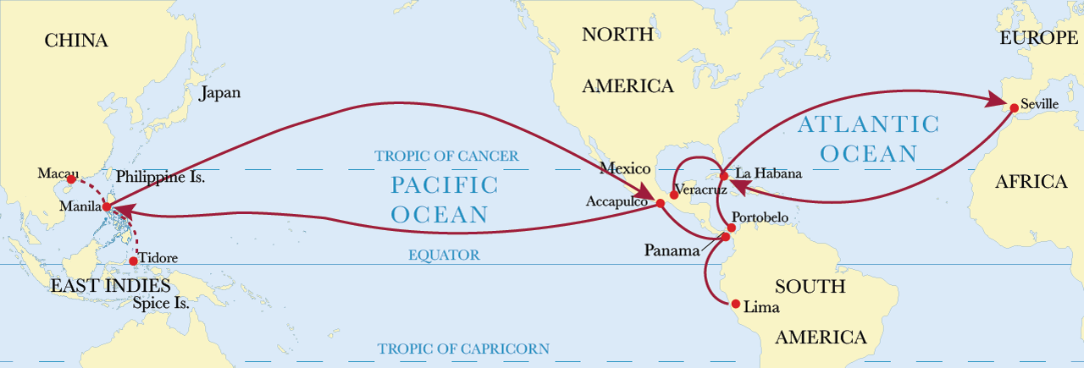
In 1565, Spain established a regular maritime route between Manila in the Philippines and Acapulco in Mexico. The Manila Galleons sailed annually across the Pacific for more than two centuries.
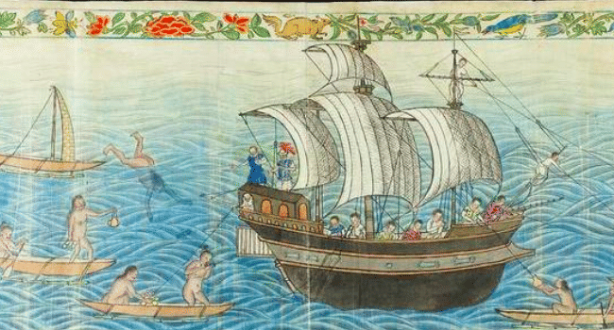
Silver from the Americas moved west to Asia. Silk and porcelain moved east toward Europe. Goods began circulating in a loop that encircled the globe.
This was globalization under sail.
The ships were enormous. The crossings were hazardous. But the route endured. For the first time, maritime trade connected three continents in a continuous commercial circuit.

Mapping the Pacific
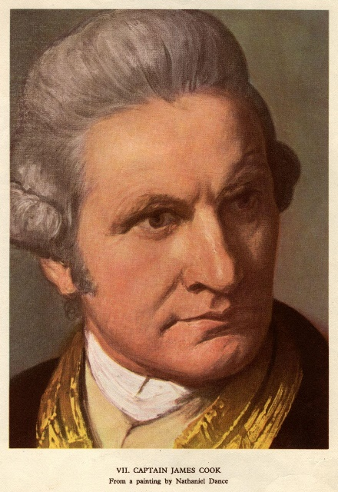
Even after early crossings, much of the Pacific remained poorly charted. Its size alone discouraged systematic exploration.
In the 17th century, Dutch explorers such as Abel Tasman sighted Tasmania and New Zealand. Yet vast stretches of ocean remained uncertain.
The decisive shift came in the 18th century with James Cook.
Cook was not simply a captain. He was a surveyor. Between 1768 and 1779, his three voyages charted the Pacific with remarkable precision. He mapped New Zealand completely, charted Australia’s eastern coastline, crossed the Antarctic Circle, and documented Hawaii. 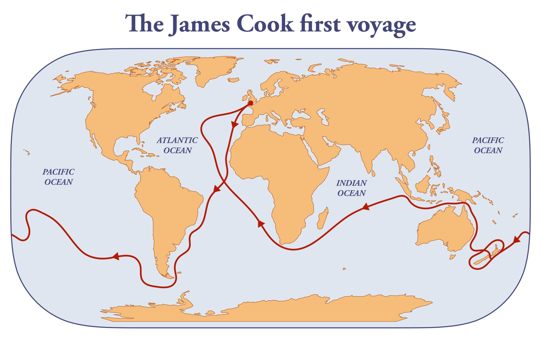
He carried astronomers and naturalists. He used John Harrison’s marine chronometer to determine longitude with unprecedented accuracy. For the first time, ships could reliably fix their east-west position at sea.
Navigation became scientific measurement.
Cook’s charts remained authoritative for decades. His strict dietary discipline dramatically reduced scurvy, transforming survival rates on long voyages.
When Cook was killed in Hawaii in 1779, the Pacific was no longer an uncertain expanse. It was a measured ocean.

Ships, Wind, and Power
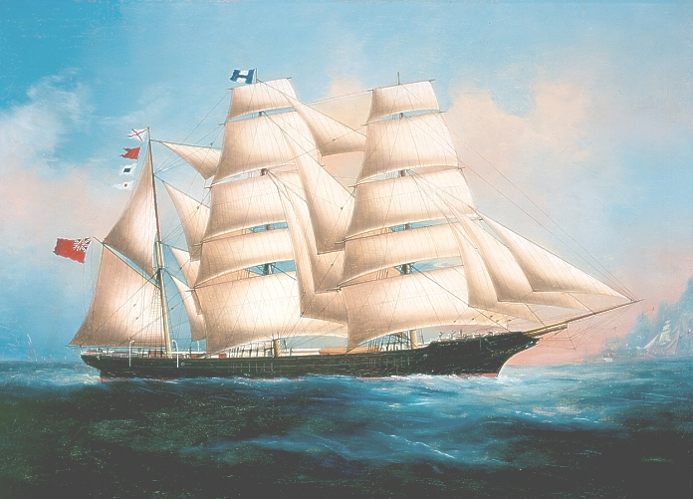
By the 19th century, the major sea routes were firmly established. The Atlantic, Indian, and Pacific oceans were no longer mysterious voids. They were interconnected arteries of commerce and empire.
Naval power enforced trade. Maritime knowledge enabled colonial expansion. Steam technology would soon reduce dependence on wind, accelerating global connection even further.
But the framework had already been built under sail.
The continents had been stitched together by ships guided by wind patterns, celestial navigation, and extraordinary endurance.
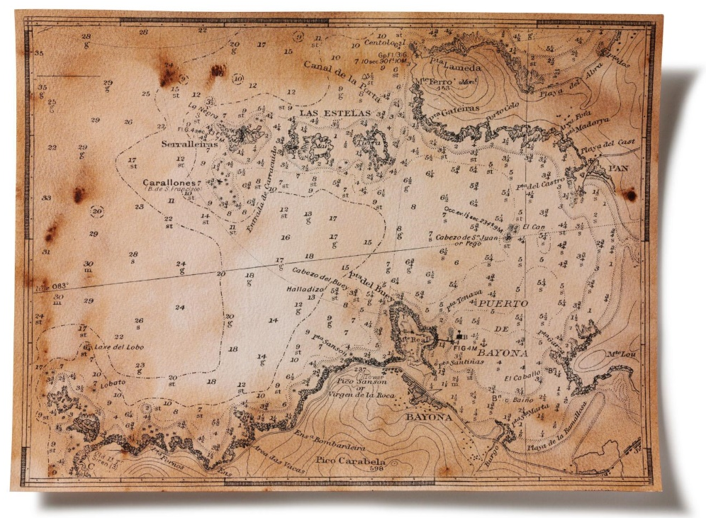
What the Sea Made Possible
The sea did not simply carry explorers.
It carried consequences.
Ocean routes enabled exchange, migration, and economic growth. They also enabled conquest, forced labor, and exploitation. The same maritime networks that carried spices and silver also carried enslaved people across the Atlantic.
The moral history of maritime exploration is not simple.
Yet without those voyages, there would be no integrated global economy, no rapid intercontinental exchange of goods and ideas, no shared awareness of the planet as a single system.
The modern world rests on sea lanes first mapped by hand, under canvas sails.
The ocean was once a boundary.
Ships turned it into a bridge.

Suggested Citations
Here is a clean citation list you can place at the end in Chicago Author-Date style:
- Boxer, C. R. 1969. The Portuguese Seaborne Empire, 1415–1825. New York: Alfred A. Knopf.
- Crosby, Alfred W. 1972. The Columbian Exchange: Biological and Cultural Consequences of 1492. Westport, CT: Greenwood Press.
- Fernández-Armesto, Felipe. 2006. Pathfinders: A Global History of Exploration. New York: W. W. Norton.
- Harrison, John. 1767. The Principles of Mr. Harrison’s Time-Keeper. London.
- Parry, J. H. 1963. The Age of Reconnaissance. Berkeley: University of California Press.
- Schottenhammer, Angela, ed. 2019. Early Global Interconnectivity across the Indian Ocean World. Cham: Springer.
- Sobel, Dava. 1995. Longitude. New York: Walker & Company.
- Spate, O. H. K. 1979. The Pacific since Magellan. Minneapolis: University of Minnesota Press.
- Subrahmanyam, Sanjay. 1997. The Career and Legend of Vasco da Gama. Cambridge: Cambridge University Press.

