Chapter 7: Do Your Research: Is Your Business Needed?

Research is crucial to determine whether your business idea fills a real market need. Learn how to analyze your target audience, assess competitors, and identify gaps in the market.
Starting a business can feel like embarking on a grand adventure. But let’s be clear: even the most exciting journey requires preparation. You wouldn’t set out on a road trip without a map or at least a good GPS. Research is your roadmap, ensuring that your business idea has the fuel it needs to succeed. This chapter helps you build that map, guiding you through market demand, customer needs, and your competitive landscape.
You might think you have the greatest idea in the world, a product or service so unique and groundbreaking that success feels inevitable. But here’s the truth: the world doesn’t care how great you think your idea is. It only cares if it’s useful, needed, or wanted. The only way to know for sure is to do your research.
I’ve seen businesses fail, not because the ideas weren’t clever, but because the people behind them didn’t stop to ask, “Is there really a market for this?” Let’s break down how you can avoid becoming a cautionary tale by conducting thorough, actionable research.
Business Research and Tools Guide: A Global Perspective
Why Research Matters
Research forms the bedrock of any successful business venture. Think of it as laying the foundation of a house – without it, everything built above risks collapse. When you undertake thorough research, you gain crucial insights into your potential customers, market demand, competitive landscape, and your unique value proposition.
Starting a business indeed feels like embarking on an exciting adventure, but even the most thrilling journey needs careful preparation. Just as you wouldn't set out on a cross-country trip without consulting a map or GPS, you shouldn't launch a business without proper research to guide your way.
Global Research Impact Stories
Success and failure in business often hinge on the quality of initial research. Consider M-PESA's triumph in Kenya, where they succeeded by deeply understanding how Kenyans actually transferred money, rather than imposing Western banking models. Their research revealed that mobile payments aligned perfectly with existing social practices, leading to widespread adoption.
Contrast this with Tesco's Fresh & Easy venture, where the British retail giant attempted to enter the US market without fully understanding American shopping habits. Despite substantial investment, they misread crucial aspects of American consumer behavior, leading to their eventual withdrawal from the market.
The Research Process

Understanding the market begins with immersion in your industry. Talk to potential customers, study industry trends, and analyze what existing businesses are doing right or wrong. Modern entrepreneurs have an advantage: digital tools allow for gathering insights from social media conversations, mobile app usage patterns, and online consumer behavior.
When validating your business idea, consider both digital and physical approaches. A well-designed landing page can test market interest before significant investment, while pop-up stores or market stalls provide direct customer feedback. The key is gathering real-world data to support or challenge your assumptions.
Financial Feasibility
Understanding the numbers requires a clear-eyed look at both startup and operating costs. Consider everything from rent and utilities to digital infrastructure and payment processing fees. Regional variations can significantly impact your bottom line – what works financially in one market might be unsustainable in another.
For instance, a coffee shop owner in Seoul faces very different cost structures than one in Seattle. Property costs, labor regulations, and even coffee consumption patterns vary dramatically between markets. Your financial analysis should reflect these regional realities.
Digital Presence and Mobile Strategy
In today's business landscape, your digital presence often serves as your first impression. This goes beyond having a website – it encompasses your entire digital ecosystem. Consider how customers will find you online, how they'll interact with your business through mobile devices, and how you'll process digital payments.
Different regions show distinct preferences in digital engagement. Asian markets often emphasize super apps and mobile payments, while European customers might prioritize privacy and data protection. Understanding these nuances helps shape your digital strategy.
Tools for Success
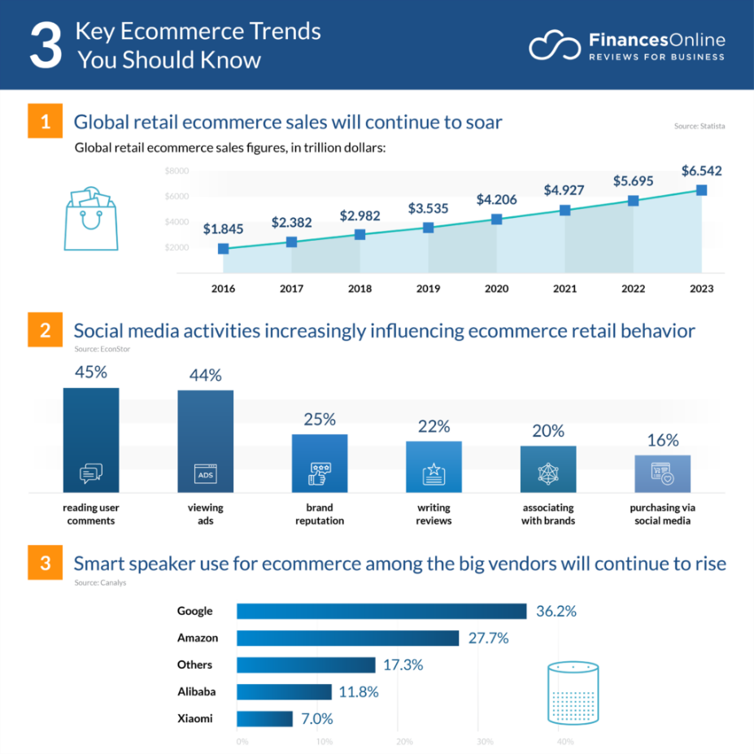
Modern entrepreneurs have access to an impressive array of tools across various price points. Starting with market research, tools like Google Trends offer free insights into consumer interests, while professional platforms like SEMrush provide deeper analysis at premium prices ranging from $119.95 to $449.95 monthly.
For business planning, options span from free SCORE templates to comprehensive platforms like LivePlan at $20-40 monthly. Financial management similarly offers choices from Wave's free accounting software to QuickBooks' tiered solutions ranging from $30 to $200 monthly.
Action Plan
The path to launching your business follows a natural progression. Start with thorough research, gathering insights about your market and potential customers. Move into planning, where you'll develop your strategy and select appropriate tools. During launch, focus on implementing your plans while gathering feedback. As you grow, continuously optimize based on real-world data and customer responses.
Final Thoughts
Success in modern business requires a balanced understanding of both traditional and digital marketplaces. Whether you're launching locally or globally, consider how digital transformation affects your industry and prepare to adapt your strategy accordingly.
Remember that research isn't a one-time task but an ongoing process. Markets evolve, customer preferences shift, and new technologies emerge. The most successful businesses stay attuned to these changes, ready to adapt and grow as circumstances demand.
Your ability to understand and respond to market conditions, coupled with wise use of available tools, will significantly influence your success. Take the time to research thoroughly, plan carefully, and execute thoughtfully. The future of your business depends on it.

