Chapter 6: Do You Truly Want to Run a Business?
Running a business requires commitment, resilience, and the ability to adapt. This chapter helps you evaluate whether entrepreneurship aligns with your skills and lifestyle.
This may sound like a stupid question, but it counts. Is owning your own business something you have always wanted to do? Do you have a real desire to be on your own? That means you make all the critical decisions and are responsible for everything good and bad that happens in your business. Are you prepared to risk your own money, time, and effort for your business?
Do you have a great idea of a product, service, or business type that you REALLY want to own and operate? Perhaps, you just don’t play well with others. Think long and hard on this before you attempt to open your own business.
I have known for many years that I just don’t like working for someone else. I have always been very independent. But never really thought that what I wanted to do was run a business. For me, it just sort of happened. Probably because I was a terrible employee. I never took directions well and usually felt that I knew how to run the company better than my bosses.
My cousin Dennis was a month younger than I am. Dennis had always been a high school teacher. He made the decision when he was in college that he wanted to teach. From what I heard, from other sources, he indeed, was very good at his chosen life’s work. Dennis and I, however, were very different. He liked or perhaps needed job security, while I never even considered it.
I remember a conversation we had about 30 years ago. He asked me “how I did It”. I didn’t understand what he was asking. So, I asked him what he meant, how I did what? His response was, “I get a check every two weeks, but you don’t know when or if your next check is coming. How do you do it?” I thought about what he said and realized that wasn’t anything I had ever worried about. I have a personality that has always been able to make money. If I needed something I would figure out a way to earn it somehow. If money security is an issue for you, then perhaps owning your own business may not be for you.
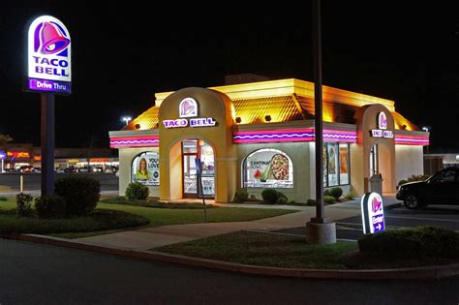
At one point in my life, I needed to get an actual job. My second wife was seeking a divorce and have frozen all may assets, so in desperation I took a job as a management trainee at Taco Bell. I actually enjoyed the interaction with customers and staff and found it to be a very simple job. I didn’t consider it as a career or a forever job, but it served its purpose. I also learned something about corporate culture from that experience. It was that few months of working for someone else, that I realized I really didn’t like it very much and realized I was much better off running my own business.

Know Before You Go
Starting a business without the proper knowledge or skills is a recipe for frustration and failure. If you haven’t been to medical school, you wouldn’t perform surgery. If you haven’t completed law school, you wouldn’t open a law office. Yet, far too often, aspiring entrepreneurs dive into ventures without the background needed for success.

The difference between wanting and needing to start a business is critical. While the desire to become your own boss is admirable, success requires more than passion, it demands preparation. Take a close look at your skills, education, and experience before investing your time and money.
The Role of Training and Certification
Once you’ve chosen a business idea, consider pursuing training or certification. Hundreds of years ago, aspiring blacksmiths or carpenters apprenticed with masters of their craft. Today, we have trade schools, workshops, and online courses that serve the same purpose.
For me, the journey began with an informal apprenticeship. When I was a sophomore in college, I started hanging out at Stereo Mart in Tarzana, where the store manager, Glen Yingling, encouraged my interest in audio equipment. He gave me hands-on tasks, like building speakers, which I initially approached with no experience. Over time, I gained the technical skills and knowledge that would become the foundation of my career.
As my career progressed, I attended over 300 training seminars on subjects ranging from technology to business practices. I hung these certificates behind the sales counter of my store as visible proof of my expertise. They weren’t just decorations; they were tools that built credibility with customers and inspired confidence in my team. I also, encouraged my sales staff to attend as many of the training seminars that were offered and paid them for their attendance. Upon completion of a course, I would frame and hang their credentials on the wall alongside mine. I took pride in having some of the most qualified sales people in my industry working alongside of myself.
Even today, years after my official retirement, I continue to attend seminars and take online courses. I firmly believe that if you’re not learning, you’re not growing.

Why Credibility Matters
Credibility is one of the most valuable assets a business owner can have. It’s not just about your knowledge, it’s about how that knowledge is perceived by your customers, staff, and even competitors. When customers walked into my store and saw the wall lined with certificates, they immediately knew they were dealing with professionals. These certificates weren’t just pieces of paper; they were tangible proof of the effort and commitment we invested in understanding our craft.
For customers, this visual evidence of training wasn’t just impressive, it was reassuring. It gave them confidence that we knew what we were talking about and that we could help them make informed decisions. In a marketplace crowded with options, credibility became the factor that set us apart from competitors. People want to do business with those they trust, and trust is built on the foundation of demonstrated expertise.
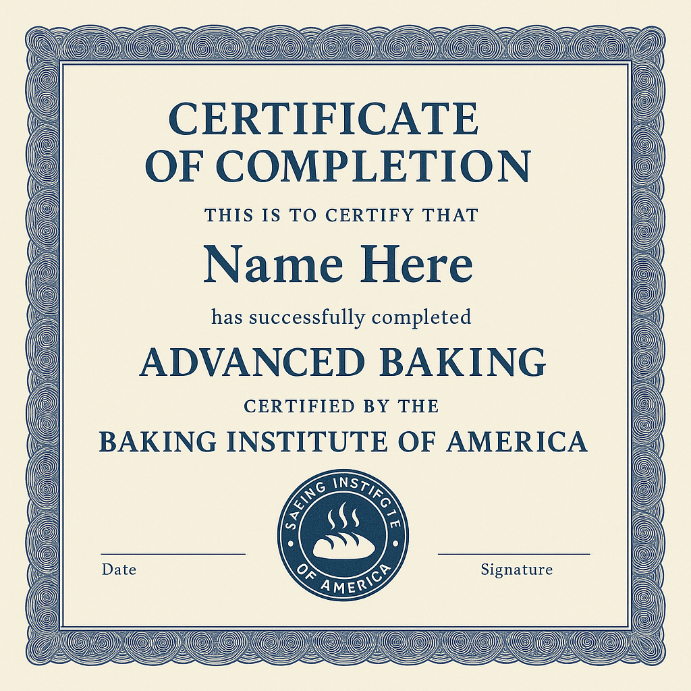
But credibility isn’t just outward-facing. Sharing what I learned with my staff amplified the impact. When my team attended training sessions, they not only gained new skills but also felt empowered and valued. This created a culture of learning within the business, where everyone, from the newest hire to the most experienced employee, was constantly improving. Customers could sense this expertise and teamwork, further solidifying their trust in us as a brand.
In addition to inspiring customer confidence, credibility opens doors in the industry. Over the years, I was invited to collaborate with manufacturers, test new products, and even offer feedback on designs. This wasn’t because I was the biggest retailer in the market; it was because my commitment to education and expertise had earned me respect in the industry.
Credibility also builds resilience. When challenges arise, whether it’s an unhappy customer, a difficult sale, or a rapidly evolving market, your reputation as a knowledgeable professional can carry you through. Customers are more likely to be patient, forgiving, and loyal when they know you’re genuinely invested in providing the best possible service or product.
Education doesn’t just elevate you, it elevates your entire business. It communicates to customers, employees, and partners that you’re committed to excellence. Every certificate, every training, and every piece of knowledge you gain tells the world: “I take this seriously, and I’m here to provide the best.” That’s why credibility matters, it’s the bridge between what you know and how much others trust you to deliver.

Never Stop Learning, Never Stop Teaching
Lifelong learning is crucial to staying relevant and successful in any business. Equally important is sharing that knowledge. By mentoring your staff and contributing to your industry, you’re not only advancing your business but also leaving a lasting impact on the people around you.
Whether it’s through certifications, hands-on experience, or mentoring others, knowledge is the foundation of a successful business. Keep learning, keep growing, and keep teaching.

