
Chapter 5: Identifying Viable Business Ideas
Finding a good business idea requires research and creativity. Use your skills, interests, and market research to identify opportunities. This chapter offers practical steps and examples to help you pinpoint a business idea that’s both profitable and fulfilling.
Embarking on a new business venture requires careful consideration of various factors to ensure its viability and alignment with your personal strengths and passions. Here's a streamlined guide to help you identify a promising business idea:
Self-Assessment Questions:
What do you love to do?
Engaging in a business that aligns with your passions can make the hard work more fulfilling.
What do you dislike doing?
Avoid starting a business that involves tasks you find unpleasant, as this can lead to frustration.
What problems can you solve?
Identifying common frustrations or unmet needs can lead to successful business ideas that improve life for others.
What are your natural talents?
Leveraging skills that come easily to you can form a strong foundation for your business.
What do people seek your advice for?
If others frequently consult you on certain topics, it may indicate an area of expertise worth exploring.
What’s a dream project you’ve always wanted to pursue?
Consider if starting a business could bring a long-held dream to life.
Reflecting on these questions can help solidify your business concept and ensure it aligns with your capabilities and aspirations.
Characteristics of a Good Business Idea:
Minimal Promotion Costs:
Utilize social media platforms like Facebook, Twitter, and YouTube to promote your business with minimal expenses.
Low Training Requirements:
Choose a business that leverages your existing expertise to reduce the need for additional training.
Low Initial Setup Costs:
Opt for businesses that require minimal investment, such as online ventures or services that can be operated from home.
Online Presence:
Online businesses offer flexibility, lower overhead costs, and the ability to operate alongside other employment.
Minimal Inventory Needs:
Consider service-based businesses or models like drop-shipping to avoid the complexities of inventory management.
Manageable Staffing Requirements:
Start with a business that you can manage independently or with minimal assistance to control costs.
Popular Business Ideas:
Here are some business ideas to consider:
Service-Based Businesses:
Virtual assistance, online tutoring, career coaching, and consulting services. E-commerce Opportunities:
Drop-shipping, print-on-demand, handmade products, and niche online stores.
Digital Services:
Content writing, social media management, web design, and app development.
Home-Based Ventures:
Home-based catering, dog walking, and personal shopping.
Remember, these are suggestions to inspire your thinking. It's crucial to choose a business that aligns with your passions and strengths.
Business Ideas to Avoid:
While exploring potential ventures, it's equally important to recognize business ideas that may pose significant challenges or have a high likelihood of failure. Here are some examples:
Non-Proprietary SaaS Products:
The software-as-a-service (SaaS) market is saturated, and entering it without a unique, proprietary offering can lead to failure due to intense competition and low entry barriers.
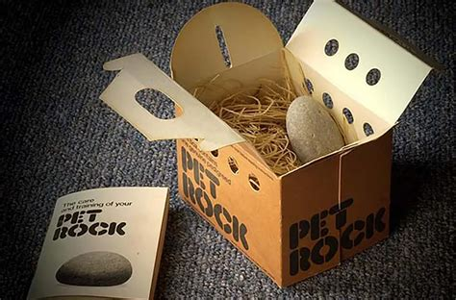
E-commerce Stores Selling Other Brands' Products:
With the rise of direct-to-consumer (D2C) models, many brands are bypassing retailers. Starting an e-commerce store that sells other brands' products can result in low margins and stiff competition from established players.
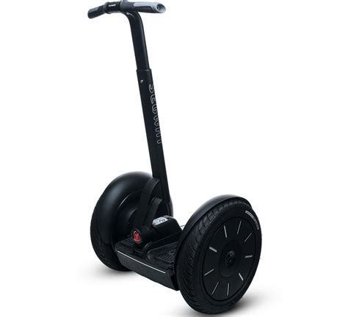
Businesses that rely on recruiting others to make money, rather than selling a legitimate product or service, are unsustainable and often illegal. They tend to collapse, leaving the majority of participants at a loss.
Novelty Products with No Long-Term Value:
Products like the Pet Rock gained rapid popularity but lacked lasting value, leading to their quick decline. Building a business on a fleeting trend can result in short-lived success.
Overly Ambitious Technological Innovations Without Market Need:
Products like the Segway, which aimed to revolutionize personal transport, failed to achieve widespread adoption due to high costs and a lack of practical utility for most consumers.
Avoiding these types of business ideas can save you time, resources, and potential legal issues. Focus on ventures that offer genuine value, have a clear target market, and align with your skills and passions.
Selecting the right business idea involves a thorough self-assessment, understanding market demands, and being aware of common pitfalls. By carefully considering these factors, you can increase your chances of building a successful and fulfilling business.

