Chapter 3: Planning for Success
A well-thought-out plan is the foundation of a successful business. Planning helps you anticipate challenges, allocate resources, and set clear objectives. Whether it’s financial planning or creating milestones, this chapter will guide you through building a strong foundation.

Starting a business without a plan is like baking cookies without a recipe, sure, you might get something edible, but it’s probably not going to be the gourmet treat you were hoping for. A good business plan is your recipe for success. It helps you organize your thoughts, identify potential challenges, and figure out what ingredients (resources) you need to turn your dream into
reality.
But before you even start writing down your plan, it’s important to take a step back and evaluate your business environment. This means looking at what you have going for you, what might hold you back, what opportunities you can seize, and what threats are lurking around the corner. This is where a SWOT analysis comes in.
What Is a SWOT Analysis?
A SWOT analysis helps you take a good, hard look at your business by breaking down its:
- Strengths: What are you already doing well? What resources or assets give you an advantage?
- Weaknesses: What could you improve? Are there gaps in your team or processes that need addressing?
- Opportunities: What trends or market needs could you take advantage of? Are there untapped markets or new customer needs that you could fill?
- Threats: What external factors could pose a risk to your business? This could include competitors, changes in regulations, or even economic downturns.
This methodical approach allows you to gain a clearer understanding of where your business stands and how you can position it for success. It’s like scouting out the entire playing field before the game begins.
Conducting Your Own SWOT Analysis
To help you get started, let’s break down each section of a SWOT analysis in detail.
Strengths
Your business’s strengths are the unique advantages you bring to the table. They’re the internal factors that set you apart from the competition. These could be your skills, your team, your technology, or even your brand reputation.
Ask yourself:
- What is our strongest asset?
- What unique skills or knowledge does our team have?
- What resources can we leverage that others can’t?
- Do we have an innovative product or service?
- What processes are we already doing right?
Weaknesses
Every business has weaknesses, and recognizing them early on allows you to address them before they become roadblocks. These are the internal factors that could hinder your growth or make you vulnerable to competitors.
Ask yourself:
- What gaps do we have on our team?
- What are we missing that we need to stay competitive?
- What business processes or systems need improvement?
- Are there technological upgrades we’ve been putting off?

Opportunities
Opportunities are the external factors that could help your business grow. These could be market trends, new customer needs, or even changes in the regulatory environment that benefit your business.
Ask yourself:
- Is there an unmet need in the market that we could address?
- What trends or shifts could we take advantage of?
- Are there partnerships or collaborations that could help us expand?
- Could we improve our pricing or offer additional products/services?
Threats
Threats are the external challenges that could hurt your business. These might include competitors, market saturation, or changes in customer preferences. Identifying these threats helps you prepare and create strategies to mitigate risks.
Ask yourself:
- Are our competitors releasing new products or improving their services?
- Could changes in regulations impact our business?
- Are we overly dependent on a single customer, supplier, or product?
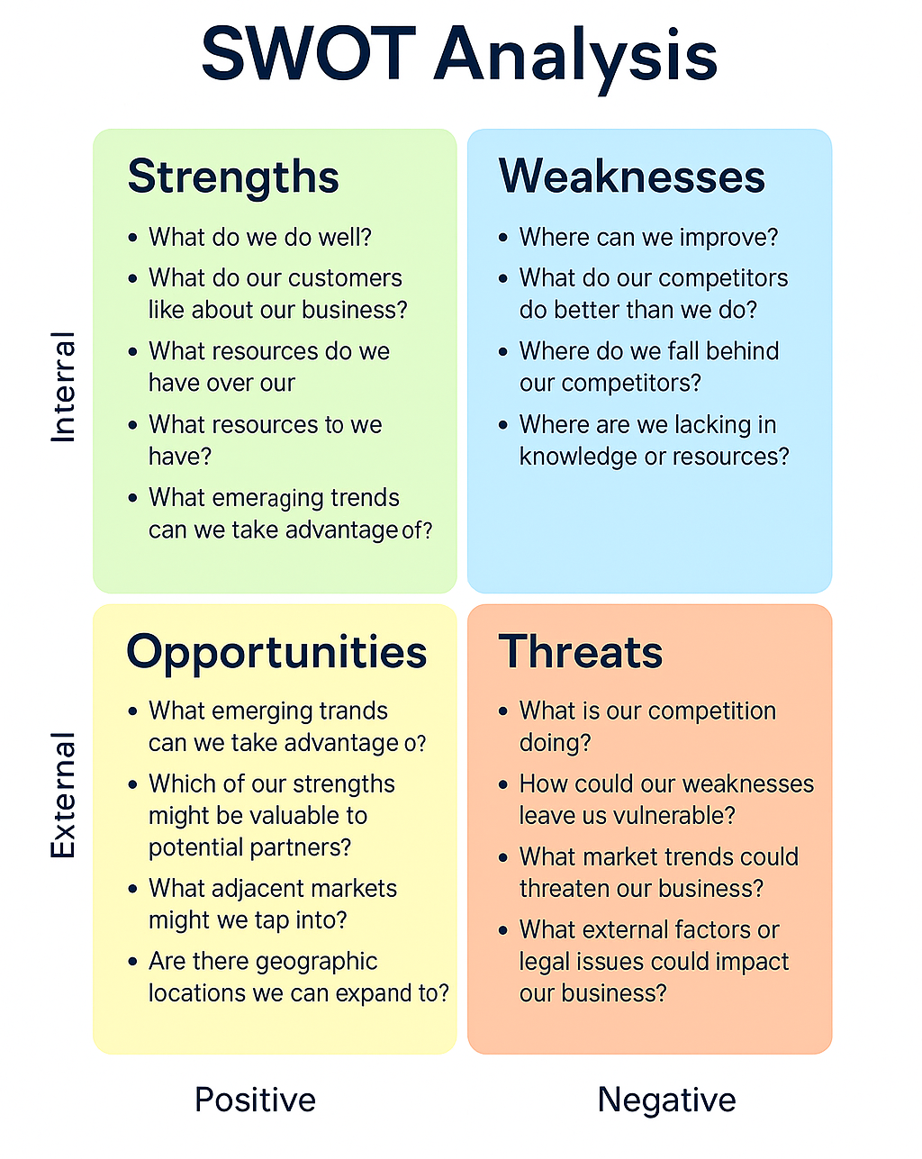
- What happens if there’s an economic downturn or supply chain disruption?
Now, to put this all together, here’s a simple chart that you can fill in to help organize your thoughts. Use this template as a starting point for your SWOT analysis:
SWOT Analysis Template
Why Your SWOT Matters
Conducting a SWOT analysis early on will give you a clear picture of where your business stands and how you can move forward. It will help you make informed decisions about everything from marketing strategies to financial planning.
Think of it like making your dough before you start shaping your cookies. Once the dough is ready (you know your strengths, weaknesses, opportunities, and threats), you can start forming your business into something that has the best chance of coming out perfectly baked.
So, take the time to fill out your SWOT analysis. Be honest with yourself and your business. This tool will serve as a solid foundation for the decisions and strategies you’ll need as you build and grow your business.
Moving Forward: Turning Strategy into Action
Once you’ve completed your SWOT analysis, use the insights to set actionable goals. For example:
- How can you leverage your strengths to overcome weaknesses?
- What steps can you take to capitalize on opportunities while defending against threats?
A solid business plan built on a thorough SWOT analysis will help you stay focused and give you a roadmap to success.

