Chapter 22: Sales and Turns Per Year:
Keeping Your Business Profitable
When you're running a cookie business (or any business), one of the critical factors to watch is how quickly you can sell your products and restock (or "turn") your inventory. Turns per year is a crucial metric that tells you how many times you sell through and replace your inventory within a year. This might sound a little technical, but it boils down to this: the more frequently you sell out and restock, the more money you're making. But there’s a balance to strike depending on your business type.
In this chapter, we’ll break down what turns per year means, the math behind it, and why different types of businesses have different turn requirements to
stay profitable.
What Are Turns Per Year?
In simple terms, turns per year refer to how many times your inventory (or stock) sells out and is replaced within a year. If your business sells out of its entire inventory and restocks once every month, you’re turning your inventory 12 times a year. If it takes longer—say you restock every three months—your business has a turn rate of 4 per year.
For a cookie business, "turns" would mean how quickly you can sell through a batch of cookies and make (or order) more.
Why Do Turns Matter?
Turns are all about cash flow and profitability. Every time you sell your inventory; you’re converting products into revenue. The faster you can do this, the faster you can generate profit and reinvest into your business.
Different businesses need different turn rates to stay profitable. For example, businesses selling high-margin, luxury products (like designer clothing or electronics) can survive with fewer turns because their profits per sale are high. But low-margin, high-volume businesses (like grocery stores or fast-food joints) need rapid turnover to stay in the game.

Cookie Business Example
Let’s break down an example to illustrate inventory turnover. Imagine you run a cookie shop, and over the course of a year, you sell $60,000 worth of cookies. This figure represents your Cost of Goods Sold (COGS). On average, you keep about $10,000 worth of cookies and ingredients in stock at any given time. This is your Average Inventory Value.
Now, using the formula for inventory turnover, we can calculate your turns per year:
The Math Behind Turns Per Year
To calculate your turns per year, you need two key numbers:
- Cost of Goods Sold (COGS) – This is the total cost of all the products you’ve sold over a certain period (like a year).
- Average Inventory Value – The average amount of inventory you have on hand during the same period.
Here’s the formula:
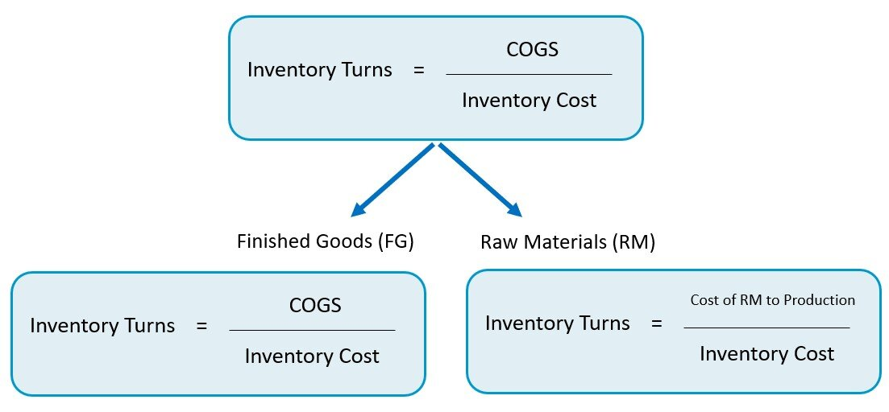
Let’s walk through an example using a cookie business.
Cookie Business Example:
You run a cookie shop and over the course of a year, you sell $60,000 worth of cookies (this is your COGS). On average, you keep about $10,000 worth of cookies and ingredients in stock at any given time (your Average Inventory Value).
Now, plug those numbers into the formula: 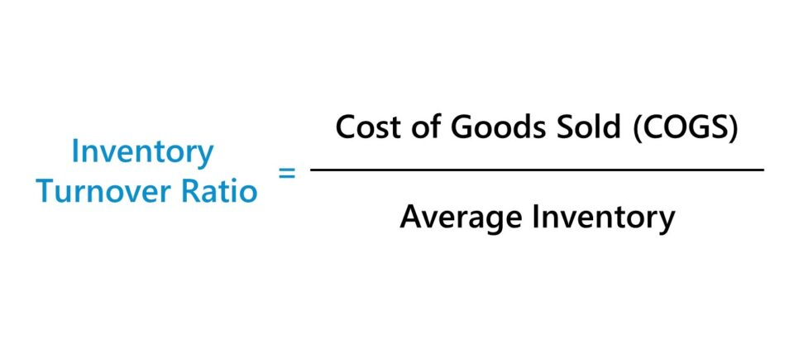
Inventory Turnover (Turns per Year):
To calculate how many times you sell and replace your inventory in a year, divide the total cost of all the goods you sold during the year (COGS) by the average value of the inventory you keep on hand.
Example:
If you sell $60,000 worth of cookies in a year and typically keep $10,000 worth of cookies and ingredients in stock, you divide $60,000 by $10,000. The result is 6, meaning you completely sell through and restock your inventory six times a year.
Why Does This Matter?
Understanding inventory turnover is critical for managing your business effectively. A higher turnover rate indicates that you’re selling inventory quickly, which is often a sign of strong sales and efficient stock management. For example, if your cookie shop is consistently restocking every two months, it means you’re aligning your inventory levels with customer demand.
On the other hand, a lower turnover rate might suggest that you’re overstocked or that sales are slow. This could lead to waste, especially in a business like a cookie shop where inventory can spoil.
By tracking your inventory turnover, you can:
- Optimize Stock Levels: Avoid overstocking or understocking.
- Improve Cash Flow: Sell inventory faster to free up cash for other expenses.
- Identify Trends: Spot seasonal fluctuations in demand and adjust accordingly.
- Enhance Profitability: Efficient inventory management reduces storage costs and waste.
In short, monitoring your inventory turnover helps ensure your business is running smoothly and profitably. It’s a key metric for identifying strengths and areas for improvement in your operations.
How Do Turns Affect Profitability?
The number of turns directly affects your cash flow and profitability. Let’s break this down for different types of businesses and what their turn rates mean.
1. High-Turn Businesses (Fast Turnover)
Examples: Grocery stores, fast food restaurants, and low-margin, high-volume businesses.
These businesses rely on high turnover because their margins per product are thin. A fast-food restaurant, for example, needs to sell a lot of burgers every day to stay profitable. With each burger sold, they make a small profit, but they need to sell thousands to keep the business running.
High-Turn Example:
If your cookie business runs on low-margin sales—maybe your cookies cost $2 to make but you only sell them for $3—your profit margin is just $1 per cookie. To make enough money, you need to sell a lot of cookies, meaning you need fast turns. Maybe you’re selling and restocking inventory every week, meaning 52 turns per year. The faster you can sell, the more profits you can stack up over the year.
2. Low-Turn Businesses (Slow Turnover)
Examples: Jewelry stores, high-end clothing boutiques, and luxury car dealerships.
Low-turn businesses deal in high-margin products, meaning they make a lot of profit on each sale. A jewelry store might only sell a handful of diamond rings each month, but because the profit margin is so high on each ring, they don’t need to turn inventory quickly.
Low-Turn Example:
If your cookie business sells gourmet cookies for $20 each (and it only costs you $5 to make each cookie), your profit margin is $15 per cookie. In this case, you don’t need to sell hundreds of cookies a week to stay profitable. Even if you only sell a few batches per month (say 4 turns per year), the high profit per sale keeps your business afloat.

What’s the Right Turn Rate for Your Business?
The right number of turns depends on your business model and profit margins. Let’s compare how different turn rates affect businesses.
- Fast-Turn Model (High Volume, Low Margin):
If you’re selling basic cookies at a low price, you’ll need fast turnover to generate enough revenue. You’ll aim for higher turn rates—maybe 12 to 52 times per year. This keeps cash flowing and prevents you from being stuck with unsold cookies or ingredients going bad.
- Slow-Turn Model (Low Volume, High Margin):
If you’re selling premium or gourmet cookies at high prices, fewer turns can still be profitable. You might only turn inventory 2 to 4 times per year, but each sale brings in a lot more profit.
Why Too Many or Too Few Turns Can Be a Problem
You might think that high turns are always better, but that’s not necessarily true. Both too many and too few turns can lead to problems.
Too Many Turns (Over-turning)
If your inventory turns too fast, it can indicate that you’re not stocking enough. You may run out of products too quickly and miss sales because you don’t have enough inventory to meet demand. This is a stock-out situation, where you’re losing potential revenue because your shelves are empty.
In our cookie business example, if you’re turning inventory every week but constantly running out of cookies, you could be missing out on profits. It might be time to increase how much you keep in stock to avoid running dry.
Too Few Turns (Under-turning)
On the other hand, if you have too few turns, it means your inventory is sitting around too long. Unsold products tie up your cash and could lead to waste or obsolescence, especially in food-related businesses.
If your cookie business is only turning inventory once every six months, it means your cookies are selling slowly. No one wants to buy 6-month-old cookies.
You might have too much inventory, or your prices are too high for the market. It could be time to adjust your pricing strategy or figure out how to increase demand.
Maximizing Turns: Keeping Your Inventory Fresh
The goal is to find the right balance for your business. Here are a few strategies to maximize your turns without running into stock issues:
- Stock Smartly:
Keep just enough inventory to meet demand but not so much that it sits on the shelves. Use past sales data to forecast how much you’ll need for upcoming periods.
- Adjust Pricing:
If inventory is turning too slowly, consider running sales or promotions to move products faster. On the flip side, if you’re selling out too quickly, it may be time to increase prices to slow sales slightly and capture more profit.
- Improve Marketing:
Better marketing can boost demand and help increase your sales velocity, which improves your turns. Focus on seasonal pushes (like holiday cookies) or special promotions to get more customers through the door.
Final Thoughts: Keep Those Turns Turning
Understanding turns per year is more than just a number—it’s a vital piece of your business’s profitability puzzle. Whether you’re running a bustling high-turn, low-margin cookie empire or a cozy low-turn, high-margin boutique operation, your inventory turnover rate is like a window into your business’s health. It shows you how efficiently your products are moving off the shelves and how well you’re managing cash flow.
A high turnover can be thrilling, signaling strong demand and a fast-paced sales cycle. But it also means staying sharp with inventory management to avoid stockouts that could disappoint eager customers. On the flip side, a lower turnover might work perfectly for a niche or luxury product that thrives on exclusivity—but you’ll need to keep a closer eye on carrying costs and spoilage.
The key? Balance. Finding that sweet spot for your business type is what keeps the gears turning smoothly. Regularly reviewing your inventory data, experimenting with pricing strategies, and staying in tune with customer demand will help you strike that balance. Don’t forget, the ideal turnover rate isn’t about being the fastest or the slowest—it’s about being just right for your unique operation.
More turns mean more chances to make money, but only if you’re turning the right products at the right time. With a thoughtful approach to inventory turnover, you’ll not only keep your cash flow healthy—you’ll create a business that’s smooth, profitable, and (most importantly) a joy to run. After all, what’s the point of baking all those cookies if you’re not having fun while you’re at it?

