Chapter 1: Introduction

Starting your own business can be one of the most exciting and rewarding decisions of your life. But where do you begin? The purpose of this book is to take the guesswork out of the process, improve your chances of success, and provide a roadmap for your entrepreneurial journey. You’ll find practical advice, examples, and tools to help you make informed decisions at every step.
My intent is to take a lot of the guesswork out of the process and improve your chances of success. If you follow my recommendations on how to start a business, you will save yourself a lot of grief and increase your chance of success.

Why listen to me? Throughout my life, I have spent the majority of it running a business. In fact, I have owned and started several businesses. Happily, or thankfully with a lot of success. But I have to admit I have made more than my share of mistakes. With any luck I hope to increase your chance of success and reduce your financial pain in the process.
As an eight-year-old, while my neighbors were selling lemonade, I was already an entrepreneur. I’d buy inexpensive supplies to build model rockets and then sell the kits to my older brother’s friends for a significant profit. This early experience taught me the fundamentals of turning an idea into a profitable business. It also gave me some insight into figuring out who has the money to spend and on what potential product.
This was just one of many different money-making ventures I came up with over the years as a child.

Looking back, I think one of my favorites was when I was in a military boarding school. Every weekend I would walk into town, buy candy bars in bulk, stop at the hostess outlet and buy discounted treats, then go to the market and buy a mixed case of soda. I had also made friends with the Helms bakery truck that would stop by the campus twice a day. At the end of the day, I would buy up his leftover donuts for a discount and he would give me his leftover dry ice, which I would put in my footlocker. I used the ice to keep the donuts and soda cold, then after call-to-quarters in the evening, I would sell them to the other cadets for anywhere from 5 to 10 times my cost. I was able to take advantage of having the snacks my classmates wanted and became their only resource to get them. It also didn’t hurt to be surrounded by customers with lots of spending money given to them by their wealthy parents.
I was able to take advantage of this early education throughout the rest of my life.
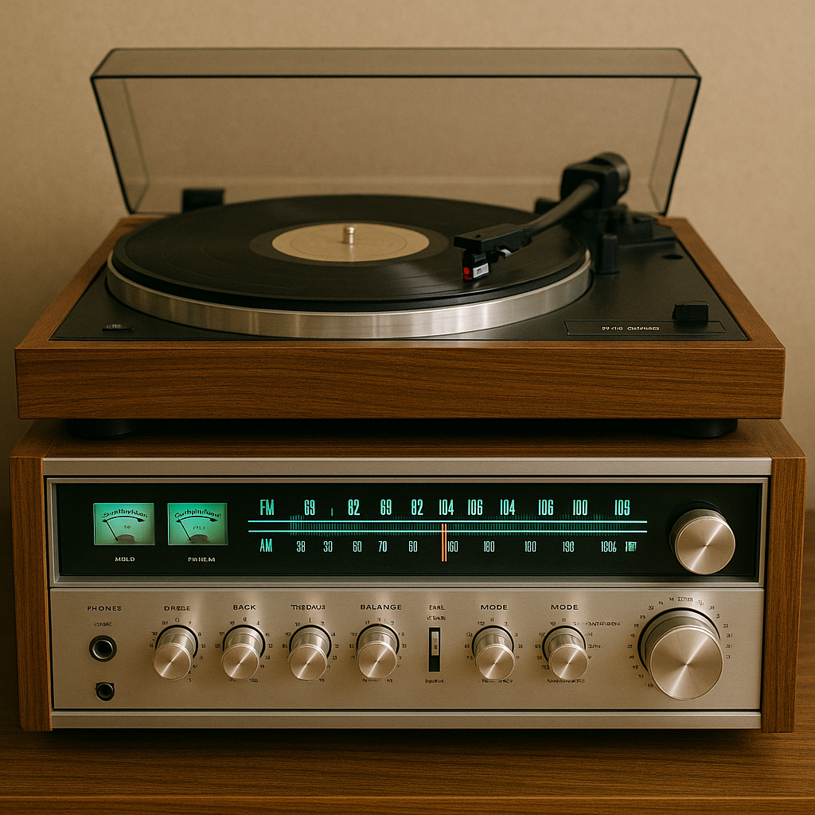
During college I started hanging out at a local Stereo Store (that’s what they were called in 1969) and the manager, Glen Yingling, told me that if I was going to hang out there, he was going to put me to work. During the time I spent at Stereo Mart in Tarzana, I was able to learn about audio from Glenn and numerous audio professionals that stopped by the store. Additionally, I was very fortunate to meet some of the industry's famous designers and engineers, like Rudy Bozak, Joe Grado, and many more. As a sideline during that time, I would buy used stereo equipment and resell it to students at college. Over time I became known as the guy to go to for a deal on Stereo gear.
I discovered my hobby which ultimately became my career. I learned my ability to explain technology to customers and help them meet their needs and fulfill their musical desires.
After graduating from college with a BA in Radio, TV, and Film I took a job at Metro Media Producers. What I learned from that job, is I don’t take direction well and that people in Show Business can be a little nut. I am actually being nice.
I bounced around a little bit selling Real Estate, which I was very good at, and actually had a story about me in a major Los Angeles newspaper. But to be perfectly honest, I really didn’t enjoy it. I also got into real Estate at the wrong time. Interest rates soared from 4% to over 7% in a very short time resulting in my losing 5 commercial building sales and a couple of rental home sales due to funding issues.
I decided that what I wanted to do was find a job doing what I truly enjoyed. Just a few doors down from my office was a discount audio chain store that I visited very often and the manager offered me a position several times. After a rather unhappy call from my escrow agent, I walked down and asked if he was serious and ultimately, I took the job at California HiFI Wholesalers as a salesman. Within two months I was promoted to store manager and shortly after that was also advising the VP of Purchasing on what to buy. My store was consistently the top performer in the chain. Again, my inability to follow directions made it difficult to stay with them. FYI, CHFW changed its name to Circuit City two years after I left the company.
After leaving CHFW I started my first HiFI store called Northridge Audio. My initial investment was $4200. With that, I rented a storefront, got my resale license, and my business license, built out the store, including fixtures, and bought some inventory. I do not recommend anyone attempting something like that. I was incredibly underfunded but fortunately, the connections I made as store manager at CHFW helped me tremendously.
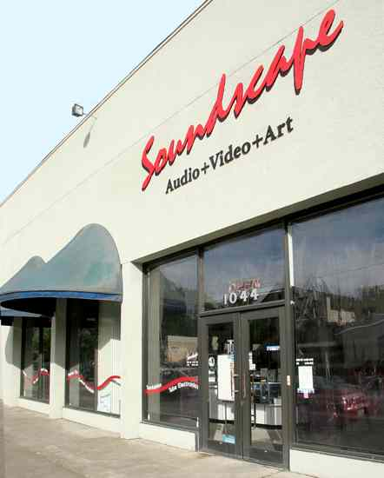
With the help of the President of a major local rep firm, I was able to get franchises and products from companies such as Sherwood, Dynaco, BSR, and others. Additionally, because of relationships I had established when I was a store manager at CHFW I was able to acquire speaker lines like RTR and KLH.
I was fortunate to establish my position early on in my career and develop relationships that gave my new business the foot-up I needed to survive in a rapidly changing industry.
Two months after opening the store, Fair Trade was eliminated by the federal government. This created a new dynamic for the audio business in general and was the cause for the first in a series of audio store failures that occurred over the next 50 years. Some dealers, who didn’t know how to maintain profitability without the protection of Fair-Trade laws were destined to fail and go out of business.
Fortunately, I was able to adapt to this new market dynamic and not just survive but prosper over the next half-decade.
Over my 54 years in business, I managed to make a lot of mistakes. I seemed to make almost every bad decision possible when operating a business. These decisions ultimately cost me what I refer to as my business education degree. I calculated that this business education cost me somewhere in the area of $750,000 over my lifetime.
I have opened, closed, moved, expanded, remodeled, and run every aspect of my stores for over 50 years. I am happy to say that despite everything I did wrong, I did a lot more, right.
The choices I made have allowed me to retire with enough money to enjoy a worry-free life. I’ve always lived frugally, avoiding wasteful spending, yet I still live comfortably. My home has been paid off for over 20 years, I travel the world for 2-3 months every year, and I’m proud to say I have no debt. With determination and a bit of luck, you can achieve even more."
What I will cover.
In the following chapters I will walk you through each step of the process in starting and running a business, from defining your business idea to registering, launching, and growing your business. I hope the information I present in this book helps you if you decide that owning your own business is what want to do.
Looking back on my journey, it’s clear that success didn’t come all at once—it was the culmination of countless small decisions, lessons learned, and moments of adaptation. From selling candy bars in boarding school to building a thriving audio business, I’ve come to understand that success isn’t a one-size-fits-all concept. It’s a personal journey, shaped by your values, goals, and the sacrifices you’re willing to make along the way. And that brings us to an important question: what does success mean to you? Before we dive into the practicalities of starting and running a business, let’s take a moment to explore this fundamental idea. Understanding your own definition of success will be the compass that guides your decisions and shapes your entrepreneurial journey.

