Champagne: The Pinnacle of Sparkling Wine
Overview
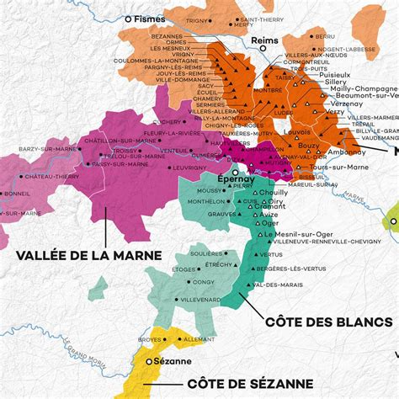
Champagne is synonymous with celebration and luxury, but behind its global reputation lies a region steeped in tradition, innovation, and strict regulations. Located in northeastern France, Champagne is the birthplace of sparkling wine as we know it today, producing wines with remarkable finesse, complexity, and longevity. Governed by precise production methods and unique terroir, Champagne remains one of the most studied and revered wine regions in the world.
Figure 1 Champagne Wine Map
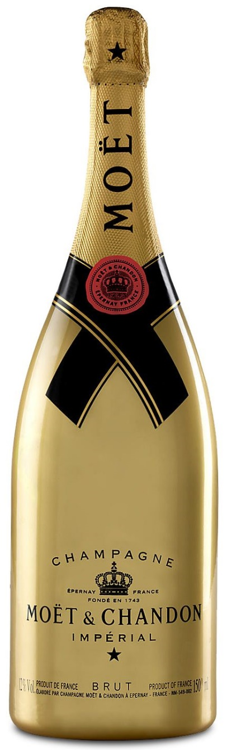
Historical Background
Figure 2 Moët & Chandon Brut Impérial Gold Edition Magnum 1,5L (12% Vol.) - Champagne
The history of Champagne dates back to Roman times, when the first vineyards were planted. By the Middle Ages, Champagne had gained prominence through its association with French royalty and coronation ceremonies held in Reims. The region’s sparkling style emerged in the 17th century, with Dom Pérignon and other winemakers refining techniques that led to controlled secondary fermentation in bottle.
The 19th century saw the rise of prestigious Champagne houses such as Moët & Chandon, Veuve Clicquot, and Bollinger, solidifying the region's global influence. Today, Champagne remains at the forefront of viticulture and innovation, blending tradition with cutting-edge production methods.
Classification System
Champagne's strict Appellation d’Origine Contrôlée (AOC) regulations ensure quality and authenticity. The classification system includes:
- Grand Cru – The highest classification, reserved for the top villages with exceptional terroir.
- Premier Cru – High-quality vineyards, though slightly below Grand Cru status.
- Autre Cru – All other classified Champagne vineyards.
The region’s unique system extends beyond vineyard classification, regulating:
- Permitted grape varieties – Chardonnay, Pinot Noir, and Pinot Meunier are the primary varieties.
- Production methods – The traditional Méthode Champenoise is mandatory.
- Aging requirements – Non-vintage Champagnes must age at least 15 months, while vintage Champagnes require three years.
Major Wine Regions
Montagne de Reims
This area is home to some of Champagne’s most powerful and structured wines. It is predominantly planted with Pinot Noir, producing wines with richness, depth, and aging potential.
Vallée de la Marne
With a slightly warmer climate and clay-based soils, the Vallée de la Marne is ideal for Pinot Meunier, which thrives in cooler conditions and brings fruitiness and suppleness to blends.
Côte des Blancs
This region is dedicated almost exclusively to Chardonnay, yielding elegant, mineral-driven Champagnes known for their finesse and aging potential.
Côte de Sézanne
A continuation of the Côte des Blancs, this region also focuses on Chardonnay, but with a riper, fruitier profile due to the slightly warmer climate.
Aube (Côte des Bar)
Situated further south, this area has a more continental climate and produces fuller-bodied wines, predominantly from Pinot Noir.
Terroir
Champagne’s terroir is unique due to its cool climate, distinct soil composition, and vineyard positioning.
- Soils – The region is famous for its chalky soils, which provide excellent drainage, regulate water supply, and contribute to Champagne’s minerality.
- Climate – Cool continental, with temperatures moderated by the Marne River, ensuring slow ripening and high acidity.
- Slope orientation – Many of Champagne’s vineyards are planted on south-facing slopes to maximize sun exposure and encourage even ripening.
Notable Grape Varieties
Chardonnay
Used primarily in Blanc de Blancs, Chardonnay contributes freshness, minerality, and longevity, with flavors of citrus, white flowers, and brioche.
Pinot Noir
The backbone of Blanc de Noirs and many blends, Pinot Noir adds structure, red fruit flavors, and body.
Pinot Meunier
Known for its fruit-forward character, Pinot Meunier brings roundness, early drinkability, and floral aromatics to Champagne blends.
Styles of Champagne
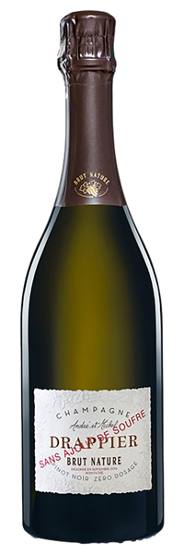
- Brut Nature (Zero Dosage) – No added sugar, showcasing Champagne’s purest expression.
- Brut – The most common style, with minimal sugar for balance.
- Extra Dry – Slightly sweeter than Brut, yet still crisp.
- Demi-Sec & Doux – Noticeably sweet styles, often enjoyed with desserts.
- Vintage Champagne – Produced from a single outstanding year, aged longer for complexity.
- Prestige Cuvée – The highest expression of a house’s winemaking, often from Grand Cru vineyards.
Notable Champagne Houses
Dom Pérignon (Moët & Chandon)
One of the most prestigious vintage-only Champagnes, Dom Pérignon is synonymous with luxury and precision winemaking.
Krug
Known for its meticulous blending process and extended aging, Krug Grande Cuvée is a benchmark for richness and complexity.
Bollinger
A house famous for its Pinot Noir-dominant Champagnes, including the powerful and structured La Grande Année.
Veuve Clicquot
Home to the renowned Yellow Label, Veuve Clicquot pioneered riddling techniques that revolutionized Champagne production.
Louis Roederer
The producer of Cristal, one of the world’s most sought-after luxury Champagnes, known for its silky texture and purity.
Key Takeaways for Sommeliers
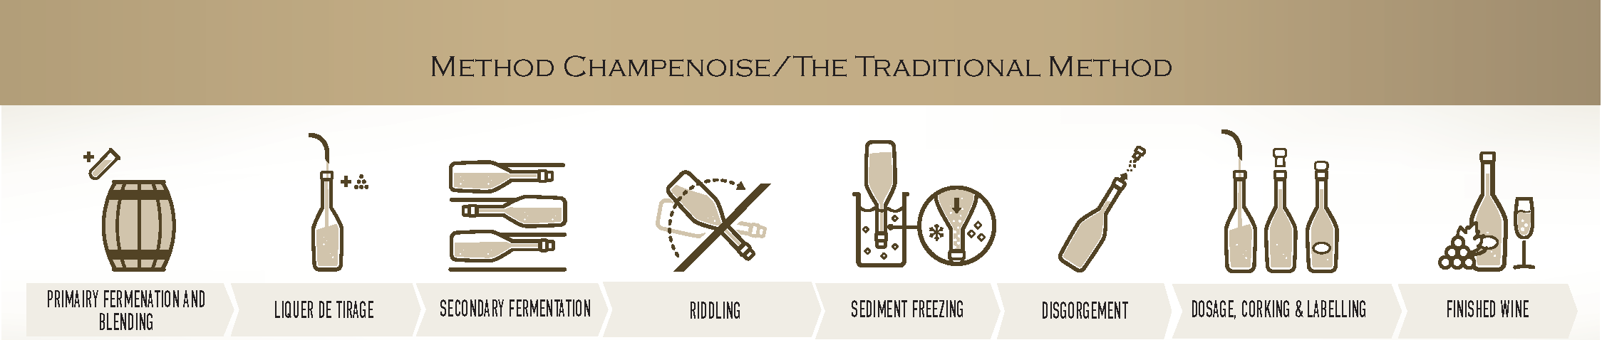
- Méthode Champenoise is essential – The secondary fermentation in bottle creates Champagne’s signature bubbles and complexity.
- Acidity and minerality are key components – Champagne’s cool climate ensures wines retain freshness and elegance.
- Blending is an art form – Most Champagnes are non-vintage, requiring skillful blending to maintain consistency.
- Different regions produce distinct styles – Montagne de Reims favors Pinot Noir, Côte des Blancs excels with Chardonnay, and Vallée de la Marne highlights Pinot Meunier.
- Aging potential varies – Vintage and Prestige Cuvée Champagnes can age for decades, developing nutty, toasty complexity.
Final Thoughts
Champagne is more than just a celebratory beverage—it is a region of unparalleled craftsmanship, terroir expression, and historical significance. Whether it’s a Blanc de Blancs from Côte des Blancs, a full-bodied Pinot Noir blend from Montagne de Reims, or an opulent Prestige Cuvée, Champagne offers an extraordinary range of styles and complexity. Mastering Champagne is essential for any sommelier looking to understand the pinnacle of sparkling winemaking.

