Champa: The Hindu–Buddhist Kingdom Southeast Asia Forgot
By Marc Silver
History has a habit of rewarding survivors. Kingdoms that endure leave records, monuments, and political descendants. Those that fall tend to become footnotes, even when their influence once rivaled the great powers of their age. Champa belongs firmly in that second category.
For more than a thousand years, a chain of seafaring Hindu–Buddhist kingdoms stretched along the central and southern coast of what is now Vietnam. These were not fringe societies or minor port towns. They were maritime powers, religious innovators, and cultural bridges between India, China, and the island world of Southeast Asia. Champa was not erased from the historical record, but it was pushed to its margins. Its rulers built temple complexes that still command awe. Its merchants controlled trade routes linking Persia to southern China. Its language and culture tied it more closely to Java and Malaysia than to its eventual conquerors to the north.
And yet, outside specialist circles, Champa rarely occupies the foreground of Southeast Asian history.
This is not because Champa lacked significance. It is because Champa lost not just wars, but narrative champions. There was no single climactic conquest to mythologize, no surviving capital to romanticize, no imperial successor eager to claim its legacy.

The Hindu–Buddhist Kingdom of Champa
Champa was never a single, unified empire in the way Rome or Han China were. It was a constellation of Cham polities, independent yet culturally connected, stretching along Vietnam’s coast from roughly the 2nd century CE until the final annexation of its last territories in 1832.
The story begins in 192 CE, when a revolt erupted in the Han-controlled district of Rinan. The leader was Khu Liên, the son of a local official. He killed the Chinese magistrate and declared independence, founding a kingdom known in Chinese records as Lâm Ấp, or Linyi. What began as a regional uprising became the nucleus of a civilization that would last more than 1,600 years.
The Cham people descended from the Sa Huỳnh culture, an Austronesian society that had flourished along Vietnam’s coast centuries earlier. They spoke Chamic languages, part of the Malayo-Polynesian family, linking them linguistically and culturally to maritime Southeast Asia rather than the mainland. This mattered. Champa’s worldview was shaped by the sea, not the river valleys that anchored Chinese and Vietnamese power.
By the 4th century, Indian cultural influence was firmly established. Through trade, diplomacy, and religious exchange, Champa became part of the broader Indianized world of Southeast Asia, alongside Funan, Chenla, and later Angkor. Sanskrit inscriptions, Hindu cosmology, and temple architecture became central to elite culture. Champa did not simply borrow Indian ideas. It adapted them, embedding Shaivism and later Buddhism into a distinctly Cham artistic and political expression.
Champa reached its height between the 6th and 15th centuries, with particular strength in the 9th and 10th centuries. At its peak, it controlled key segments of the spice and silk trade linking China, India, Indonesia, and Persia. Its ports were cosmopolitan, multilingual, and wealthy. Champa was not peripheral to the medieval world economy. It was a participant.
Religion evolved alongside politics. Hinduism dominated early, particularly Shaivism, shaping temple construction and royal ideology. Islam arrived by the 8th century through Indian merchants from the Tamil and Konkan coasts. By the 11th century, segments of the royal family had converted, and Islam became the state religion in parts of Champa, coexisting with older Hindu and Buddhist traditions. This coexistence was not always seamless, but it was sustained over centuries through accommodation rather than forced replacement.
The decline began in earnest as the Vietnamese kingdom of Đại Việt expanded southward. Amaravati fell around 1000. Vijaya followed in 1069. The final blow came in 1471, when forces of the Lê dynasty shattered Champa’s political core. What remained lingered for centuries as tributary states until Emperor Minh Mạng formally annexed the last Cham territories in 1832.
Champa did not vanish overnight. It was dismantled, piece by piece.

Temples That Rival Empires
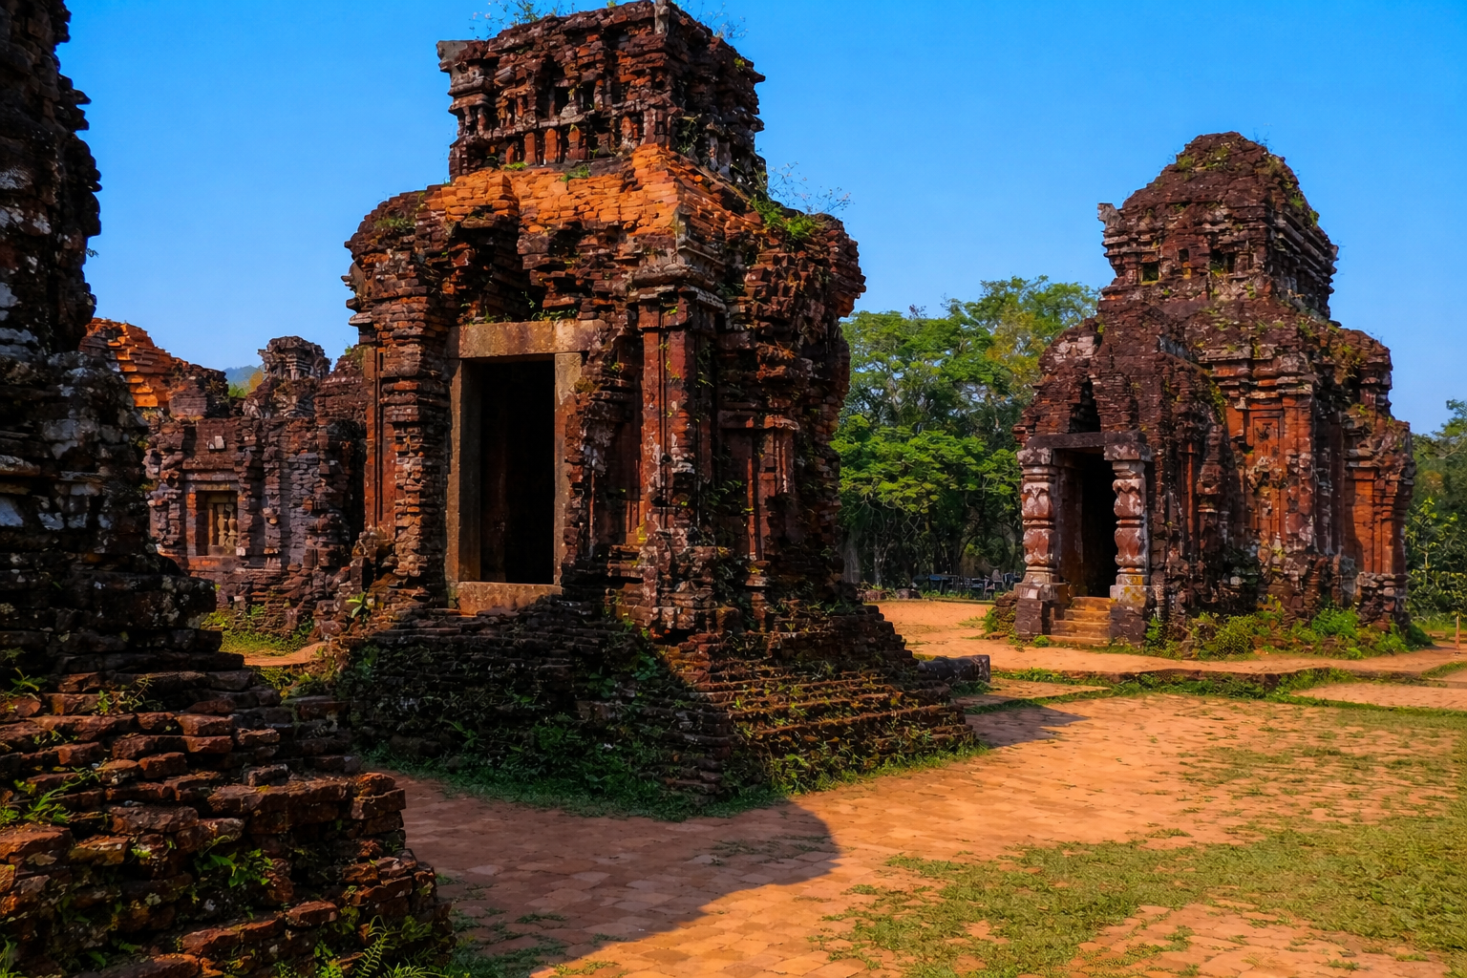
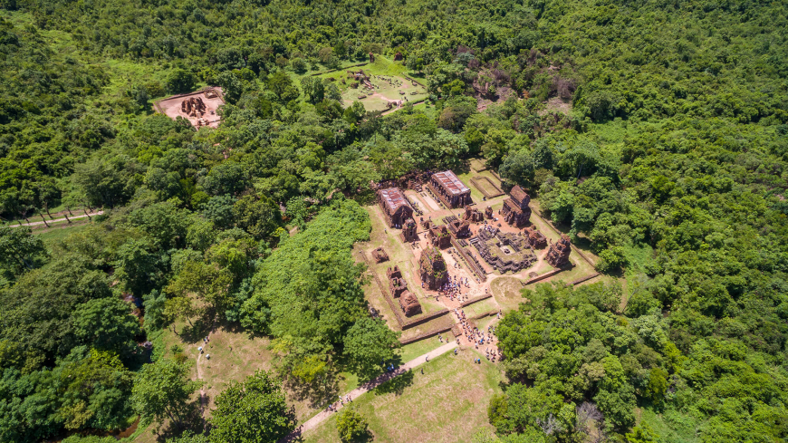
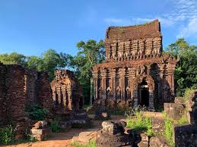
Unlike Angkor’s vast stone enclosures, Mỹ Sơn’s brick towers privilege verticality and ritual density over imperial scale. If Champa had left nothing behind but ruins, those ruins alone would justify its place in history.
The most famous of these is the Mỹ Sơn Sanctuary, a cluster of Shaiva Hindu temples constructed between the 4th and 13th centuries. Set in a forested valley in central Vietnam, Mỹ Sơn was both a religious center and a royal necropolis, dedicated to Shiva as the divine protector of the Cham kings.
Originally, the complex contained more than seventy towers arranged in eight architectural groups across roughly two kilometers. Each tower symbolized Mount Meru, the cosmic axis of Hindu cosmology. The scale was deliberate. These were statements of divine legitimacy and royal authority, built to endure.
What continues to puzzle archaeologists is how they were built. The temples are constructed primarily of fired brick, laid without visible mortar. The bonds between bricks remain extraordinarily strong even after centuries of weathering. Sandstone was used for pillars and bas-reliefs depicting scenes from Hindu mythology, rendered with remarkable precision and stylistic coherence.
The technology behind this construction remains only partially understood. The Chams clearly possessed advanced engineering knowledge, yet left no clear written record of the method. Like much of Champa’s history, the technique survives without explanation.
Mỹ Sơn is often compared to Borobudur, Angkor Wat, Wat Phou, Bagan, and Prasat Hin Phimai. The comparison is justified. Champa was not imitating these cultures. It was competing with them, using a distinct architectural language rooted in brick construction, symbolic density, and ritual continuity rather than sheer monumentality.
That rivalry occasionally turned violent. In 1177, Cham forces launched a naval assault up the Mekong and sacked Angkor, seizing palace complexes of the Khmer Empire. It was an audacious strike by a confident maritime kingdom at the height of its influence. The Khmer response was decisive. Under Jayavarman VII, Angkor regrouped and eventually crushed Champa’s remaining power centers, ensuring that the raid would be remembered as bold, but ultimately costly.
Much of Mỹ Sơn was destroyed during the Vietnam War, when U.S. bombing targeted suspected Viet Cong activity in the surrounding valley. A large portion of the sanctuary was lost in a matter of days. The irony is difficult to ignore. A civilization dismantled over centuries lost its most important monuments in a single campaign. UNESCO recognition in 1999 came too late to save much of what once stood, but enough remains to testify to Champa’s sophistication.
Beyond Mỹ Sơn, roughly fifty Cham towers still dot central Vietnam. Sites such as Po Shanu near Phan Thiết, Nhạn Tower in Phú Yên, Po Dam in Bình Thuận, and Yang Prong in the Central Highlands reveal a culture that was geographically extensive and architecturally coherent, even when politically fragmented.

A People Scattered, Not Erased
The fall of Champa did not end the Cham people. It transformed them.
Today, roughly 180,000 Cham live in Vietnam, officially recognized as one of the country’s 54 ethnic groups. Many more live in Cambodia, where the largest Cham population, predominantly Muslim, resides. Others migrated farther afield, particularly to Malaysia.
Following Vietnamese conquest, the last Cham Muslim king, Pô Chien, led his followers into Cambodia. Coastal communities fled by sea to Trengganu in Malaysia. During the Vietnam War, additional waves of Cham refugees were granted sanctuary by the Malaysian government, partly out of religious solidarity. By the mid-1980s, tens of thousands had settled there permanently.
What followed was not displacement alone, but attempted eradication.
The Cambodian Cham endured one of the darkest chapters of modern history. Under the Khmer Rouge, between 90,000 and 500,000 Cham were killed. Entire communities were targeted for their religion and cultural identity. By 1979, as many as seventy percent of Cambodia’s Cham population had been exterminated. In 2018, Khmer Rouge leaders Nuon Chea and Khieu Samphan were convicted of genocide, including crimes committed against the Cham.
Survival under those conditions required adaptability. Cham society retained its matrilineal structure even as political systems collapsed. Traditional crafts endured. Cham women continued to weave silk. Pottery was still fired in open-air kilns. Music persisted through instruments such as the paranung drum and xaranai trumpet, quietly shaping regional folk traditions.
Religion diversified rather than disappeared. Today, the Cham are largely Muslim, with Hindu minorities concentrated in Ninh Thuận and Bình Thuận provinces. Some communities follow older syncretic forms of Islam. Others adhere to more orthodox practices learned through transnational networks linking them to Malaysia, Indonesia, southern Thailand, and the Middle East.
These networks are not relics. They are active channels of education, labor, and identity formation. Champa may be gone as a state, but Cham connections still follow the old maritime logic.

Trade, Art, and Memory
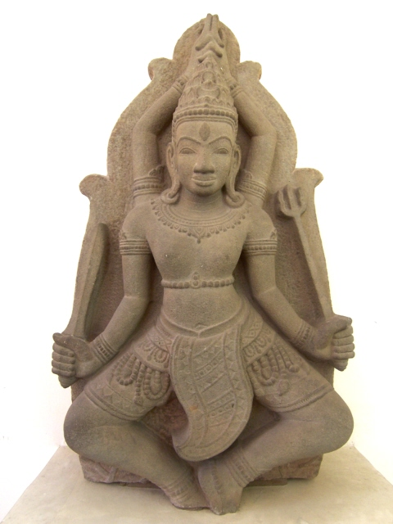
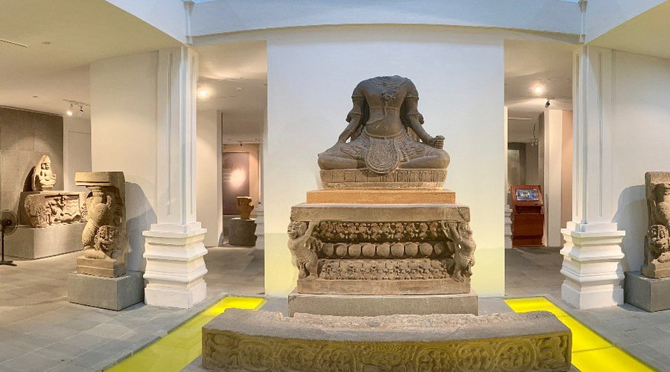

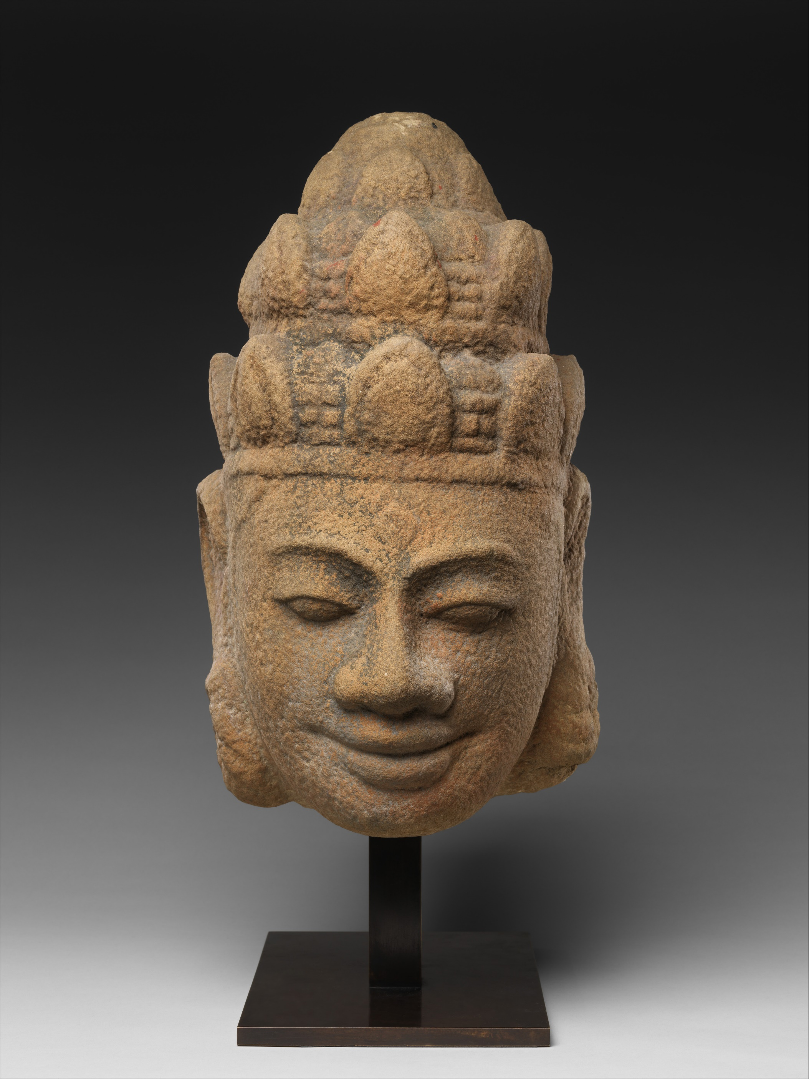
Champa’s wealth came from the sea. Its merchants operated along the Maritime Silk Road, trading spices, gems, precious metals, exotic animals, and enslaved people. Ships sailed to China, Japan, Java, and beyond. Cham ports were hubs of exchange long before European vessels entered the region.
That wealth funded art.
The Museum of Cham Sculpture in Đà Nẵng, founded in 1919, houses the world’s largest collection of Cham art. Sandstone sculptures of deities, dancers, and mythological figures reveal a refined aesthetic that blends Indian iconography with local expression. Faces are calm but forceful. Movement is suggested rather than exaggerated. These works were not provincial copies. They were confident statements of cultural identity.
The International Office of Champa exists for a practical reason. For many Cham families, the most immediate losses are not only historical, they are administrative. Land rights, legal recognition, and the ability to protect religious and cultural sites often hinge on paperwork, local enforcement, and who gets heard in provincial disputes. The IOC frames its work around civil protections rather than nostalgia for a restored kingdom, because that is where daily pressure still appears. It treats Champa less as a flag to raise and more as a lived identity that needs room to exist, on maps, in schools, and in public life.

A History That Refuses to Vanish
Champa did not survive as a state, but it survived as a people, a culture, and a way of seeing the world shaped by the sea rather than the land. Its history corrects several persistent misconceptions about Southeast Asia. It shows that maritime power could rival agrarian empires for centuries. It demonstrates that religious pluralism existed long before modern secularism. It challenges the assumption that regional history naturally flowed northward toward China.
Most of all, Champa forces a reckoning with how historical memory works. Civilizations that leave political descendants are remembered. Those that do not are often reduced to ruins and museum labels.
The Cham people are still here. Their temples still stand, scarred but stubborn. Their language, music, and rituals persist across borders.
History did not forget Champa by accident. It was convenient for states, curricula, and dominant narratives to let it fade.
And that alone makes remembering it necessary.
References
Higham, Charles. Early Mainland Southeast Asia: From First Humans to Angkor. Bangkok: River Books, 2014.
Kiernan, Ben. Blood and Soil: A World History of Genocide and Extermination from Sparta to Darfur. New Haven: Yale University Press, 2007.
(See chapters on Cambodia and the targeting of the Cham under the Khmer Rouge.)
Taylor, Keith W. A History of the Vietnamese. Cambridge: Cambridge University Press, 2013.
Vickery, Michael. Champa Revised. Canberra: Australian National University, 2005.
Hall, Kenneth R. Maritime Trade and State Development in Early Southeast Asia. Honolulu: University of Hawai‘i Press, 1985.
Maspero, Georges. The Champa Kingdom. Translated by Walter E. J. Tips. Bangkok: White Lotus Press, 2002.
(Originally published 1928; still foundational.)
UNESCO World Heritage Centre. “Mỹ Sơn Sanctuary.”
https://whc.unesco.org/en/list/949/
Nguyễn Văn Huy and Trần Kỳ Phương. The Cham Sculpture Museum in Đà Nẵng. Hanoi: Thế Giới Publishers, 2011.
Po Dharma. The Cham of Vietnam: History, Society and Art. Paris: Association Archipel, 1987.
Manguin, Pierre-Yves. “The Archaeology of Early Maritime Polities of Southeast Asia.” Journal of Southeast Asian Studies 31, no. 2 (2000): 282–313.
Mabbett, I. W. “The Symbolism of Mount Meru.” History of Religions 23, no. 1 (1983): 64–83.
Chandler, David P. A History of Cambodia. Boulder: Westview Press, 2008.
International Office of Champa. “Mission and Advocacy.”
https://www.champa.org
General Statistics Office of Vietnam. Results of the 2019 Population and Housing Census. Hanoi, 2020.

Population figures, dates, and casualty estimates vary by source; ranges reflect scholarly consensus rather than precise totals.

