Central Valley (Valle Central): The Heart of Chilean Winemaking
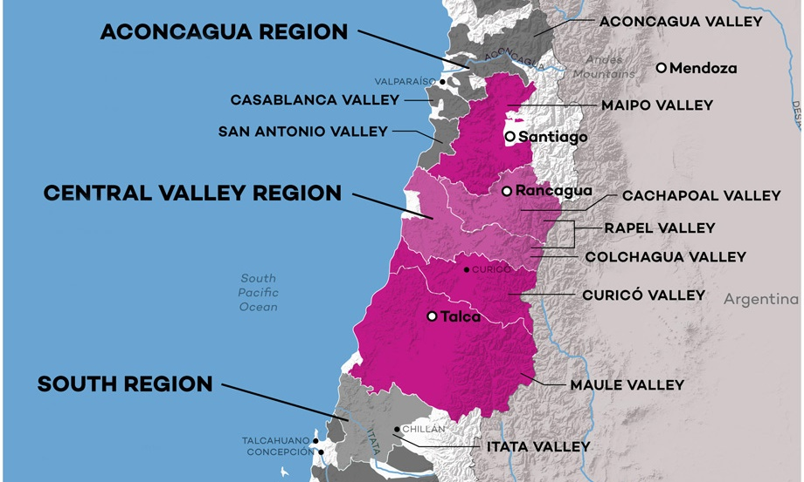
Region Overview
The Central Valley (Valle Central) is Chile’s largest and most important wine-producing region, responsible for the majority of the country’s wine exports. Spanning from 33° to 38° latitude south, this expansive region lies between the Andes Mountains and the Coastal Range, creating a variety of microclimates that support an impressive diversity of grape varieties.
The Mediterranean climate of the Central Valley, with warm, dry summers and mild, wet winters, provides ideal conditions for viticulture. Rivers flowing from the Andes supply natural irrigation, while cooling influences from the Pacific Ocean and mountain airflows help moderate temperatures, preserving acidity and freshness in the wines. Soils vary from alluvial deposits to clay and volcanic compositions, further contributing to the region’s diverse wine profiles.
Key Grape Varieties
The Central Valley is the backbone of Chilean wine production, known for its red and white varietals:
- Cabernet Sauvignon – The dominant red variety, producing structured, fruit-driven wines with cassis, plum, and spice.
- Carménère – Chile’s signature grape, offering deep color, soft tannins, and distinctive herbal and black fruit notes.
- Merlot – Smooth and approachable, often blended with Cabernet Sauvignon and Carménère.
- Syrah – Bold and peppery, thriving in warmer subregions.
- Sauvignon Blanc – Crisp and zesty, flourishing in cooler parts of the valley.
- Chardonnay – Ranges from fresh and mineral-driven to rich and oak-aged styles.
Wine Classification System
The Central Valley DO encompasses four key subregions, each contributing distinct characteristics to Chilean wine:
- Maipo Valley – Known as the “Bordeaux of Chile,” it is famous for Cabernet Sauvignon, producing wines with elegance, structure, and aging potential.
- Rapel Valley – Divided into Cachapoal and Colchagua Valleys, this area specializes in Carménère, Syrah, and Merlot, with rich, full-bodied expressions.
- Curicó Valley – A diverse region producing both red and white wines, with a strong reputation for Chardonnay and Sauvignon Blanc.
- Maule Valley – The largest and most traditional wine area, historically known for Carignan and old-vine reds, now embracing sustainable viticulture.
Notable Wine Styles
- Classic Chilean Cabernet Sauvignon – Full-bodied, with black fruit, tobacco, and firm tannins.
- Signature Carménère – Velvety, herbal, and spicy, with deep plum and cocoa notes.
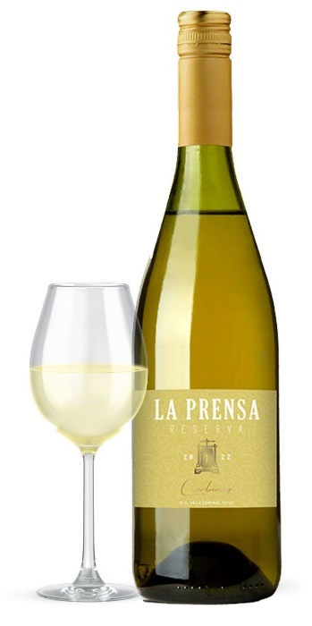
- Expressive Syrah – Bold and dark-fruited, with black pepper and smoky undertones.
- Fresh Sauvignon Blanc – High acidity, citrus, and tropical fruit flavors.
- Chardonnay (Both Unoaked and Oaked) – Ranging from bright and mineral-driven to lush and buttery.
Additional Context
The Central Valley has long been the engine of Chile’s wine industry, home to some of the country’s oldest vineyards and most established wineries. While once associated with bulk wine production, many producers are now focusing on quality-driven, terroir-expressive wines, particularly in subregions like Colchagua and Maipo.
With sustainability and innovation on the rise, winemakers in the Central Valley are embracing organic and biodynamic farming, as well as modern winemaking techniques to refine their styles. The region’s accessibility and affordability make it the gateway to Chilean wine, offering a wide spectrum of wines for every palate.
Takeaway for Sommeliers
For sommeliers, the Central Valley is an essential region to understand, offering the best introduction to Chilean wine. Whether it’s a classic Maipo Cabernet Sauvignon, a spicy Carménère from Colchagua, or a fresh Sauvignon Blanc from Curicó, the diversity and consistency of Central Valley wines make them ideal for both casual consumers and collectors.
References
- Robinson, J., & Harding, J. (2020). The Oxford Companion to Wine (5th ed.). Oxford University Press.
- Wines of Chile. (2023). Regional Profiles and Climate Data. Retrieved from https://www.winesofchile.org
- Tapia, P. (2022). The Wines of South America. Infinite Ideas.
- Wine Enthusiast. (2022). Exploring the Diversity of Chile’s Central Valley. Retrieved from https://www.winemag.com

