Cachaça it’s Not Rum
By: Marc Silver
I have just returned from a four-week trip to the Amazon, and one thing is immediately clear. Of the several regions in Brazil that produce wine, the Amazon is definitely not one of them. The climate is simply too hot, too wet, and too unpredictable for vitis vinifera to gain any kind of lasting foothold. Rain arrives when it wants to. Heat never really leaves. Fungi thrive. Grapes simply can’t survive in this environment.
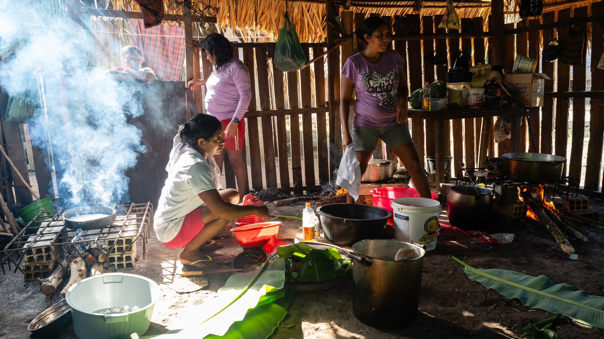
That absence, though, does not mean the Amazon lacks alcohol. Far from it.
Humans have been fermenting sugars here for centuries, long before European maps caught up with the rivers. When grapes refuse to cooperate, people adapt. They always have.
During my travels, I was introduced to a local spirit I initially heard called chasaka. The pronunciation shifted depending on who said it, and how much Portuguese they assumed I spoke. What I was tasting, though, was almost certainly cachaça. Brazil’s national spirit. The name can blur in remote regions, especially when passed verbally, but once you know what you are looking at, the connection becomes obvious.
Cachaça is often described as “Brazilian rum.” That comparison is convenient, and mostly wrong.
It is similar, yes. It is also its own thing entirely, with a history, flavor profile, and cultural role that go far deeper than most drinkers realize.

What cachaça actually is
At its core, cachaça is a distilled spirit made from fresh sugarcane juice, not molasses. That single detail matters more than any tasting note ever could.
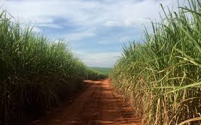
Most rum begins life as a byproduct. Molasses is what remains after sugar crystals are extracted. It is cooked, concentrated, stable. Cachaça starts with cane that is crushed and fermented quickly, while the vegetal character of the juice is still alive.
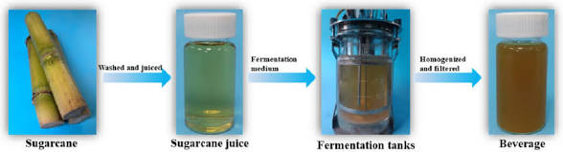
The result is a spirit that tastes green, grassy, sometimes herbal or faintly funky. Citrus peel shows up. Fresh earth. Occasionally a note that feels closer to olive brine than caramel.
If rum reminds you of baked sugar and vanilla, cachaça leans toward raw cane and sunlight.
That difference is not academic. It is structural. It is why the two spirits may be related, but never interchangeable.
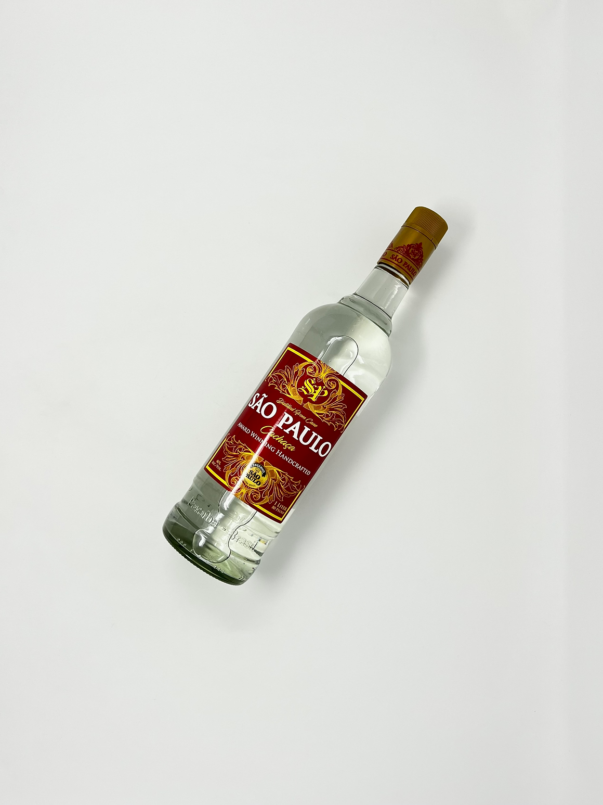
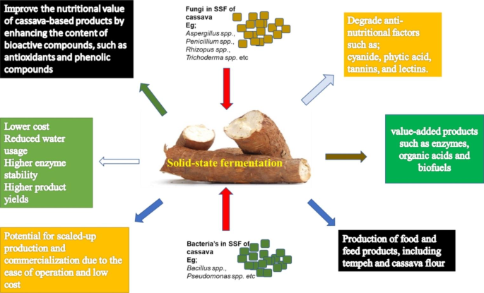
Fermentation before distillation
Long before stills arrived, indigenous peoples across the Amazon basin were fermenting what the forest and fields gave them. Cassava, fruits, honey, and eventually sugarcane were all used to create low-alcohol beverages meant to be consumed fresh.
These drinks were communal, seasonal, and tied to daily life. They were not about intoxication. They were about nourishment, hospitality, and ritual.
Fermentation was understood intuitively. Heat speeds it up. Time changes flavor. Yeast does the work if you let it.
Distillation, though, was a different story.
That technology arrived with the Portuguese in the 16th century, along with sugarcane itself. Cane thrived in Brazil’s climate. It grew fast, aggressively, and in places where European crops struggled. Plantation economies followed quickly, along with forced labor and a rigid colonial hierarchy.
What emerged from that system was not planned innovation, but practical improvisation.
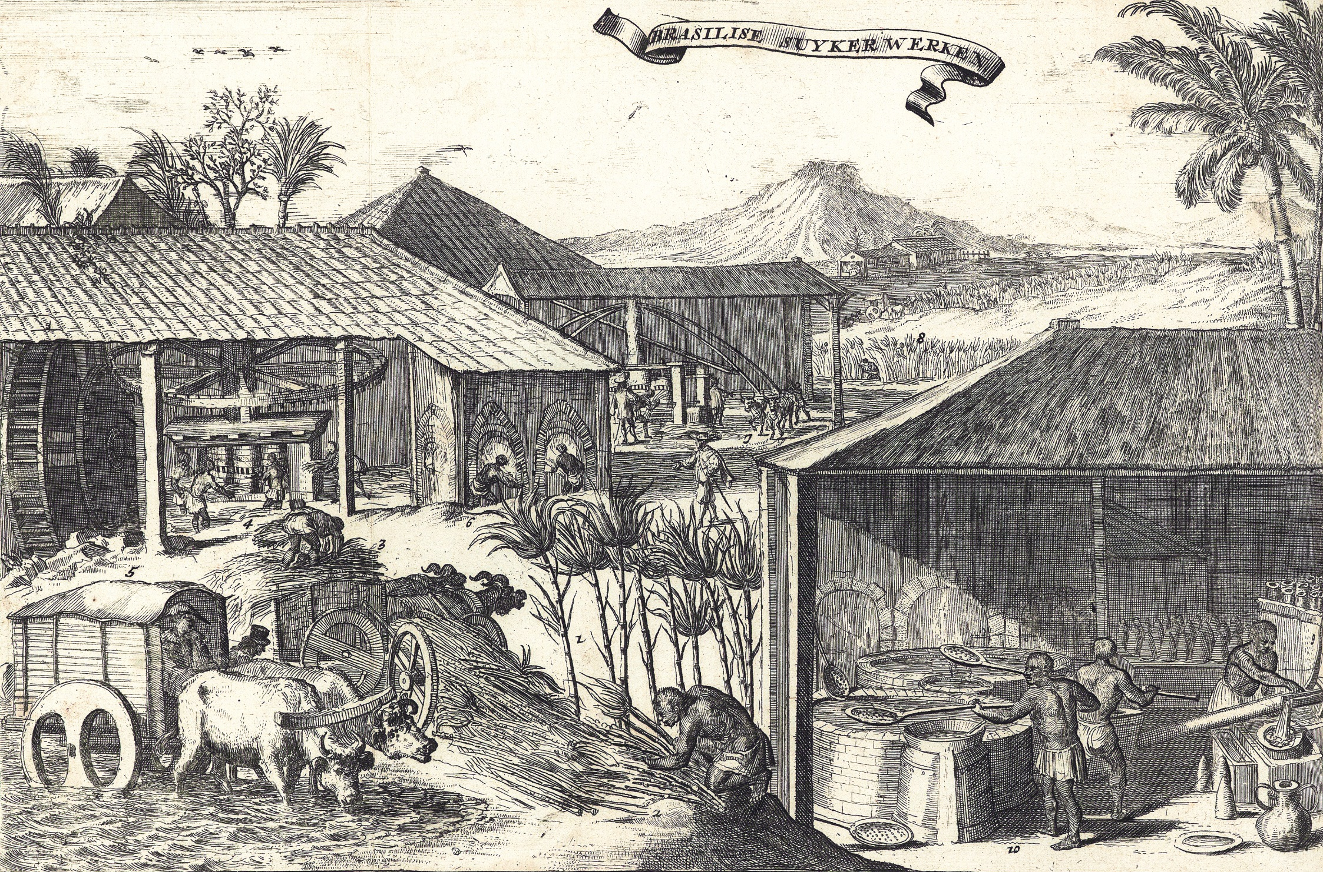
Slavery, labor, and unintended invention
Enslaved Africans working Brazil’s sugar plantations were surrounded by fermentation. Cane juice foamed and soured in the heat. Skimmings collected. Waste accumulated. Someone noticed that the frothy liquid left behind after sugar processing had potential.
Early distillation was crude. Stills were simple. Results varied. What mattered was that the process worked.
By the early 1600s, cane spirits were being produced locally and traded informally. Cachaça was cheap, potent, and accessible. It spread quickly through rural communities, ports, and interior regions alike.
The Portuguese Crown tried to stop it.
Imported grape brandy from Portugal was taxed and protected. Cachaça competed directly with those imports. Bans were imposed. Production was restricted. Enforcement failed.
People kept making it.
By the time Brazil moved toward independence in the 19th century, cachaça had become more than a drink. It was a marker of local identity, of self-reliance, and of quiet resistance to imposed tastes.
No speeches were required. The stills spoke for themselves.
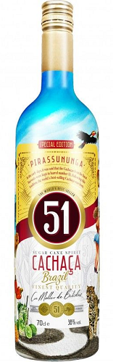
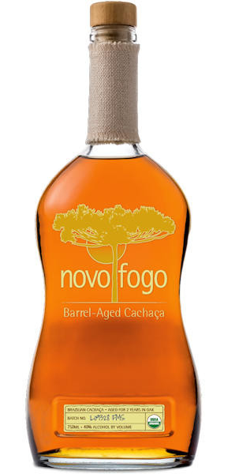
Why cachaça feels at home in the Amazon
Most commercial cachaça production happens outside the deep Amazon basin, closer to the coast and established agricultural zones. Even so, the spirit feels completely at home in the Amazon.
Sugarcane grows easily in hot, humid conditions. Small stills can operate far from cities. Fermentation happens quickly. Aging can be done locally, using native woods rather than imported oak.
In Amazonian regions, you are more likely to encounter cane spirits aged in woods like amburana, bálsamo, or jequitibá. These woods impart flavors that are spicy, resinous, sometimes floral, sometimes medicinal. Vanilla rarely dominates. Sweetness is restrained.
This is not refinement in the European sense. It is expression.
What you taste in the glass is not polish. It is place.

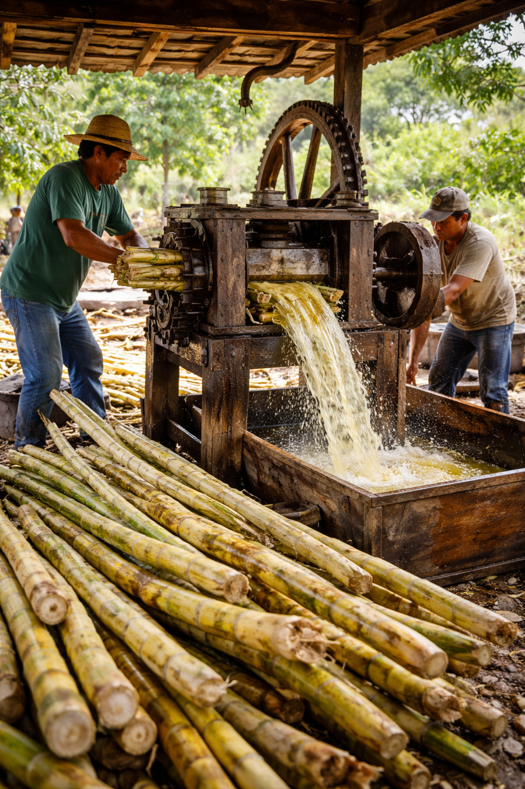
How cachaça is traditionally made
The basic process remains remarkably direct.
Sugarcane is harvested and crushed, often within hours. The juice is fermented naturally or with simple yeast cultures. Fermentation is fast. Sometimes just a day or two. Distillation usually takes place in copper pot stills, producing a spirit that can be bottled young or rested briefly.
Industrial producers refine this process for consistency. Large column stills. Blending. Filtration. Uniformity.
Small producers lean into variation. That is where personality shows up.
A rustic cachaça can be wild and aromatic, occasionally rough at the edges. A well-made artisanal example can be nuanced and elegant, closer to an agricole rum than many drinkers expect.
Both are legitimate. Both belong.

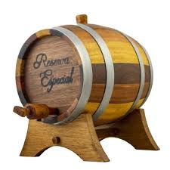
The forest gives, but not everything
Of the many things the Amazon offers, one of the most historically important is the rubber tree. Rubber reshaped global industry. It built fortunes. It powered empires.
It also produces nothing drinkable. That matters.
The Amazon is generous, but selective. Alcohol here comes from cultivation and fermentation, not extraction. From human intervention, not passive harvest. Sugarcane had to be planted, tended, rushed, and transformed.
Cachaça exists because people worked with the environment rather than waiting for it to provide something ready-made.
That distinction mirrors much of Amazonian life. Adaptation is not optional. It is constant.

Drinking cachaça in context
In the Amazon, cachaça is rarely dressed up. It is sipped neat. Shared casually. Mixed with lime or local fruit. The famous caipirinha is only one expression of a much broader tradition.
More importantly, cachaça is social.
It is offered, not marketed. It marks the end of a workday. The beginning of a conversation. A gesture of welcome. A pause in the heat.
This is not a spirit designed to sit untouched on a shelf. It exists to be consumed, passed, and remembered.
That may be why exported versions often feel different. They arrive filtered, standardized, branded. They travel well, but something subtle is lost along the way.
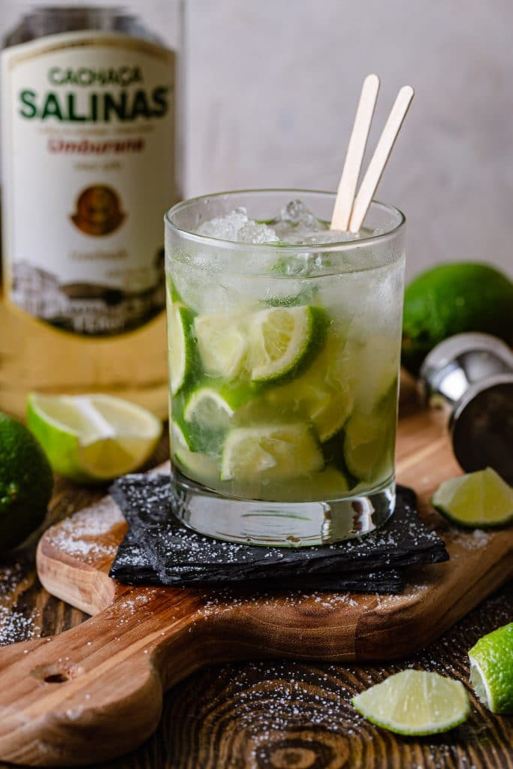
Cachaça makes the most sense where it is made.

A final reflection
The Amazon does not grow wine grapes, but it produces something just as revealing. Cachaça carries the history of sugarcane, colonization, resistance, adaptation, and survival in a single glass.
It is raw where wine is refined. Immediate where wine is patient.
Tasting it in the Amazon makes that distinction impossible to ignore. You are not drinking a polished export or a carefully controlled appellation. You are drinking a regional truth.
And that, in its own way, is every bit as compelling as a great bottle of wine.
Indigenous roots and colonial reality
Indigenous peoples of the Amazon were fermenting cassava, fruits, and sugarcane long before Europeans arrived. These early beverages were low-alcohol, communal drinks, consumed fresh and tied closely to ritual, hospitality, and daily life. Distillation, though, arrived with the Portuguese in the 16th century.
Sugarcane thrived in Brazil, and enslaved Africans working the plantations quickly learned that the frothy liquid skimmed off fermenting cane juice could be distilled into something far stronger. By the early 1600s, cachaça was already being made in crude stills and traded locally.
The Portuguese crown tried to suppress it. Cachaça competed directly with imported Portuguese grape brandy, and taxes favored European spirits. The bans failed. People kept making it, drinking it, and improving it.
By the time Brazil moved toward independence in the 19th century, cachaça had become more than a drink. It was a symbol of local identity and quiet resistance.
Why it feels so at home in the Amazon
Even though most commercial cachaça production happens outside the Amazon proper, the spirit feels completely at home there. Sugarcane grows aggressively in hot, humid conditions. Small stills can operate far from cities. Aging can be done in native woods rather than imported oak.
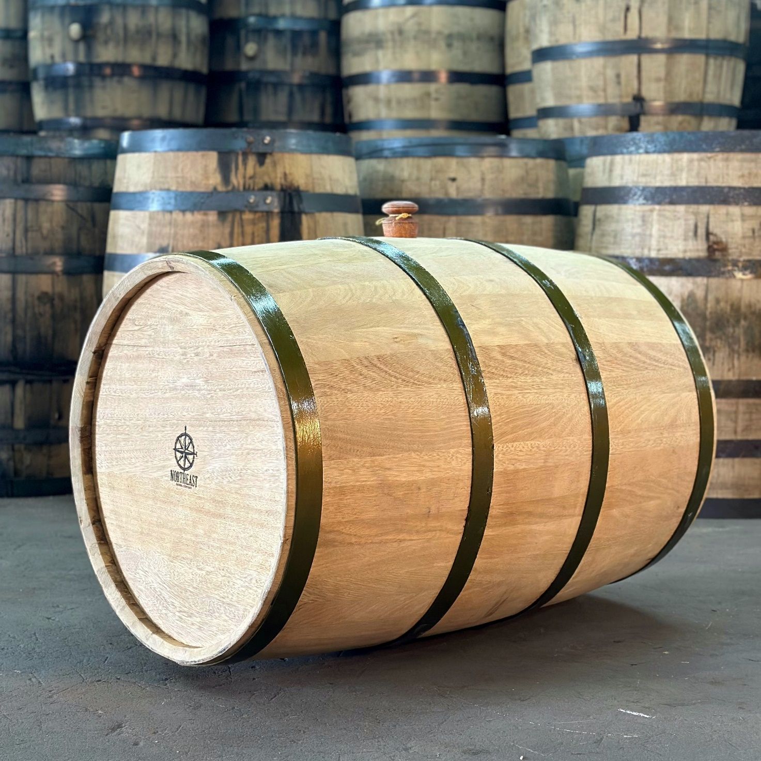
In Amazonian regions, you will often encounter locally distilled cane spirits aged in woods like amburana, bálsamo, or jequitibá. These woods impart flavors that are spicy, resinous, and sometimes slightly medicinal. It is a far cry from vanilla-driven oak aging, and it makes the spirit feel deeply regional.
What you taste in the glass is not polish. It’s place.
Drinking it in context
In the Amazon, cachaça is rarely dressed up. It is sipped neat, shared casually, or mixed with fresh fruit and lime. The famous caipirinha is only one expression of a much broader tradition.
More importantly, it is social. It is offered, not marketed. It marks the end of a workday, the beginning of a conversation, or a moment of welcome.
That matters. Spirits like this were never designed to be trophies on a shelf. They exist to be consumed in the rhythm of everyday life.
A final reflection
The Amazon does not grow wine grapes, but it produces something just as revealing. Cachaça carries the history of sugarcane, colonization, resistance, adaptation, and survival in a single glass. It is raw where wine is refined, immediate where wine is patient.
Tasting it in the Amazon makes that distinction impossible to ignore. You are not drinking a polished export. You are drinking a regional truth.
And that, in its own way, is every bit as compelling as a great bottle of wine.

