Cabo San Lucas Walking Tour
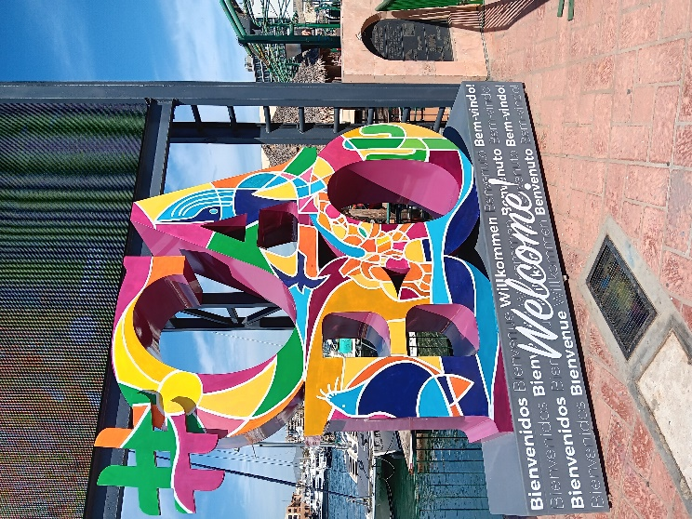
Starting Point: Marina Cabo San Lucas (Cruise Tender Dock)
Cruise ships anchor in the bay and tender passengers ashore. It’s a short but sometimes bumpy ride in small boats, with a few steps in and out. Keep in mind if mobility is a concern getting on and off the tender can be a little un-nerving. Once at the dock walk up the ramp and make a right to the end of the pier. There are a lot of tourist trap shops and restaurants. Also, there are dozens of people wanting to sell you tours. Ignore them and make a right turn and walk up the sidewalk in front of all the boats.
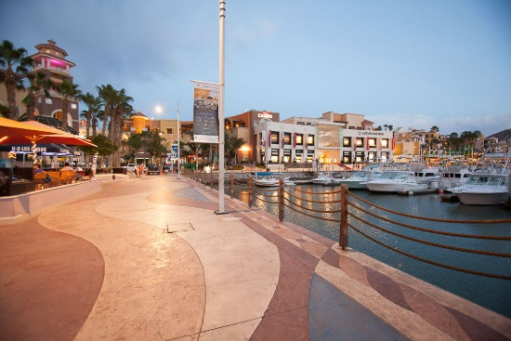
1. Marina Boardwalk (0 min, 0 ft)
At the end make another right. You’ll arrive directly at the marina boardwalk—lined with shops, bars, and charter boats. This is the hub of Cabo's tourist zone. Expect a busy but safe atmosphere with great people-watching.
Follow the walk toward the mall.
2. Luxury Avenue Mall (5 min walk, 0.2 miles / 350 yards)
A quick walk inland leads to this upscale, air-conditioned mall. Continue walking beside the harbor to the end and you will arrive at the Luxury Avenue Mall.
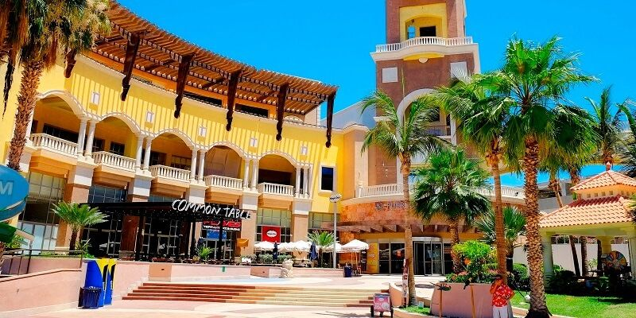
If you're looking for designer goods or just a cool place to regroup, it’s worth the detour.
3. Plaza Bonita (3 min walk from Luxury Avenue, 0.15 miles / 260 yards)
Just beyond Luxury Avenue, this open-air shopping plaza features local crafts, jewelry shops, and shaded spots to take a break.
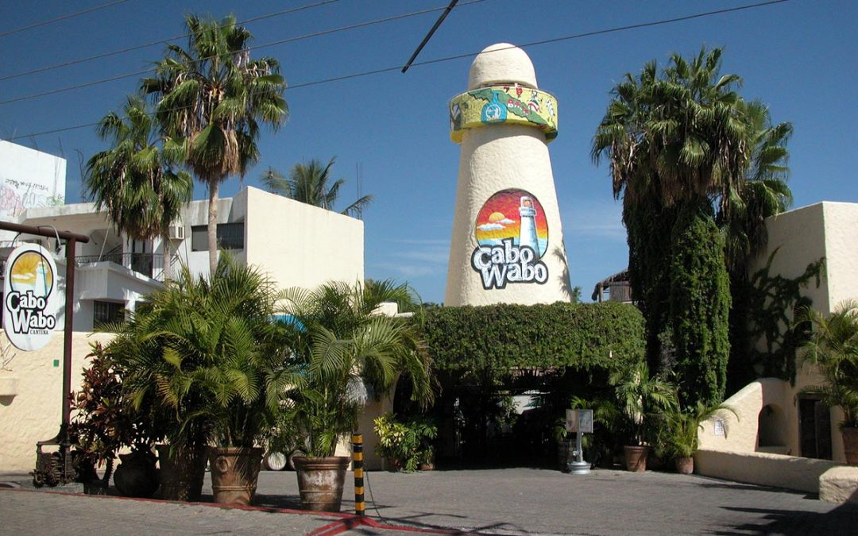
4. Cabo Wabo Cantina (4 min walk from Plaza Bonita, 0.2 miles / 350 yards)
It is hard to miss Cabo Wabo as the tower can be seen from everywhere. Head a bit farther inland and you’ll find this legendary cantina started by rocker Sammy Hagar. Loud, fun, and very Cabo.
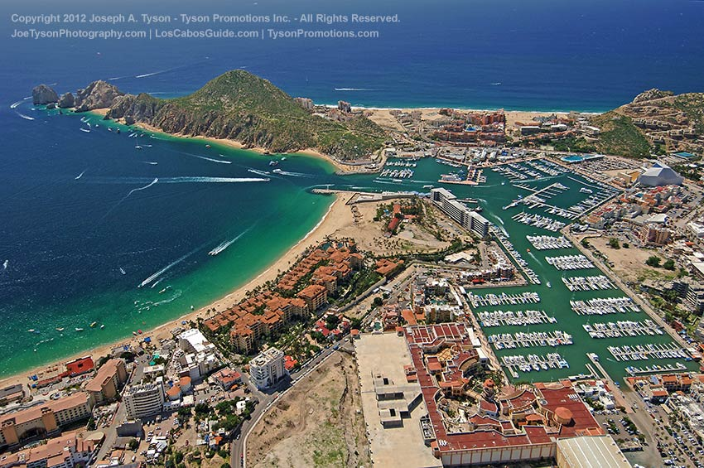
5. Medano Beach (3 min walk from Cabo Wabo, 0.15 miles / 260 yards)
Follow the road back toward the coast and you'll reach Medano Beach—Cabo’s main swimming beach. Calm waters, soft sand, and bars right on the beach make it ideal for a relaxing stop.
6. Playa El Médano Restaurants (3 min stroll down the beach, 0.15 miles / 260 yards)
Continue along the beach for a cluster of restaurants and bars. Many have lounge chairs you can use if you’re ordering food or drinks.
7. Puerto Paraiso Mall (10 min walk from the beach via main road, 0.5 miles / 880 yards)
If you're up for a little more walking, loop back toward the marina and visit this large indoor mall—ideal for picking up souvenirs or ducking into a café.
8. Land’s End Viewpoint (15 min walk from Puerto Paraiso, 0.7 miles / 1,230 yards)
While the Arch itself isn’t accessible by foot, you can follow the marina edge or beach toward the southern point for great views of Land’s End. Want to get closer? Water taxis leave from the marina ($10–15 USD round trip per person).
Return to Marina (15 min walk from viewpoint, 0.7 miles / 1,230 yards)
Head back the way you came along the marina walkway. It’s a good time to grab a cold drink and enjoy the harbor views before boarding your tender.
Total Distance: ~2.5 miles (4 km) round trip
Time Needed: 3–4 hours with casual stops
Difficulty Level: Moderate — The route is mostly flat and paved, though beach walking can be a little slower and there's limited shade.

