Burgundy: The Pinnacle of Terroir-Driven Wines

1. Region Overview
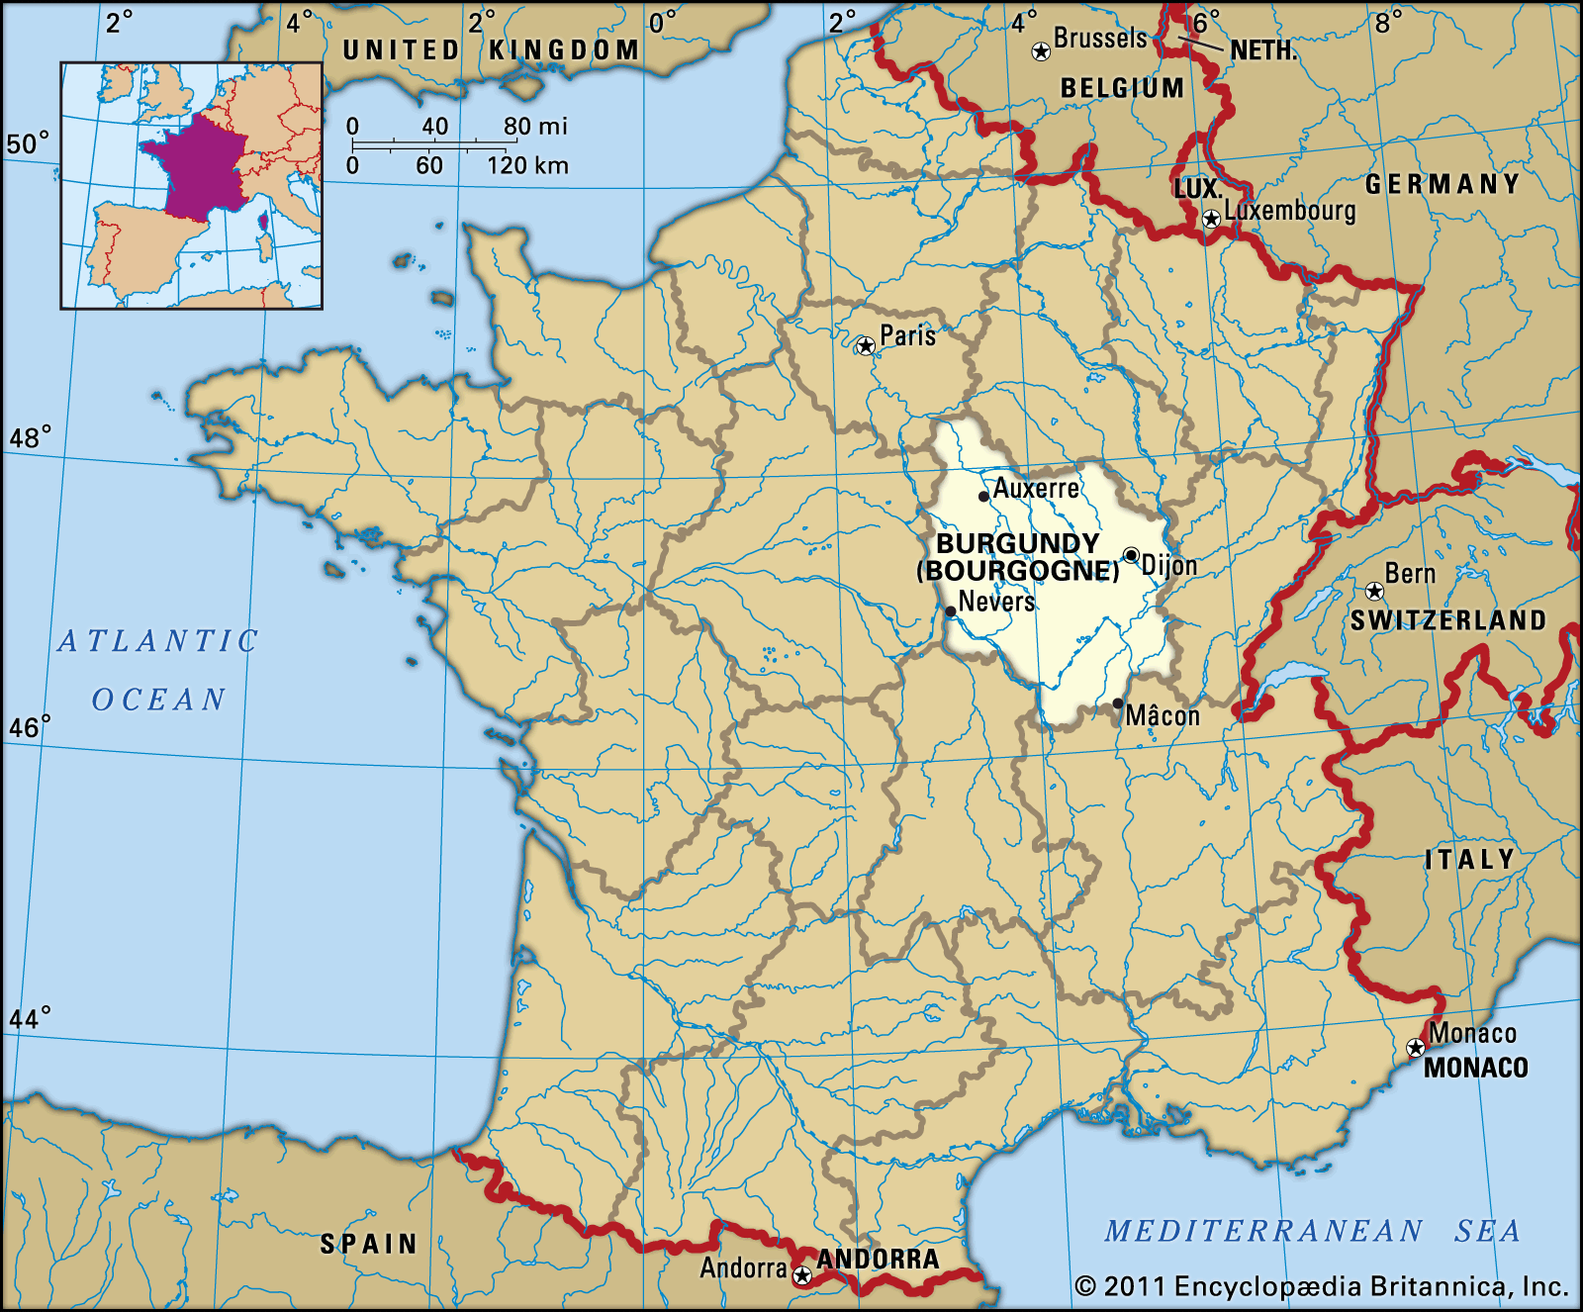
Burgundy, located in east-central France, is revered for its emphasis on terroir, producing some of the world’s most sought-after Pinot Noir and Chardonnay wines. Stretching from Chablis in the north to Beaujolais in the south, the region benefits from a continental climate with varied microclimates defining each vineyard site's character. Burgundy’s classification system, rooted in monastic traditions, meticulously ranks its vineyards, making it a benchmark for terroir expression in winemaking.

2. Key Grape Varieties
Primary Red Variety:
- Pinot Noir: The defining red grape, known for its elegance, complexity, and ability to reflect terroir.
Primary White Variety:
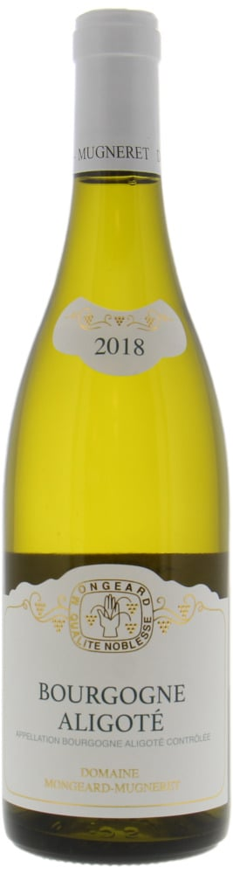
- Chardonnay: Burgundy’s flagship white variety, offering a wide range of expressions from steely Chablis to rich Meursault.
Indigenous and Regional Varieties:
- Aligoté: A crisp, high-acid white variety traditionally used for Kir.
- Gamay: The primary grape of Beaujolais, producing fruit-forward, youthful wines.
- Sauvignon Blanc: Found in Saint-Bris, an anomaly within Burgundy.

3. Wine Classification System
Burgundy’s vineyards are classified in a strict hierarchy based on terroir quality:
- Grand Cru: The highest classification, representing only 1% of total production, with legendary vineyards such as Romanée-Conti and Montrachet.
- Premier Cru: High-quality vineyards making up about 10% of production, offering exceptional wines just below Grand Cru status.
- Village Wines: Representing individual communes like Gevrey-Chambertin or Meursault, providing distinctive regional character.
- Bourgogne AOP: The broadest designation, covering wines made across the entire region, often offering excellent value.

4. Notable Wine Styles
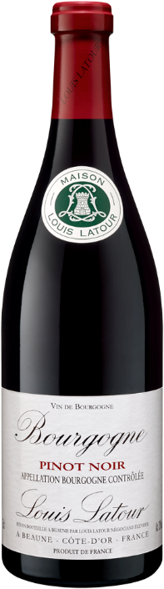
Red Burgundy (Pinot Noir)
Figure 1 2020 Louis Latour Bourgogne Pinot Noir,
- Classification Level: Grand Cru, Premier Cru, Village, Bourgogne AOP.
- Composition: 100% Pinot Noir.
- Production Method: Traditional fermentation, often with whole-cluster inclusion for added complexity.
- Aging Requirements: Variable; Grand Cru wines often require years to reach peak expression.
- Alcohol Content: Typically 12.5–14% ABV.
- Organoleptic Profile: Red fruit, earth, floral notes, and elegant tannins with a long, refined finish.
White Burgundy (Chardonnay)
- Classification Level: Grand Cru, Premier Cru, Village, Bourgogne AOP.
- Composition: 100% Chardonnay.
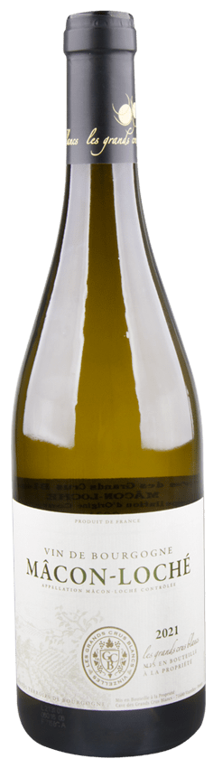
- Production Method: Barrel fermentation and aging, with variations in oak influence depending on the appellation.
Figure 2 Les Grands Crus Blancs Mâcon-Loché 2021
- Aging Requirements: Higher-tier wines benefit from extended aging.
- Alcohol Content: Typically 12.5–14% ABV.
- Organoleptic Profile: Citrus, apple, mineral, and hazelnut notes, with pronounced texture and acidity.
Chablis (Unoaked Chardonnay)
- Classification Level: Grand Cru, Premier Cru, Chablis AOP, Petit Chablis AOP.
- Composition: 100% Chardonnay.
- Production Method: Typically fermented in stainless steel to retain minerality and freshness.
- Aging Requirements: No strict requirements, but top wines can age gracefully.
- Alcohol Content: 12–13% ABV.
- Organoleptic Profile: Flinty minerality, green apple, citrus zest, and crisp acidity.
Beaujolais (Gamay)
- Classification Level: Beaujolais AOP, Beaujolais-Villages AOP, Cru Beaujolais.
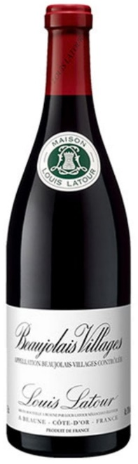
- Composition: 100% Gamay.
Figure 3 Louis Latour Beaujolais-Villages 2019
- Production Method: Carbonic maceration is commonly used for fruity, approachable styles.
- Aging Requirements: Typically consumed young, though Cru Beaujolais can age.
- Alcohol Content: 12.5–13.5% ABV.
- Organoleptic Profile: Red berries, floral notes, and a soft, juicy texture.

5. Additional Context
- Recent Developments: Increased focus on organic and biodynamic viticulture, particularly in Côte d’Or.
- Historical Context: Burgundy’s vineyard system dates back to medieval monastic traditions, with meticulous attention to terroir.
- Food Pairing Notes: Red Burgundy pairs well with roast duck and mushroom dishes; White Burgundy complements seafood and creamy sauces.
- Producer Information: Notable producers include Domaine de la Romanée-Conti, Domaine Leflaive, and Georges Duboeuf for Beaujolais.

This structured chapter ensures a deep understanding of Burgundy’s complex classification and terroir-driven wines, making it an essential reference for sommelier exam preparation.

