Building the Ultimate Budget Listening Room
By: Marc Silver
I. So, You Want to Build a Listening Room?
Let me guess, you’ve been thinking about setting up a dedicated space to really enjoy your music. Maybe you’ve already got some gear, or maybe you’re starting from scratch. Either way, you want it to sound great, but you don’t want to go broke doing it. Good. You’re in the right place.
Forget the glossy magazine shots of $500,000 to $1,000,000 rooms lined with exotic hardwood and gear that costs more than a Lamborgini. That’s fantasy. This is about the kind of room you can actually build, without taking out a second mortgage. A space that sounds right, feels comfortable, and gets you lost in the music, not the gear.
I’ve been creating listening rooms for over 50 years, and if there’s one thing I’ve learned, it’s this: it’s not all about how much you spend.
Anyone can spend 7 figures and end up with an amazing listening room, but I don’t have that type of budget and I have only had three customers in all those years that could. But to be honest, they didn’t want to spend that much.
My approach to system design has always been to invest as little as possible, but get magnitudes more in performance. It’s about how well you listen, and how smart you are about putting the pieces together. Room acoustics, speaker placement, used gear that still holds its own, these are the things that matter. Not the latest buzzwords or boutique cable nonsense.
So that’s what this article is about. Real advice. Real tools. Stuff you can do yourself, in the space you already have, with the budget you can actually afford. Whether you’re setting up in a spare bedroom, the garage, or just carving out a corner of the living room, I’ll walk you through how to make it sound good, and more importantly, how to make it yours.
Let’s get started with the room itself.

II. Start with the Room You Have, Not the One You Wish You Had
Before you buy a single thing, stop and take a good look at the space you’re working with. This is where most people go wrong, they think they need to upgrade their gear when what they really need is to understand their room.
Now, let’s be honest: if you’ve got a purpose-built, rectangular room with some decent dimensions and no parallel walls, great. But most of us don’t. Maybe you’re setting up in a spare bedroom. Maybe it’s a section of your basement, or even a corner of the living room. That’s fine too. You can make just about any space work with a little planning and a few smart tweaks.
Here’s what you’re looking for:
- Avoid square rooms if you can. They’re the worst for sound, too many reflections, and too much bass build-up in the corners.
- Hard surfaces (tile floors, bare drywall, big windows) are going to bounce sound around like a racquetball court. But don’t panic, we’ll fix that with some simple treatment later.
- Rooms with some “stuff” already in them, a couch, bookshelves, rugs, are actually better starting points than empty which acts like and echo chambers. Furniture helps break up reflections and tame harshness.
Also, think about how the room is used. Is this space shared with a TV setup? Do you need it to still look like a living room? If so, we’ll keep things flexible and good-looking. On the other hand, if it’s your private den or music cave, we can get more focused and functional.
The main thing is this: don’t wait for the perfect room. Use what you have. Make it work. Then make it better.

III. Taming the Room: Acoustic Treatment Without the Nonsense
Let me say this up front: if you skip room treatment, you’re never going to get the sound you’re chasing. I don’t care how much you spent on your speakers, if your room is a mess acoustically, it’s like putting racing tires on a Yugo. Looks good but it’s still a disaster.
Here’s the good news: treatment doesn’t have to be expensive, and you don’t need a degree in acoustical engineering. You can fix most common problems with a few materials, some basic tools, and a couple of weekends.
Let’s break this down into two problem areas: midrange reflections and boomy bass.

A. Midrange Madness: Sound Baffles to the Rescue
You know that harsh echoey sound when you clap your hands in a bare room? That’s your midrange reflecting off hard surfaces, walls, ceilings, floors. That slap-back echo is what makes music sound fuzzy and fatiguing.
The fix is simple: soft, absorptive panels called baffles.
You don’t have to buy overpriced foam tiles that look like a kid’s playroom. Instead, build your own panels using:
- A wood frame (1x2s or 1x4s work great)
- A filler like Rockwool, fiberglass, or even dense carpet pad
- A breathable fabric cover (burlap, muslin, or my favorite, open weave double-knit)
Mount them where they’ll do the most good:
- Side walls next to your speakers, use the old mirror trick: sit where you normally listen and move a mirror along the wall. Wherever you see the speaker’s reflection, that’s were the sound hits first.
- Behind your chair if your seat is near a back wall.
- Ceiling if it’s high or hard-surfaced. You can hang panels from hooks or even suspend them like clouds.
The difference in clarity is immediate. Vocals clean up. Instruments don’t smear together. You’ll find yourself turning the volume down because you can finally hear everything.

B. Bass Problems? Time to Trap It
Bass is a different beast. Low frequencies are long, lazy waves that bounce around until they settle into corners and turn your room into a swamp. That’s where bass traps come in.
Again, you can build your own. I’ve made dozens over the years out of scrap wood, mineral wool, and leftover fabric. The two main styles I’d recommend are:
- Triangular corner traps (also called SuperChunks): stack dense insulation in room corners from floor to ceiling. Add a fabric front and you’re done. These soak up deep bass like nothing else.
- Rectangular wall traps: like the baffles, but thicker, at least 4 inches, and better if they’re spaced a bit off the wall. Great for behind speakers or behind your seat.
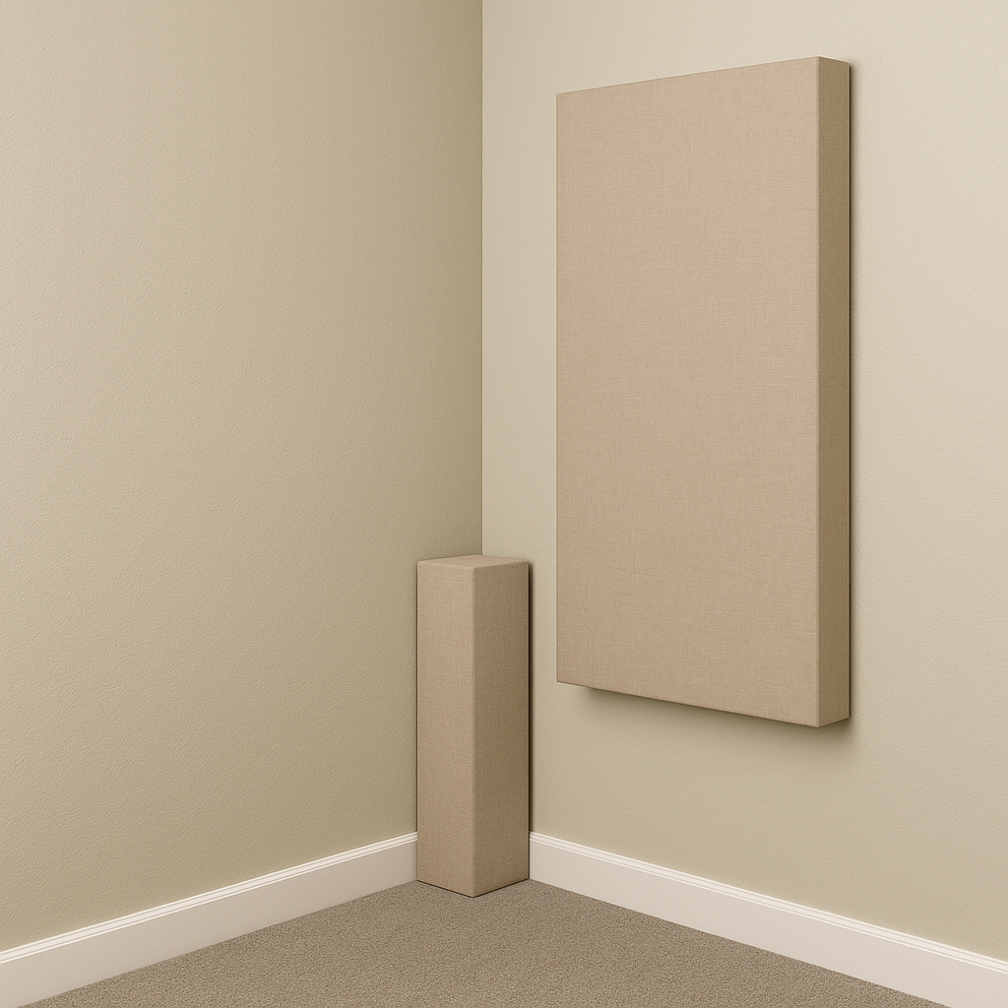 Corners are where most of your bass problems live, so start there. Even two traps in the front corners of your room can make a night-and-day difference.

C. How Much Is Enough?
You don’t need to cover every inch of the room. In fact, too much absorption can make things sound dead. Start small. Build a couple of baffles, hang them at key spots, and listen. Add bass traps as needed. This isn’t a one-and-done thing, it’s a process. And you get to enjoy every improvement along the way.
The goal here isn’t “perfect” acoustics. It’s better acoustics. Clean up the worst of the reflections, tame the bass, and suddenly your gear starts to sound a whole lot more expensive than it is.

IV. Used Gear: The Secret Weapon
Let me tell you a secret that every seasoned audiophile knows but barely talks about, the best bang-for-the-buck gear is almost always used.
I’ve bought, sold, and rebuilt more components than I care to count. And time after time, I’ve heard $1000 used systems walk all over $3,000 to $5,000 setups fresh out of the box. Why? Because good gear doesn’t stop sounding good just because it’s old. If you can spend $300 on a power amp that used to cost $2000 and a new version might cost $3k or more, that’s a good investment. My second system I have set up in my living room has a Sumo Electra Preamp built in 1988 and I couldn’t replace it for $2000 today.

Start with the Speakers
If you’re on a tight budget, put most of your money here. A great pair of speakers will bring life to everything you play.
I have always use the ratio of 40% to 50% of my equipment budget goes to the speakers.
Here’s what I tell people shopping used:
- Stick to passive speakers (not powered).
- Check the foam surrounds, if they’re crumbling, factor in a re-foam job.
- Give them a listen if you can. If not, ask good questions.
There’s no shortage of gems out there. Classic KLH, Advent, early Polk, Vandersteen, Snell, Wharfedale, and Magnapan are all good choices. But there are hundreds more to choose from. If you find a possible used speaker choice go online and find a review from when it was released. Go on audio forums and see what other audio enthusiast have to say.
You just need to know what you’re looking at before you buy, because once you buy them they are yours. Remember Used means AS-is, Where -is!

Amps and Integrateds: Workhorses with Soul
Look for Yamaha, Denon, NAD, Pioneer, Sansui, or Nikko. You can also consider some of the classic tube gear, like Dynaco or Fisher. If you can spend more, Consider some of the High-end separates. Don’t worry if the knobs crackle, dirty pots are an easy fix. Ask if it’s been serviced. If not, budget for a recap or cleanup.

Sources: Use What You’ve Got (and Add Later)
Got a CD player? Use it. Vinyl? Focus on the cartridge. A classic turntable selling for under $200 can offer performance that can easily exceed spending $500 new. Streaming? Even a cheap DAC will do the job. Consider a Pro-Ject DAC Box E or a Audio Quest DragonFly both are amazing little DACs for not a lot and can outperform a lot of High-end DACs built in separate preamps.
Remember you don’t have to get everything perfect the first time.

Where to Look, and What to Avoid
Where to look: Craigslist, Facebook Marketplace, AudioCircle, Audiokarma, estate sales. I have found incredible buys at yard sales and Goodwill. Be careful and verify everything is working well before you buy.
What to avoid: Mildew, sketchy repairs, “just needs a fuse” listings, or anything that smells off.
Used gear is where your system starts to feel personal, something you built, not something you just unboxed.

V. Speaker Placement: The Best Upgrade You’re Not Paying For
Once your gear is in place, speaker positioning is your next move, and it’s free. Even the best components can sound off, if they’re in the wrong spot. I have gone to nearly 100 different audio shows during my career and I have heard great setups and others that I walked out thinking did anyone listen to the system before they opened the doors. Even “professionals” can screw up, and they do that more often than one would think. It’s all about how you position the speakers in the room.

The Triangle Rule
Your two speakers and your listening seat should form an equilateral triangle, equal distance between each point.
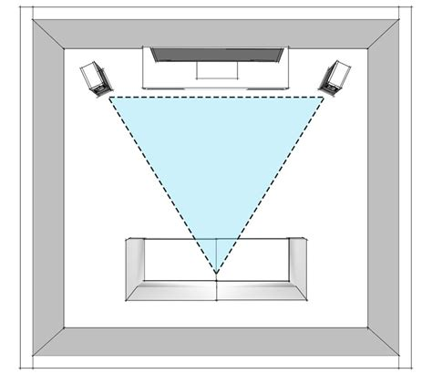
Diagram: Classic listening triangle, equal distances between speakers and listener, with a slight inward toe-in.

Quick Math: How Far Apart Should the Speakers Be?
Here’s an easy rule:
Speaker spacing = 75 to 85% of the distance from you to the speakers
If you’re sitting 8 feet away, your speakers should be 6 to 6.5 feet apart. Or for a pure triangle, keep all three distances equal.
Formula:
Speaker Distance = Listening Distance × 0.78

Practical Placement Tips
- Raise them: Tweeters should be at ear level.
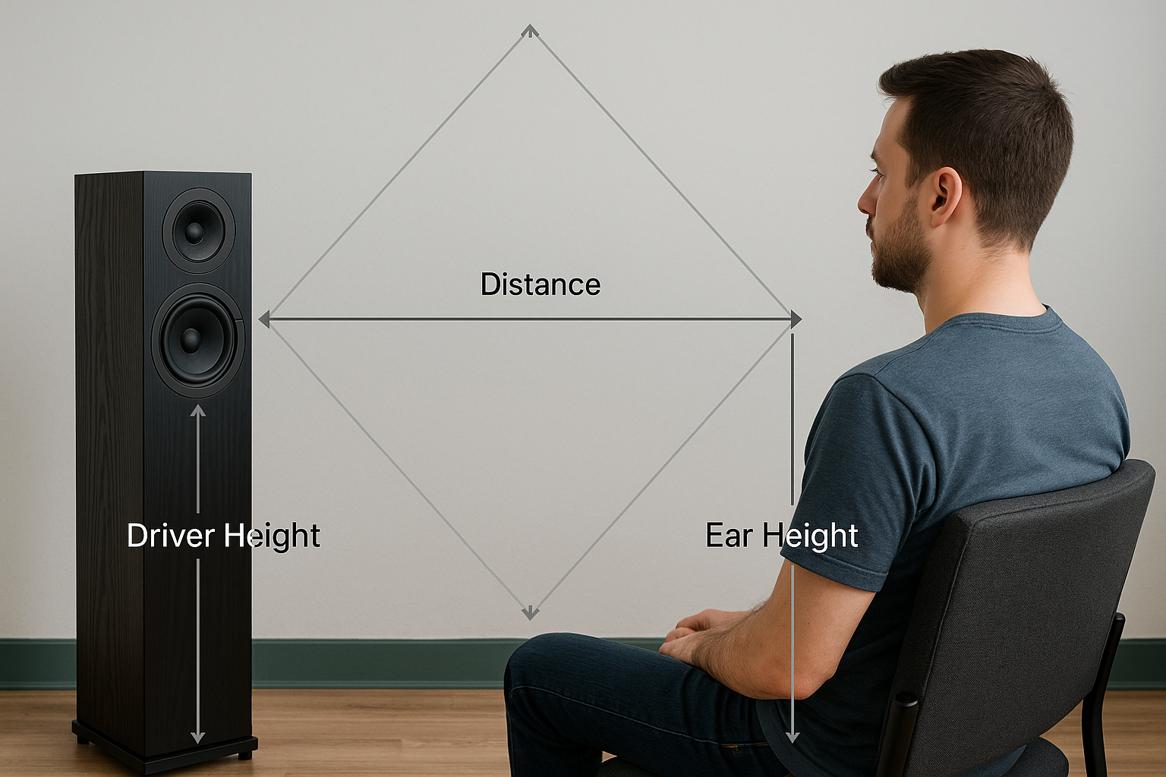

- Avoid corners: Pull them away from walls, 18 to 24 inches is a good start.
- Toe-in: Aim the speakers so they point just behind your head.
And if you’ve got a hard floor, lay down a rug. Cuts down midrange reflection and adds warmth. Remember the speaker will send secondary sound in all directions, so realize sound will bounce of the floor, the ceiling and the walls before it reaches your ears.
Final Tip: Listen and Adjust
Small moves make a big difference. Slide them a bit, toe them in, scoot your chair, trust your ears. Don’t be afraid to reposition the speaker in the room. Little changes can make big differences.

VI. Where You Sit Matters More Than You Think
You’ve picked a room, treated the worst reflections, found some great used gear, and dialed in your speaker placement. You’re almost there. But here’s one more thing that can make or break your sound, your listening position.
People forget this part. They’ll spend weeks fussing over speaker angle or swapping cables, but they plant their chair right against the back wall and wonder why the bass sounds like mush.

The Wall Is Not Your Friend
If your seat is right up against the wall, especially in a small or untreated room, you’re sitting in the worst possible place for bass. That’s where all the low-frequency energy piles up. You get boom, smear, and no definition.
Even moving your sitting possition, a foot or two forward can help clean that up dramatically. If you can, try sitting around 68% of the room’s length from the front wall (where your speakers are). It’s a sweet spot that avoids a lot of the worst standing waves.
Example: In a 12-foot-long room, 68% puts you about 8 feet from the front wall and 4 feet from the rear wall.
This should fit in conjunction with the triangle for speaker placement. Again, feel free to move things around.

Symmetry Helps
Try to center yourself between the side walls. You don’t want one speaker jammed next to a bookshelf while the other fires into open space. That throws off imaging. Even if your room isn’t symmetrical, your seating should be as balanced as possible. 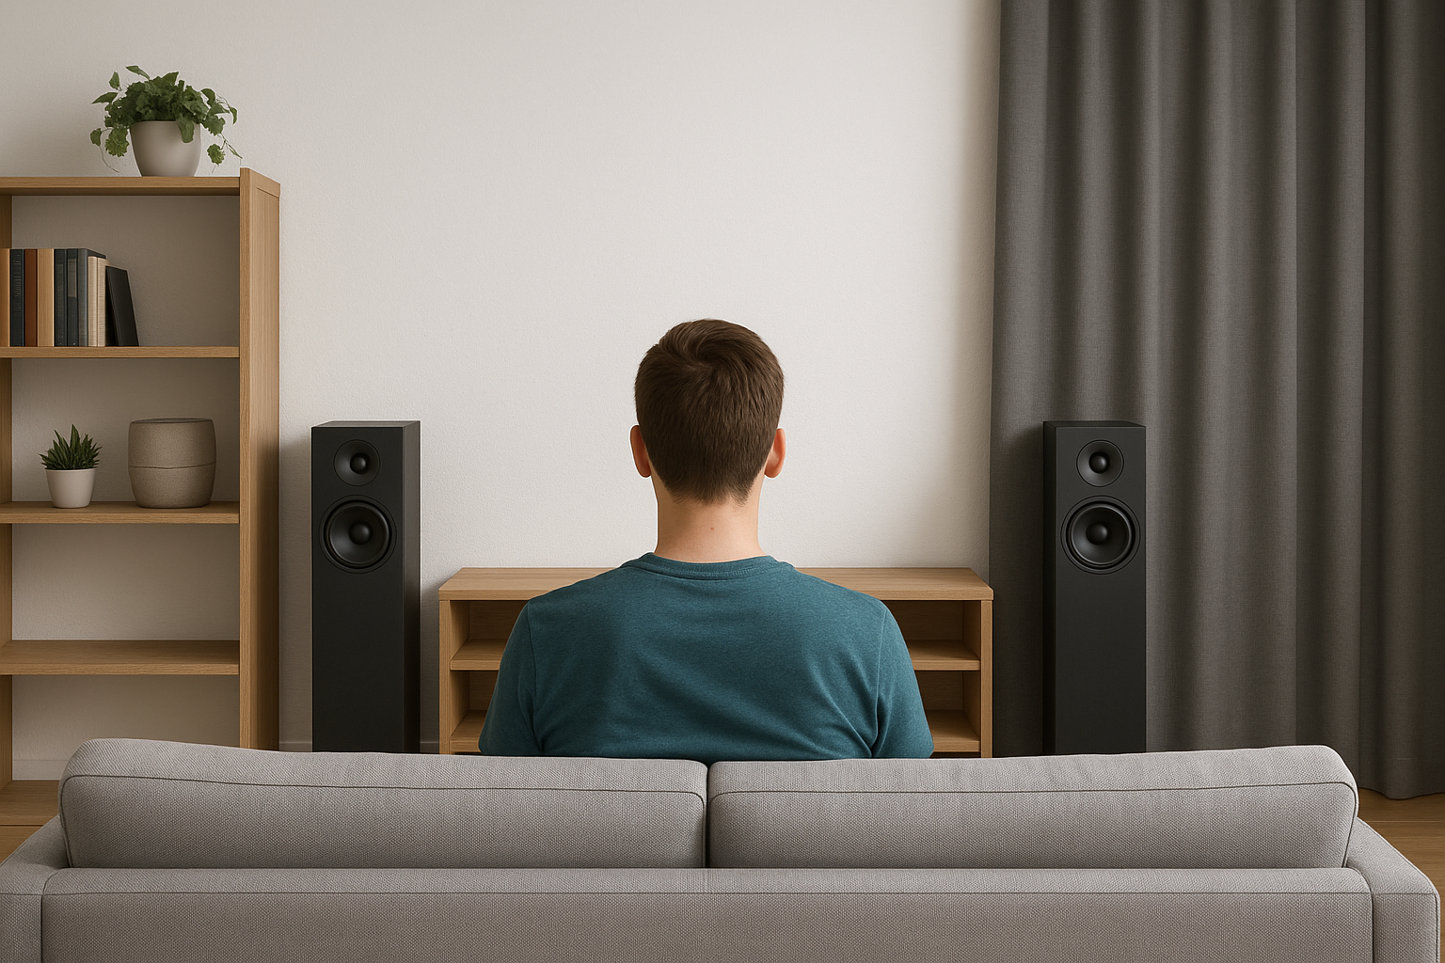
If one side has a window and the other side has a bare wall, think about adding a curtain or panel to even things out acoustically.

Treat the Wall Behind You (If You Can)
If your sitting position has to stay near the back wall, hang a couple of thick sound baffles or even a bookshelf filled with random books and objects. It’ll break up reflections and help prevent slap-back echo that can ruin your imaging.

Comfort Counts, Too
Let’s not forget, you’ll be spending hours here. Make it comfortable. A decent chair or couch with a low back works better than a big overstuffed recliner. You want to hear the speakers, not bounce sound off your headrest.
And don’t overlook simple things like lighting. A warm lamp, a small table, somewhere to put your drink, this isn’t just about fidelity, it’s about enjoying the music.
VII. Cables, Power, and Snake Oil
This is where a lot of people lose the plot, and their wallets. They’ve set up a great room, decent gear, and then someone tells them they need $800 speaker cables or a power conditioner with cryogenically frozen outlets. Next thing you know, they’re broke and their system doesn’t sound any better.
Let’s keep it simple.

Cables: Use Good Ones, but don’t go nuts.
Do cables matter? Yes. But not in the way you’ve been told.
What matters:
- Solid connections
- Proper gauge wire
- Clean, tight terminals
What doesn’t matter:
- Fancy jackets
- Gold-plated marketing
- Magical “burn-in” claims
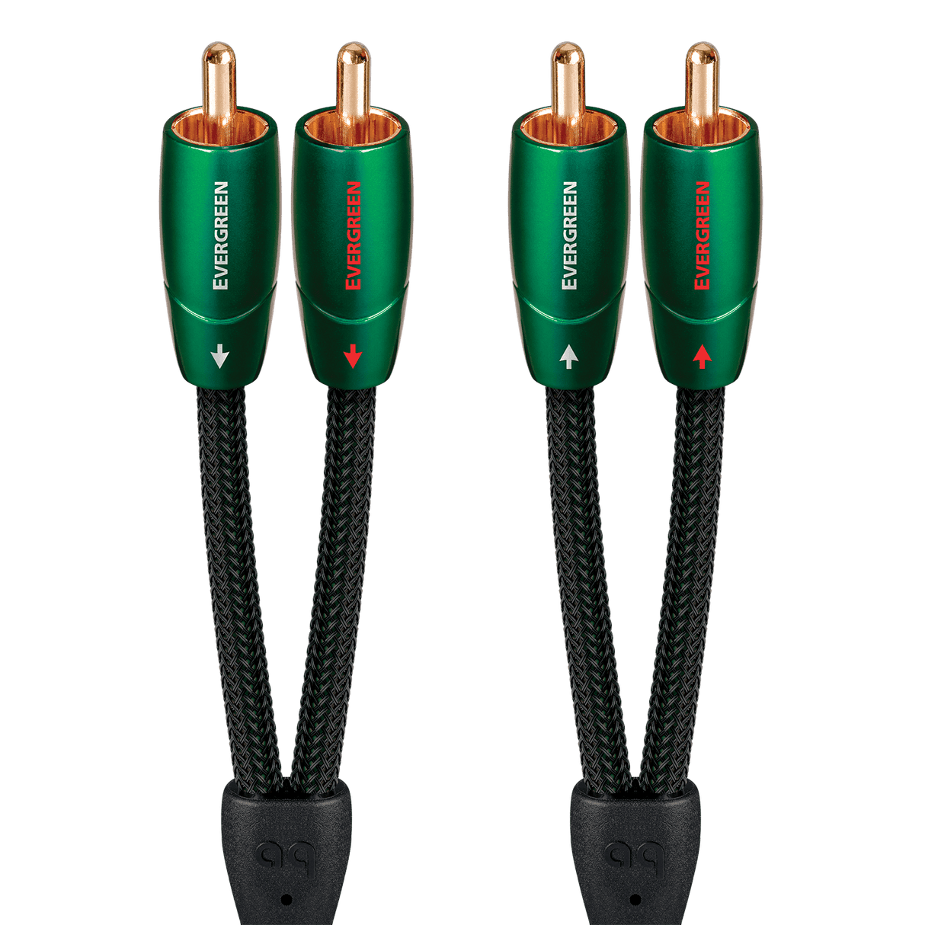
Use at least a 14-gauge or thicker OFC speaker wire for most setups. If your runs are under 20 feet, 16-gauge can be acceptable. You can buy this stuff by the spool from a hardware store. Get some banana plugs or spade lugs if it makes connecting easier. I am a firm believer that you don’t put Pirelli P7 tires on a Pinto and you don’t buy 4 ply nylon tires for your Porsche. If you plan on buying mega dollar wire, barrow a pair and listen to them in your system. Then decide does the improvement make financial sense. I have used Nordost Valhalla as part of my display at High End show and they are amazing cables, but I also was showing pretty respectable gear.
For RCA cables? Avoid the dollar-bin junk with loose fittings and sketchy shielding. There are plenty of decent ones out there, lines like Kimber Kable, Apature, WireWorld and Audioquest all make reasonably priced, well-built, wire without the hype.
Figure 1 Evergreen RCA > RCA $73.95/pr

Power: Keep It Clean, Not Complicated
Most of the time, your system will run just fine plugged into a basic surge protector. The hum, buzz, and noise that people blame on “dirty power” usually comes from:
- Ground loops
- Bad interconnects
- Fluorescent lighting or dimmer switches
Start by plugging everything into the same outlet or power strip to avoid ground loops. If you hear a buzz, unplug components one at a time to find the offender. It’s usually the cable box, subwoofer, or something plugged into a different circuit.
Do you need a power conditioner? Probably not. I personally use an assortment of line conditioners on all four of my systems. So, I obviously recommend using them. If you live in an area with sketchy voltage or storms, sure, get one with surge protection and maybe some filtering. But don’t expect it to turn your mid-fi setup into a mastering studio.

The Real Fixes Are Often Free
Here are things that help more than $400 cables ever will:
- Clean your connections with DeoxIT or 99% alcohol.
- Tighten every terminal, loose RCA jacks are a common noise source.
- Keep power cables and signal cables from lying on top of each other.
- Dress your cables neatly, less clutter, fewer surprises.

A Note on Hum and Buzz
Got a low hum that won’t quit? It’s almost always a grounding issue. Try lifting the ground on a single component using a cheater plug (just be safe and don’t make this permanent unless you understand what you’re doing). Or isolate your sub with a ground loop eliminator.
And check your lighting. Dimmers, compact fluorescents, and cheap LED bulbs can throw nasty RF interference into your system. Sometimes swapping a bulb makes more difference than anything else.

This section’s takeaway is simple: don’t get distracted by the shiny stuff. The boring, practical fixes are the ones that actually work.
Next up: Let’s talk about living with your room, not just tweaking it endlessly. Looks, comfort, and why your system should invite you in, not wear you out.
VIII. Looks, Lighting, and Livability
Once your room starts sounding right, something funny happens, you actually want to spend time in it. That’s the whole point, right? Not just great sound, but a place that feels like yours. So, let’s talk about making it livable.
You don’t need your space to look like a recording studio or an equipment shrine. You just need it to feel comfortable. Inviting. Like somewhere you’d want to sit for an hour and really listen.

Make the Treatment Blend In
Acoustic panels don’t have to look like gray tombstones. If you’re building your own, take a little extra time with fabric. Use colors that work with the room. You can even stretch patterned cloth or printed canvas over the frame to make it look like art.
Got bookcases? Fill them unevenly with books, records, knickknacks, anything that breaks up sound and hopefully means something to you. This is your home, remember. That’s free diffusion and it looks better than a grid of black foam tiles.
And don’t underestimate plants. A tall leafy one in the corner not only looks good, it helps scatter reflections. You’re not building a lab; you’re building a space that’s nice to be in.

Lighting Makes a Bigger Difference Than You Think
Skip the overhead fluorescents. Go for soft, warm lighting, lamps, dimmers, even old-school bulbs if you can find them. Harsh lighting makes the room feel clinical. A warm glow helps you relax, focus, and stay in the zone.
I like a small lamp next to the sitting position, another one behind the speakers or near a rack. Adds depth and makes the gear look better, too. Bonus points for vintage shades or Edison bulbs if you’re going for a vibe.

Cable Management = Sanity
This is where things sneak up on you. One minute you’ve got a few wires, next thing you know, there’s a nest of tangled spaghetti under your rack.
Keep it neat:
- Velcro ties are cheap and reusable
- Route cables in clean lines
- Label things if you swap gear a lot
Not only does this keep your room clean, but it helps you troubleshoot faster if something happens to go wrong later.

The Listening Sitting Position Matters
This is your throne. Make it a good one.
Low or open-backed chairs are better acoustically, but don’t let that stop you from picking something comfortable. If you’re cramped or 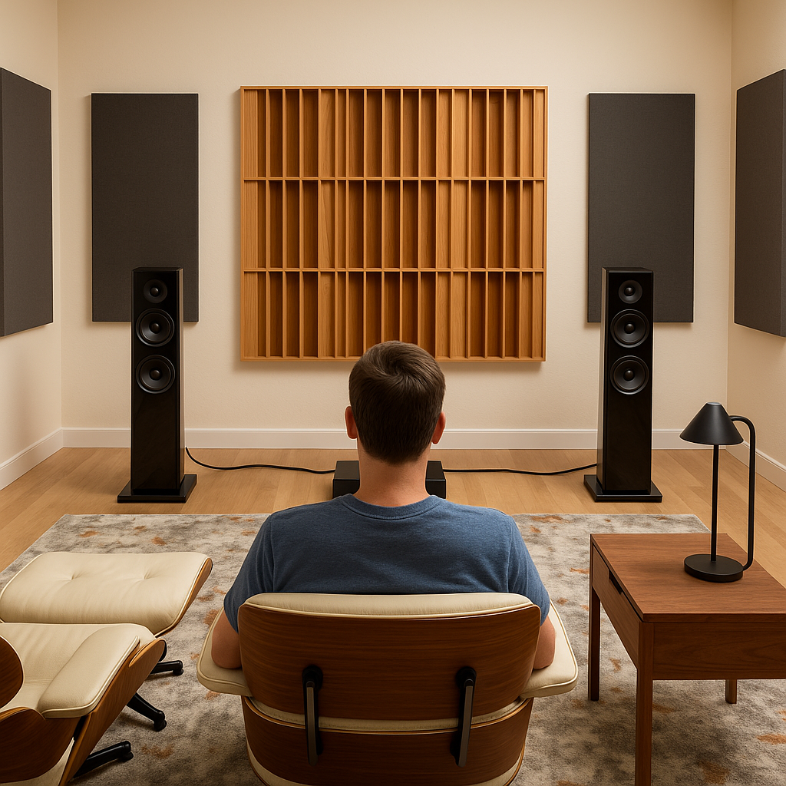 distracted, you won’t enjoy the music. I’ve seen people spend thousands on speakers and then sit on a creaky folding chair. Don’t be that guy.
Also, think about foot traffic. If this room has other uses, family room, guest room, office, you want to be able to get in, out, and around without knocking over your speakers.

It’s Your Space. Own It.
This room doesn’t need to impress anyone but you. Fill it with the music you love, the gear you trust, and the little touches that make you feel at home. A record shelf. A print of your favorite album cover. An old concert poster. A hook for your headphones. A drawer for remote controls and stylus cleaner.
The more time you spend in the room, the more you’ll want to tweak and refine. That’s part of the fun. But never lose sight of the goal: music, joy, connection.
IX. Experience Over Equipment
Here’s the part most people miss: this isn’t about gear. It’s not about chasing specs or reviews or what the forums say is “better.” It’s about experience. It’s about listening.
You don’t need the most expensive speakers, or a room built from scratch, or cables blessed by monks. You just need a space that works, where music sounds the way it should, and you feel connected to what you’re hearing.
The truth is, a well-set-up budget $2,000 system in a treated room will beat the pants off a $10,000 system in an echo chamber. Every time. Because what matters most isn’t the badge on your amp. It’s what you hear when you close your eyes.
And here’s the best part: when you build it yourself, when you figure out your own room, solve your own acoustic problems, track down that used gem, and dial in your setup, you’ll know your system. It won’t just sound good. It’ll feel like yours.
You’ll stop thinking about upgrades and start thinking about what you want to play next.
So go ahead, start with what you have, spend wisely, trust your ears, and build a room that invites you in. That’s the ultimate budget listening room.
Because in the end, it’s not about having more gear.
It’s about getting more out of what you already have.

