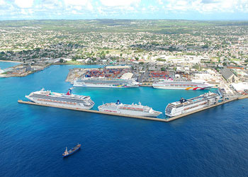
Bridgetown, Barbados Walking Tour
Bridgetown Self-Guided Walking Tour: A Journey through History and Harbor
Starting Point: Bridgetown Cruise Terminal (Deep Water Harbor)
Total Distance: Approximately 2 miles (3.2 km) round trip
Estimated Time: 2 to 2.5 hours at a leisurely pace
Difficulty: Easy — flat terrain on paved streets and sidewalks.
Language Note: English is the official language, and the local Bajan dialect is widely spoken.

1. From the Cruise Port to the Careenage
Exit the Bridgetown Cruise Terminal and follow the signs for the city center. After a short 10-minute walk, you'll arrive at the Careenage, the picturesque inner harbor that has been the city's heart since the 17th century. This is where ships were once tipped on their sides ("careened") for cleaning and repair. Today, it's a tranquil area filled with fishing boats and yachts, surrounded by restaurants and historic buildings.
Tip: Take a moment on the bridges to admire the view and spot sea turtles swimming in the clear water.
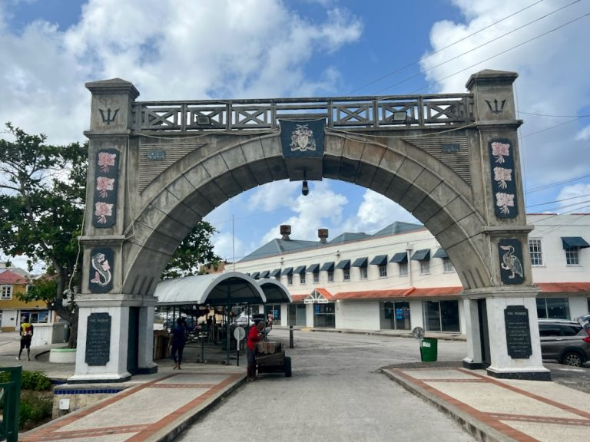
2. Independence Arch & National Heroes Square
Cross the Chamberlain Bridge from the Careenage, passing under the Independence Arch—a modern monument celebrating Barbados's journey to nationhood. This leads you directly into National Heroes Square (formerly Trafalgar Square). Here you'll find the Dolphin Fountain, the War Memorial, and statues of the island's national heroes, including the righteously defiant Bussa.
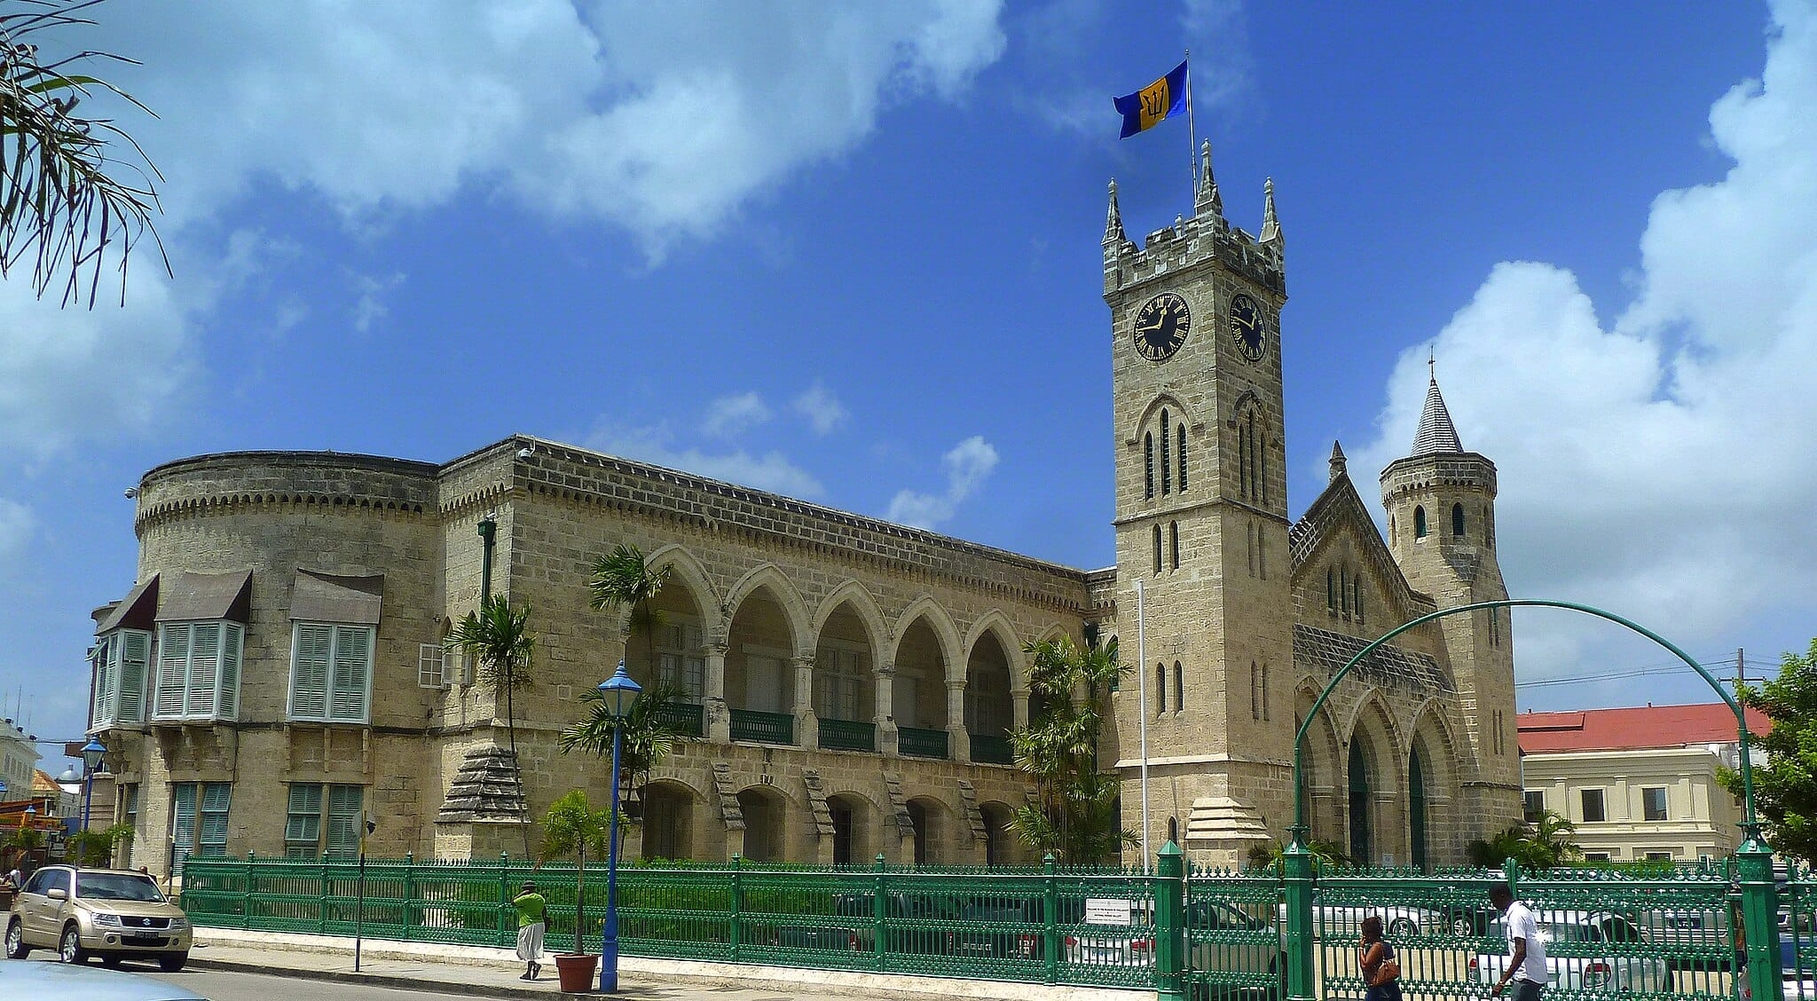
Time here: 15–20 minutes
Tip: Look for the plaque dedicated to the Syrians and Lebanese, highlighting another thread in Barbados's diverse cultural tapestry.
3. Parliament of Barbados & Parliament Museum
A one-minute walk from the square brings you to the Public Buildings, a magnificent neo-Gothic structure housing the Parliament of Barbados. Established in 1639, it's the third-oldest parliament in the Commonwealth. Visit the small but excellent Parliament Museum to see the mace and other historical treasures, or simply admire the architecture from the outside.
Tip: The museum has a small fee and is a great way to escape the midday heat for a few minutes.
4. St. Michael's Cathedral
Walk up the gentle incline of St. Michael’s Row for about 5-7 minutes to reach the iconic St. Michael's Cathedral. The original church was built in 1665, but the current stone structure dates from the 19th century after being rebuilt following a hurricane. Step inside to feel the cool, quiet serenity and admire the beautiful stained-glass windows.
Tip: Notice the churchyard's ancient tombstones, which tell stories of Bridgetown's early settlers.
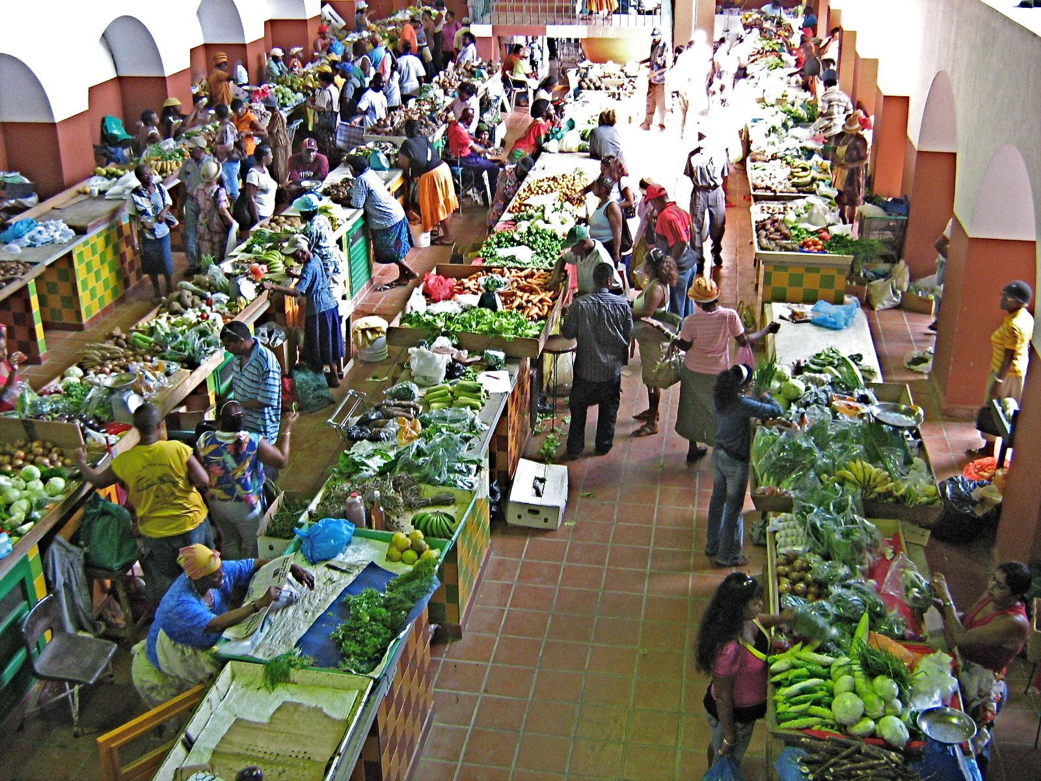
5. Cheapside Market
From the cathedral, head west to the bustling Cheapside Market. This is the city's main public market, where vendors sell fresh, colorful produce, flying fish, and local spices. The energy is vibrant, and the scents are a mix of the sea, fresh fruit, and Bajan seasonings. It’s a fantastic place to see local life in action.
Time here: 20 minutes
Tip: Vendors are friendly, but always ask before taking photos. It's a great place to buy local seasoning like Bajan pepper sauce.
6. Lunch & Refreshment Stop — A Taste of Bajan Flavor
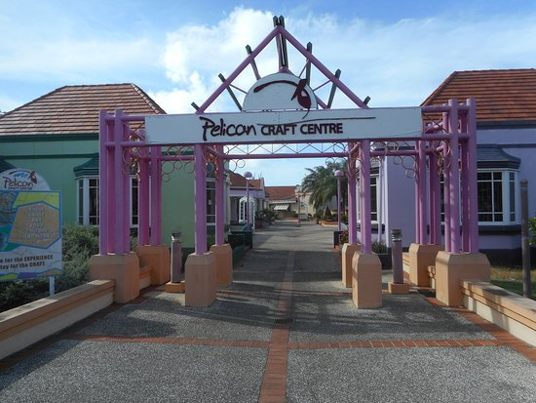
After the market, it's time for a refreshment. The streets around the Careenage and Broad Street (the main shopping street) are lined with options. For an authentic experience, find a casual spot to try a Banks Beer (the local lager) or a Mauby (a unique bitter-sweet bark-based drink). For a snack, you can't go wrong with a fish cake from a street vendor or a flying fish cutter (a sandwich) from a cafe.
Tip: Many restaurants along the Careenage have outdoor seating, perfect for watching the world go by.
7. Return to the Port via the Pelican Craft Village
For your return, take a slightly different route. Walk south for about 10 minutes from the city center to the Pelican Craft Village. This complex houses local artisans in dedicated workshops where you can see them creating and sell their wares, from pottery and woodcarvings to jewelry and fine art. It’s a more relaxed shopping experience than the city center.
From here, it's a straightforward 15-minute walk back to the cruise terminal.
Tip: This is one of the best places on the island to buy authentic, high-quality souvenirs directly from the artists.

Before You Go
- Currency: The local currency is the Barbadian Dollar (BBD), but U.S. dollars are widely accepted. Prices are often listed in both currencies.
- Safety: Bridgetown is generally safe during the day. Standard city precautions apply: be aware of your surroundings and keep valuables secure.
- Weather: Barbados has a sunny tropical climate. Wear a hat, sunglasses, and sunscreen. A bottle of water is essential, and a light rain jacket might be handy for sudden, brief showers.
- Etiquette: Bajans are famously friendly. A cheerful "Good morning" or "Good afternoon" before starting a conversation is the norm and is greatly appreciated.
In Summary
This walking tour takes you from the modern port through the historic core of a UNESCO World Heritage Site. You'll experience the colonial history, the vibrant market culture, the serene spiritual sites, and the creative pulse of modern Barbados—all within a compact and walkable area.
Bridgetown is more than just a port; it's a living museum and a bustling Caribbean capital, offering a rich tapestry of stories waiting to be discovered just steps from your ship.

