Bose's Acquisition of McIntosh and Sonus Faber: A Strategic Move into Automotive Audio
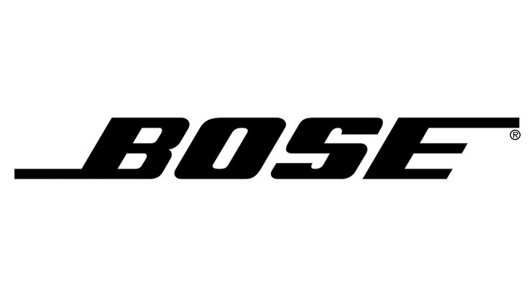
By Marc Silver
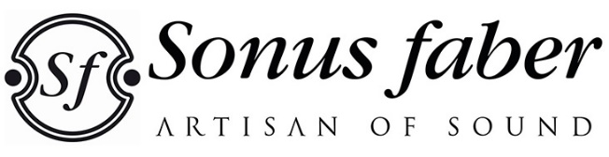

If you are anything like me, the acquisition of McIntosh and Sonus Faber by Bose Corporation was a shock. As a long-time audiophile and devout believer in maintaining the quality and standards of the Audio Specialty industry, this move was tantamount to seeing a cherished artisanal craft risk being absorbed into the world of mass production. Would McIntosh’s iconic blue meters and Sonus Faber’s handcrafted elegance be reduced to mere branding? Or could Bose, a name synonymous with accessible sound solutions, truly honor the legacy of these storied companies? My curiosity—and skepticism—drove me to explore what this acquisition could mean for the future of high-end audio.
This is more than just a business story; it’s a glimpse into the evolving priorities of the audio industry, where luxury and technology increasingly converge in unexpected ways. Bose’s move might seem like an odd pairing, but digging deeper reveals a strategic play that reflects broader trends shaping high-end sound. It also invites comparison to other notable acquisitions in the industry.
The Automotive Audio Opportunity
While McIntosh and Sonus Faber are revered for their high-performance home audio systems, it’s their growing presence in the automotive sector that likely caught Bose’s attention. McIntosh’s collaboration with Jeep, providing premium audio systems for models like the Grand Wagoneer, and Sonus Faber’s partnerships with luxury automakers Maserati and Lamborghini, illustrate the lucrative potential of automotive audio.
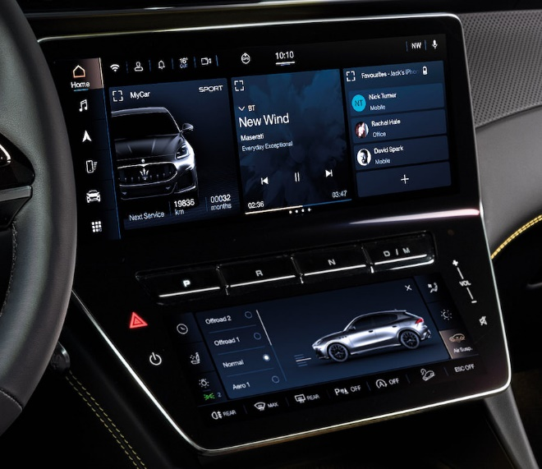
This focus aligns with an industry-wide trend: the fusion of luxury and cutting-edge technology in vehicles. Unlike traditional home audio products that require intricate craftsmanship, automotive systems rely on standardized components and streamlined manufacturing. This makes them both scalable and profitable, offering companies like Bose an avenue for significant revenue growth. By integrating McIntosh’s and Sonus Faber’s expertise with its own, Bose aims to deliver cutting-edge in-car audio experiences across a broader spectrum of vehicles.
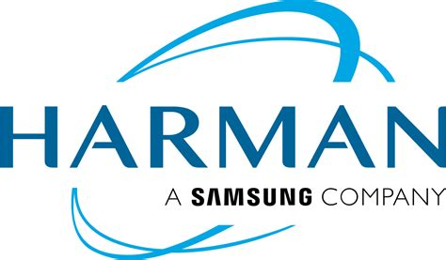
Notably, other acquisitions in the audio industry have followed a similar pattern. Harman International, for example, was acquired by Samsung Electronics in 2017 in a bid to integrate premium audio with smart technologies, including automotive applications. Similarly, Sound United’s acquisition of brands like Marantz and Denon aimed to consolidate market leadership in both home and automotive audio segments. Interestingly, Sound United itself was previously connected to McIntosh and Sonus Faber before the McIntosh Group split off to form its own entity, ultimately paving the way for Bose’s recent acquisition. These moves mirror Bose’s strategy of blending established high-end audio legacies with broader technological ecosystems.
Preserving Brand Integrity
Despite the acquisition, Bose has committed to maintaining the unique identities and operational independence of McIntosh and Sonus Faber. These brands will continue to focus on their signature offerings, including high-end amplifiers, loudspeakers, and turntables. By preserving their craftsmanship and legacy, Bose seeks to ensure that loyal customers and audiophiles remain engaged with the brands.
This strategy aligns with broader trends in the audio industry, where acquisitions often aim to diversify portfolios while protecting the core values of acquired companies. For Bose, the move also represents an opportunity to elevate its reputation among high-end audio enthusiasts by associating with McIntosh’s and Sonus Faber’s storied histories. Bose has already highlighted plans to continue producing products under the McIntosh and Sonus Faber names without compromising their renowned quality.
Shifts in the High-End Audio Landscape
The acquisition of McIntosh underscores a significant shift in the high-end audio industry. Long dominated by a handful of giants, including McIntosh, the sector has seen consolidation and transformation in recent years. Other iconic names have faced challenges:
- Mark Levinson has shifted focus to automotive and headphone markets.
- Audio Research is adapting to new ownership after financial difficulties.
- Classé Audio has reduced operations, including the closure of its Montreal facility.
- Krell faces uncertainty due to leadership changes and financial setbacks.
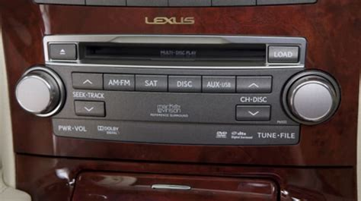
At the same time, new players such as T+A, SPL, and CH Precision have emerged, redefining the market with innovative engineering and modern strategies. These companies are catering to a diverse audiophile audience, ranging from boutique enthusiasts to ultra-premium buyers willing to spend upwards of $50,000 on a single component.
A Dual-Path Future
Bose’s acquisition reflects the bifurcated path of the high-end audio industry. On one side, automotive licensing offers a scalable and profitable business model. On the other hand, boutique manufacturers continue pushing traditional audiophile excellence's boundaries. This dual trajectory ensures that while industry giants adapt to evolving market dynamics, opportunities for innovation and acoustic perfection remain abundant.
Looking Ahead
The integration of McIntosh and Sonus Faber into Bose’s portfolio signals a new chapter for all three brands. By leveraging McIntosh’s automotive partnerships and Sonus Faber’s luxury appeal, Bose is poised to redefine its position in the global audio market. For audiophiles, this evolution may bring a mix of optimism and skepticism, but it also reflects a changing audiophile culture—one that embraces both innovation and tradition. Whether in the living room or behind the wheel, the pursuit of exceptional sound remains the driving force behind this industry's ongoing transformation.

