Bordeaux: The Benchmark of Fine Wine
Overview
Bordeaux is arguably the most prestigious and influential wine region in the world. Located in southwestern France, it is renowned for producing some of the finest red and white wines, with a complex classification system and a tradition dating back centuries. Bordeaux’s wines are celebrated for their structure, aging potential, and balance, making the region a cornerstone of sommelier education.
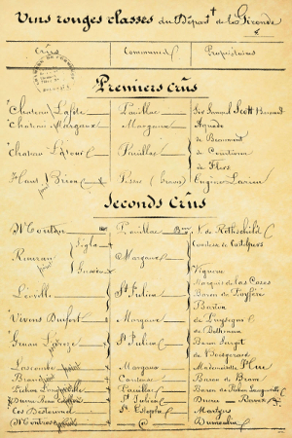
Historical Background
Figure 1 Bordeaux 1855 Classification
Winemaking in Bordeaux dates back to Roman times, with vineyards established as early as the first century AD. The region flourished under English rule in the 12th century, with Bordeaux wines becoming a favorite of the British aristocracy. The 1855 Classification, ordered by Napoleon III, further solidified Bordeaux’s reputation, ranking the top Médoc and Sauternes estates. Today, Bordeaux continues to set the standard for fine wine worldwide, with both traditional and innovative winemaking techniques.
Classification System
Bordeaux employs multiple classification systems based on subregion and historical prestige:
- 1855 Classification (Médoc and Sauternes) – A five-tier system ranking the region’s top estates, with Château Lafite Rothschild, Château Latour, Château Margaux, Château Haut-Brion, and Château Mouton Rothschild as First Growths.
- Graves Classification (1953) – Recognizes the best wines of Graves, with Château Haut-Brion as its most famous estate.
- Saint-Émilion Classification – A dynamic ranking system updated approximately every 10 years, highlighting Premier Grand Cru Classé A estates like Château Ausone and Château Cheval Blanc.
- Crus Bourgeois (Médoc) – A quality designation for excellent, but non-classified wines of the Médoc.
- Pomerol (No Official Classification) – Despite lacking formal ranking, Château Pétrus and Le Pin are considered some of the world’s most prestigious wines.
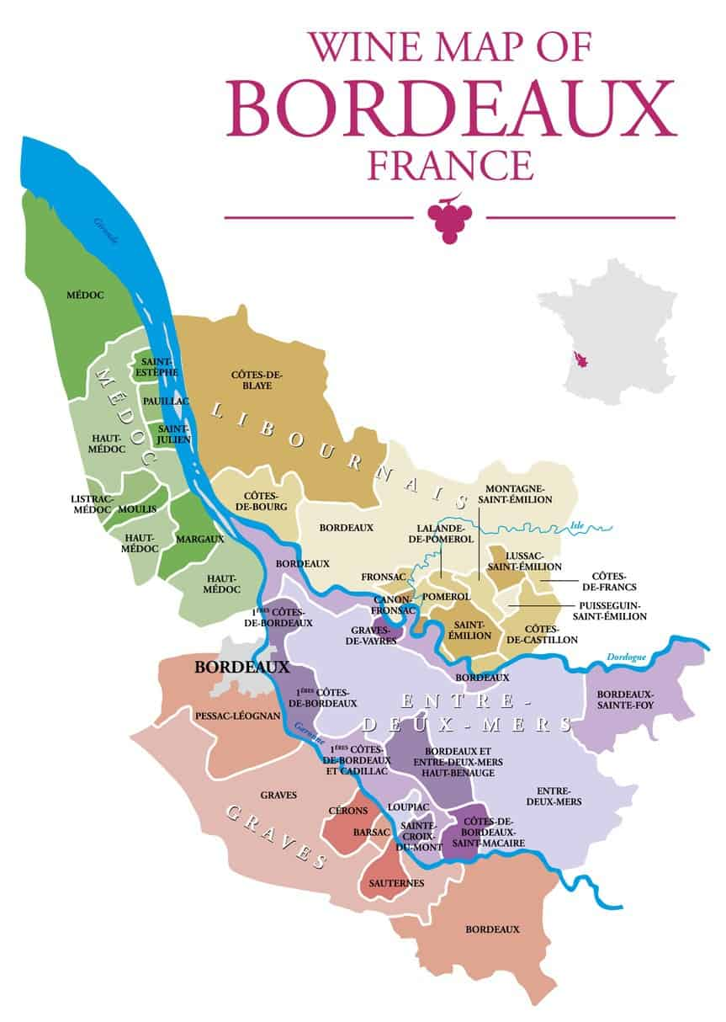
Major Wine Regions
Left Bank (Médoc & Graves)
Known for its Cabernet Sauvignon-dominant blends, the Left Bank produces wines with firm tannins, deep complexity, and long aging potential.
- Médoc – Home to the famous 1855 Classification châteaux, producing structured and powerful reds.
- Pauillac – A powerhouse region with three First Growths and wines of remarkable concentration and aging potential.
- Margaux – Produces the most elegant and perfumed wines of the Left Bank.
- Saint-Julien – Balanced and refined wines that bridge the styles of Pauillac and Margaux.
- Graves – Known for both red and white wines, with Château Haut-Brion as the standout estate.
Right Bank (Saint-Émilion & Pomerol)
The Right Bank is Merlot-dominant, producing wines with softer tannins and rich fruit concentration.
- Saint-Émilion – A UNESCO-listed village, home to Château Ausone, Château Cheval Blanc, and Château Angélus.
- Pomerol – Despite its small size, Pomerol produces some of the most coveted wines in the world, including Château Pétrus.
Entre-Deux-Mers
A large, diverse region producing mostly dry white wines from Sauvignon Blanc, Sémillon, and Muscadelle.
Terroir
Bordeaux’s diverse terroir is key to its world-class wines.
- Soils – The Left Bank features gravel soils, perfect for Cabernet Sauvignon, while the Right Bank has clay and limestone soils, ideal for Merlot.
- Climate – Maritime-influenced, ensuring moderate temperatures and sufficient rainfall.
- Rivers – The Gironde estuary, Garonne, and Dordogne rivers help moderate climate and define the region’s appellations.
Notable Grape Varieties
Red Grapes
- Cabernet Sauvignon – The backbone of Left Bank wines, known for its structure, blackcurrant flavors, and aging potential.
- Merlot – The dominant grape in the Right Bank, adding richness, plush texture, and approachability.
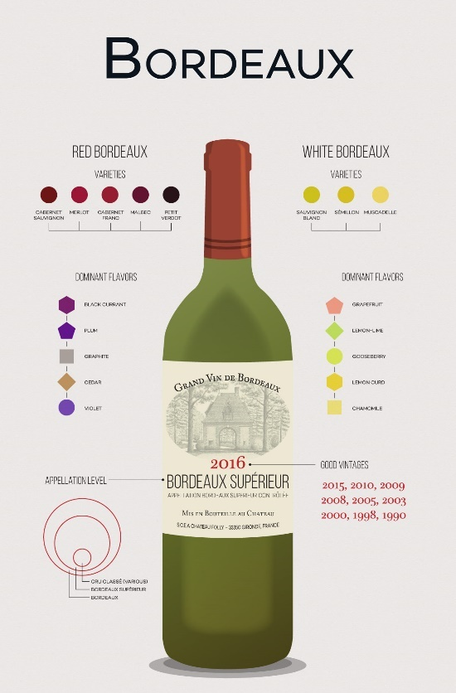
- Cabernet Franc – Provides aromatics, spice, and structure, especially in Right Bank blends.
- Petit Verdot – Adds color, depth, and floral notes in small quantities.
White Grapes
- Sauvignon Blanc – Brings acidity, citrus notes, and freshness to dry and sweet wines.
- Sémillon – The key grape in Sauternes, adding body and aging potential.
- Muscadelle – Contributes floral aromatics and complexity.
Notable Wine Styles
- Left Bank Reds – Powerful, tannic, and age-worthy, showcasing black fruit, tobacco, and graphite.
- Right Bank Reds – Plush, fruit-forward, and velvety, often with notes of plum, chocolate, and spice.
- White Bordeaux – Crisp and aromatic (Graves, Pessac-Léognan) or rich and opulent (Sauternes, Barsac).
- Sauternes & Barsac – Iconic sweet wines made from botrytized Sémillon and Sauvignon Blanc, with Château d’Yquem as the benchmark.
Notable Bordeaux Estates
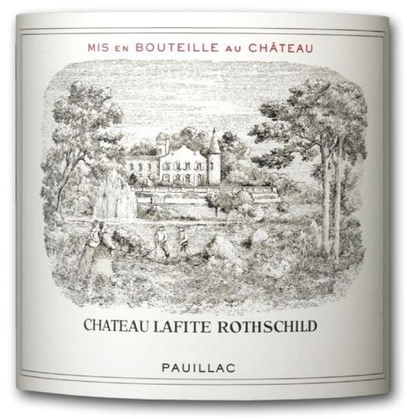
First Growths (1855 Classification)
- Château Lafite Rothschild (Pauillac) – Elegant, perfumed, and long-lived.
- Château Latour (Pauillac) – Powerful, structured, and intensely concentrated.
- Château Margaux (Margaux) – The epitome of finesse and fragrance.
Figure 2 Château Lafite Rothschild
- Château Haut-Brion (Graves) – The only First Growth outside the Médoc, blending opulence with earthiness.
- Château Mouton Rothschild (Pauillac) – Bold and expressive, known for its iconic artist-designed labels.
Other Prestigious Estates
- Château Pétrus (Pomerol) – A Right Bank legend, made from nearly pure Merlot, known for its depth and silkiness.
- Château Cheval Blanc (Saint-Émilion) – An elegant, Cabernet Franc-dominant wine with great longevity.
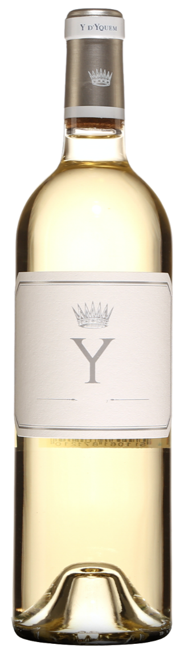
- Château d’Yquem (Sauternes) – The world’s most renowned sweet wine, capable of aging for decades.
Figure 3 Château d'Yquem Y Bordeaux 2018
Key Takeaways for Sommeliers
- Left Bank = Cabernet Sauvignon dominance, Right Bank = Merlot dominance – Understanding this fundamental distinction is key.
- Classification matters – The 1855 ranking still holds influence, while the Saint-Émilion classification evolves.
- Bordeaux wines age exceptionally well – Many Grand Cru Classé wines require decades of cellaring.
- Food pairings – Classic Bordeaux reds pair well with steak, lamb, and aged cheeses, while Sauternes shines with foie gras and blue cheese.
Final Thoughts
Bordeaux remains the gold standard for fine wine, balancing power, structure, and elegance. Whether exploring the iconic First Growths, discovering hidden gems from Pomerol, or enjoying the richness of Sauternes, mastering Bordeaux is an essential part of every sommelier’s journey.

