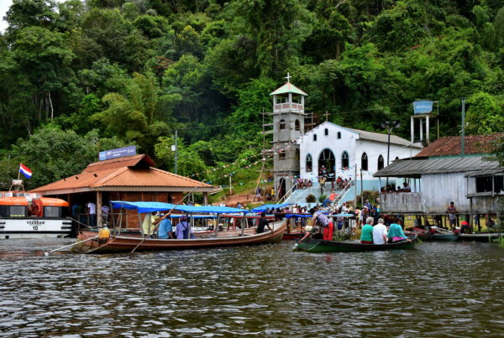
Boca da Valeria Self-Guided Walking Tour: A Glimpse into Riverine Life
Starting Point: Tender Dock, Boca da Valeria
Total Distance: Less than 1 mile (1.5 km) round trip—the village is very small.
Estimated Time: 1.5 to 2.5 hours (highly dependent on your pace of interaction)
Difficulty: Easy but rustic — dirt paths, no cars. Can be muddy if it has rained.
Language Note: Portuguese. Locals know basic greeting words in English for tourists.

1. From the Dock to the Main Path
As your tender boat arrives at the simple wooden dock, you are stepping into a postcard of Amazonian life. Boca da Valeria is not a town in the traditional sense, but a tiny riverine community of about 100 people. You will be greeted by local children in simple dress, often with their friendly pet monkeys, sloths, or parrots.
Follow the single main dirt path from the dock. This short walk is an immediate immersion into the rhythm of the village.
Tip: It is customary to give a small tip (R$5-10) for taking photos of the children with their animals. Have small Brazilian Reais (BRL) notes ready.
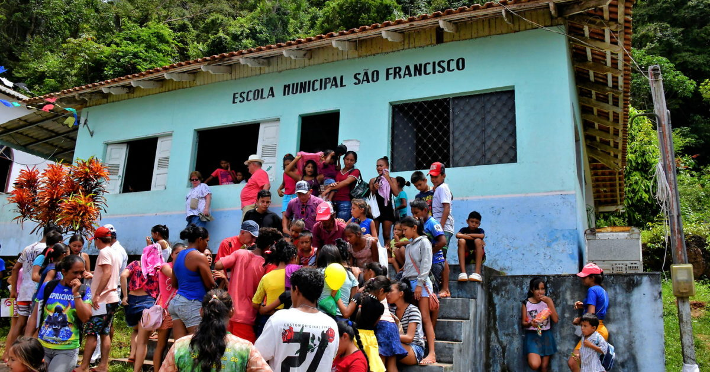
2. The Main Square & Schoolhouse
A two-minute walk up the path brings you to the heart of the village: a small, open dirt square. Here, you'll find the community's most prominent buildings: a simple church and a one-room schoolhouse. Peek inside the schoolhouse to see where the village children are educated—a humbling reminder of life in this remote location.
Time here: 15–20 minutes
Tip: The school often has handmade crafts laid out for sale by the children and their families. This is a direct way to support the community.
3. Meeting the Community & Cultural Exchange
This is the core of the Boca da Valeria experience. The path winds past simple, elevated wooden houses (palafitas). Locals are accustomed to visitors and are generally welcoming. You may be invited to look inside a home or see a demonstration of daily tools and crafts.
This is a chance to observe riverine life firsthand—fishing nets drying, cassava being processed, and the simple, resourceful way of living with the forest and the river.
Time here: 30–60 minutes (or more)
Tip: Be respectful. Always ask for permission with a gesture before taking close-up photos of people or their homes. A smile is a universal language.
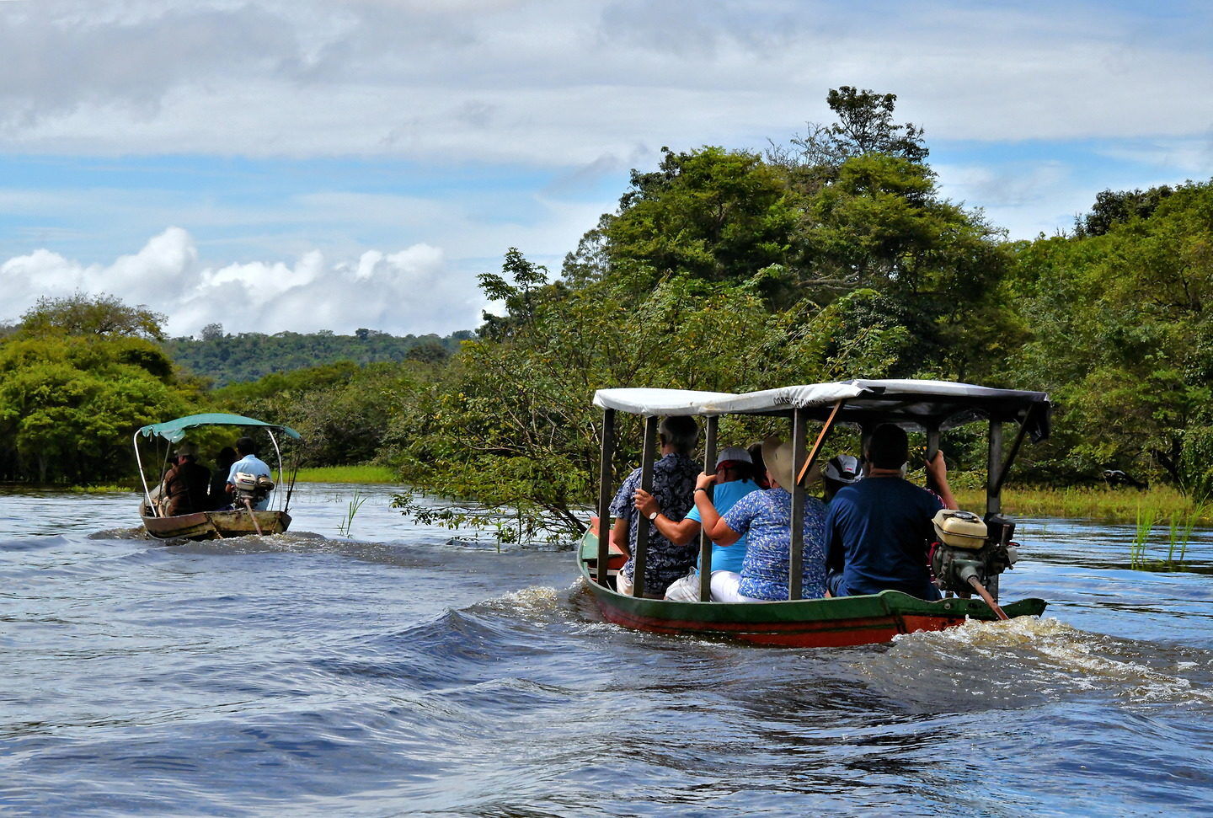
4. The "Igarapé" (Creek) & Canoe Ride
At the end of the main path, you'll reach a small creek, or igarapé, that gives the village its name ("Mouth of the Valeria Creek"). This is where you can take a short canoe ride paddled by a local guide. Gliding through the narrow, overhung waterways offers a completely different perspective and a moment of serene beauty in the Amazon jungle.
Time here: 20–30 minutes
Tip: The canoe ride requires a separate, small fee (in BRL). It's highly recommended for a more complete experience.
5. Refreshment & Souvenir Stop
Back near the main square, you might find a small, informal stall selling cold sodas or water. The primary "souvenirs" are the handmade crafts laid out on blankets—necklaces made from seeds and piranha jaws, woven baskets, and small wood carvings. The prices are very low, and bargaining is not appropriate; your purchase directly supports a family.
Tip: Bring small Brazilian Real notes (R$5, R$10, R$20). U.S. dollars may be accepted but at an unfavorable rate.
6. Return to the Dock
Your walk concludes by retracing your steps down the main path to the tender dock. The return walk is a chance for final photos and farewells.
Tip: If you promised to buy a craft from a specific child on your way in, be sure to follow through on your way out.

Before You Go
- Currency: Brazilian Reais (BRL) in SMALL DENOMINATIONS are essential. There are no ATMs or banks. Your ship may not be able to provide small bills, so plan ahead.
- Safety: The village is extremely safe. The main considerations are watching your step on uneven paths and being respectful of the people and their homes.
- Weather: The Amazon is hot and humid. Wear light, breathable clothing, a hat, and strong insect repellent. Sturdy, closed-toe shoes are better than sandals due to muddy paths.
- Etiquette: This is a cultural encounter, not a theme park. The villagers are sharing their lives with you. Be polite, patient, and respectful. A friendly "Bom dia" (Good morning) and "Obrigado/obrigada" (Thank you) will be warmly received.
In Summary
Boca da Valeria offers an unfiltered, intimate, and humbling look at the simplicity and challenges of life in a remote Amazonian community. It is a place for cultural connection, photography, and reflection, rather than traditional sightseeing.
This is not a polished tourist attraction; it is a living village. Your visit is a brief exchange, offering you a powerful memory and providing the community with a vital source of income. Tread lightly, observe openly, and enjoy this unique glimpse through the "Door of the Amazon."

