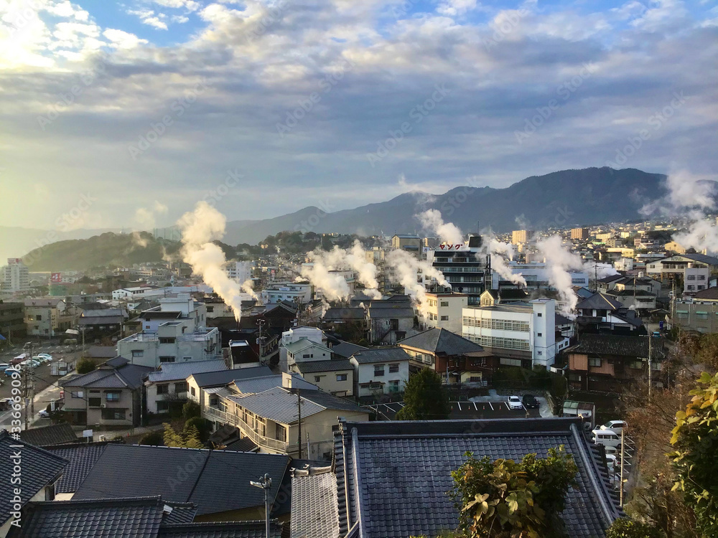
Beppu Walking Tour
Welcome to BeppuWelcome to Beppu, Japan’s most famous hot spring town. Nestled between mountains and sea on the island of Kyushu, Beppu is home to more than 2,000 hot springs, more than anywhere else in Japan. Steam rises from the streets, bathhouses glow at night, and the scent of sulfur drifts gently through the air.
Our walking tour explores the heart of Beppu’s Kannawa Onsen District, where you can see the town’s legendary “Hells,” stroll through historic bathhouses, and experience a culture that revolves entirely around hot water.

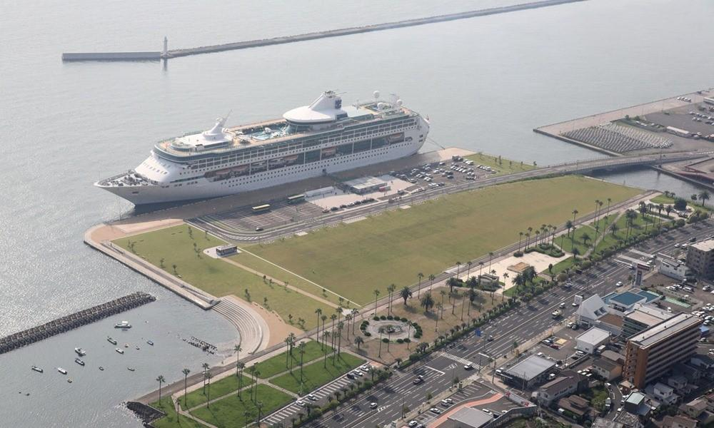
Starting Point – Beppu Port
We begin at Beppu Port, where your ship docks just a few miles from the city center. From here, it’s an easy 10–15 minute taxi ride to the Kannawa Onsen District, the steaming heart of Beppu.
You’ll immediately notice what makes Beppu unique, vents of white steam rising from rooftops and sidewalks. The entire city sits on a geothermal field that powers both spas and daily life.

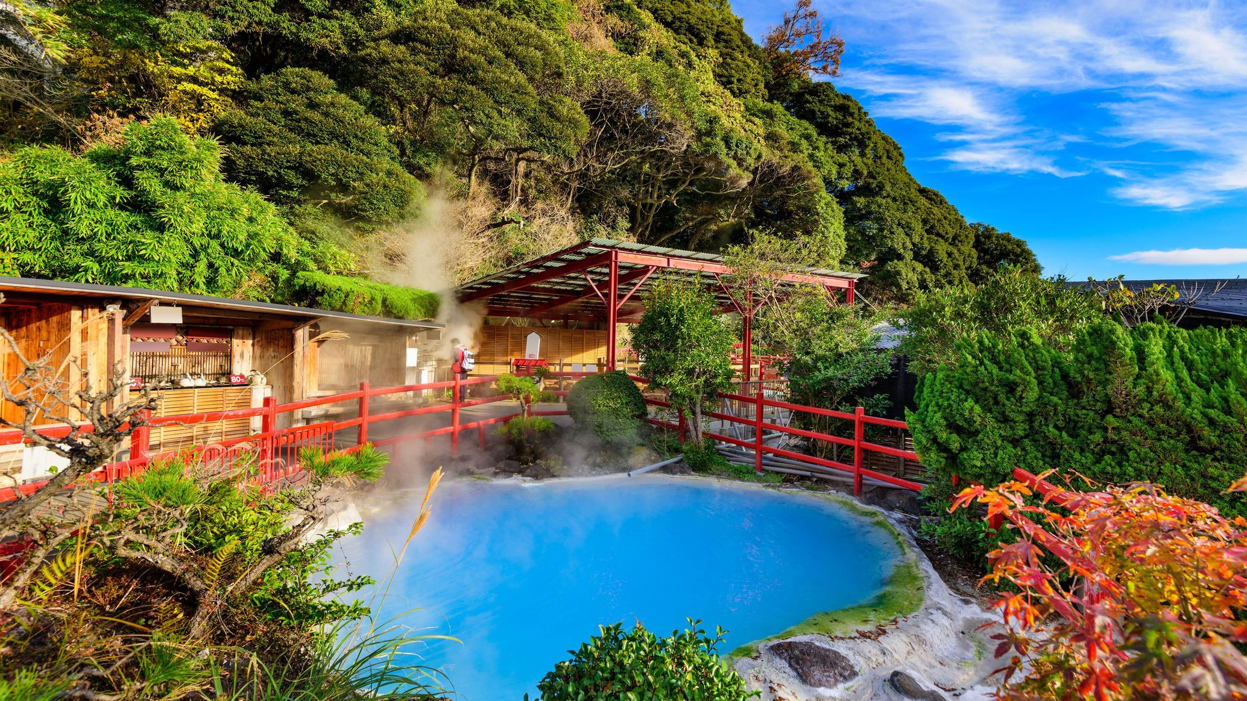
Stop 1 – Kannawa Onsen District
Our first stop is Kannawa Onsen, one of Beppu’s oldest neighborhoods. The area was developed in the 13th century by a Buddhist monk who helped harness the natural hot springs for bathing.
Here, you can walk narrow cobblestone streets where steam pours from grates in the ground. Locals call it the “town that breathes.” Traditional ryokans (inns) and public baths line the streets, many of which have been operating for over a century.

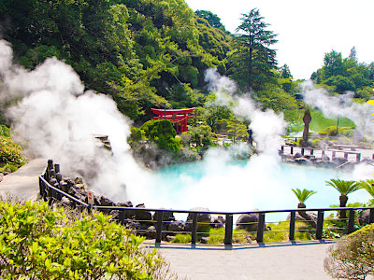
Stop 2 – Umi Jigoku (“Sea Hell”)
A short walk from Kannawa’s main street brings you to Umi Jigoku, the “Sea Hell.” Despite the name, this vivid blue pool is one of Beppu’s most beautiful sights. The water reaches nearly 400°F (93°C), and the color comes from dissolved minerals in the volcanic soil.
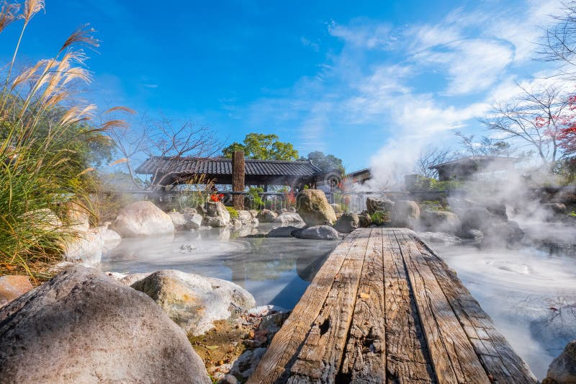
This is one of Beppu’s “Eight Hells”, natural geothermal springs that are too hot for bathing but spectacular to see. The site also includes a greenhouse heated entirely by steam and a small café serving boiled eggs cooked in the hot spring water.

Stop 3 – Oniishibozu Jigoku (“Shaven Monk Hell”)
Just down the path, you’ll find Oniishibozu Jigoku, named for the bubbling gray mud pools that resemble the shaved heads of Buddhist monks. The rhythmic popping of the mud and the rising steam create an otherworldly atmosphere.
Nearby foot baths allow you to relax in naturally heated mineral water, a perfect spot for a short rest during the tour.

Stop 4 – Kamado Jigoku (“Cooking Pot Hell”)
Continue to Kamado Jigoku, or “Cooking Pot Hell,” a series of smaller geothermal pools watched over by colorful statues of demons (called oni). Traditionally, locals used this area to cook rice, eggs, and vegetables in the steam vents.
You can still try this yourself, buy a small snack from the vendors and watch it steam-cooked before your eyes. It’s a fun, flavorful way to experience Beppu’s geothermal culture.

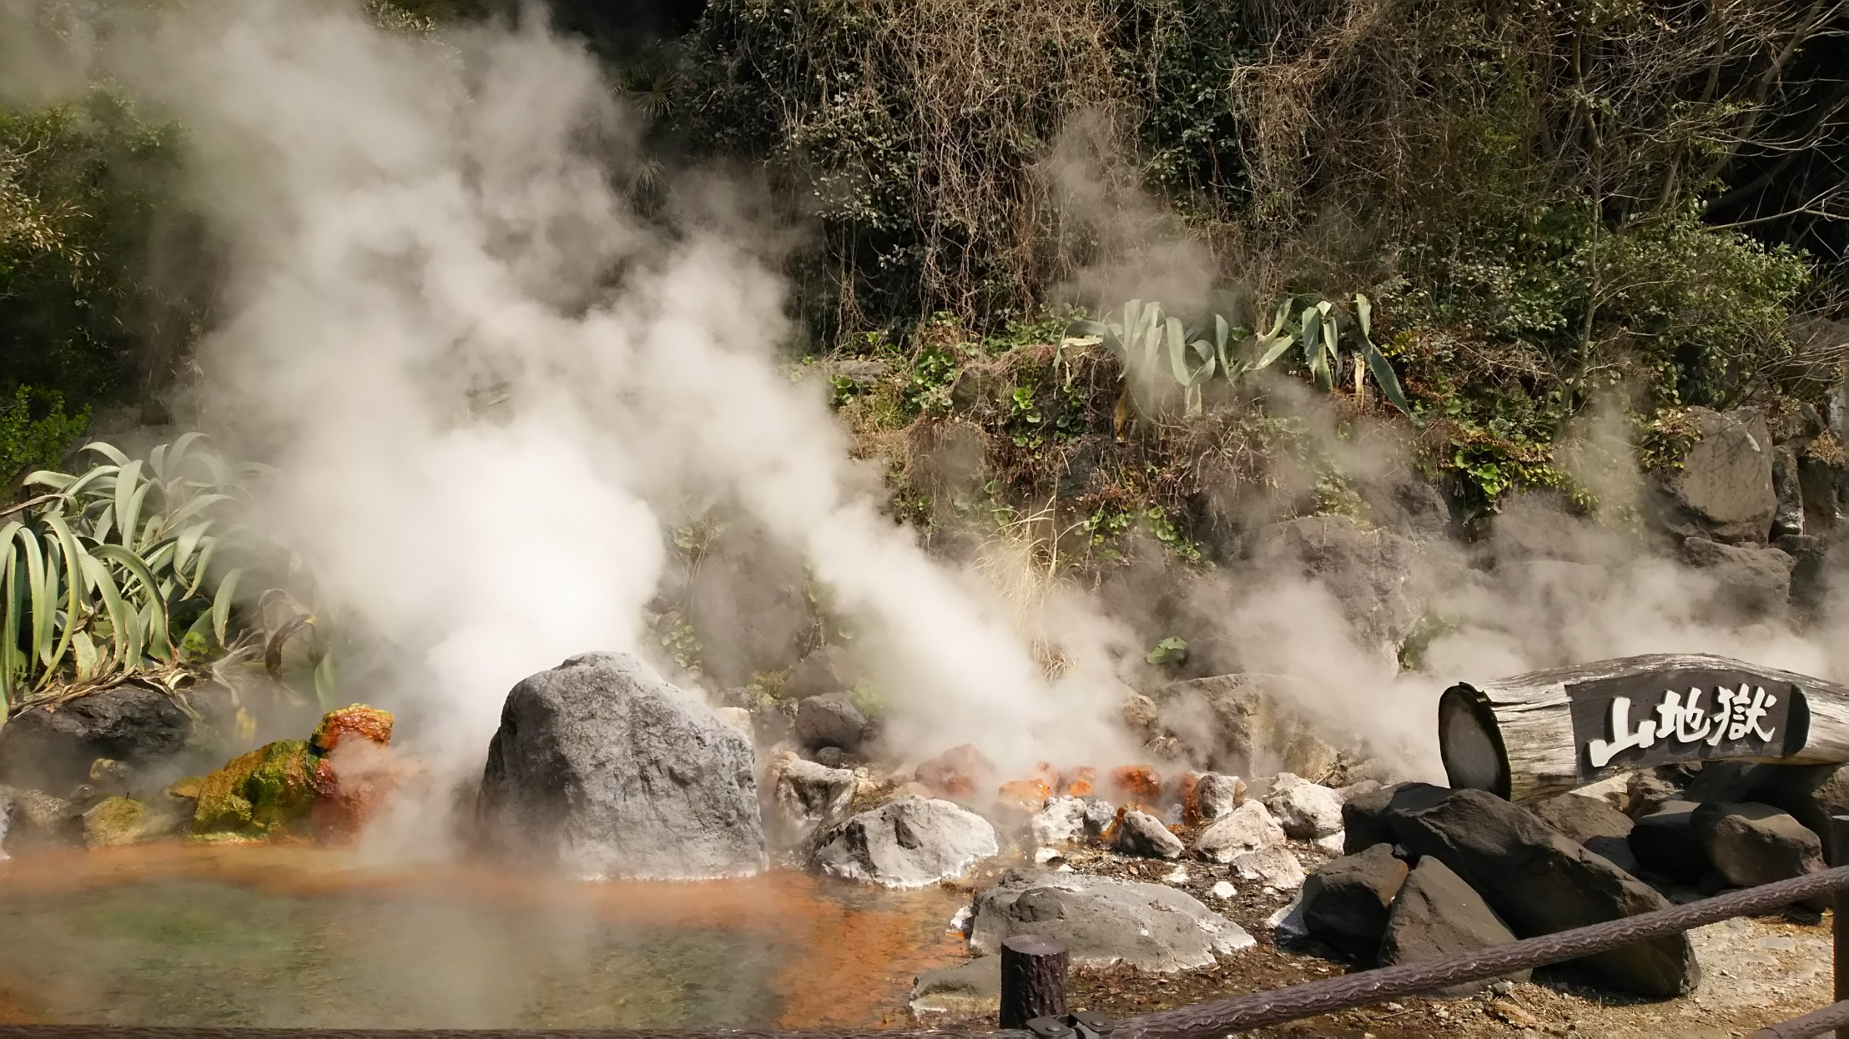
Stop 5 – Steam Cooking Center (Jigoku Mushi Kobo Kannawa)
A few minutes’ walk away, you’ll find the Jigoku Mushi Kobo Kannawa, a public steam kitchen where you can rent a bamboo basket and cook your own meal using volcanic steam.
Locals swear it makes vegetables sweeter and seafood more tender. It’s simple, healthy, and quintessentially Beppu, where even lunch comes straight from the earth.

Stop 6 – Hyotan Onsen (Traditional Bath Experience)
Next, visit Hyotan Onsen, one of Beppu’s most famous bathhouses and a great introduction to Japan’s bathing culture. It’s a large, public onsen with indoor and outdoor baths, sand baths, and even family rooms for private soaking.
If you prefer not to bathe, you can still enjoy the ashiyu, or foot bath, just outside. Shoes off, feet in, it’s a simple, relaxing pleasure that everyone can enjoy.
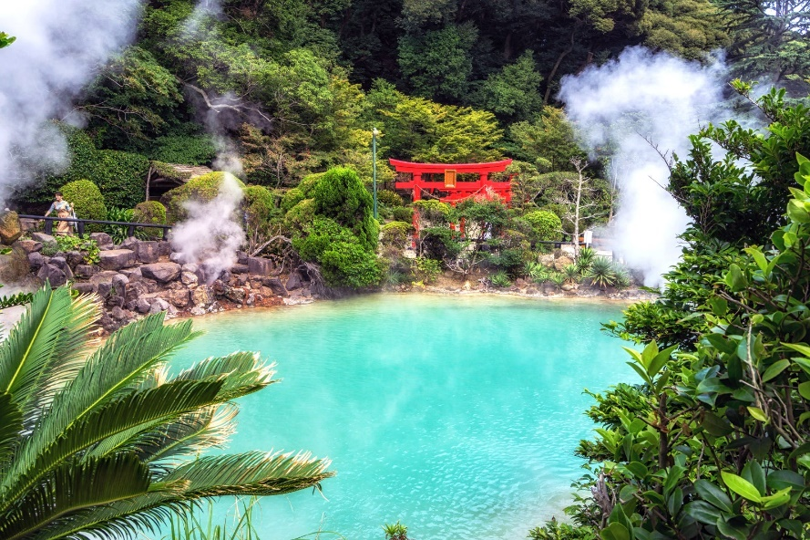
Stop 7 – Beppu Park and City Center
From Kannawa, you can take a short taxi or bus ride to Beppu Park, located in the city center. It’s a peaceful green space with walking trails, bamboo groves, and seasonal flowers.
Locals come here to unwind or enjoy a picnic. The park also offers clear views of Mount Tsurumi, an active volcano whose geothermal energy fuels the city’s famous springs.

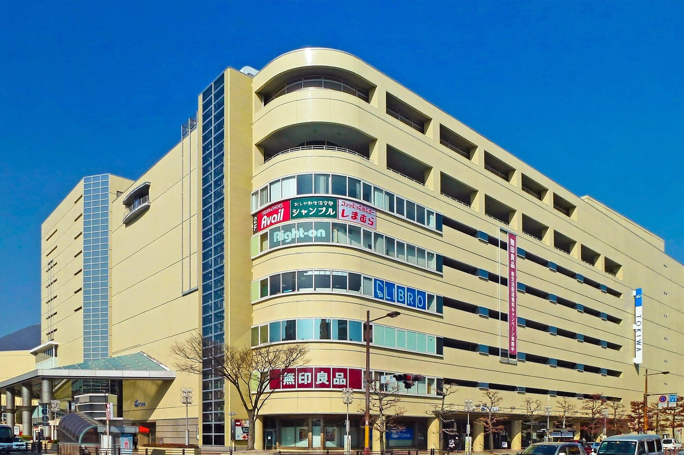
Stop 8 – Beppu Station & Shopping Arcade
Head back toward Beppu Station, where you’ll find the lively Ekimae Shopping Arcade. It’s filled with souvenir shops selling hot spring salts, onsen towels, and local sweets like yuzu manju, soft buns filled with citrus-flavored bean paste.
There are also casual eateries serving toriten (tempura-style chicken), a regional specialty. It’s a good place to grab lunch or pick up a few gifts before returning to the ship.

Optional Add-Ons
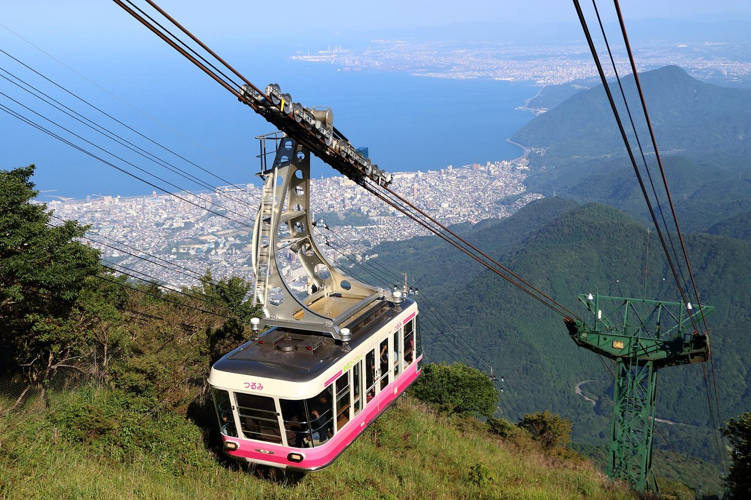
If you have extra time:
- Take the Beppu Ropeway up Mount Tsurumi for panoramic views across Beppu Bay.
- Visit Myoban Onsen, known for its milky white sulfur baths and thatched yunohana huts used to harvest mineral salts.
- Or stop by the Beppu Tower, a 1950s landmark offering a retro observation deck and a look back at Japan’s Showa-era design.

Beppu is unlike anywhere else in Japan, a place where nature and daily life are intertwined through heat, water, and steam. Walking its streets, you see not just hot springs, but the culture that grew around them: hospitality, community, and quiet renewal.
Whether you soaked your feet, sampled steamed treats, or simply watched the city breathe, Beppu leaves visitors with a sense of warmth, both literal and spiritual.

