Beneath the Vines of Moldova
By: Marc Silver
Moldova’s Monumental Wine Cellars and the Rebirth of a Wine Culture
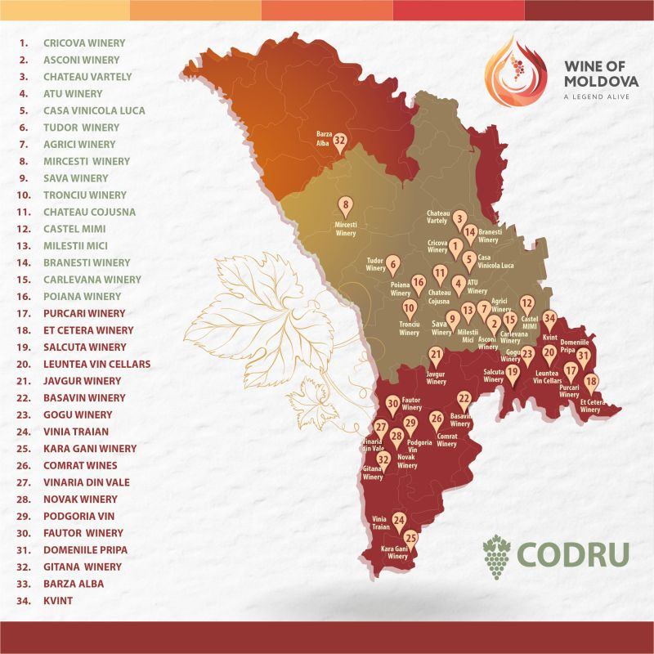
To the seasoned sommelier, Eastern Europe often appears on the periphery of the Old-World wine narrative. Yet hidden beneath the quiet countryside of Moldova, a small nation tucked between Romania and Ukraine, lies an astonishing enological legacy: hundreds of kilometers of subterranean wine cellars, aging over 2.5 million bottles in geological formations as ancient as the region’s vinous tradition itself.
For professionals who think they’ve seen it all, vertical tastings in Burgundy caves, barrel rooms in Napa, Moldova’s Cricova and Milestii Mici cellars offer an experience as humbling as it is enlightening.

A Soviet-Scaled Legacy with Deeper Roots
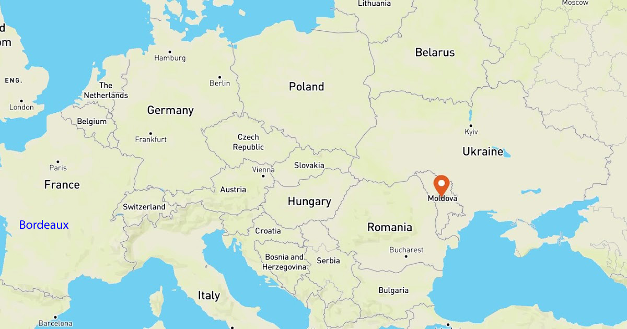
Wine has been cultivated in Moldova for more than five millennia, long before the Romans codified viticulture in Gaul. Sitting on the same latitude as Bordeaux, the country shares a temperate continental climate ideal for Vitis vinifera. Its position between the Carpathians and the Black Sea creates a microclimate well-suited for both international and indigenous varietals.
But Moldova’s modern wine story can’t be told without Soviet intervention. In the mid-20th century, vast limestone quarries near Cricova and Milestii Mici were converted into underground wine warehouses. The Soviets saw Moldova as the wine cellar of the USSR. These naturally insulated caves, some extending over 120 miles, became the storage backbone for mass-scale production.
By the 1970s and early 1980s, Moldova was producing up to two-thirds of all the wine consumed in the Soviet Union, with its best vintages sequestered in state-controlled reserves.
Then came the crackdown. In 1985, the Soviet Union launched a sweeping anti-alcohol campaign under Mikhail Gorbachev. Moldova’s vineyards were among the hardest hit. Thousands of acres were uprooted, production quotas were slashed, and some of the grand underground cellars were sealed off or fell into disrepair. It was a blunt-force policy that devastated not just industry but identity. The scars still linger long after the Soviet Union itself dissolved.

Post-Soviet Collapse and the Artisan Rebirth
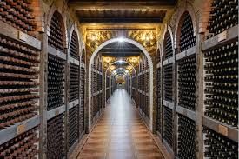
When the USSR collapsed in 1991, Moldova lost its largest guaranteed market. Wineries, many of them state-owned, struggled to adjust to a free-market economy. Equipment aged, vineyards sat fallow, and wine quietly matured in the dark, often forgotten.
But by the early 2000s, a quiet restoration was underway. Winemakers, many trained in France, Italy, Romania, and even California, returned with new ideas and old pride. They restored the limestone cellars, not for volume, but for value, often backed by a mix of foreign investment, EU development funds, and private capital. Focus shifted toward terroir, typicity, and varietal expression. The constant 54–57°F temperatures and high humidity in these caves proved ideal for aging structured reds, and notably, for traditional-method sparkling wines.

The Geology and Microbiology of Ideal Maturation
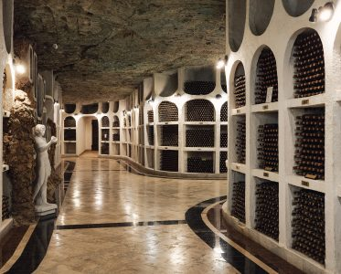
Moldova’s cellars aren’t just historic curiosities, they’re active tools. Carved from ancient seabed limestone, the caves absorb moisture and regulate temperature with precision. This creates a maturation environment comparable in some respects superior to, the cellars of Champagne or Mosel.
But it’s not just about temperature and humidity. Recent attention has turned to the caves’ microbial terroir, the unique yeasts and bacteria that inhabit the walls and air of these underground spaces. Much like in the caves of Tokaj or Epernay, these microbial communities may subtly influence flavor development, particularly during long-term aging and bottle fermentation. Though under-researched, Moldova’s untouched corridors likely shelter microbial ecosystems with their own enological fingerprints.

Milestii Mici, with over 124 miles of tunnels, holds the Guinness World Record for the largest wine collection, more than 1.5 million bottles.
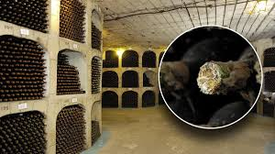
Cricova, slightly more compact but grand in design, offers marble-lined tasting halls and a presidential wine archive that includes rare WWII-era vintages, some of which were originally confiscated from Nazi officers and reportedly intended for Adolf Hitler’s inner circle. These bottles, still preserved in their original German-labeled glass, serve as silent relics of a darker time, repurposed as symbols of resilience and historical preservation.
For sommeliers, these aren’t just photo ops. They’re working laboratories that show how environment shapes evolution, how tannin integration, aromatic lift, and oxidative development all shift with time and place.

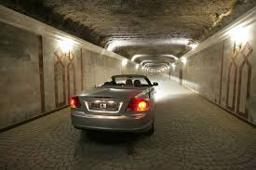
A Cellar That Moves Like a City
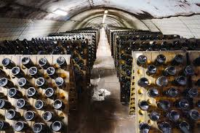
What often surprises first-time visitors is the scale and infrastructure of these caves. Milestii Mici is so vast that delivery trucks and small cars are used to navigate it. The passageways have street names. Pallets of wine are moved with forklifts, and temperature zones are carefully mapped.
Bottle handling, riddling, and storage of sparkling wines all occur underground. Some cellars are still hand-riddled; others use gyro pallets to manage larger volumes. Ventilation, mold control, and lighting are handled by specialized staff who treat the space more like a biosphere than a warehouse. The sheer logistics of operating these cellars—navigated by vehicles and mapped like a city—are more complex than many above-ground facilities, regardless of size.
From Local Varietals to Global Expression
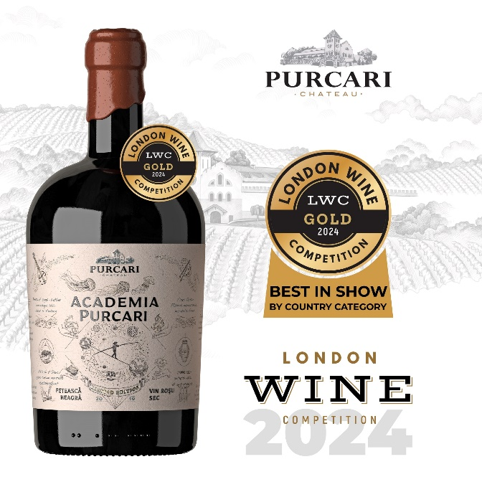
While Moldova cultivates international staples like Cabernet Sauvignon, Merlot, and Chardonnay, it’s the native grapes that often catch the eye of sommeliers seeking freshness and regional character.
- Fetească Neagră: Structured, spicy, with dark fruit and ageability. It can be compared to a blend of Syrah and Sangiovese in style and personality, depending on how it’s made.
- Rară Neagră: Lighter, aromatic, with a delicate herbal lift, excellent in both blends and solo efforts. It is often called Moldova’s “gentle red,” and is typically compared to lighter, aromatic red wines like Gamay (Beaujolais). It shares a similar light body, bright acidity, and fresh red fruit profile (think sour cherry, cranberry, and raspberry). It is sometimes compared to Pinot Noir’s cool-climate styles. In its more elegant, single-varietal form.
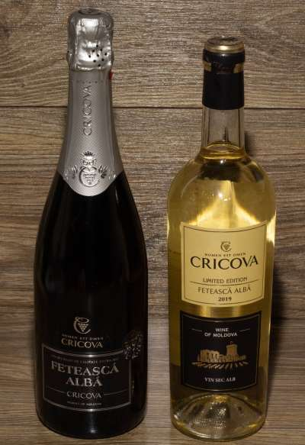
- Fetească Albă and Fetească Regală: Floral, crisp, and highly adaptable to both still and sparkling formats. Fetească Albă is often likened to Pinot Blanc or Albariño, offering citrus, white peach, and floral notes with a balanced freshness. Fetească Regală, a natural cross between Fetească Albă and Grasă de Cotnari, has more structure and zest, evoking comparisons to Grüner Veltliner or dry Riesling, particularly when grown at altitude or vinified with a touch of skin contact. Viorica: A muscat-scented white grape gaining traction in dry, semi-dry, and pét-nat bottlings.
Planted in the rich Chernozem soils, some of the most fertile on Earth, these grapes are showing that Moldova isn’t just borrowing from international playbooks. It’s writing its own.

The Rise of Moldovan Sparkling
Sparkling wine isn’t new to Moldova, but its reputation is. Under Soviet rule, the region was a major supplier of “Sovetskoye Shampanskoye,” often made by bulk methods. Today, that’s changing.
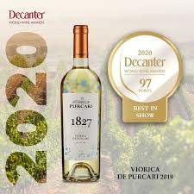
Cricova and other producers are now crafting Méthode Traditionnelle sparkling wines using both international and native varietals. Their bottlings, particularly those made from Fetească Albă and Chardonnay, are aged sur lie for 18 to 36 months, showing fine bubbles, brioche notes, and admirable structure.
Domestic demand is growing, but it's the export market that's taking notice. Moldova’s sparkling wines are appearing in Central Europe, the Baltics, and parts of Asia. For sommeliers hunting for Champagne-quality at Prosecco prices, Moldova has become a place to watch.

Wine Tourism and Tasting Archives
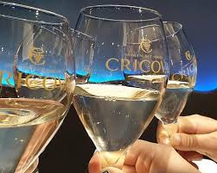
Moldova’s cellars have become more than aging facilities; they’re full-blown wine destinations. At Cricova, vertical tastings of Fetească Neagră show how vintages evolve with age and oak. Sparkling wine tours showcase riddling racks and disgorgement rooms. At Purcari Estate, tastings of Negru de Purcari, a Bordeaux-style blend once favored by Russian tsars, blend history with elegance.
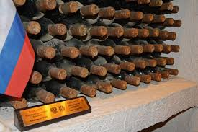
Many producers maintain private library collections going back decades. Some of these bottles are still uncorked, aging undisturbed under ideal cave conditions. The presidential collection at Cricova includes wines from the early 20th century, many of them rare and historically significant. Select tastings from this archive are occasionally offered to visiting dignitaries and professionals. Notable figures who have bottles held in the collection include Angela Merkel, John Kerry, and Traian Băsescu. Wines previously associated with Vladimir Putin were recently removed from display, while Volodymyr Zelensky is currently recognized with a dedicated label in the collection.
Boutique estates like Castel Mimi and Asconi are pairing sommelier-led masterclasses with curated menus, making Moldova’s wine tourism scene feel closer to Tuscany than to post-Soviet recovery.

A Cellar Worth Watching
For the curious sommelier, Moldova isn’t a novelty, it’s an unfolding story. Its limestone tunnels, once relics of Soviet overproduction, now house some of the most exciting wines in Eastern Europe. The 1985 anti-alcohol laws nearly broke the country’s viticultural backbone. Vineyards were uprooted, wineries shuttered, and generational knowledge nearly lost. But instead of fading, Moldova adapted.
Today, its sparkling wines compete with far more famous regions, its indigenous grapes are winning medals abroad, and its wine caves are no longer silent, they're filled with voices, glasses, and stories. Moldova may have once been buried beneath Soviet policy and global indifference. Moldova may have once been buried beneath Soviet policy and global indifference. Today, what’s rising is unmistakable: a wine culture that’s no longer underground.

References
- Anderson, Kym, and Nanda R. Aryal. 2020. Which Winegrape Varieties Are Grown Where? A Global Empirical Picture. University of Adelaide Press. https://www.adelaide.edu.au/press/titles/winegrapes
- Guinness World Records. 2023. “Largest Wine Cellar.” GuinnessWorldRecords.com. https://www.guinnessworldrecords.com/world-records/largest-wine-cellar
- International Organisation of Vine and Wine (OIV). 2023. State of the World Vitivinicultural Sector in 2022. https://www.oiv.int
- Ministry of Agriculture and Food Industry of Moldova. 2022. Moldovan Wine Industry Report. https://www.maia.gov.md
- National Office of Vine and Wine (ONVV). 2023. Annual Report on Wine Production and Export Trends. https://www.wineofmoldova.com
- Purcari Wineries Group. 2023. “Sparkling Wine Portfolio & Export Markets.” Investor Relations Presentations. https://purcari.wine
- The World Bank. 2021. Moldova: Agricultural Transition and the Wine Sector. https://documents.worldbank.org
- Wines of Moldova. 2023. “History, Regions, and Grape Varieties.” Official Tourism and Trade Promotion Portal. https://wineofmoldova.com/en
- Yergin, Daniel. 1991. The Prize: The Epic Quest for Oil, Money & Power. Simon & Schuster.

