Beaujolais: The Expression of Gamay and Terroir
Region Overview: Beaujolais, situated in the southernmost part of Burgundy, is bordered by Burgundy to the north and Rhône to the south. Renowned primarily for vibrant, fruit-driven red wines made from Gamay, the region enjoys a warmer semi-continental climate compared to the rest of Burgundy, ideal for approachable, fresh wines. While historically overshadowed by Burgundy’s Pinot Noir and Chardonnay, Beaujolais has increasingly gained recognition for unique traditions like carbonic maceration and its distinct terroir expressions.
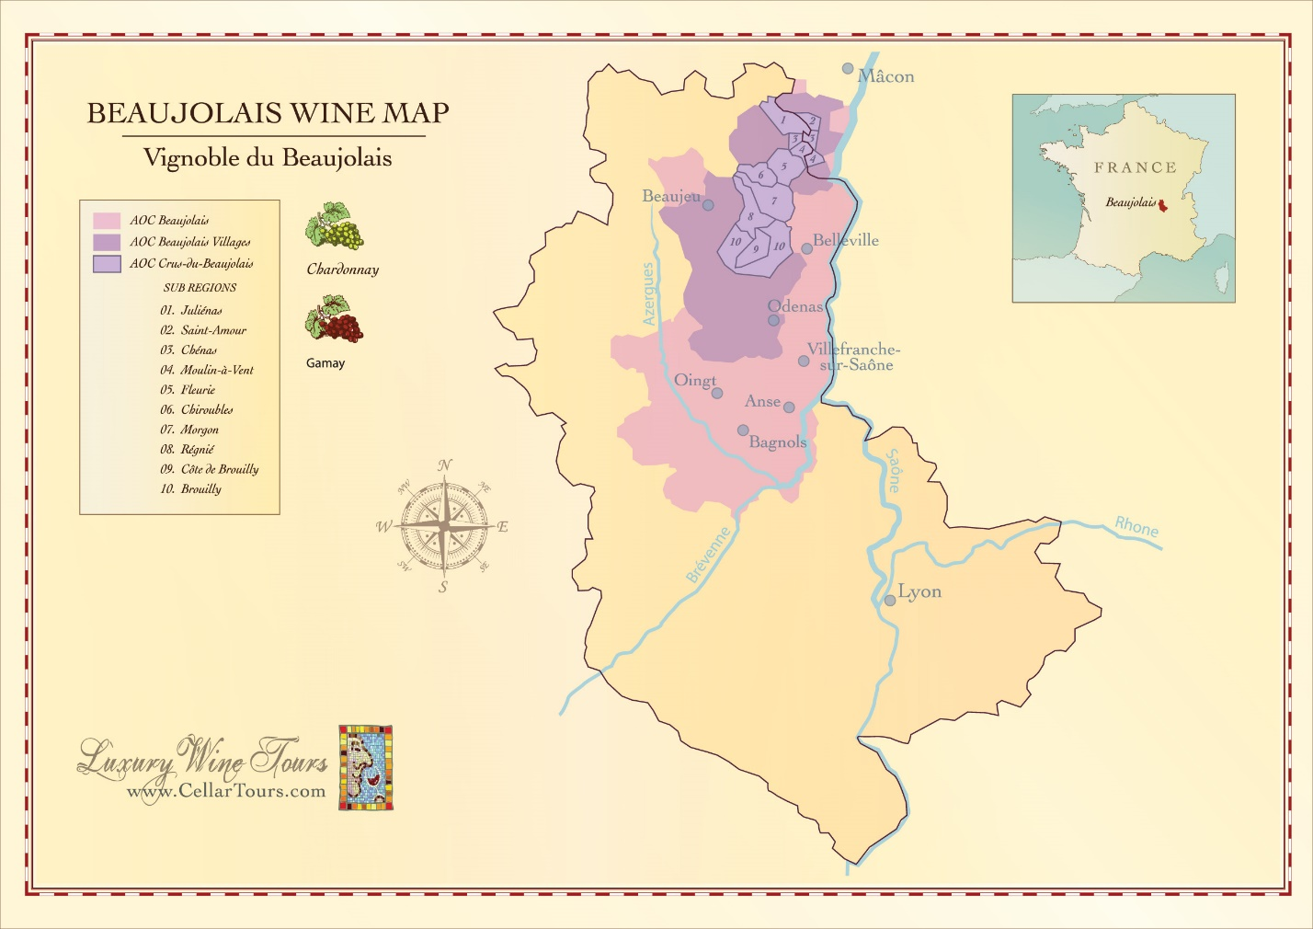
Key Grape Varieties
Primary Red Variety:
- Gamay: Bright red fruit, soft tannins, versatile; the defining grape of the region.
Primary White Variety:
- Chardonnay: Limited production, typically fresh, citrus-driven in Beaujolais Blanc.
Wine Classification System Beaujolais is structured into three tiers:
- Beaujolais AOP: Entry-level, fresh, approachable.
- Beaujolais-Villages AOP: Higher quality from selected villages, exhibiting more complexity.
- Cru Beaujolais: Highest quality, comprising ten Crus, each displaying distinct terroir-driven characteristics and potential for aging.
The ten Crus of Beaujolais (ordered from lightest to most structured):
- Lighter-bodied: Brouilly, Régnié
- Medium-bodied: Chiroubles, Fleurie, Saint-Amour
- Structured and age-worthy: Morgon, Moulin-à-Vent, Juliénas, Côte de Brouilly, Chénas
Notable Wine Styles
Beaujolais Nouveau:
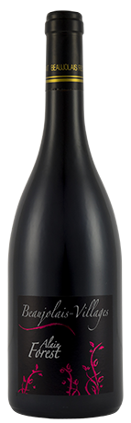
- Classification: Beaujolais AOP
- Composition: 100% Gamay
- Method: Carbonic maceration
- Profile: Juicy red fruit, banana-like aromas, low tannins; consumed young
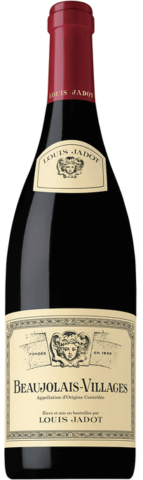
- Pairings: Charcuterie, pâtés, light appetizers
Cru Beaujolais:
- Classification: Cru Beaujolais
- Composition: 100% Gamay
- Method: Traditional or semi-carbonic maceration; variable oak usage
- Profile: Ranges from floral elegance (Fleurie) to structured intensity (Moulin-à-Vent)
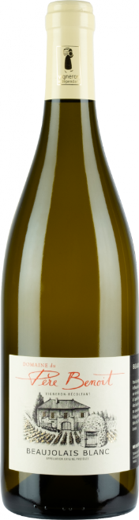
- Pairings: Roasted poultry, grilled meats, rich pasta dishes
Beaujolais Blanc:
- Classification: Beaujolais-Villages AOP
- Composition: 100% Chardonnay
- Profile: Citrus, green apple, floral notes, bright acidity
- Pairings: Seafood dishes, creamy sauces, soft cheeses
Additional Context
- Recent Developments: Movement away from carbonic maceration by some producers to highlight structure, complexity, and aging potential.
- Historical Context: Winemaking in Beaujolais dates back to Roman times; recently the region’s wines have gained renewed respect through a revival of traditional and terroir-focused winemaking.
Notable Producers:
- Georges Duboeuf
- Domaine Marcel Lapierre
- Jean Foillard
- Château Thivin
Takeaway for Sommeliers: Beaujolais presents a wide spectrum of styles suitable for diverse food pairings and wine lists, from approachable Nouveau to sophisticated Crus with aging potential. Sommeliers can leverage its versatility and excellent price-to-quality ratio to enrich wine offerings.
References:
- Robinson, J., & Harding, J. (2020). The Oxford Companion to Wine (5th ed.). Oxford University Press.
- Wine Scholar Guild. (2022). French Wine Scholar: Beaujolais.
- Johnson, H., & Robinson, J. (2019). The World Atlas of Wine (8th ed.). Mitchell Beazley.
- Beaujolais Wines. (2023). Regional Report. Retrieved from https://www.beaujolais.com
- Wine Enthusiast. (2023). Guide to Beaujolais Wines. Retrieved from https://www.winemag.com

