Australia Wine Regions Overview

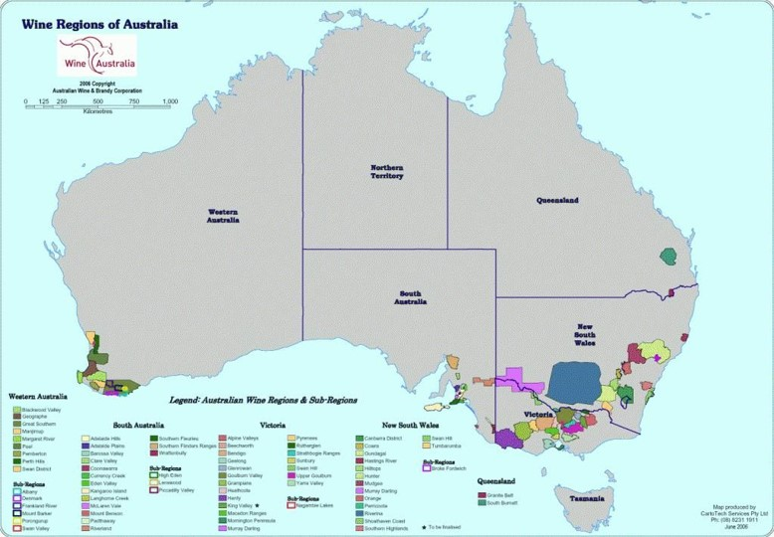
1. Region Overview
Australia, one of the world’s largest wine producers, boasts diverse climates and terroirs across its six states. Key regions include South Australia (Barossa Valley, McLaren Vale, Clare Valley), New South Wales (Hunter Valley), Victoria (Yarra Valley, Mornington Peninsula), Western Australia (Margaret River), and emerging cool-climate zones like Tasmania. The continent’s winegrowing areas span from sun-drenched, Mediterranean-like regions to maritime-influenced coasts and high-altitude valleys.
Australia is renowned for bold Shiraz, refined Cabernet Sauvignon, age-worthy Semillon, and vibrant Riesling. Its reputation balances New World innovation with Old World-inspired elegance, underpinned by sustainable practices and a focus on regional identity.

2. Key Grape Varieties
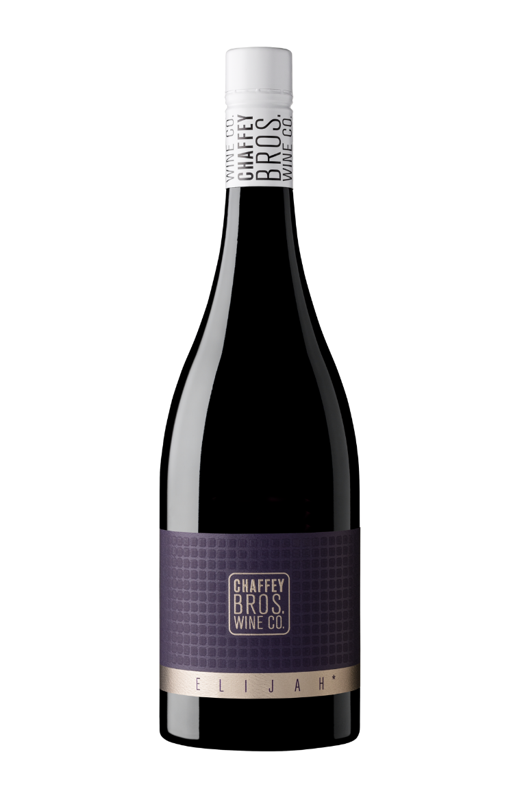
Primary Red Varieties:
- Shiraz (Syrah): The iconic grape of Australia, dominating Barossa Valley (full-bodied, dark fruit, chocolate) and McLaren Vale (plush, Mediterranean spice).
- Cabernet Sauvignon: Star of Coonawarra (terra rossa soils, minty cassis) and Margaret River (Bordeaux-like structure).
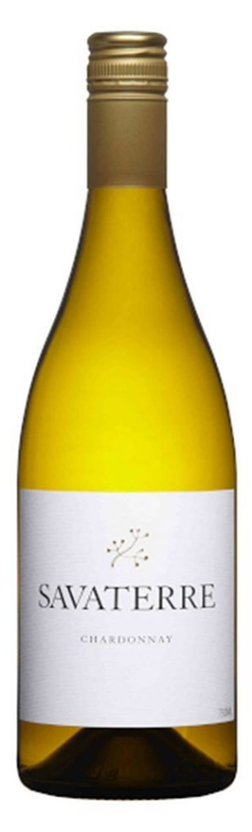
- Pinot Noir: Thrives in Yarra Valley and Tasmania (bright red fruit, earthy complexity).
Primary White Varieties:
- Chardonnay: Versatile across regions—Margaret River (citrus, stone fruit) and Adelaide Hills (lean, mineral-driven).
- Semillon: Hunter Valley’s signature, evolving from crisp citrus to honeyed richness with age.
- Riesling: Clare Valley and Eden Valley produce lime, floral, and petrol-driven styles.
Heritage/Notable Varieties:
- Grenache: Old-vine gems in McLaren Vale (raspberry, spice).
- Muscat: Rutherglen’s legendary fortified wines (raisin, toffee).
Figure 1 Savaterre Chardonnay 2019, Beechworth, Victoria
International Varieties:
Sangiovese, Tempranillo, and Fiano are emerging in warmer regions.

3. Wine Classification System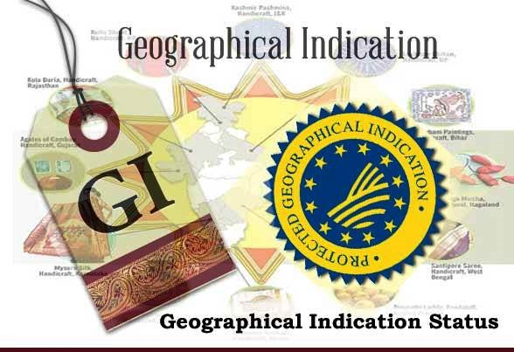
Australia uses a Geographical Indication (GI) system, dividing regions into:
- Zones: Broad areas (e.g., South Eastern Australia).
- Regions: Specific winegrowing areas (e.g., Barossa Valley).
- Sub-regions: Distinct terroirs (e.g., Coonawarra’s terra rossa strip).
While less regulated than European systems, labels must declare if 85% of grapes come from the stated GI.

4. Notable Wine Styles
Barossa Valley Shiraz (GI)
- Composition: 100% Shiraz, often from century-old vines.
- Production Method: Open-fermentation, aging in American oak.
- Alcohol Content: 14.5–15.5% ABV.
- Organoleptic Profile: Blackberry, licorice, mocha, and velvety tannins.
- Market Position: Global benchmark for bold, opulent Shiraz.
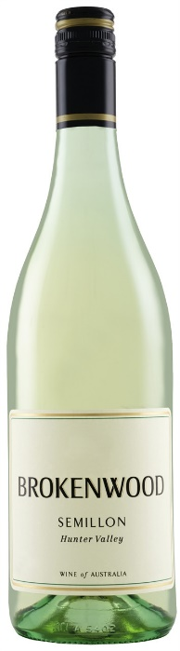
Hunter Valley Semillon (GI)
Figure 2 Brokenwood Hunter Valley Semillon
- Composition: 100% Semillon, unoaked.
- Production Method: Early harvest, stainless steel fermentation.
- Aging Potential: Develops honey, toast, and lanolin over 10+ years.
- Alcohol Content: 10–11% ABV.
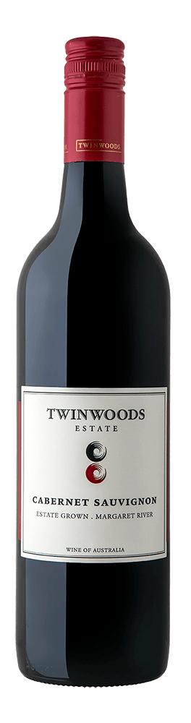
- Organoleptic Profile: Lemon zest, grass, and crisp acidity in youth.
Margaret River Cabernet Sauvignon (GI)
- Composition: Often blended with Merlot or Malbec.
- Production Method: Cool fermentation, aging in French oak.
- Organoleptic Profile: Blackcurrant, bay leaf, graphite, and polished tannins.
- Comparison: Likened to Bordeaux’s Left Bank but with riper fruit.
Figure 3 Twinwoods Margaret River Cabernet Sauvignon

5. Additional Context
Recent Developments:
- Sustainability: Over 20% of vineyards are certified organic or sustainable (e.g., McLaren Vale’s Sustainable Winegrowing Program).
- Climate Adaptation: Shift toward drought-resistant varieties and cooler regions (e.g., Tasmania for sparkling wine).
Historical Context:
Viticulture began with European settlers in the 18th century. The 19th-century gold rush spurred growth, while the 1970s “wine boom” modernized the industry.
Food Pairings:
- Barossa Shiraz with slow-cooked lamb shanks or chargrilled steak.
- Hunter Valley Semillon with oysters or goat cheese.
- Coonawarra Cabernet with herb-crusted rack of lamb.
Key Producers:
Penfolds (Grange), Henschke (Hill of Grace), Leeuwin Estate (Art Series Chardonnay), and Tyrrell’s Wines (Vat 1 Semillon).
Takeaway for Sommeliers:
Australia’s strength lies in its regional diversity, contrast Barossa’s power with Yarra’s finesse. Highlight old-vine heritage and value compared to European counterparts.
Final Thoughts:
A land of sunburnt soils and pioneering spirit, Australia crafts wines as bold and dynamic as its landscapes, marrying tradition with innovation to secure its place among the world’s elite wine nations.

Citations:
- Australian Wine Research Institute. National Vintage Report. 2023.
- Halliday, J. The Australian Wine Encyclopedia. 2020.
- “Australia’s Wine Revolution.” Decanter, 2022.

