Austral: The Southernmost Wine Region of Chile
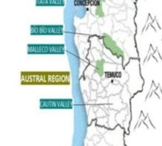
Region Overview
The Austral wine region is Chile’s newest and southernmost recognized viticultural area, located between 40° and 45° latitude south. This remote, cold-climate region represents the frontier of Chilean winemaking, where producers are pushing the limits of viticulture in cool, rainy conditions similar to those of Patagonia.
With an extreme maritime influence from the Pacific Ocean, abundant rainfall, and limited sunlight hours, Austral presents unique challenges for grape growing. However, its volcanic soils, high acidity retention, and long growing season allow for the production of elegant, high-acid wines with great aging potential.
Key Grape Varieties
Austral’s winemaking is still in its early stages, but cool-climate varieties are proving particularly successful:
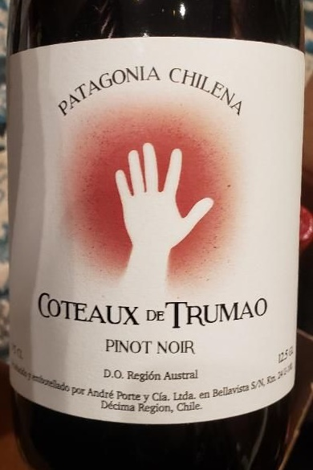
- Pinot Noir – Light-bodied, fresh, and structured, with red berry and earthy notes.
- Chardonnay – Crisp and mineral-driven, with citrus and saline elements.
- Sauvignon Blanc – Aromatic and high in acidity, with green apple and herbal characteristics.
- Riesling – Increasingly planted, showing potential for complex, age-worthy wines with bright acidity.
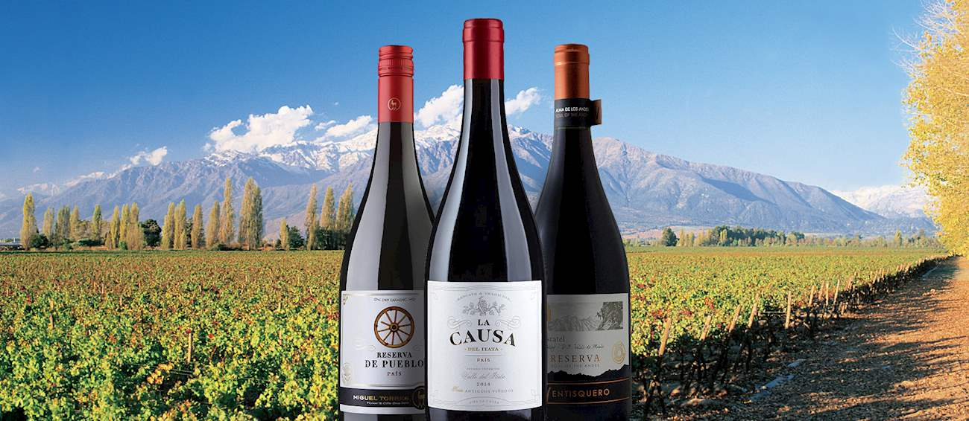
- País – One of Chile’s heritage varieties, showing a more delicate expression in this cool climate.
Wine Classification System
Austral is officially recognized within Chile’s Denomination of Origin (DO) system, though it remains a small-scale, experimental region. The primary subregions currently developing their own unique styles are:
- Osorno Valley – The most developed subregion, known for its volcanic soils and promising Pinot Noir and Chardonnay.
- Llanquihue – A humid, high-rainfall area where organic and natural winemaking techniques are being explored.
- Chiloé Archipelago – A newly planted extreme coastal region, testing the limits of maritime viticulture.
Notable Wine Styles
- Cool-Climate Pinot Noir – Bright acidity, light tannins, and red fruit flavors with earthy complexity.
- Mineral-Driven Chardonnay – High-acid, citrus-forward, and saline, with elegant structure.
- Aromatic Riesling – Crisp, floral, and refreshing, with potential for aging.
- Lively Sauvignon Blanc – Zesty and herbaceous, with mouthwatering acidity.
- Delicate País – Fresh and floral, showing softer tannins compared to warmer-climate expressions.
Additional Context
Austral’s wine industry is in its infancy, with only a few pioneering wineries leading the charge. Producers are experimenting with organic farming, dry-farming techniques, and volcanic soil expressions, creating wines that are highly distinctive and unlike any other in Chile. The cold temperatures and significant rainfall mean that disease management is a major challenge, but also that vineyard pests are minimal, allowing for sustainable viticulture.
With climate change shifting the boundaries of viticulture, Austral is emerging as a key future region for cool-climate Chilean wines. Its remote, wild landscapes and handcrafted small-batch wines make it an exciting frontier for sommeliers and wine enthusiasts alike.
Takeaway for Sommeliers
Austral is Chile’s most extreme and least-explored wine region, producing high-acid, cool-climate wines that stand apart from the country’s traditional offerings. As winemakers continue to develop Pinot Noir, Chardonnay, and Riesling, this region will likely gain greater international recognition for its unique terroir and sustainability-driven approach.
References
- Robinson, J., & Harding, J. (2020). The Oxford Companion to Wine (5th ed.). Oxford University Press.
- Wines of Chile. (2023). Emerging Wine Regions and Climate Adaptation. Retrieved from https://www.winesofchile.org
- Tapia, P. (2022). The Wines of South America. Infinite Ideas.
- Wine Enthusiast. (2023). Exploring Chile’s Cold-Climate Wine Frontier. Retrieved from https://www.winemag.com

