Auckland Wine Region: A Sommelier's Guide
1. Region Overview
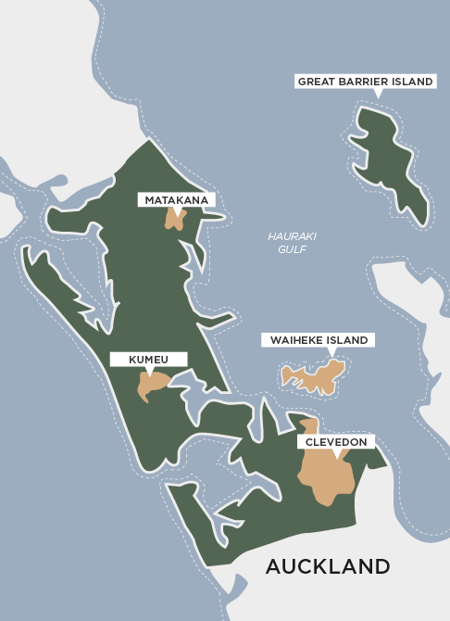
Geographic Location
Auckland is a key North Island wine region, located in and around New Zealand’s largest city. The region includes three main sub-regions:
- Waiheke Island – An island wine-growing area east of Auckland, known for Bordeaux-style reds.
- West Auckland – Home to some of New Zealand’s oldest wineries, specializing in Chardonnay and Syrah.
- Matakana – A boutique region north of Auckland, producing elegant, small-batch wines.
Climate and Terroir
Auckland has a humid, maritime climate, with moderate temperatures and high rainfall. Key climatic influences include:
- Warm summers and mild winters, allowing for consistent ripening.
- Coastal winds from the Tasman Sea and Pacific Ocean, moderating extreme heat.
- Rainfall and humidity, which can pose challenges for disease control.
Soils vary by sub-region:
- Waiheke Island – Iron-rich clay, gravel, and volcanic soils, ideal for structured red wines.
- West Auckland – Heavy clay and loam soils, well-suited for full-bodied whites.
- Matakana – Sandy loam over sandstone, producing complex, mineral-driven wines.
Structural Organization
Auckland is a recognized Geographic Indication (GI) within New Zealand’s appellation system, with the following notable sub-regions:
- Waiheke Island GI
- Matakana GI
- West Auckland (unofficial but historically significant)
Historical Context
Auckland is one of New Zealand’s oldest wine regions, with winemaking dating back to the early 1900s. Croatian and Dalmatian immigrants played a key role in the industry’s development, establishing family-run wineries that still operate today. The region remains a center for premium winemaking, particularly for full-bodied reds and rich, textured whites.
Distinctive Features
- Strong Bordeaux influence, particularly on Waiheke Island.
- Some of New Zealand’s best Chardonnay comes from West Auckland.
- Boutique winemaking in Matakana, with a focus on low-yield, handcrafted wines.
- Challenging climate, requiring careful vineyard management to control disease pressure.

2. Key Grape Varieties
Primary Red Varieties
- Cabernet Sauvignon & Merlot – Dominant on Waiheke Island, producing rich, structured Bordeaux blends.
- Syrah – A standout varietal, particularly in West Auckland and Waiheke, offering spicy, elegant styles.
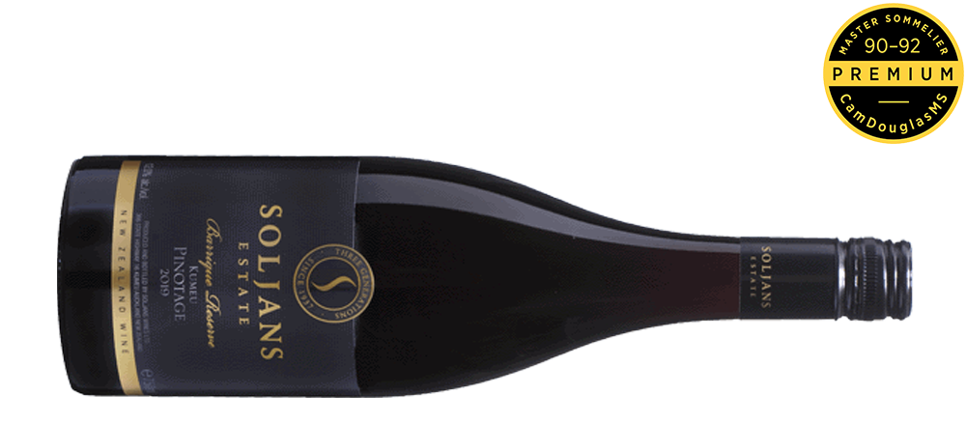
- Pinotage – A niche variety, grown in Matakana and parts of West Auckland.
Figure 1 Soljans Estate Barrique Reserve Kumeu Pinotage 2019,
Primary White Varieties
- Chardonnay – West Auckland’s flagship white, producing full-bodied, barrel-aged styles.
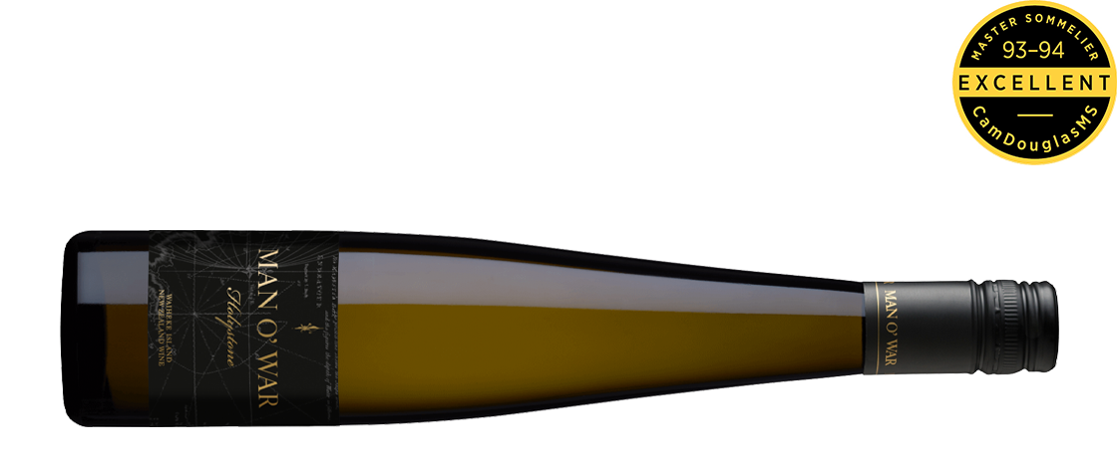
- Pinot Gris – Grown in Matakana, often showing rich, textural elements.
- Viognier – Found in Waiheke and Matakana, producing aromatic, floral-driven wines.
Indigenous/Regional Varieties
Auckland does not have indigenous grape varieties but is a leader in Syrah, Bordeaux blends, and rich Chardonnay.
Significance
- Cabernet Sauvignon, Merlot, and Syrah dominate Waiheke Island.
- Chardonnay is Auckland’s top white varietal.
- Boutique regions like Matakana focus on alternative varieties and small-scale production.

3. Wine Classification System
Quality Hierarchy
Auckland follows New Zealand’s GI system, with wines labeled under regional and sub-regional designations.
Appellation Structure
- Auckland GI – Covers the greater Auckland wine region.
- Waiheke Island GI – A prestigious sub-region focusing on Bordeaux blends and Syrah.
- Matakana GI – Known for small-batch, premium winemaking.
Special Classifications
- Sustainable Winegrowing New Zealand (SWNZ) – Many Auckland wineries are certified sustainable.
- Organic and biodynamic certifications – Increasingly popular among boutique producers.
Sub-Regional Distinctions
- Waiheke Island – Warm, dry climate, producing bold reds.
- West Auckland – Historic wineries specializing in Chardonnay and Syrah.
- Matakana – A boutique wine region focused on alternative grape varieties.

4. Notable Wine Styles
Waiheke Island Bordeaux Blends
- Classification Level: Waiheke Island GI
- Composition: Cabernet Sauvignon, Merlot, Cabernet Franc
- Production Method: Oak aging in French barrels
- Alcohol Content: 13.5–15%
- Organoleptic Profile: Blackcurrant, plum, tobacco, cedar
West Auckland Chardonnay
- Classification Level: Auckland GI
- Composition: 100% Chardonnay
- Production Method: Barrel fermentation and aging
- Alcohol Content: 12.5–14%
- Organoleptic Profile: Citrus, stone fruit, creamy oak integration
Auckland Syrah
- Classification Level: Auckland GI
- Composition: 100% Syrah
- Production Method: Traditional fermentation, often aged in French oak
- Alcohol Content: 13–14%
- Organoleptic Profile: Black pepper, dark berries, floral notes, elegant tannins

5. Additional Context
Recent Developments
- Growing recognition for Syrah, particularly from Waiheke Island.
- Continued emphasis on premium Chardonnay production.
- Expansion of organic and biodynamic practices.
Food Pairing Notes
- Bordeaux Blends – Grilled steak, roasted lamb, aged cheeses.
- Chardonnay – Grilled seafood, creamy pasta, poultry.
- Syrah – Spiced dishes, game meats, hard cheeses.
Producer Information
- Stonyridge Vineyard – Iconic Waiheke Island producer known for Bordeaux-style reds.
- Kumeu River Wines – One of New Zealand’s top Chardonnay producers.
- Te Motu – Boutique producer specializing in aged Bordeaux-style blends.
- Obsidian Wines – A rising star in Waiheke, focusing on Syrah and unique red blends.

6. Key Takeaways for Sommeliers
- Auckland is one of New Zealand’s oldest wine regions, with a focus on premium reds and whites.
- Waiheke Island is the top sub-region, producing Bordeaux-style blends and Syrah.
- West Auckland is home to some of the country’s best Chardonnay.
- Matakana focuses on boutique, alternative varieties.
- The maritime climate and coastal breezes create wines with freshness and structure.

7. Citations and References
- New Zealand Winegrowers, 2023. https://www.nzwine.com/
- Wine Spectator, 2023. https://www.winespectator.com/
- Halliday Wine Companion, 2023. https://www.winecompanion.com.au/
- Decanter, 2023. https://www.decanter.com/

