Atacama: The Desert Frontier of Chilean Wine
Region Overview 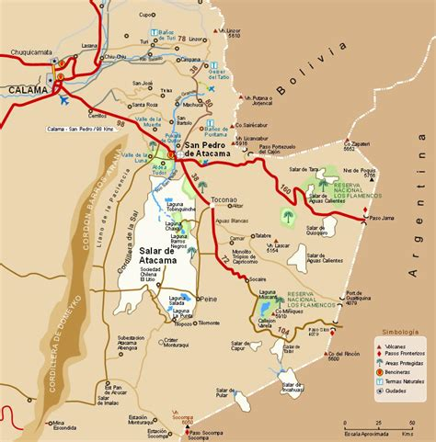
Figure 1 Atacama Wine Region
The Atacama wine region, situated in northern Chile, is one of the most extreme viticultural areas in the world. Covering the Atacama and Coquimbo regions, this area is primarily known for the production of Pisco, Chile’s famed grape brandy, but is also home to a small yet innovative wine industry. With an arid, high-altitude desert climate, minimal rainfall, and intense sunlight, viticulture here depends entirely on irrigation from the Andes.
The region’s vineyards are planted between 27° and 29° latitude south, pushing the limits of where fine wine grapes can be successfully grown. The dry conditions drastically reduce the risk of vine diseases, while the significant diurnal temperature shifts help to preserve acidity and freshness in the grapes. Soils are diverse, with limestone, clay, and alluvial deposits, offering unique potential for high-quality wines.
Key Grape Varieties
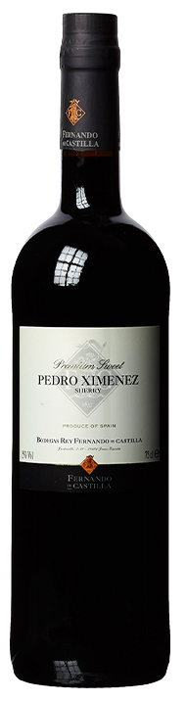
Atacama remains a small-scale wine region, but pioneering winemakers are experimenting with a range of varieties suited to its harsh conditions:
- Pedro Ximénez (PX) – Historically used for Pisco production, but now also crafted into crisp, mineral-driven white wines.
- Muscat (Moscatel de Alejandría) – The dominant grape for Pisco, with some dry and semi-sweet still wines emerging.
- Syrah – Thrives in extreme conditions, producing bold, spicy reds with deep color and structure.
- Cabernet Sauvignon – Grown in selected sites, showing concentrated dark fruit and firm tannins.
- Chardonnay – Gaining recognition for its bright acidity and saline minerality, reflecting the coastal influence.
Wine Classification System
The Atacama wine region is part of Chile’s formal Denomination of Origin (DO) system, falling under the broader Coquimbo DO. However, wine production remains limited, with most vineyards located within the subregions of Huasco Valley and Copiapó Valley. These areas are at the forefront of Chile’s push to expand viticulture into non-traditional zones.
Notable Wine Styles
- Mineral-Driven Pedro Ximénez – Bright acidity, citrus, and saline notes, showing potential beyond Pisco.
- Expressive Muscat Wines – Floral and aromatic, with fresh tropical fruit flavors.
- High-Altitude Syrah – Deeply structured, with black pepper, dark fruit, and savory umami characteristics.
- Coastal-Influenced Chardonnay – Crisp and elegant, balancing ripe orchard fruits with saline minerality.
Additional Context
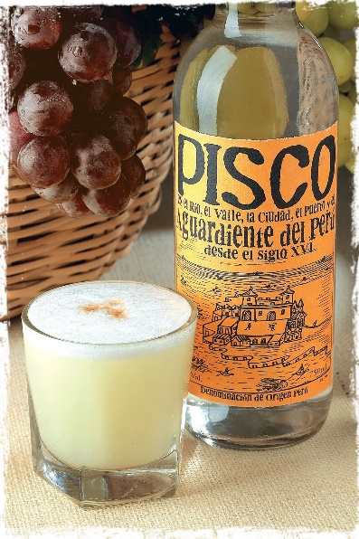
The Atacama wine industry remains experimental and small in scale, with only a handful of wineries exploring the potential of this hyper-arid landscape. Some key challenges include water scarcity, extreme heat, and the need for extensive irrigation infrastructure. Despite these obstacles, a handful of producers are proving that quality viticulture is possible in one of the driest places on Earth.
Takeaway for Sommeliers
Atacama is a niche but exciting wine region that represents Chile’s drive for innovation in extreme climates. While Pisco remains its dominant product, the region’s white wines (Pedro Ximénez and Muscat) and Syrah are worth seeking out for their unique mineral-driven expression and high-altitude freshness. As technology and viticultural knowledge advance, Atacama’s wine industry is poised to expand, offering distinctive wines unlike anything else in Chile.
References
- Robinson, J., & Harding, J. (2020). The Oxford Companion to Wine (5th ed.). Oxford University Press.
- Wines of Chile. (2023). Regional Profiles and Climate Data. Retrieved from https://www.winesofchile.org
- Tapia, P. (2022). The Wines of South America. Infinite Ideas.
- Wine Enthusiast. (2022). Exploring Chile’s Extreme Vineyards. Retrieved from https://www.winemag.com

