Aomori Japan Walking Tour
Slide 1: Welcome to Aomori
Welcome to Aomori, the northern gateway to Japan’s main island of Honshu. Surrounded by mountains and sea, Aomori is best known for its apples, Nebuta Festival, and the warmth of its people.
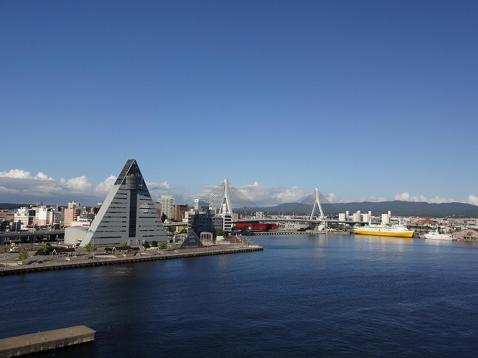
Today’s walking tour explores the Aomori waterfront district, including the Nebuta Museum, A-FACTORY market, and ASPAM observation center — all within easy reach of the cruise terminal.
This is a gentle, scenic walk rich in culture, food, and local color.

Slide 2: Starting Point – Aomori Port Terminal
Your ship docks at the Aomori Port Terminal, just a short 10-minute walk from the city center.
As you leave the pier, the first thing you’ll notice is the striking Aomori Bay Bridge, arching over the harbor. The waterfront promenade is modern, clean, and perfect for walking — with art sculptures, cafés, and ocean views along the way.

Slide 3: Stop 1 – Nebuta Museum Wa-Rasse
Our first stop is the Nebuta Museum Wa-Rasse, one of Aomori’s top attractions. The museum celebrates the city’s famous Nebuta Matsuri, a summer festival featuring massive illuminated floats made of washi paper and wire.
Inside, you can see full-size festival floats up close, learn about their construction, and even try your hand at beating the taiko drums or wearing traditional festival costumes.
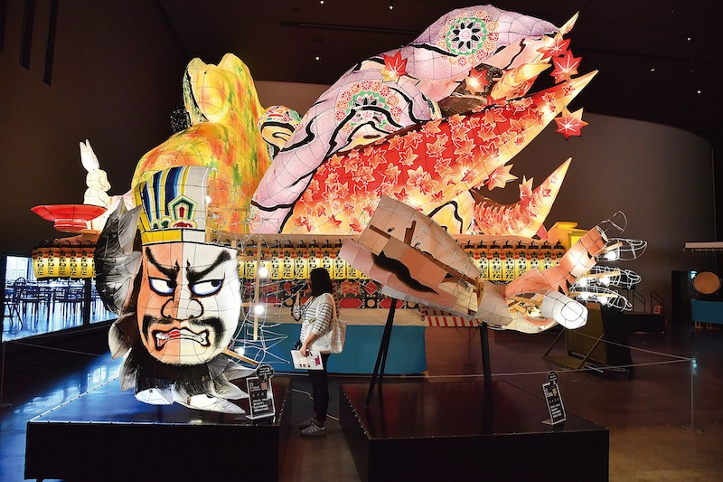
It’s a vibrant, immersive start to understanding Aomori’s creative spirit.

Slide 4: Stop 2 – A-FACTORY Market & Cidery
Just next door, visit A-FACTORY, a stylish marketplace that showcases Aomori’s agricultural pride — especially its apples. Inside you’ll find local crafts, jams, and a working cider brewery visible through glass walls.
Sample freshly pressed Aomori apple cider, try apple pastries, or pick up handmade souvenirs. The waterfront terrace here is an excellent place for a coffee break with a view of the bay.

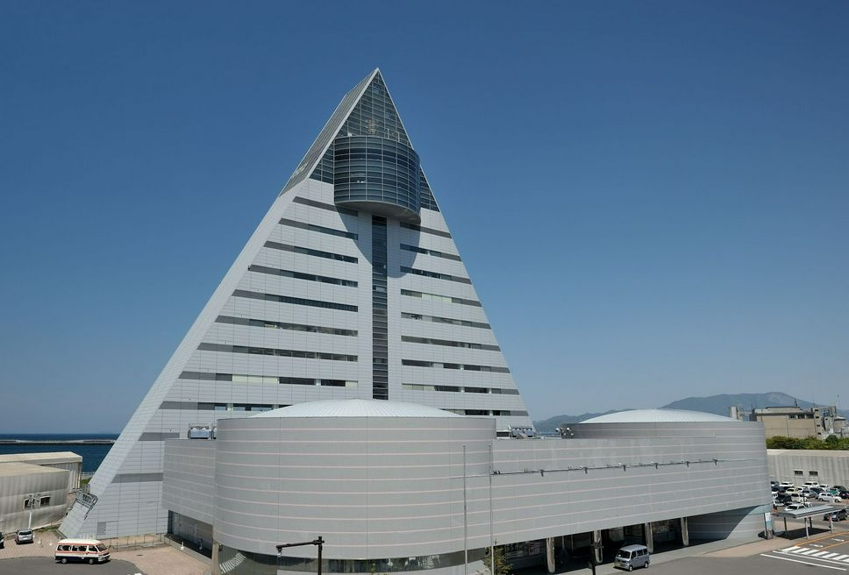
Slide 5: Stop 3 – ASPAM Building (Aomori Prefecture Tourist Center)
A few steps farther along the promenade stands the ASPAM Building, an A-shaped structure symbolizing “Aomori Prefecture.”
Inside you’ll find regional shops, restaurants, and an observation deck on the 13th floor with sweeping views of the city, the bay, and, on clear days, even Mount Hakkōda across the horizon.
It’s an ideal spot to orient yourself — and to photograph your ship in port from above.

Slide 6: Stop 4 – Aomori Bay Promenade
Continue along the Aomori Bay Promenade, a scenic walkway connecting the port area with the city center. Public art installations line the path, and it’s common to see locals fishing or strolling.
At dusk, the bridge and buildings reflect in the water, creating one of northern Japan’s most photogenic cityscapes.

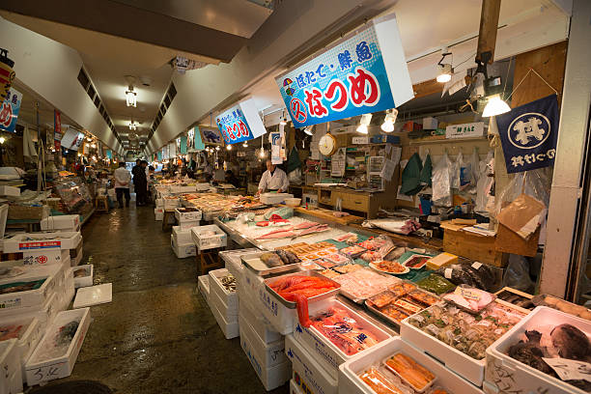
Slide 7: Stop 5 – Aomori Gyosai Center (Furukawa Fish Market)
Just a few blocks inland lies the Aomori Gyosai Center, a lively fish market that’s as much about eating as shopping.
The highlight here is the Nokke-don, or “build-your-own seafood bowl.” You purchase rice, then walk among the stalls selecting your own toppings — salmon, tuna, crab, scallops, even sea urchin — to create a personalized meal.
It’s a fun, delicious, and affordable way to sample the local catch.

Slide 8: Stop 6 – Aomori Station & Surrounding Shops
A short walk brings you to Aomori Station, the hub of the city. Around the station are souvenir shops and cafés selling everything from apple pies to Tsugaru lacquerware.
This is a good place to browse local crafts, rest, or simply people-watch. The streets are compact, safe, and easy to navigate.

Slide 9: Stop 7 – Auga Basement Market (Optional Stop)
If you’d like to explore further, check out the Auga Market, located beneath the Auga shopping building near Aomori Station.
It’s smaller and quieter than the main fish market, but it offers a glimpse of everyday local life — from early morning fishmongers to lunchtime noodle counters.
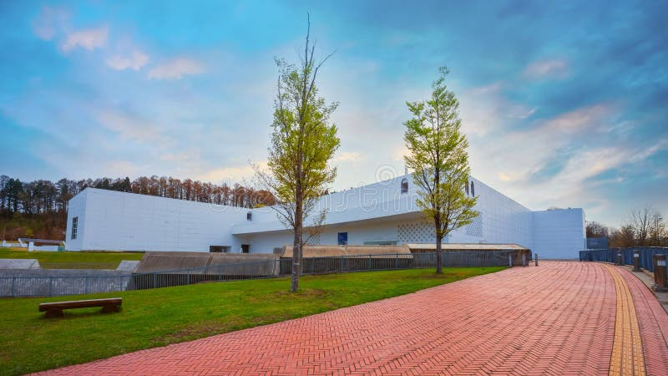
You’ll find ready-to-eat bento boxes perfect for a light picnic by the waterfront.

Slide 10: Stop 8 – Aomori Museum of Art (Optional Extension)
If you have extra time or transportation, consider visiting the Aomori Museum of Art, a short taxi or bus ride from the city center.
The museum showcases modern Japanese and international art, including the famous Aomori Dog sculpture by Yoshitomo Nara. The stark white architecture contrasts beautifully with the green landscape around it.

Slide 11: Optional Add-Ons
If you’re staying longer in the region:
- Take a day trip to Hirosaki Castle, one of Japan’s best-preserved castles, surrounded by cherry trees in spring.
- Visit Mount Hakkōda for hiking, hot springs, or the scenic ropeway.
- Or relax at Asamushi Onsen, a seaside hot spring resort just 20 minutes away by train.

Slide 12: Return Toward Port
As you walk back along the bay, the city lights begin to shimmer against the water. The Aomori Bay Bridge glows softly, and steam from the cider brewery rises into the cool evening air.
It’s a simple, memorable end to a walk that combines tradition, creativity, and the natural beauty of northern Japan.

Slide 13: Closing Slide
Aomori may feel small compared to Japan’s big cities, but its heart is large — full of artistry, hospitality, and pride in local life. From festival floats to seafood bowls, this port captures the spirit of northern Japan: welcoming, flavorful, and quietly unforgettable.
Whether you came for culture, food, or the sea breeze, Aomori leaves you with one lasting thought — simple places often tell the richest stories.

