Antsiranana (Diego Suarez), Madagascar Walking Tour
Self-Guided Walking Tour: Antsiranana (Diego Suarez), Madagascar
Approx. Time: 2 hours | Total Distance: 1.3 miles (2 km) | Start & End: Cruise Tender Dock, Port of Antsiranana
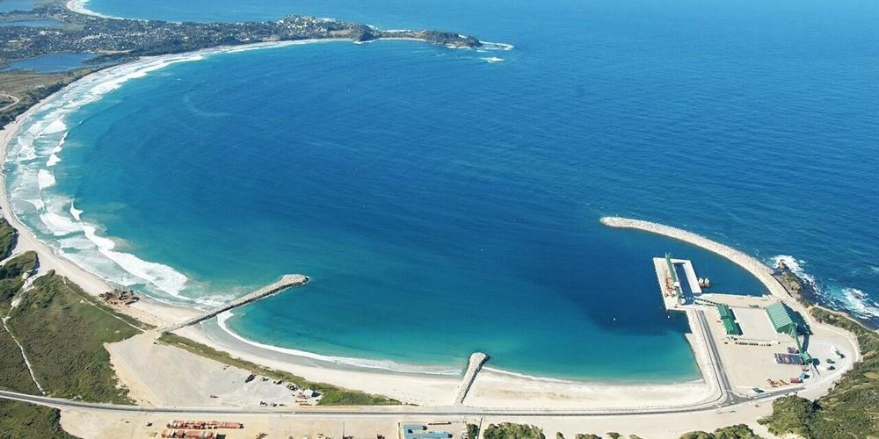
1. Port Area and Waterfront (Start)
Time: Begin directly at the tender pier
Highlight: The tour starts along Boulevard Joffre, overlooking Diego Bay — one of the largest natural harbors in the Indian Ocean. You’ll see fishing boats, bright market stalls, and locals going about their day.
Tip: Stop for a quick espresso or fresh fruit juice at one of the small cafés near the waterfront before heading inland.

2. Independence Plaza (Place de l’Indépendance)
Time: 10-minute walk from the port
What to See: The city’s main square, surrounded by colorful colonial buildings and lively shops. The plaza often hosts local musicians or school groups. In the center stands a monument commemorating Madagascar’s independence from France in 1960.
Photo Stop: The tropical gardens and mountain views framing the square.

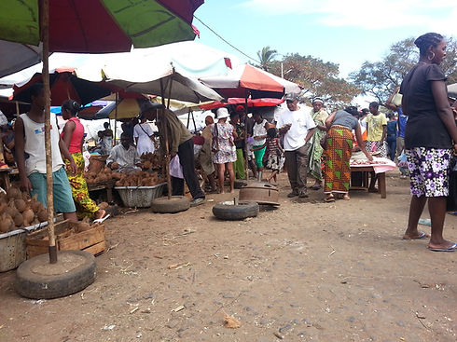
3. The Old Market (Bazary Be)
Time: 5-minute walk south from the plaza
Highlight: “Bazary Be” means “Big Market” in Malagasy — and it lives up to its name. Stalls spill into the streets, selling tropical fruit, vanilla pods, spices, textiles, and carved wood souvenirs.
Tip: Bargaining is normal and friendly. A few words of Malagasy or French go a long way — try “Misaotra!” (Thank you).

4. Boulevard de l’Indépendance & Colonial Architecture
Time: Continue along the boulevard heading west
What to See: Many of the old colonial-era buildings here date back to the late 1800s when Diego Suarez served as a French naval base. The pastel façades, wrought-iron balconies, and shaded arcades give the street a nostalgic charm.
Note: The Town Hall (Hôtel de Ville), with its clock tower, is a good landmark and photo stop.

5. The Cathedral of Saint Joseph
Time: 10 minutes from the market
Highlight: This small but beautiful Catholic cathedral stands as one of the city’s oldest surviving buildings. Inside, sunlight filters through stained glass, and from the steps, you can see views over the rooftops and harbor.
Tip: The cathedral grounds are open most days; please dress modestly if entering.

6. The Military Fortifications
Time: 10-minute walk northeast toward the harbor
What to See: Remnants of the French colonial fort overlook the sea — a reminder of Diego Suarez’s strategic importance. The cannons and lookout points here offer excellent photo opportunities across the bay toward Pain de Sucre, the sugarloaf-shaped island at the harbor’s mouth.
Optional: A short local-guided visit explains the area’s role during World War II.
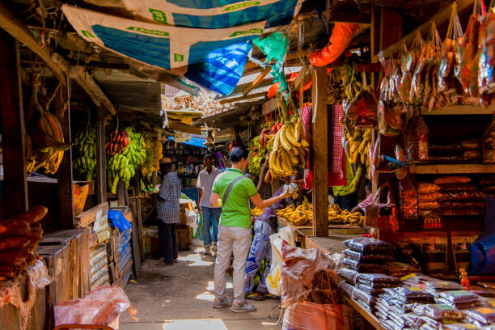
7. Craft Market and Waterfront Return
Time: 10–15-minute stroll back toward the port
Highlight: As you return, stop by the artisan stalls near the waterfront. Local crafts include woven hats, raffia bags, and hand-carved rosewood figurines.
Tip: Prices are reasonable — purchases directly support local families.

8. Café Stop and Harbor Views (End)
Time: End at a café or terrace near the tender dock
What to See: Relax with a cold THB (Three Horses Beer) or a cup of local coffee as you watch dhows and fishing boats drift across the bay. It’s the perfect way to end your morning in Diego Suarez.

Local Tips
- Currency: Malagasy Ariary (MGA); small euro notes often accepted.
- Language: Malagasy and French; some English near port.
- Dress: Casual, light clothing; modest attire for churches.
- Safety: Very safe and friendly; keep valuables secure in crowded markets.
- Tipping: 5–10% appreciated for guides or café service.
- Hydration: Bring bottled water — it’s warm and humid year-round.

Total Walking Time: ~2 hours (plus market and café stops)
Difficulty: Easy – mostly flat, some uneven streets

Tagline for footer:
“Keep exploring — your next favorite discovery might be waiting in Diego Suarez’s colorful streets.”

