Anjou: The Heart of Loire’s Diversity
Region Overview
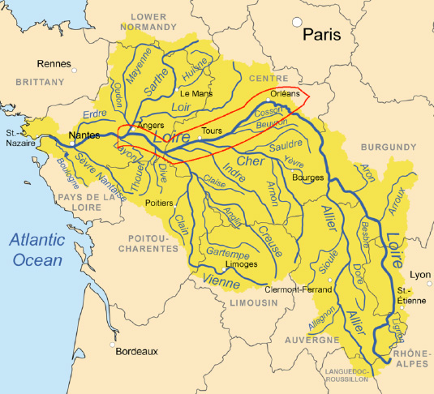
Anjou, located in the western Loire Valley, is one of France’s most versatile wine regions. Bordered by Saumur to the east and the Muscadet region to the west, Anjou benefits from a temperate maritime climate with Atlantic influences, transitioning to a more continental climate further inland. The region features a diverse terroir dominated by schist, slate, and limestone soils, which contribute to the mineral-driven character of its wines (Wine-Searcher, 2024).
Anjou is renowned for its expressions of Chenin Blanc and Cabernet Franc, producing a wide spectrum of wines—from crisp and structured dry whites to lusciously sweet botrytized wines, as well as refined reds and elegant rosés. The region has historically played a crucial role in the Loire’s winemaking heritage and continues to be a key contributor to France’s diverse wine landscape (Decanter, 2023).
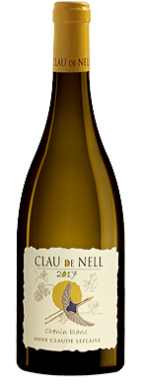
Key Grape Varieties
- Primary White Varieties:
  - Chenin Blanc: The dominant white grape of Anjou, capable of producing dry, off-dry, and sweet wines, often exhibiting high acidity and complex aging potential (Jancis Robinson, 2022).
- Primary Red Varieties:
  - Cabernet Franc: The leading red variety, producing elegant, structured wines with red fruit, herbal notes, and refined tannins (Wine Spectator, 2024).
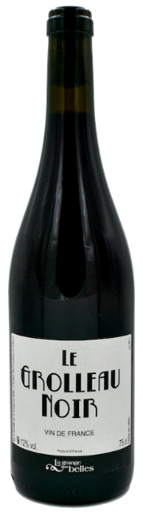
- Indigenous and Regional Varieties:
  - Grolleau: Primarily used for rosé production, adding fresh red fruit and lively acidity (Loire Valley Wines, 2023).
  - Cabernet Sauvignon: Often blended with Cabernet Franc to enhance structure and depth.
  - Sauvignon Blanc: Found in small quantities, typically blended for aromatic whites.
Wine Classification System
Anjou’s appellation system covers a broad range of styles, ensuring the region’s diversity is well represented:
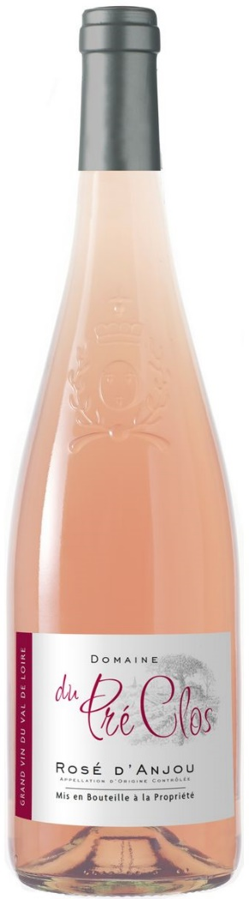
- Anjou AOP – Encompasses reds, whites, and rosés under general quality standards (INAO, 2024).
- Anjou Blanc AOP – Focuses on dry to sweet Chenin Blanc wines.
- Anjou Rouge AOP – Primarily Cabernet Franc-based wines, often blended with Cabernet Sauvignon.
- Anjou-Villages AOP – Higher-quality reds from specific vineyard sites.
- Savennières AOP – A prestigious dry white wine appellation producing some of France’s most age-worthy Chenin Blanc.
- Coteaux du Layon AOP – The leading designation for sweet wines made from botrytized Chenin Blanc.
- Quarts de Chaume AOP – A Grand Cru appellation for exceptional sweet wines.
- Rosé d’Anjou AOP & Cabernet d’Anjou AOP – Notable for their fresh, slightly off-dry rosé wines.
Notable Wine Styles
- Savennières (Chenin Blanc)
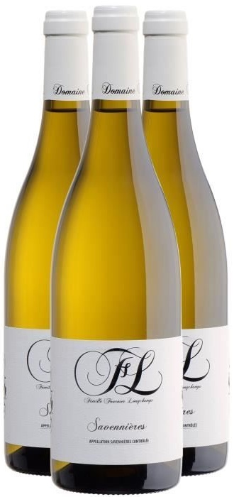
  - Classification Level: AOP
  - Composition: 100% Chenin Blanc
  - Production Method: Fermentation in stainless steel or oak, with extended aging potential.
  - Aging Requirements: No strict minimum, but best examples evolve beautifully over time.
  - Alcohol Content: 12.5–14% ABV
  - Organoleptic Profile: High acidity, intense minerality, and complex notes of citrus, honey, and wet stone (Wine Enthusiast, 2024).
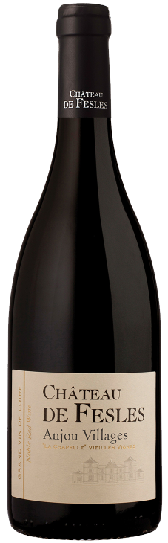
- Anjou-Villages (Cabernet Franc-Based Reds)
  - Classification Level: AOP
  - Composition: Predominantly Cabernet Franc, sometimes blended with Cabernet Sauvignon.
  - Production Method: Traditional fermentation with oak aging to enhance structure.
  - Aging Requirements: No strict minimum; best examples develop complexity with aging.
  - Alcohol Content: 12.5–14% ABV
  - Organoleptic Profile: Red berries, herbal notes, firm tannins, and earthy undertones (Decanter, 2023).
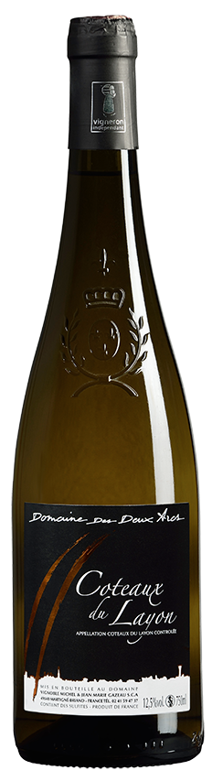
- Coteaux du Layon (Sweet Chenin Blanc)
  - Classification Level: AOP
  - Composition: 100% Chenin Blanc
  - Production Method: Late-harvest grapes, often affected by noble rot.
  - Aging Requirements: Varies; top wines can mature for decades.
  - Alcohol Content: 11–14% ABV
  - Organoleptic Profile: Rich honeyed texture, tropical fruit, citrus, and floral aromas with vibrant acidity (Wine Spectator, 2024).
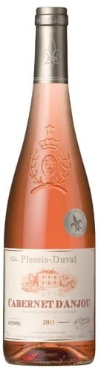
- Rosé d’Anjou & Cabernet d’Anjou (Rosé Wines)
  - Classification Level: AOP
  - Composition: Grolleau and Cabernet Franc (Rosé d’Anjou), Cabernet Franc and Cabernet Sauvignon (Cabernet d’Anjou).
  - Production Method: Direct pressing or short maceration for color extraction.
  - Aging Requirements: Typically consumed young.
  - Alcohol Content: 10.5–12.5% ABV
  - Organoleptic Profile: Fresh, fruity, with notes of strawberry, raspberry, and a hint of sweetness (Loire Valley Wines, 2023).
Additional Context
- Recent Developments: Increased focus on organic and biodynamic viticulture, with producers emphasizing terroir expression (Wine-Searcher, 2024).
- Historical Context: Anjou has a long history of viticulture, with records of wine production dating back to the Middle Ages (Jancis Robinson, 2022).
- Food Pairing Notes: Dry Savennières pairs well with shellfish and creamy cheeses, while Anjou reds complement roasted meats and charcuterie. The region’s sweet wines shine with foie gras and fruit-based desserts.
Notable Producers
- Domaine Belargus – Specializing in biodynamically farmed Chenin Blanc, producing site-specific terroir-driven wines.
- Domaine des Baumard – Known for its age-worthy Savennières and exceptional sweet wines from Coteaux du Layon.
- Château de Fesles – A historic estate producing some of the finest Quarts de Chaume wines.
- Château de la Roulerie – Focuses on structured Anjou-Villages reds and refined whites.
Take-Away for Sommeliers
Anjou’s diversity, from its iconic Chenin Blanc expressions to its structured reds and lively rosés, makes it a key Loire Valley region for sommeliers to study. Its appellations offer a broad spectrum of styles, allowing for versatile food pairings and cellar-worthy selections. Understanding Anjou’s terroir-driven approach and commitment to quality is essential for those seeking to master the nuances of Loire Valley wines.
References
- Decanter, 2023. The Wines of the Loire Valley.
- INAO, 2024. French Wine Appellations.
- Jancis Robinson, 2022. The Oxford Companion to Wine.
- Loire Valley Wines, 2023. Regional Wine Guide.
- Wine Enthusiast, 2024. Loire Valley Wine Review.
- Wine-Searcher, 2024. Anjou Wine Market Trends.
- Wine Spectator, 2024. Best Loire Valley Wines.

