Amplifier Technology and Bias
By Marc Silver

The Bias We All Carry
Every audiophile, dealer, and engineer comes to the table with personal preferences. Some swear by tubes, others by solid-state muscle. I’m no different.
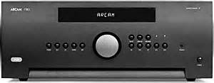
In my system, a 200-watt-per-channel Arcam Sliding Bias Class A integrated amplifier (Arcam calls it Class G) is the workhorse. But if I could choose purely by taste, I’d live with a single-ended triode tube amp. The catch is my speakers. I’ve been running Acoustat 2+2 electrostatics for more than thirty years. They’re extraordinary, but they’re also demanding. Years ago, I drove them with a 300-watt McIntosh solid-state amplifier. The Acoustats devoured every watt, still asking for more.

Over time I learned that when it comes to electrostatics, high-current solid-state usually outperforms the romantic glow of tubes. Could I switch to something more efficient, like a Martin Logan electrostat? Sure. But for me, nothing else sounds quite as right. That’s why I admit my bias at the start, because when we talk about amplifiers, we’re always talking about taste as much as technology.

Why This Article?
The goal here is simple: to talk about amplifiers in terms that make sense. We’ll look at both tube and solid-state designs, the main operating classes, their strengths and weaknesses, and a few key technical terms.
I’ll focus on power amplifiers, but the same principles apply to integrated amplifiers that combine preamp and power stages in one box.

What Is an Amplifier?
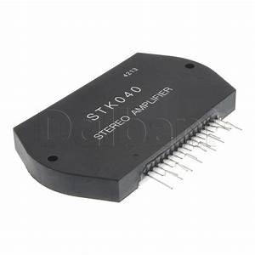
Strip away the mystique and an amplifier is just a device that takes a small electrical signal and makes it strong enough to drive a loudspeaker or headphone. The difference between input and output is called gain.
Amplifiers can be standalone, like a stereo power amp, or built into other devices, a phono stage, for instance, which combines amplification with equalization. And while we’re zeroing in on audio, amplification is central to nearly all modern electronics.
Figure 1 Opperational Amplifier Chip Set

Historically, the story begins with the triode vacuum tube, invented in 1906 by Lee De Forest. By 1912, the first amplifiers were built, and we’ve been refining them ever since. Transistors followed in 1947, revolutionizing electronics. Today, most amplifiers are solid-state, yet tube production is enjoying a surprising boom, more tube models are available now than at any point in history.

The Building Blocks of an Amplifier
Every amplifier, whether tube or transistor, shares the same basic structure:
- Power Supply – Converts the wall’s alternating current (AC) into direct current (DC) the circuit can use. Typically involves a transformer and rectifiers.
- Pre-Driver Stage – Boosts the low-level input signal in voltage. In a dual-stage design, this stage handles voltage while the next stage handles current.
- Output Stage – Delivers usable power to the loudspeakers. This is the “engine room” where current is produced.
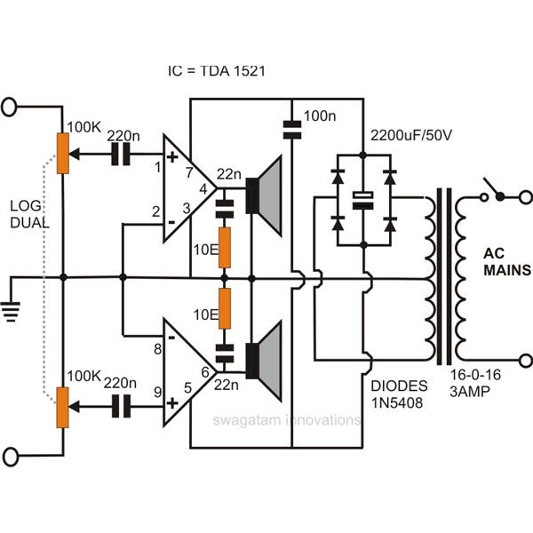
Amplifier Classes
Amplifiers are grouped by how their output devices operate. For home audio, four classes dominate:
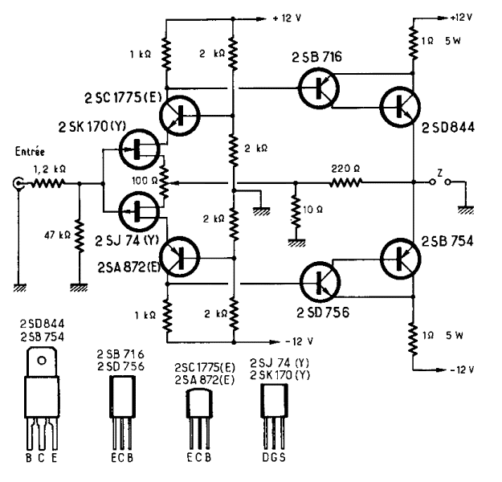
- Class A – Output devices are always on. Single-ended triode tube amps are the classic case. They’re inefficient, hot-running, and usually low-power. Yet many audiophiles prize them for sonic purity.
Figure 2 Basic Amp design
Figure 3 Class A Amplifier.
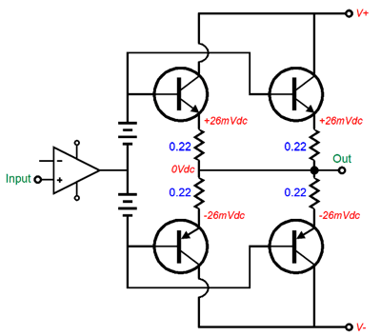
- Class AB – Push-pull operation, where one device handles the positive half of the waveform and another handles the negative. More efficient than Class A, cooler running, and the most common topology in both tube and transistor designs.
Figure 4 AB Amp Layout.
- Class G – Also called sliding bias. Starts in Class A for low-level signals, then switches to Class AB as demand increases. Arcam and Parasound use this to balance musical finesse with dynamic punch.
- Class D – Once dismissed as “switching amps,” these are now mainstream. They use high-frequency switching to achieve extraordinary efficiency and compact size. Early models sounded rough, but today Class D powers everything from subwoofers to high-end stereo systems.
Class | Efficiency | Heat | Sonic Character
A | 20-30% | Very High | Smooth Natural
AB | 40-70% | Moderate | Dynamic and Balanced
D | 80-95% | Low | Clean but Sterile
G | 30-60% | Moderate-High | Mix of Class A warmth & AB Power

Tubes vs. Transistors
Few topics stir more debate. Tubes are said to be warm, liquid, and musical. Solid-state is hailed for bass control, dynamics, and low distortion. Both claims hold truth, but both have exceptions.
I once believed tubes lacked bass authority. Then I heard a Rogue Audio tube amp that shook that assumption. I also believed that only tube designs were truly musicality, until I experienced Pass Labs transistor designs and changed my mind.
Electrically, the difference is straightforward. Tubes use vacuum tubes, usually transformer-coupled to the speakers. Solid-state relies on transistors, often direct-coupled in modern designs. Hybrids, tube input stages feeding transistor outputs, offer a blend of both. The MOSCODE 600 from New York Audio Labs was an early example, and hybrids are common today, especially from Chinese manufacturers.
There’s a saying in the tube world: “It’s only 20 watts, but it sounds like 100 solid-state.” The reason isn’t magic, it’s measurement. Amplifier specs are usually tested one frequency at a time, averaged across the spectrum. Music, of course, is thousands of frequencies at once. Tubes handle that complexity differently, which can make modest-power amps sound more powerful than their ratings suggest.

Understanding Distortion
Two forms matter most:
- Harmonic Distortion – Extra frequencies added at multiples of the original tone (a 1 kHz tone producing faint 2 kHz, 3 kHz, etc.).
- Intermodulation Distortion (IMD) – Created when two signals mix and produce unwanted sum or difference tones. Imagine a singer and a guitar overlapping, and suddenly “ghost notes” appear that weren’t played.
Even-order distortion (common in tubes) often sounds pleasant. Odd-order distortion (more typical in transistors) can sound harsh. Specs don’t always capture how these distortions are perceived by the ear.

The Specs That Matter
When comparing amplifiers, these parameters help decode the numbers:
- Gain – Ratio of output to input, often shown as watts per channel.
- Bandwidth – Frequency range handled, usually 20 Hz to 20 kHz.
- Efficiency – How much of the power drawn becomes usable output.
- Linearity – Consistency of output across volume levels.
- Noise / Signal-to-Noise Ratio – How much hiss or hum is mixed in.
- Dynamic Range – Difference between the quietest and loudest usable levels.
- Slew Rate – How quickly the amp can respond to changes in signal.
- Rise Time – Speed at which a waveform is formed.
- Damping Factor – Control over the speaker cone, especially in the bass.
Term | Definition | Why it matters
Gain | Increase input to output | Controls how loud system can play
Bandwidth | Range of frequency response | Full music spectrum 20-20k
Efficiency | Ratio of power used | Affects heat, and power draw
Linearity | Accuracy of input to output | Linearity displays accuracy of music
Noise (S/N) | Unwanted noise | Higher number mean lower noise
Dynamic Range | Quietest to Loudest | Preserve Musical Contrast
Slew Rate | Speed of signal change | Impacts clarity and transients
Damping Factor | Control of speaker movement | Tight, Clean Bass Response

Closing Thoughts
Amplifiers sit at the heart of every audio system. They can glow softly with tubes or drive hard with banks of transistors. They can be measured in distortion charts, damping factors, and slew rates. But in the end, the real measure is how they make music feel.
My own journey has been one of balancing science, specs, and personal taste. That tension is what makes amplifier choice endlessly fascinating. Numbers guide us, but listening decides.

