American Wine: Innovation, Diversity, and a Spirit of Exploration
American wine is a story of ambition. Unlike the ancient vineyards of Europe, where tradition dictates style and classification, the United States offers winemakers a freedom that has led to some of the most exciting and innovative wines in the world.
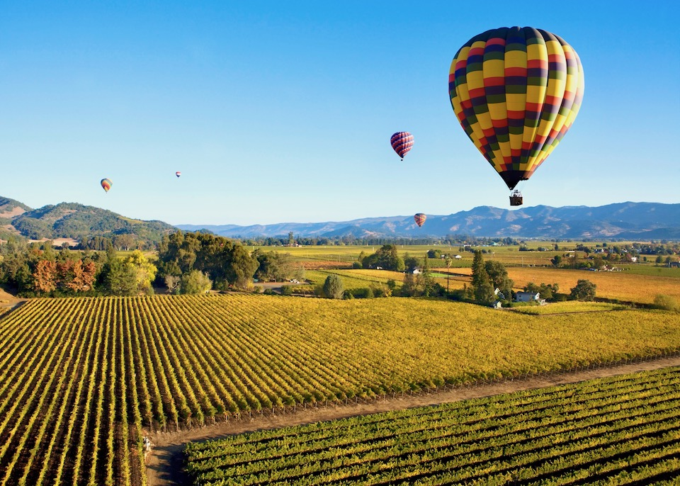
From the sun-drenched valleys of California to the cool-climate slopes of Oregon and Washington, American wine is defined not by centuries-old rules, but by an adventurous, pioneering spirit.
The U.S. may not have the same historical depth as France or Italy, but in a short time, it has made a lasting mark. Napa Valley’s Cabernet Sauvignon rivals Bordeaux’s best. Oregon’s Pinot Noir is a benchmark outside of Burgundy. Washington State’s structured reds have drawn comparisons to the Rhône, and regions as diverse as Texas, New York, and Virginia are proving that world-class wine can come from unexpected places. American winemakers embrace technology, push  boundaries, and experiment with styles, from classic Bordeaux blends to natural wines and unconventional varieties.
But American wine isn’t just about innovation—it’s also about terroir. While the country lacks the rigid classification systems of the Old World, it has developed its own identity through the American Viticultural Area (AVA) system, which highlights the distinctiveness of each region. Whether it’s the volcanic soils of Napa, the maritime influence of Sonoma, or the arid, high-altitude vineyards of Washington, the diversity of climates and landscapes across the U.S. allows for a remarkable range of styles.
In this chapter, we’ll explore America’s most influential wine regions, uncover their defining characteristics, and examine how the country has evolved from a newcomer to a global leader in fine wine.
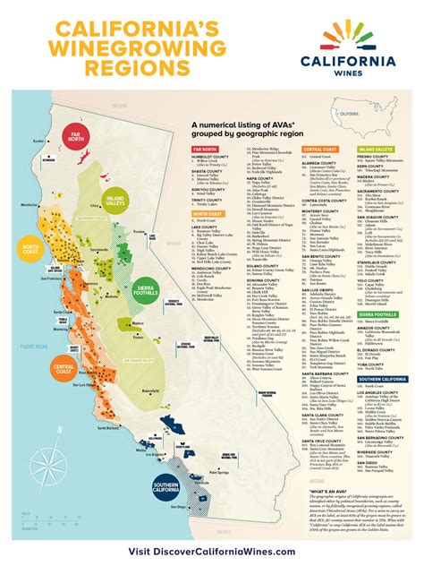
The primary wine regions covered in this chapter include:
- California – The heart of American wine, home to legendary Napa Valley Cabernet, diverse Sonoma County wines, and exciting coastal regions like Santa Barbara and Monterey.
- Oregon – Best known for its elegant, cool-climate Pinot Noir from the Willamette Valley, alongside rising stars like Chardonnay and sparkling wines.
- Washington State – A dynamic region producing bold, structured reds, particularly in the Columbia Valley, where Cabernet Sauvignon, Syrah, and Merlot thrive.
- New York – The East Coast’s wine frontier, with the Finger Lakes excelling in Riesling and Long Island producing refined Bordeaux-style blends.
- Texas – A rapidly growing wine state where Mediterranean varietals like Tempranillo and Mourvèdre flourish in warm, dry conditions.
- Virginia – A historic yet emerging wine region known for Viognier, Cabernet Franc, and its dedication to terroir-driven winemaking.
American wine is constantly evolving. Unlike the Old World, where wine traditions are often tied to centuries of history, the U.S. is still writing its own story. With a willingness to experiment and a deep respect for terroir, American winemakers continue to push the boundaries of what’s possible. By the end of this chapter, you’ll have a deeper appreciation for why the U.S. has become one of the most exciting and influential wine-producing countries in the world.

