Alter do Chão Self-Guided Walking Tour: The Amazon's Riviera
Starting Point: Alter do Chão Main Dock (Cais de Alter do Chão)
Total Distance: Approximately 2 miles (3.2 km) round trip, including beach time
Estimated Time: 2.5 to 4 hours (highly flexible for relaxing)
Difficulty: Very Easy — flat, sandy paths and beaches.
Language Note: Portuguese is the main language.

1. From the Dock to Praça do Cajueiro
Begin at the Alter do Chão Main Dock, where the clear, green waters of the Tapajós River greet you. Walk directly inland for just a few minutes to reach the heart of the village: Praça do Cajueiro (Cashew Tree Square). This charming, shady plaza is named after the enormous, ancient cashew tree at its center. Here, you'll find a tourist information kiosk, local vendors, and the relaxed pulse of the town.
Tip: This is a great spot to get your bearings, use restrooms, and pick up a cold bottle of water.
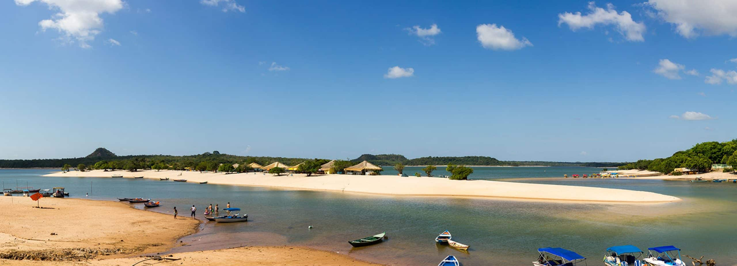
2. Igreja Nossa Senhora da Saúde
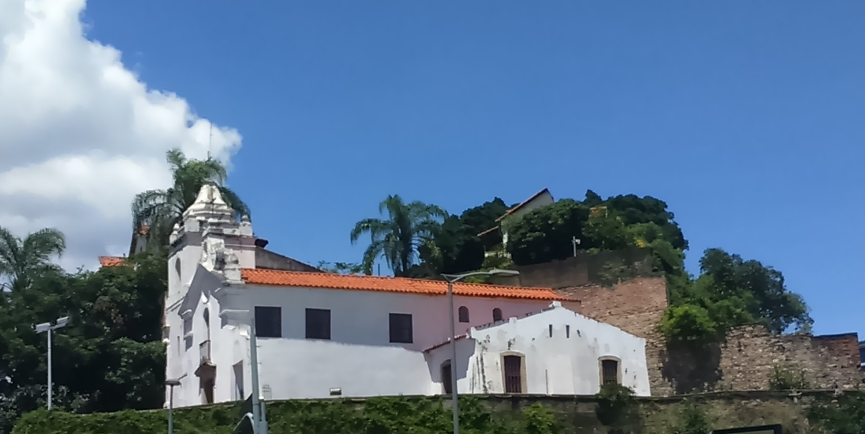
On the edge of the square stands the simple, white Igreja Nossa Senhora da Saúde (Church of Our Lady of Health). This historic church dates back to the 18th century and is a serene landmark. Step inside to enjoy a moment of quiet coolness and admire the humble altar.
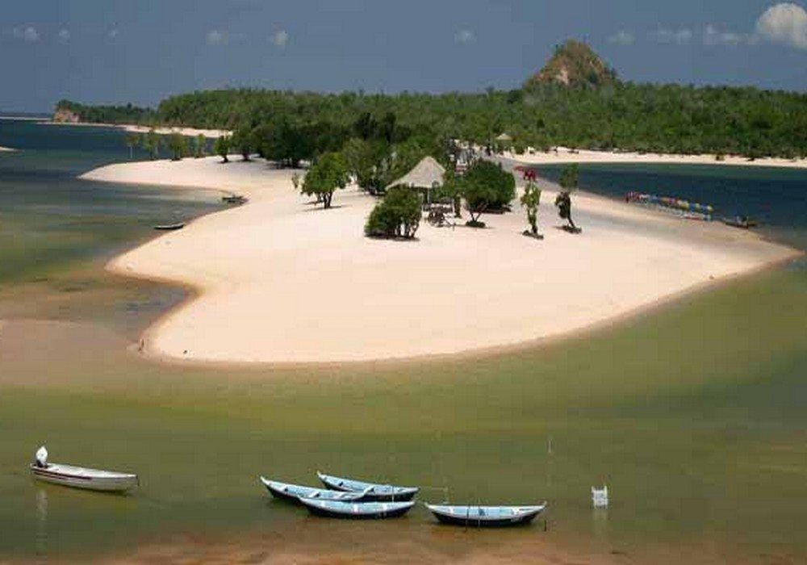
Time here: 10 minutes
Tip: Notice the church's traditional Portuguese colonial architecture, a stark contrast to the lush tropical surroundings.
3. The Famous Sandbar: Ilha do Amor
From the church, follow the path leading to the main beach, Praia do Sairí. Depending on the season, you will see the village's most famous feature: the Ilha do Amor (Island of Love). During the dry season (approx. August-December), a vast sandbar emerges in the middle of the Rio Tapajós, creating breathtaking white-sand beaches and shallow, warm, turquoise water that rivals any Caribbean shore.
Wade or take a quick canoe ride (offered by locals) across the narrow channel to explore the island.
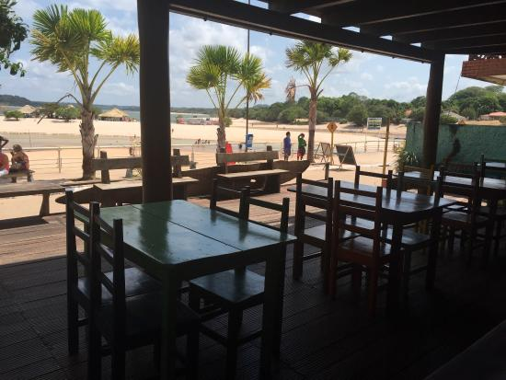
Time here: 45–90 minutes (or more!)
Tip: This is the centerpiece of the tour. Wear your swimsuit, bring a towel, and don't forget your camera. The water is incredibly inviting.
4. Lunch with a View
After your beach time, return to the village shoreline, which is lined with numerous rustic restaurants and barracas (thatched-roof eateries). Find a table with a view of the river and the Ilha do Amor. This is the perfect place to try regional specialties.
Must-try dishes include tucunaré (a flavorful Amazonian peacock bass) or tambaqui grilled with local herbs, served with farofa and vinagrete. For a refreshing drink, try a suco de cupuaçu or açaí.
Tip: The "casquinha de caranguejo" (crab served in its shell) is a delicious local appetizer.
5. Museu dos Povos do Tapajós
For a dose of culture, take a short 5-minute walk from the main beach to the Museu dos Povos do Tapajós (Museum of the Tapajós People). Housed in a beautiful traditional building, this small but excellent museum showcases the rich history and pottery of the pre-Columbian Tapajó civilization, as well as the culture of contemporary riverine communities.

Time here: 30 minutes
Tip: The museum provides essential context, showing that this paradise has been a center of life and culture for centuries.
6. Artisan Shops & Souvenir Hunting
Stroll back through the village's main streets, like Rua Dr. Hugo de Mendonça, where you'll find small boutiques and stalls selling local handicrafts. Look for beautiful ceramics inspired by ancient Tapajó pottery, jewelry made from seeds and local woods, and colorful hammocks.
Time here: 30 minutes
Tip: This is a great place to find a more authentic and artistic souvenir than in larger cities.
7. Return to the Dock & Sunset View
Loop back to the main dock. If your timing is right, find a spot along the beach or at a waterfront bar to witness the spectacular sunset over the Tapajós River. The sky often erupts in a palette of oranges, pinks, and purples, reflecting off the calm water—a perfect end to the day.
Tip: If you're not on a tight schedule, staying for sunset is highly recommended.

Before You Go
- Currency: The Brazilian Real (BRL). While some tourist spots may accept cards, cash (especially smaller notes) is king in the village's shops and restaurants.
- Safety: Alter do Chão is a very safe, small, and walkable village. The main concern is sun protection and keeping an eye on your belongings while on the beach.
- Weather: The climate is hot and sunny. A swimsuit, towel, sun hat, strong biodegradable sunscreen, and insect repellent are essential. The water level and the appearance of the Ilha do Amor depend entirely on the rainy/dry season cycle.
- Etiquette: The vibe is extremely laid-back. A friendly "Bom dia" or "Boa tarde" is always appreciated.
In Summary
This tour is a blend of natural wonder, relaxation, and gentle culture. Alter do Chão offers a unique Amazonian experience—not of dense jungle, but of stunning freshwater beaches, crystal-clear water, and the gentle, welcoming spirit of a riverine village.
Alter do Chão is a paradise where the Amazon surprises you with its beauty and tranquility. It’s less a walking tour and more an invitation to slow down, wade into the warm water, and fall in love with the 'Caribbean' heart of the rainforest.

