Alsace: The Jewel of Old-World Wine
Region Overview
The story of Old-World wine begins thousands of years ago, where ancient civilizations cultivated vines along the fertile banks of the Mediterranean. From the amphorae of the Romans to the meticulously classified vineyards of France, this part of the world has shaped global winemaking traditions.
The Old-World encompasses wine-producing regions in Europe, North Africa, and parts of the Confederation of Independent States. Historically, these regions developed viticulture through centuries of tradition, emphasizing terroir and time-honored winemaking techniques. While China’s classification remains debated, its winemaking approach leans more toward the New World style (Jancis Robinson, 2022). 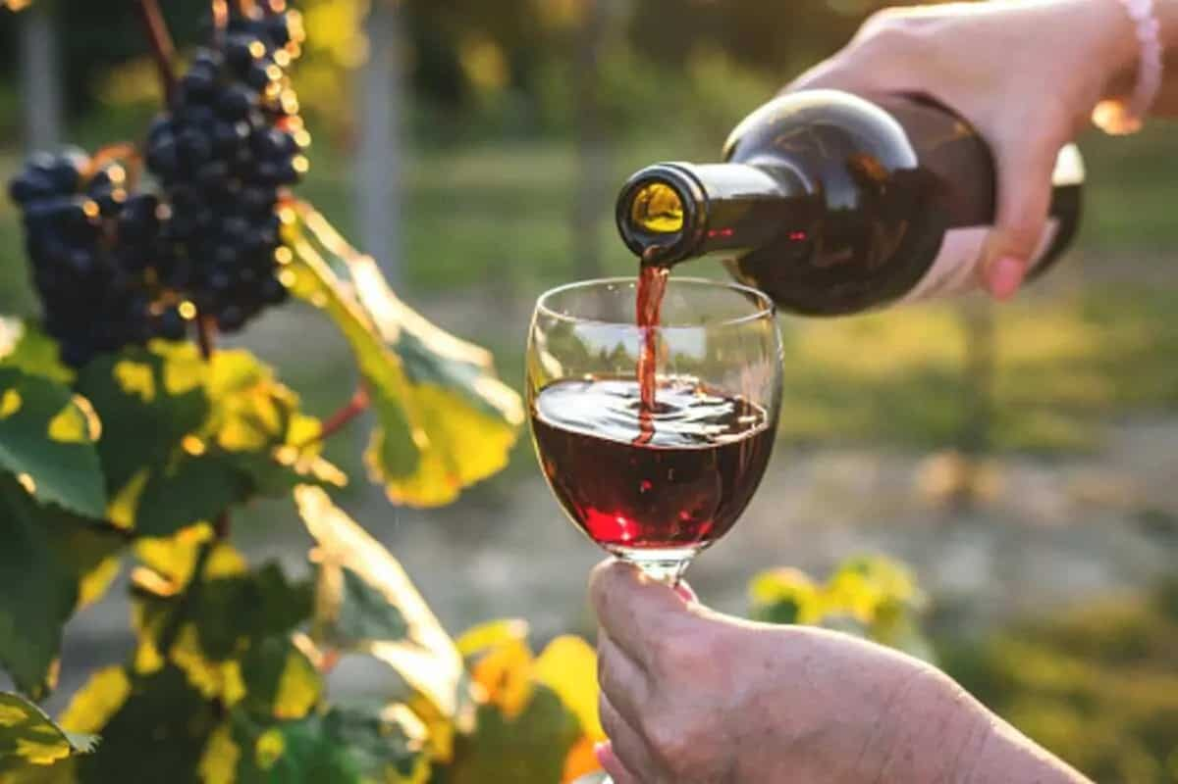
The Old-World encompasses wine-producing regions in Europe, North Africa, and parts of the Confederation of Independent States. Historically, these regions developed viticulture through centuries of tradition, emphasizing terroir and time-honored winemaking techniques. While China’s classification remains debated, its winemaking approach leans more toward the New World style (Jancis Robinson, 2022).
Traditionally, Old-World wines have been known for their subtlety, complexity, and aging potential, in contrast to the fruit-forward, high-alcohol, and oak-influenced styles often found in New World wines. However, modern technological advances have blurred these distinctions, with New World producers adopting Old-World techniques and vice versa (Wine Spectator, 2024). Countries like South Africa and New Zealand produce wines that reflect Old-World characteristics, showcasing terroir-driven elegance alongside contemporary innovation.
France: The Standard Bearer of Old-World Wines
France remains a global leader in viticultural diversity, historical significance, and wine production volume. Alongside Italy and Spain, France consistently ranks among the top three wine-producing countries in the world, each with distinct styles and traditions.
While France is known for its terroir-driven classification system, Italy emphasizes regional diversity with DOC and DOCG regulations, and Spain showcases bold expressions through its aging-focused designations like Rioja and Ribera del Duero. In 2023, the country produced over 45 million hectoliters of wine, with a significant portion classified under the Appellation d’Origine Contrôlée (AOC) system (INAO, 2024).
Key Wine Regions in France
- Major Regions: Alsace, Bordeaux, Burgundy, Champagne, Loire, Rhône.
- Lesser-Known Regions: Bergerac, Cahors, Côtes de Duras, Gaillac, Jura, Jurançon, Limoux, Languedoc-Roussillon, Madiran.
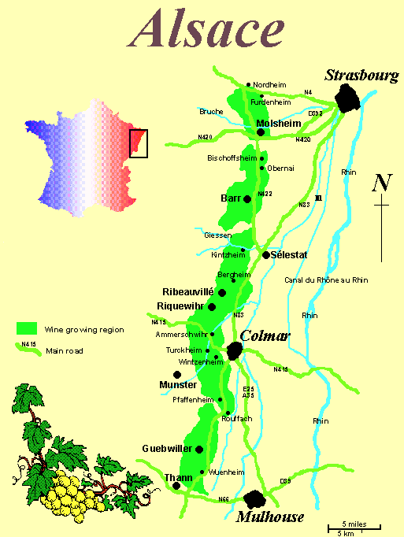
Alsace: The Jewel of Eastern France
Geographic & Climatic Profile
Alsace stretches for 75 miles from Strasbourg to Mulhouse, nestled along the eastern slopes of the Vosges Mountains near the German border. The varying elevations and orientations of vineyards create distinct microclimates, allowing winemakers to produce a diverse range of styles from crisp, high-acid Rieslings to rich, aromatic Gewürztraminers. nestled along the eastern slopes of the Vosges Mountains near the German border. The region benefits from a rain shadow effect, resulting in a dry continental climate ideal for grape growing. This microclimate contributes to the production of highly expressive wines, particularly in the Haut-Rhin, where the best vineyards are located (Decanter, 2023).
Key Grape Varieties
- Primary White Varieties:
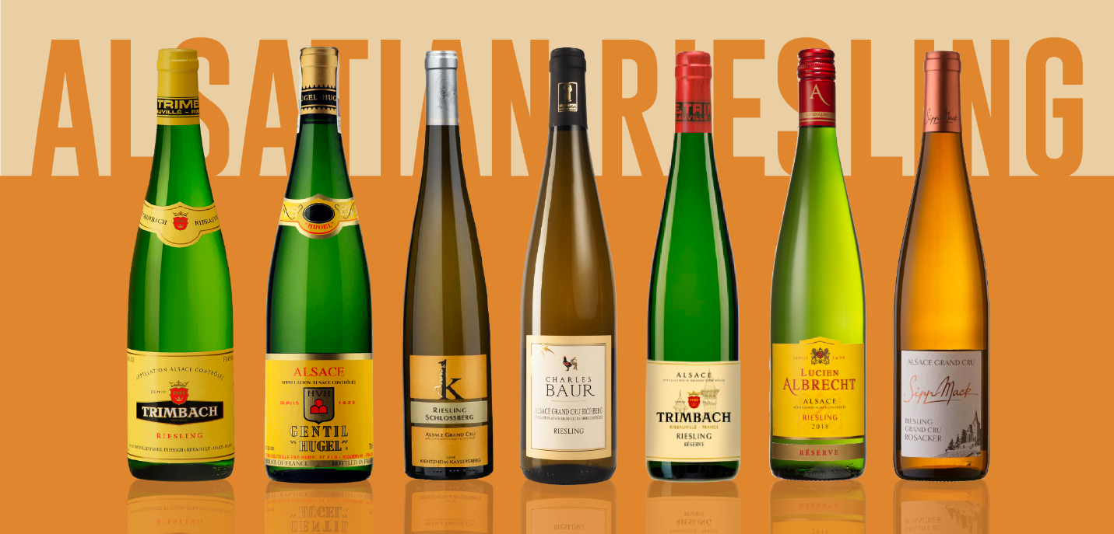
  - Riesling – High acidity, mineral-driven, capable of long aging.
  - Gewürztraminer – Full-bodied, aromatic, often with lychee and floral notes.
  - Pinot Gris – Rich texture, stone fruit, and spice flavors.
  - Muscat – Fragrant, with intense grape and floral aromas (Wine Enthusiast, 2024).
- Secondary Varieties:
  - Sylvaner, Pinot Blanc, Chasselas, and Auxerrois are also cultivated.
Wine Classification System
- AOC Alsace – The primary designation for Alsace wines, covering all permitted grape varieties.
- AOC Alsace Grand Cru – Established in 1975, this classification includes 51 vineyards that must adhere to strict yield and quality regulations. Only Riesling, Gewürztraminer, Pinot Gris, and Muscat are allowed, except for Zotzenberg, which includes Sylvaner.
- AOC Crémant d’Alsace – A sparkling wine designation produced using the traditional method, featuring Pinot Blanc, Auxerrois, Pinot Gris, Pinot Noir, Riesling, and Chardonnay (INAO, 2024).
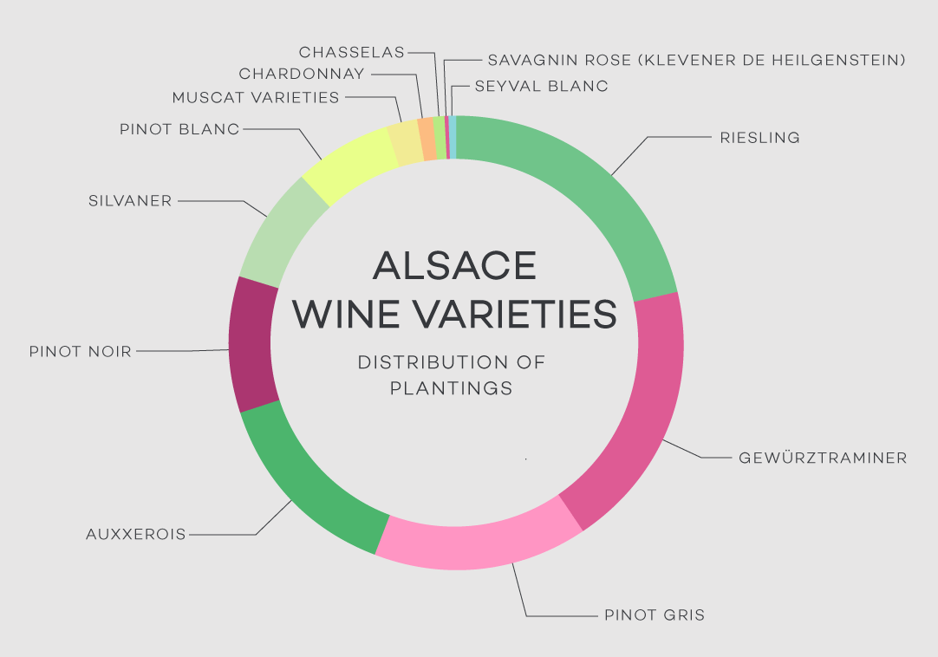
Notable Wine Styles
- Riesling (Dry White)
  - Classification Level: AOC Alsace / Grand Cru
  - Composition: 100% Riesling
  - Production Method: Fermented in stainless steel or neutral barrels
  - Aging Potential: 5–15 years
  - Alcohol Content: 12–14% ABV
  - Organoleptic Profile: High acidity, flinty minerality, citrus, and petrol notes with age (Wine-Searcher, 2024).
- Gewürztraminer (Aromatic White)
  - Classification Level: AOC Alsace / Grand Cru
  - Composition: 100% Gewürztraminer
  - Production Method: Fermented in stainless steel, minimal intervention.
  - Aging Potential: 5–10 years
  - Alcohol Content: 13–15% ABV
  - Organoleptic Profile: Lychee, rose petals, exotic spices, full-bodied (Decanter, 2023).
- Crémant d’Alsace (Sparkling)
  - Classification Level: AOC Crémant d’Alsace
  - Composition: Pinot Blanc, Auxerrois, Pinot Gris, Pinot Noir, Riesling, Chardonnay.
  - Production Method: Traditional method (méthode champenoise)
  - Aging Potential: 2–6 years
  - Alcohol Content: 11.5–13% ABV
  - Organoleptic Profile: Fine bubbles, crisp acidity, green apple, brioche, floral (Wine Spectator, 2024).
Additional Context
- Historical Background: Alsace’s winemaking history dates back to Roman times. The region has alternated between French and German control, influencing its viticultural identity (Jancis Robinson, 2022).
- Recent Developments: Increasing organic and biodynamic practices among top producers (Decanter, 2023).
- Food Pairings: Riesling pairs with seafood and white meats, Gewürztraminer complements spicy cuisine and foie gras, while Crémant d’Alsace is a versatile aperitif (Wine Enthusiast, 2024).
Notable Producers
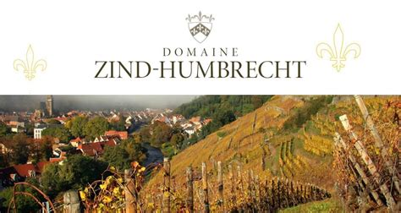
- Domaine Zind-Humbrecht – A leader in biodynamic viticulture, producing intense, age-worthy wines.

- Trimbach – Famous for dry, structured Rieslings with exceptional longevity.
- Domaine Weinbach – Specializing in Grand Cru Riesling and Gewürztraminer.
- Hugel & Fils – Producing traditional and noble sweet wines with exceptional balance.
Take-Away for Sommeliers
Alsace offers a unique perspective for sommeliers due to its balance between Old-World tradition and Germanic influence. Unlike Germany, where Riesling often retains residual sweetness, Alsace predominantly produces dry, full-bodied expressions with higher alcohol levels.
The region’s strict Grand Cru system, diverse microclimates, and emphasis on single-varietal wines provide an excellent study in terroir-driven winemaking. Mastering Alsace’s classifications and understanding its influence on food pairings can enhance a sommelier’s ability to guide wine selections with precision and confidence (Wine-Searcher, 2024).
Alsace is an essential region for sommeliers due to its diverse terroir-driven white wines. The emphasis on varietal purity, minimal intervention, and the AOC Grand Cru system provides a benchmark for understanding aromatic white wines. Sommeliers should focus on the distinctions between soil types, the influence of the Vosges Mountains, and the balance of acidity and residual sugar in various styles (Wine-Searcher, 2024).
References
- Decanter, 2023. Alsace Wine Guide: History and Evolution.
- INAO, 2024. French Wine Appellations and Classification.
- Jancis Robinson, 2022. The Oxford Companion to Wine.
- Wine Enthusiast, 2024. The Best Wines of Alsace: A Buyer’s Guide.
- Wine-Searcher, 2024. Trends in Alsace Wine Exports.
- Loire Valley Wines, 2023. Alsace Terroir and Varietals.

